Second Sunday in Advent December 8, 2013

PREPARE THE WAY FOR THE LORD
PREPARE THE WAY WITH SINCERE REPENTANCE

EVANGELICAL LUTHERAN CHURCH

elcome! Thank you for joining us for worship this morning. In our service we gather before our almighty God to offer him our worship and praise. We also gather to strengthen ourselves through the
W
study of God’s holy and powerful word.

 Restrooms are located in the hallway directly opposite the entrance to the sanctuary.

 Cry-room. If you have a young child or nursing infant and are in need of a cry-room, you will find it to the right as soon as you exit the sanctuary. A speaker there allows you to hear the service.

 Staffed nursery. We offer a staffed nursery for ages 2 to 5 and special needs children. It is located to the left of the entry foyer, near the kitchen window.

 Connection cards are found inside each worship folder. We ask that before worship or during the offering, you fill those out, front and back. You can return the card either in the offering plate or in the connection card basket you will find at the exit of the church after worship.

Summerville campus
720 Old Trolley Road Summerville, SC 29485 843.873.5522
bselc.office@gmail.com
Moncks Corner campus
Foxbank Plantation Road Moncks Corner, SC 29461 843.826.4057
Staff
Kyle Burmeister, Pastor 262.365.7123 (cell) pastorburmeister@gmail.com
Jonathan Hein, Pastor 843.860.1838 (cell) pastorhein@gmail.com
Jonathan Quinn, Pastor 843.826.4057 (home)
revjquinn@gmail.com
Nathan Loersch, Vicar 920.342.4723 (cell) vicarloersch@gmail.com

www.ourbeautifulsavior.com

WORSHIP NOTES
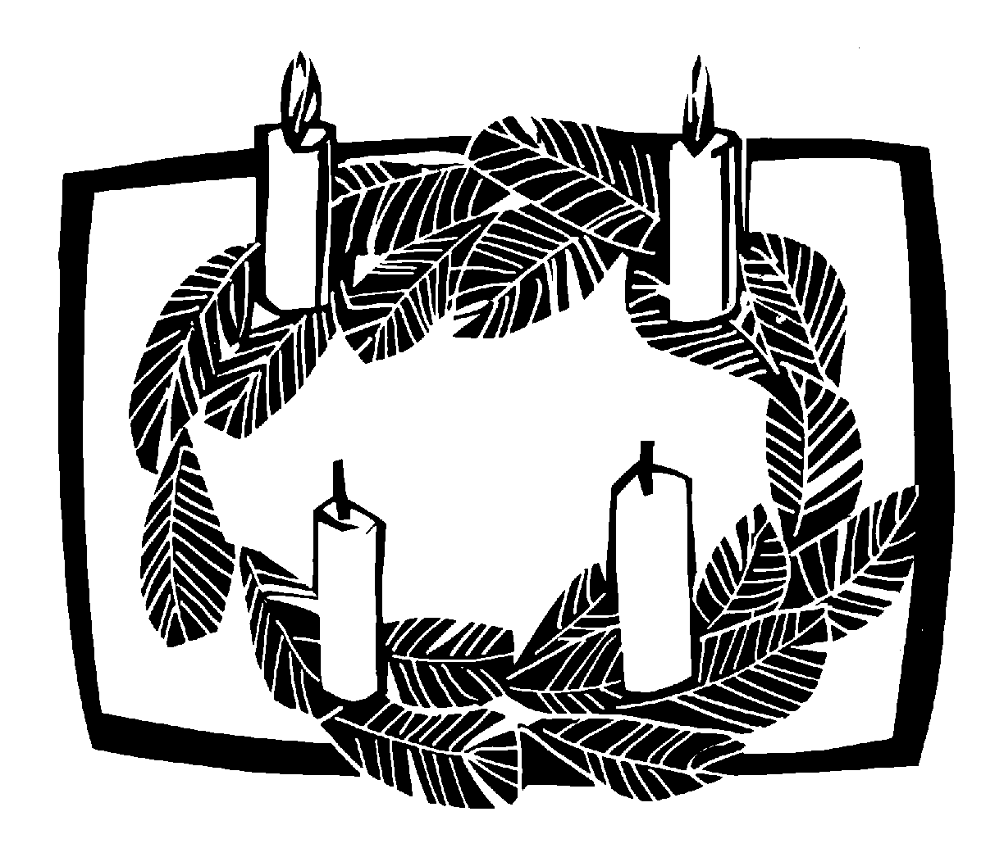THE SEASON OF ADVENT
Advent is a Latin word that means “coming.” The season of Advent is the four week period before Christmas that the Church uses to remember the “coming” of the Christ. We celebrate that he came once as a baby in Bethlehem, and that he will come again at the end of time.
OUR WORSHIP SERIES
This is a busy time of year. There is much to do to prepare for the celebration of Jesus’ birth. However, more important than celebrating Jesus’ first coming is being prepared for his second coming on the Last Day. Christmas is only important because of what it means for us at the end of time. In this worship series, we make the connection between Christ’s first coming as Savior and his second coming as Judge. Our worship follows this pattern.

PREPARE THE WAY FOR THE LORD
First Sunday in Advent | Prepare, for the Lord will come again unexpectedly
Second Sunday in Advent | Prepare the way with sincere repentance
Third Sunday in Advent | Prepare the way by proclaiming good news
Fourth Sunday in Advent | Prepare the way. Immanuel comes!

OUR THEME FOR TODAY
Prepare the way with sincere repentance. When Jesus came into the world the first time, God raised up John the Baptist to prepare people to meet him. John preached a powerful message of repentance, and it brought about a renewal of life. People ran to Jesus, the bringer of salvation. Jesus is going to come into the world a second time, and we are to prepare the same way — with sincere repentance. For the unrepentant, Christ’s return will mean an eternity of sorrow. But for God’s repentant people, Christ’s return will mean an eternity in his glorious Kingdom.

Order of Service for
THE SEASON OF ADVENT

AWAKE, O SLEEPER
Minister: Refrain
Congregation: Refrain

 The Gathering 

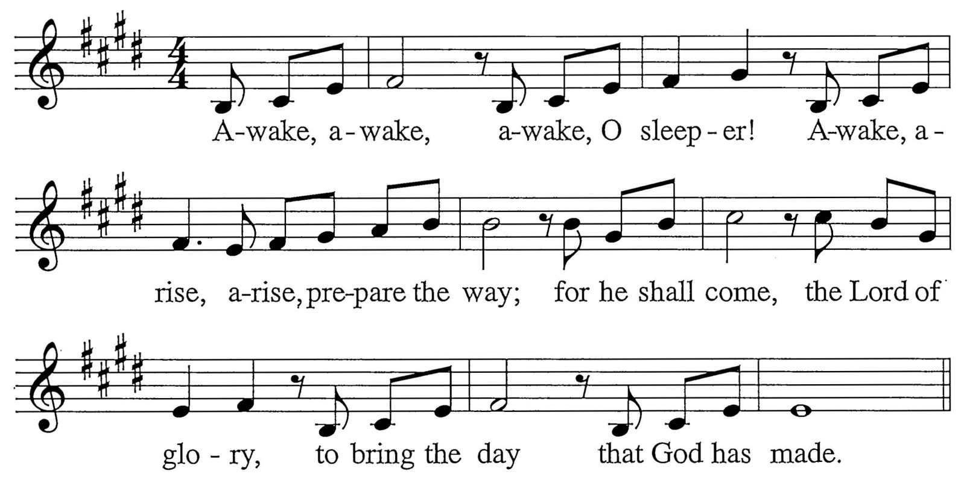

M: Lion and calf together shall run; the wolf be the guest of the lamb.
Nations shall seek him, the One who is love. His justice fills the land.
C: Refrain
M: Singe with one voice to the glory of God. Live with each other in peace.
Repent and believe for the time is at hand when sinners find release.
C: Refrain
M: There in the desert a voice shall cry: “Prepare now the way of the Lord!” Straighten his path and herald the day when justice is restored.
C: Refrain

INVOCATION
M: In the name of the Father and of the Son  and of the Holy Spirit.

C: Amen.
M: Look! Christ is coming with the clouds.

C: Every eye will see him, even those who pierced him. Revelation 1:7

CONFESSION OF SINS
M: Lest that Day surprise us unprepared, let us make confession of our sins, imploring our heavenly Father to have mercy on us for the sake of Jesus Christ.
Silence for personal confession
M: You came to call us from darkness into light: Lord have mercy.

C: 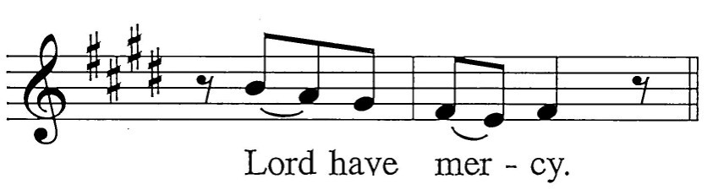
M: You came to visit your people with peace: Christ have mercy.

C: 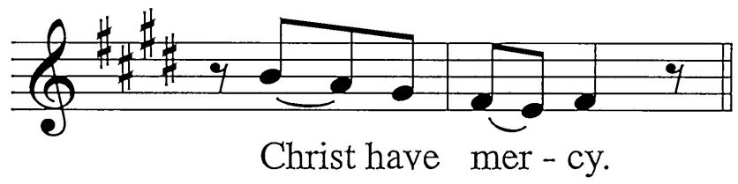
M: You will return and our joy will be full: Lord have mercy.

C:
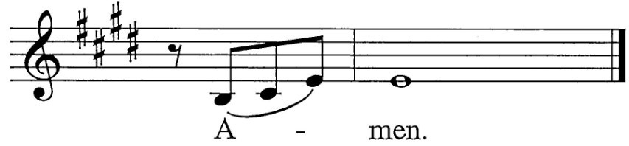M: May almighty God have mercy on us, forgive us our sins and bring us to everlasting life. Amen.

C:

ABSOLUTION
M: God, our heavenly Father, has been merciful to us
and has given his only Son to be the atoning sacrifice for our sins. Therefore, as a called servant of Christ and by his authority,
I forgive all your sins in the name of the Father and of the Son  and of the Holy Spirit.

C: Amen!
The Rite of Holy Baptism may take place here.
M: In the peace of forgiveness, let us praise the Lord.
C: Final Refrain

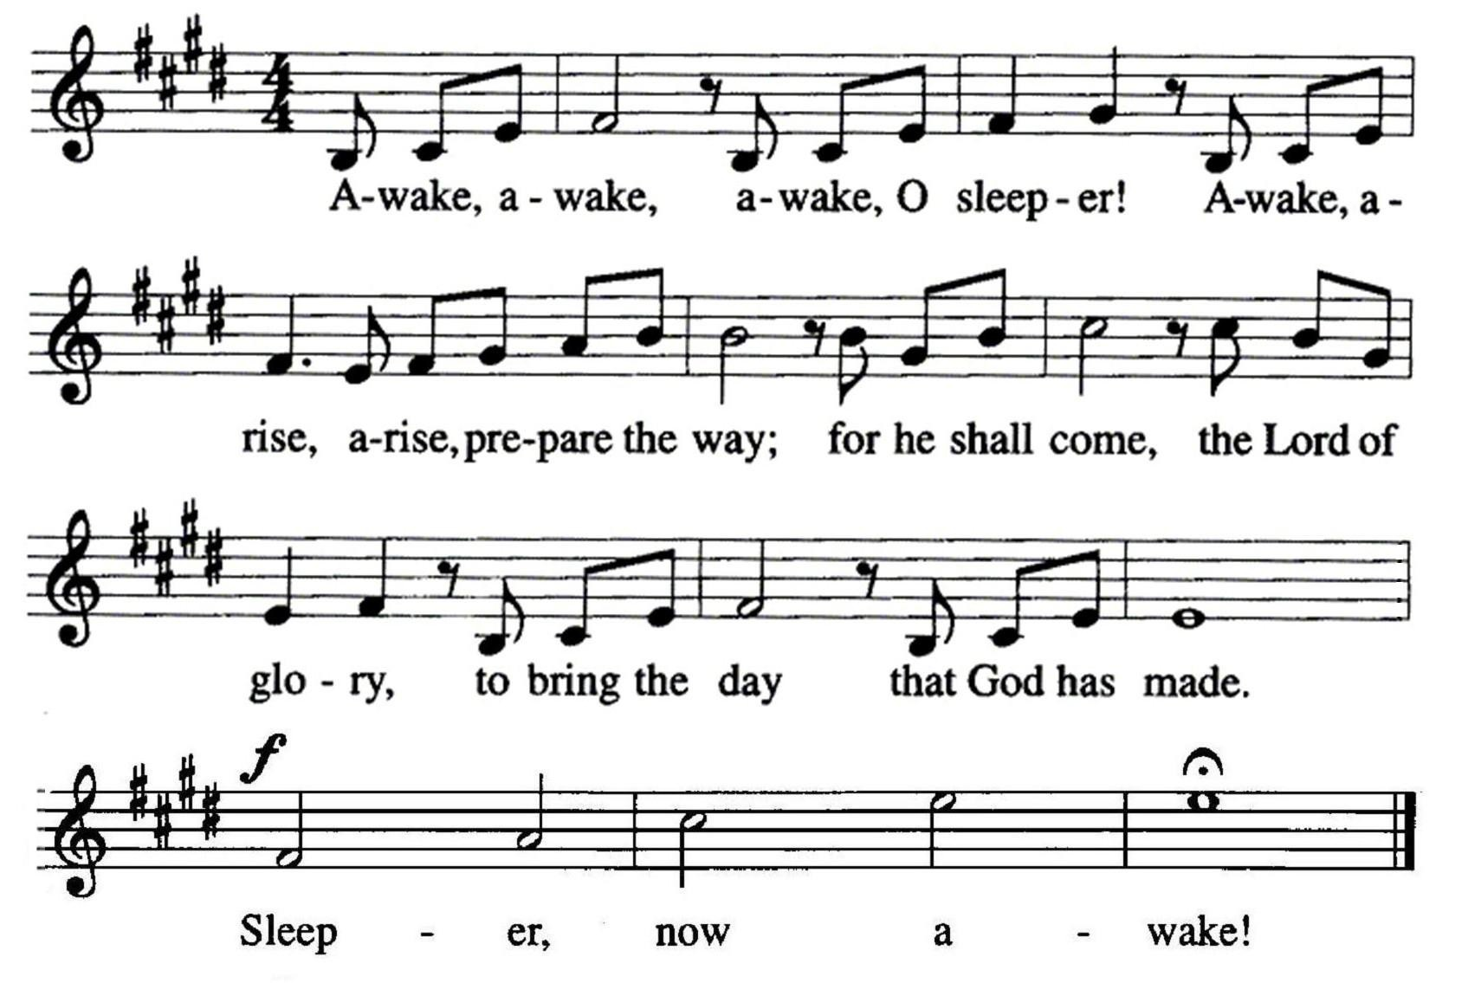

PRAYER OF THE DAY
M: Stir up our hearts, O Lord,

 The Word 

to prepare the way for your only Son.
By his coming give us strength in our conflicts
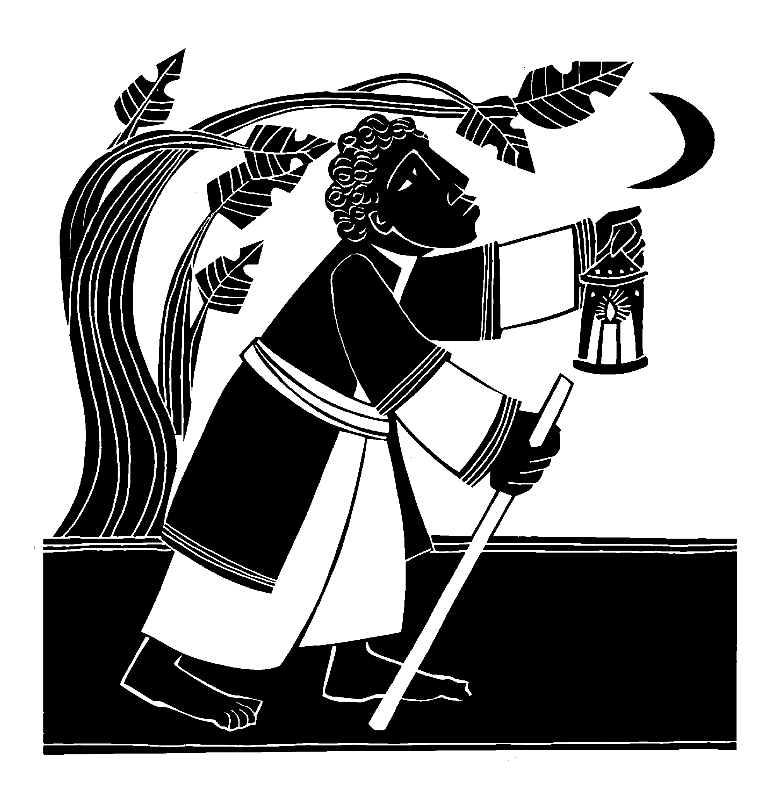and shed light on our path through the darkness of this world; through your Son, Jesus Christ our Lord,
who lives and reigns with you and the Holy Spirit, one God, now and forever.

C: Amen.

FIRST LESSON Isaiah 11:1-10
1 A shoot will come up from the stump of Jesse; from his roots a Branch will bear fruit.
2 The Spirit of the LORD will rest on him—
the Spirit of wisdom and of understanding, the Spirit of counsel and of power,
the Spirit of knowledge and of the fear of the LORD -
3 and he will delight in the fear of the LORD.
He will not judge by what he sees with his eyes, or decide by what he hears with his ears;
4 but with righteousness he will judge the needy,
with justice he will give decisions for the poor of the earth. He will strike the earth with the rod of his mouth;
with the breath of his lips he will slay the wicked.
5 Righteousness will be his belt
and faithfulness the sash around his waist.
6 The wolf will live with the lamb,
the leopard will lie down with the goat,
the calf and the lion and the yearling together; and a little child will lead them.
7 The cow will feed with the bear, their young will lie down together,
and the lion will eat straw like the ox.
8 The infant will play near the hole of the cobra,
and the young child put his hand into the viper's nest.
9 They will neither harm nor destroy on all my holy mountain,
for the earth will be full of the knowledge of the LORD as the waters cover the sea.
10 In that day the Root of Jesse will stand as a banner for the peoples; the nations will rally to him, and his place of rest will be glorious.

LIGHTING OF THE ADVENT WREATH1

To introduce the song, the refrain and verse play. At this time, candles are lit. The congregation then sings the refrain, then verses 1 and 2 in order, and then the refrain again. During the final refrain, the children may come forward for the children’s message.
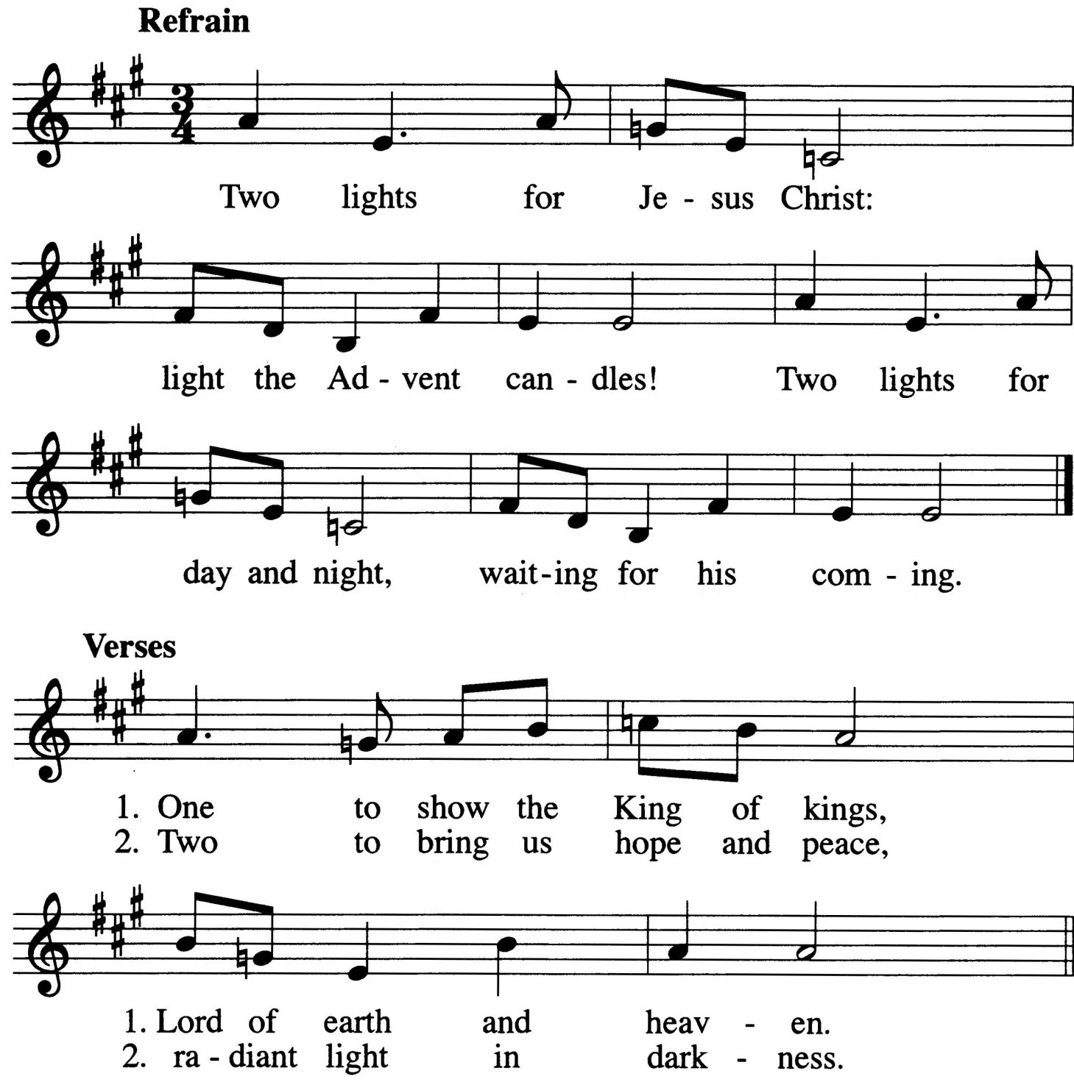

CHILDREN’S MESSAGE
1 The Advent Wreath is a combination of two very common symbols: light and the fir tree. From the early centuries of Christianity it has been the practice to represent Christ by a burning candle. The fir tree has a long history of religious use. No doubt the Advent Wreath was suggested by the Christmas tree. It seems that the Advent Wreath originated a few hundred years ago among the Lutherans of eastern Germany. A wreath of evergreens, made in various sizes, was either suspended from the ceiling or placed on a table. Four candles representing the four Sundays of Advent were fastened to the wreath. Eventually the use of the Advent Wreath became widespread and moved also from the home into the church. The general symbolism of the Advent Wreath lies in the growing light of the wreath, increasing each week as we approach the birthday of Jesus, the Light of the world.

SECOND LESSON Acts 3:19-26
19Repent, then, and turn to God, so that your sins may be wiped out, that times of refreshing may come from the Lord, 20and that he may send the Christ, who has been appointed for you—even Jesus. 21He must remain in heaven until the time comes for God to restore everything, as he promised long ago through his holy prophets. 22For Moses said, 'The Lord your God will raise up for you a prophet like me from among your own people; you must listen to everything he tells you. 23Anyone who does not listen to him will be completely cut off from among his people.
24"Indeed, all the prophets from Samuel on, as many as have spoken, have foretold these days. 25And you are heirs of the prophets
and of the covenant God made with your fathers. He said to Abraham, 'Through your offspring all peoples on earth will be blessed. 26When God raised up his servant, he sent him first to you to bless you by turning each of you from your wicked ways."

VERSE OF THE DAY Isaiah 40:3
M: Refrain
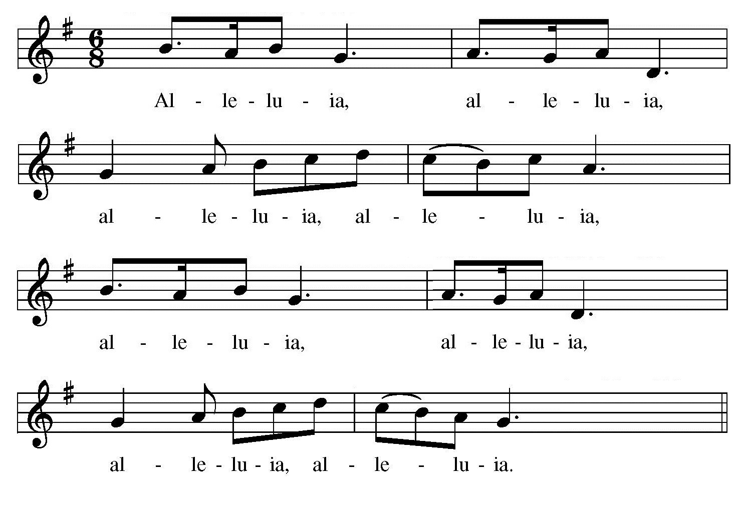C: Refrain

M: Prepare the way of the Lord; make straight paths.
All flesh shall see the salvation, the salvation of God.
C: Refrain

GOSPEL Matthew 3:1-12
1In those days John the Baptist came, preaching in the Desert of Judea 2and saying, "Repent, for the kingdom of heaven is near." 3This is he who was spoken of through the prophet Isaiah:
"A voice of one calling in the desert, 'Prepare the way for the Lord,
make straight paths for him.' "
4John's clothes were made of camel's hair, and he had a leather belt around his waist. His food was locusts and wild honey. 5People went out to him from Jerusalem and all Judea and the whole region of the Jordan.
6Confessing their sins, they were baptized by him in the Jordan River.
7But when he saw many of the Pharisees and Sadducees coming to where he was baptizing, he said to
them: "You brood of vipers! Who warned you to flee from the coming wrath? 8Produce fruit in keeping with repentance. 9And do not think you can say to yourselves, 'We have Abraham as our father.' I tell you that out of these stones God can raise up children for Abraham.
10The ax is already at the root of the trees, and every tree that does not produce good fruit will be cut down and thrown into the fire.
11"I baptize you with water for repentance. But after me will come one who is more powerful than I, whose
sandals I am not fit to carry. He will baptize you with the Holy Spirit and with fire. 12His winnowing fork is in his hand, and he will clear his threshing floor, gathering his wheat into the barn and burning up the chaff with unquenchable fire."

M: This is the Gospel of our Lord.

C: Praise be to you, O Christ!

HYMN 16 On Jordan’s Bank the Baptist’s Cry
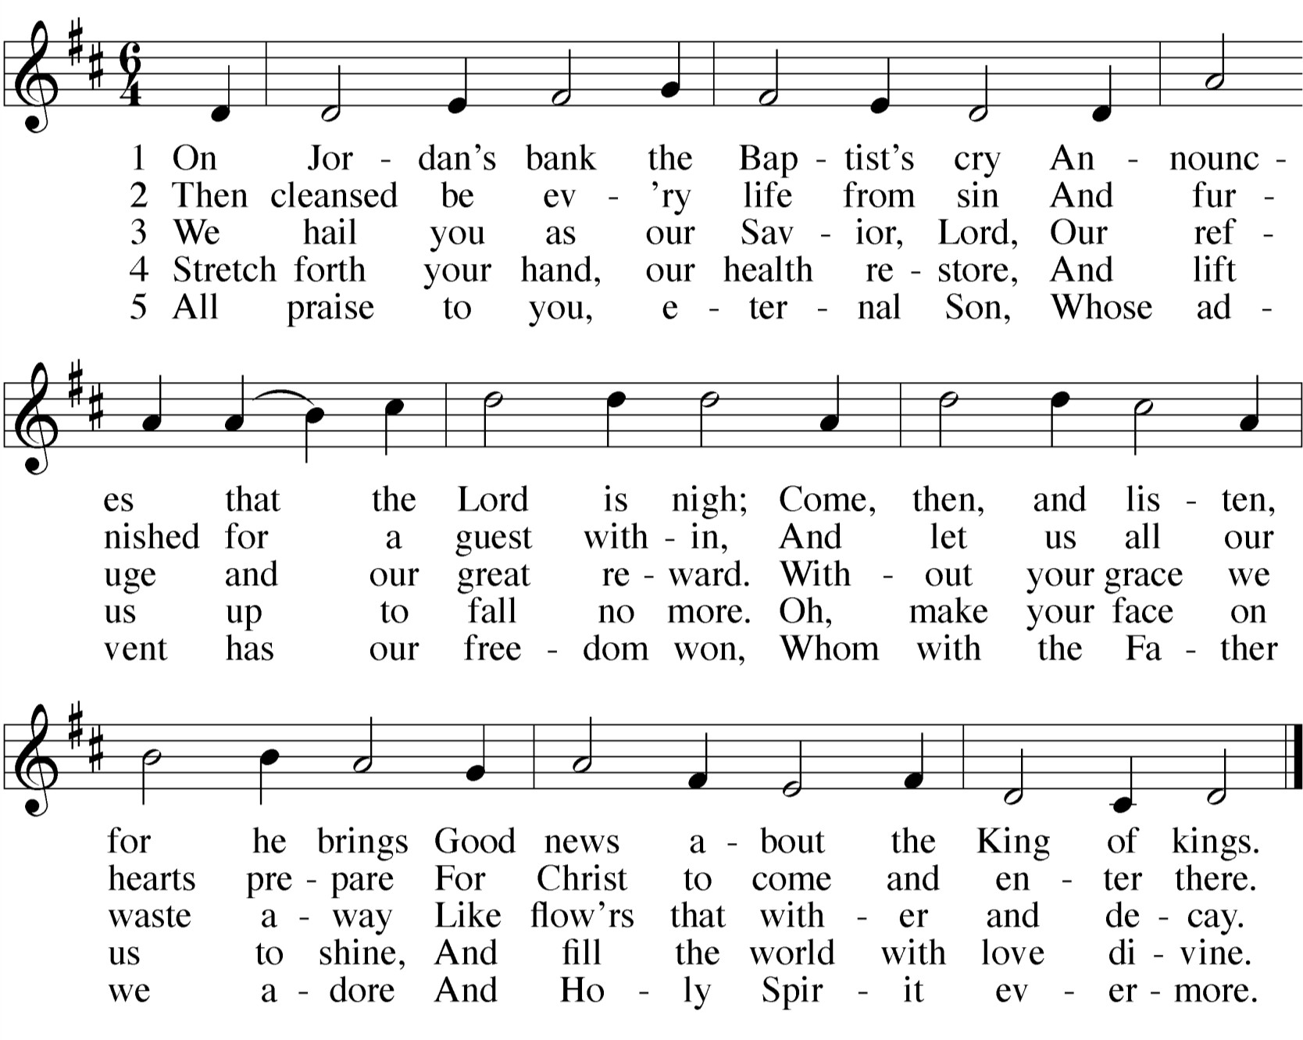

SERMON

CONFESSION OF FAITH The Apostles’ Creed

I believe in God, the Father almighty, maker of heaven and earth.
I believe in Jesus Christ, his only Son, our Lord, who was conceived by the Holy Spirit,
born of the virgin Mary, suffered under Pontius Pilate,
was crucified, died, and was buried. He descended into hell.
The third day he rose again from the dead. He ascended into heaven,
and is seated at the right hand of God the Father almighty. From there he will come to judge the living and the dead.
I believe in the Holy Spirit,
the holy Christian Church, the communion of saints,
the forgiveness of sins,
the resurrection of the body, and the life everlasting. Amen.

THANK OFFERING

 The Prayers 

THE PRAYER OF THE CHURCH
Prayers and petitions are offered on behalf of the Church.
M: Hear us, Lord, as we bring you our private petitions.
Silent prayer
M: Into your hands we commend all for whom we pray, trusting in your mercy, through Jesus Christ, our Lord.

C Amen.
THE LORD’S PRAYER
M: Lord, remember us in your kingdom, and teach us to pray:

C: Our Father in heaven, hallowed be your name, your kingdom come,
your will be done on earth as in heaven. Give us today our daily bread.
Forgive us our sins, as we forgive those who sin against us. Lead us not into temptation,
but deliver us from evil.
For the kingdom, the power, and the glory are yours now and forever. Amen.

THE BLESSING
M: Brothers and sisters, go in peace. Live in harmony with one another. Serve the Lord with gladness.
The Lord bless you and keep you.
The Lord make his face shine on you and be gracious to you. The Lord look on you with favor and give  you peace.

C: Amen.

HYMN 19 0 Lord, How Shall I Meet You

1$ b i J
I J J j I r r
r I r r

1 0 Lord, how shal l meet you, How wel - come
- Love caused your In - car - na ti on; Love brought you
- Re - joice, then, you sad - heart ed, Who sit i n
4 Sin 's debt, that fear - ful bur den, Let not you r
5 He comes to judge the na tions , A ter - ror

1$ '' j I
r· J
I J J j I r r

you a - right? Your peo - pie long to greet you,
down | to | me. | Your | thi rst | for | my | sal | va | tion
deep - | est | gl oom, | Who | mourn | o'er | joys | de | - part | ed
soul s | dis | - tress; | Your | gui l t | the | Lord | wi ll | par | don
to | his | foes, | A | l ight | of | con - | so | l a | tions,

1$ b r I r r
j r· r
I r
r r r

My Hope, my h eart's De - l ight. 0 Je - SUS, let your Pro - cured my l i b - er - ty. Oh, love be - yond all And trem - ble at your doom. De - spair not ; he is And COY - er by his grace. He comes, for you pro - And bless - ed hope to those Who love the Lord 's ap -
I
j j

1$ b a J J I r
Word te l l | be  i ng |  | A  That | l amp l ed | to you |  | l i ght to |  | my em |  | way,  - brace |  | To I n |  | show l ove, | me all
near | you, |  | He's | stand - ing |  |  | at |  | the |  | door |  | Who best can
cu r | i ng |  | The | peace of |  |  | si n |  | for |  | - giv 'n, |  | Hi s chi l - d ren
pear | - i ng. |  | 0 | gl o - rious |  |  | Sun, |  | now |  | come, |  | Send forth you r
b j J |  |  | I J | J | J | I j J J J I J.
how to |  |  | please | you, | To | gu id e me ev - 'ry day.
l ove | ex | - eel |  | l i n g, | Our |  | lost |  |  | and | fall |  | - en | race!
hel p | and | cheer |  | you | A nd |  | bids |  |  | Y?U | weep |  | no | more.
th us se - cur i n g |  |  |  |  |  | A |  | her |  | - I - |  | tage |  | i n | heav 'n.
beams most cheer - i ng, |  |  |  |  |  | And |  | gu id e |  | us |  | safe |  | - l y | home.

I fl J I J J

1$ 1 1

16

All music is either public domain or reprinted under put your license info here if necessary

Awake, O Sleeper: Advent Gathering Rite
Text and Tune: Francis Patrick O’Brien © 2001 GIA Publications, Inc.

Advent Wreath Song
Text and Tune: Paul Inwood © 2005 GIA Publications, Inc.

Advent Gospel Acclamation
Music: Andrew Wright © 1999 Andrew Wright. Published by OCP.

Savior of the Nations, Come
Text: Ambrose German version: Martin Luther Tune: Geystliche gesangk Buchleyn, Wittenberg Setting © 1999 Kermit Moldenhauer

O Lord, How Shall I Meet You
Text: Paul Gerhardt Tune: Melchoir Teschner
Setting © 1970 Barenreiter-Verlag

www.ourbeautifulsavior.com

