First Sunday in Advent December 2, 2013

PREPARE THE WAY FOR THE LORD
PREPARE, FOR THE LORD WILL COME AGAIN UNEXPECTEDLY

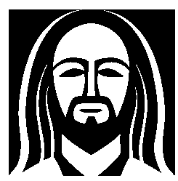EVANGELICAL LUTHERAN CHURCH

elcome! Thank you for joining us for worship this morning. In our service we gather before our almighty God to offer him our worship and praise. We also gather to strengthen ourselves through the
W
study of God’s holy and powerful word.

 Restrooms are located in the hallway directly opposite the entrance to the sanctuary.

 Cry-room. If you have a young child or nursing infant and are in need of a cry-room, you will find it to the right as soon as you exit the sanctuary. A speaker there allows you to hear the service.

 Staffed nursery. We offer a staffed nursery for ages 2 to 5 and special needs children. It is located to the left of the entry foyer, near the kitchen window.

 Connection cards are found inside each worship folder. We ask that before worship or during the offering you fill those out, front and back. You can return the card either in the offering plate or in the connection card basket you will find at the exit of the church after worship.

Summerville campus
720 Old Trolley Road Summerville, SC 29485 843.873.5522
bselc.office@gmail.com
Moncks Corner campus
Foxbank Plantation Road Moncks Corner, SC 29461 843.826.4057
Staff
Kyle Burmeister, Pastor 262.365.7123 (cell) pastorburmeister@gmail.com
Jonathan Hein, Pastor 843.860.1838 (cell) pastorhein@gmail.com
Jonathan Quinn, Pastor 843.826.4057 (home)
revjquinn@gmail.com
Nathan Loersch, Vicar 920.342.4723 (cell) vicarloersch@gmail.com

www.ourbeautifulsavior.com

WORSHIP NOTES
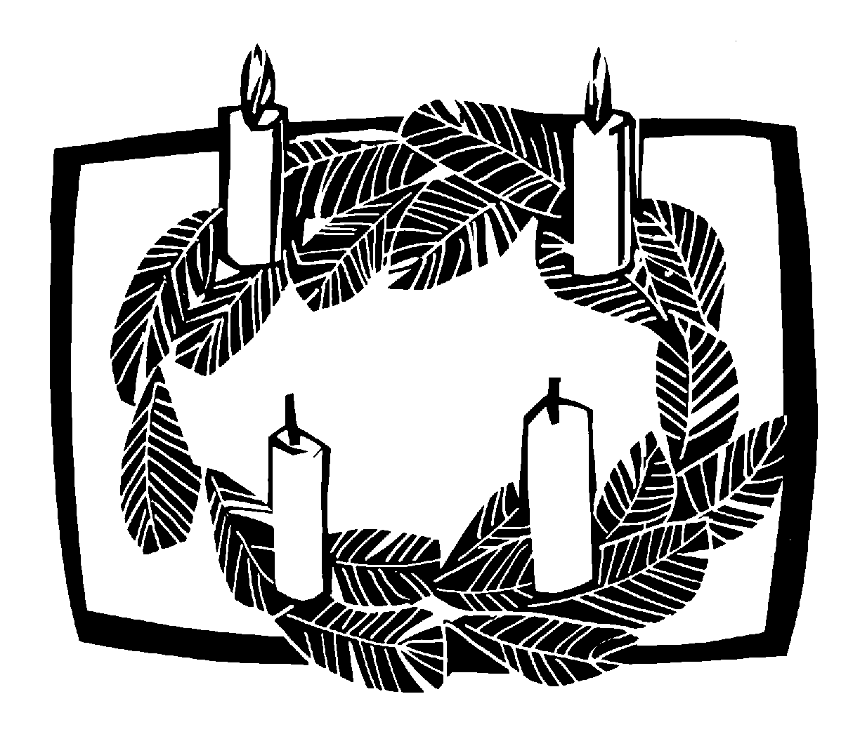THE SEASON OF ADVENT
Advent is a Latin word that means “coming.” The season of Advent is the four week period before Christmas that the Church uses to remember the “coming” of the Christ. We celebrate that he came once as a baby in Bethlehem, and that he will come again at the end of time.

OUR WORSHIP SERIES
This is a busy time of year. There is much to do to prepare for the celebration of Jesus’ birth. However, more important than celebrating Jesus’ first coming is being prepared for his second coming on the Last Day. Christmas is only important because of what it means for us at the end of time. In this worship series, we make the connection between Christ’s first coming as Savior and his second coming as Judge. Our worship follows this pattern.

PREPARE THE WAY FOR THE LORD
First Sunday in Advent | Prepare, for the Lord will come again unexpectedly
Second Sunday in Advent | Prepare the way with sincere repentance
Third Sunday in Advent | Prepare the way by proclaiming good news
Fourth Sunday in Advent | Prepare the way. Immanuel comes!

OUR THEME FOR TODAY
Prepare, for the Lord will come again unexpectedly. There are no surprises with Christmas. We know exactly when December 25th shall arrive. We can calculate the very minute. That is not the case with Christ’s second coming. We have no idea when it will take place. It could be ten-thousand years away. It could be in the next ten minutes. But God kept his promise to send Christ the first time; therefore, we have confident faith he will keep the promise to send Christ again. Because we do not know when that will be, we must always be prepared.

Order of Service for
THE SEASON OF ADVENT

AWAKE, O SLEEPER1
Minister: Refrain
Congregation: Refrain

 The Gathering 

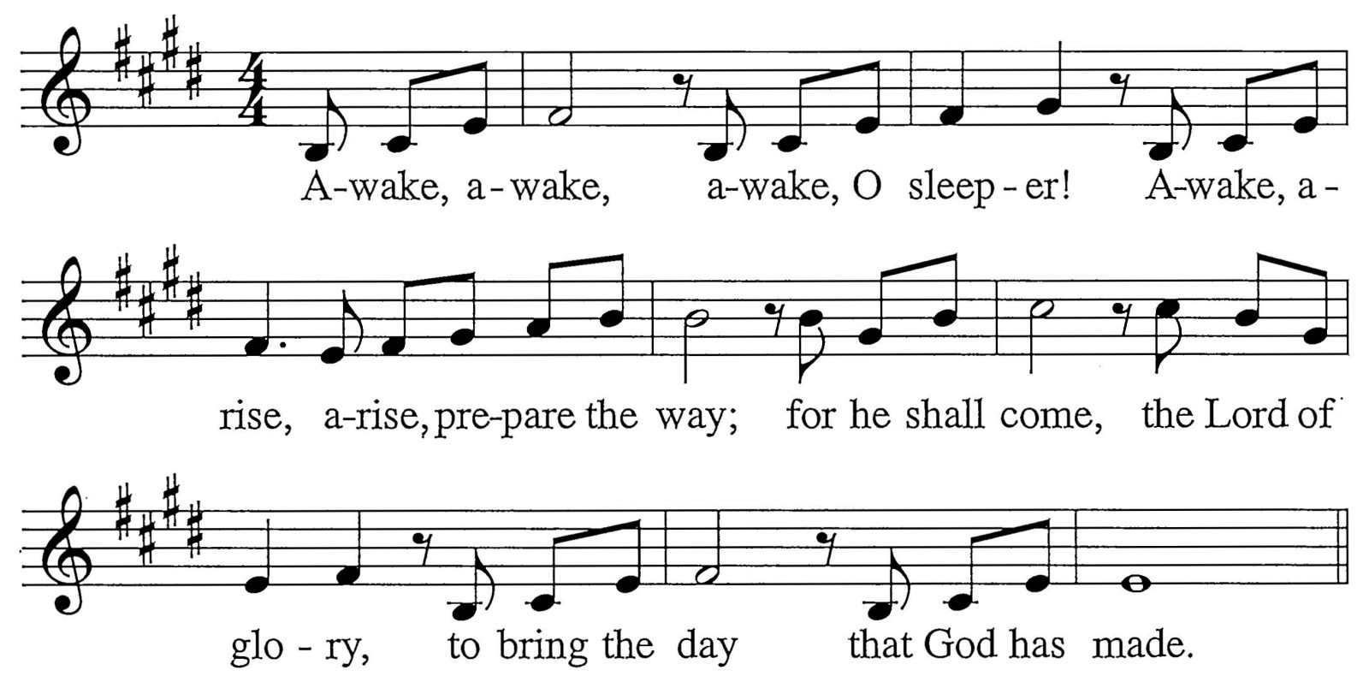

M: Rise from the darkness; wake from the night. Welcome the splendor of day.
Live as God’s children; live in the light. Go, prepare God’s way.
C: Refrain
M: Come let us go to the house of the Lord; all people together give praise.
Learn from the one who is justice and truth; follow in God’s ways.
C: Refrain
M: Who can fortell the return of the Lord? Who knows the day or the hour?
Ready your hearts for the One who is love, coming in his pow’r.
C: Refrain

INVOCATION
M: In the name of the Father and of the Son  and of the Holy Spirit.

C: Amen.
M: Look! Christ is coming with the clouds.

C: Every eye will see him, even those who pierced him. Revelation 1:7

CONFESSION OF SINS
M: Lest that Day surprise us unprepared, let us make confession of our sins, imploring our heavenly Father to have mercy on us for the sake of Jesus Christ.
Silence for personal confession
M: You came to call us from darkness into light: Lord have mercy.

C: 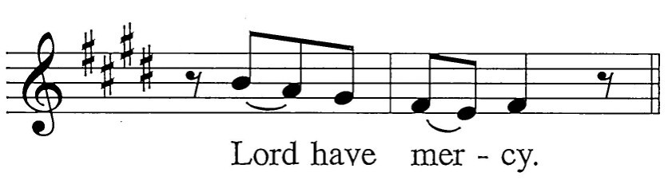
M: You came to visit your people with peace: Christ have mercy.

C: 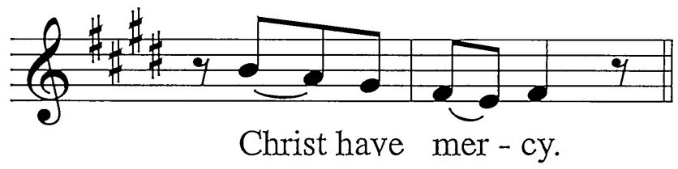
M: You will return and our joy will be full: Lord have mercy.

C:
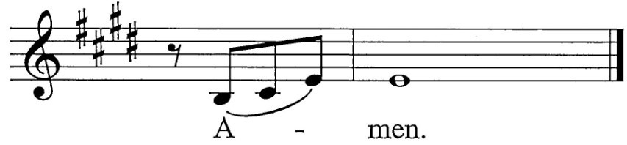M: May almighty God have mercy on us, forgive us our sins and bring us to everlasting life. Amen.

C:

ABSOLUTION
M: God, our heavenly Father, has been merciful to us
and has given his only Son to be the atoning sacrifice for our sins. Therefore, as a called servant of Christ and by his authority,
I forgive all your sins in the name of the Father and of the Son  and of the Holy Spirit.

C: Amen!
The Rite of Holy Baptism may take place here.
M: In the peace of forgiveness, let us praise the Lord.
C: Final Refrain

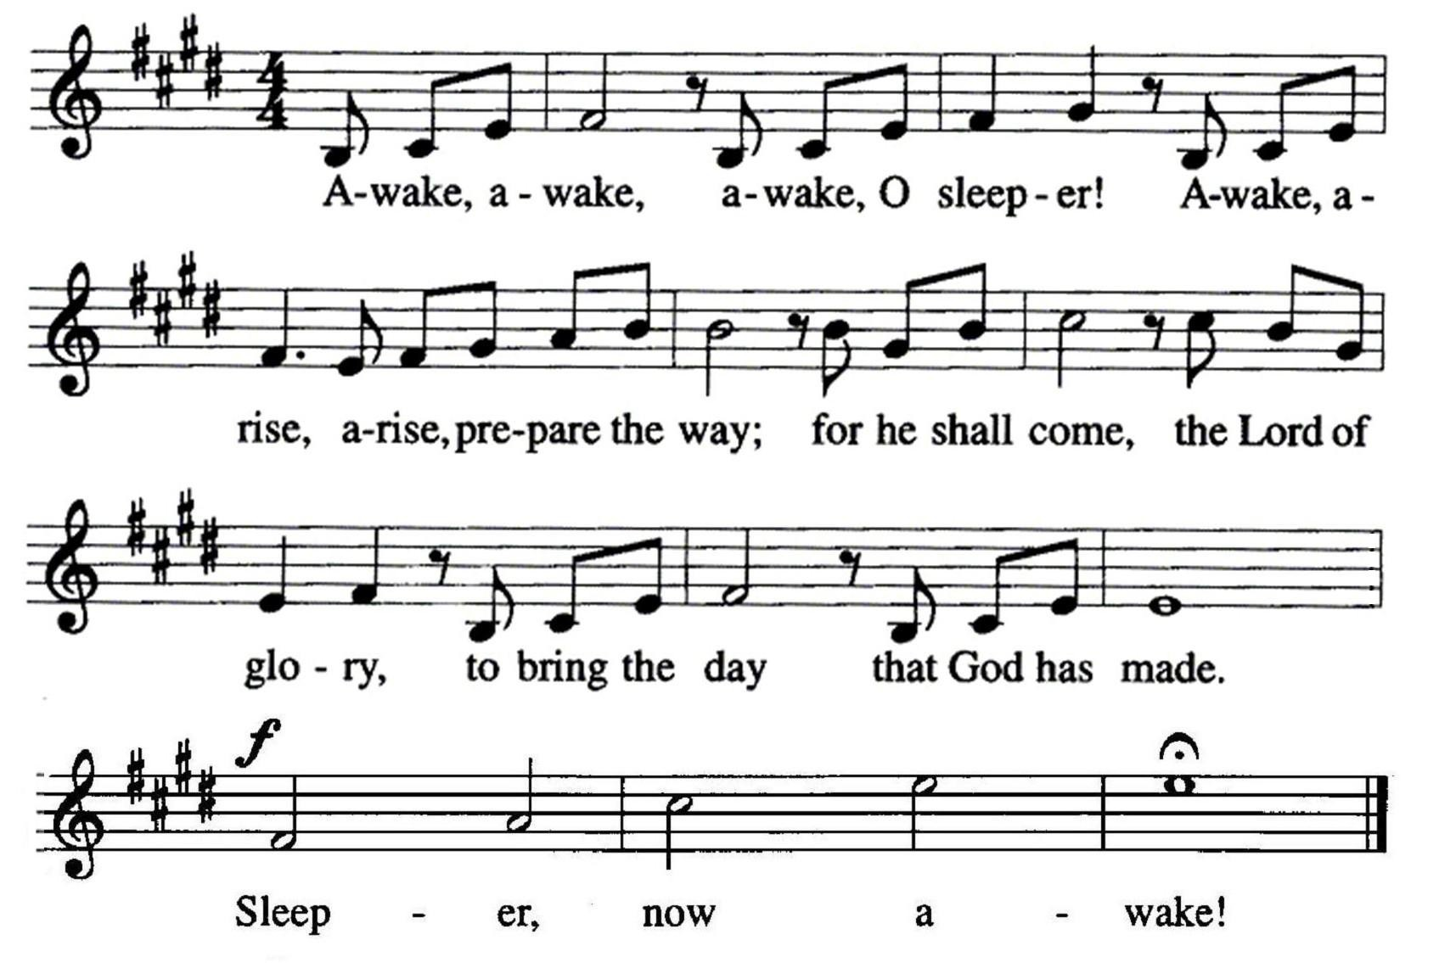

- Traditionally, in Advent, the Gloria and other songs of praise are not sung to open worship. The astute worshiper will notice this mirrors our practice of Lent. The high festival of Easter is preceded by a six-week period of preparation known as Lent. Likewise, the high festival of Christmas is preceded by a four-week period of preparation known as Advent. Both seasons — Lent and Advent — have a solemn and penitential nature.

PRAYER OF THE DAY2
 The Word 

M: Stir up your power, O Lord, and come. Protect us by your strength and save us from the threatening dangers of our sins;
for you live and reign with the Father and the Holy Spirit, one God, now and forever.

C: Amen.

- The Prayers of the Day for Advent are some of the oldest in Christianity, dating back to the early Christian church fathers. They are simple and short and perfectly capture the nature of the preparatory season of Advent. They are entirely appropriate for daily use in the home during these four weeks, supplementing one’s other personal prayers.

FIRST LESSON Isaiah 2:1-5
1 This is what Isaiah son of Amoz saw concerning Judah and Jerusalem:
2 In the last days
the mountain of the LORD's temple will be established as chief among the mountains;
it will be raised above the hills, and all nations will stream to it.
3 Many peoples will come and say,
"Come, let us go up to the mountain of the LORD, to the house of the God of Jacob.
He will teach us his ways,
so that we may walk in his paths." The law will go out from Zion,
the word of the LORD from Jerusalem.
4 He will judge between the nations
and will settle disputes for many peoples. They will beat their swords into plowshares and their spears into pruning hooks.
Nation will not take up sword against nation, nor will they train for war anymore.
5 Come, O house of Jacob,
let us walk in the light of the LORD.

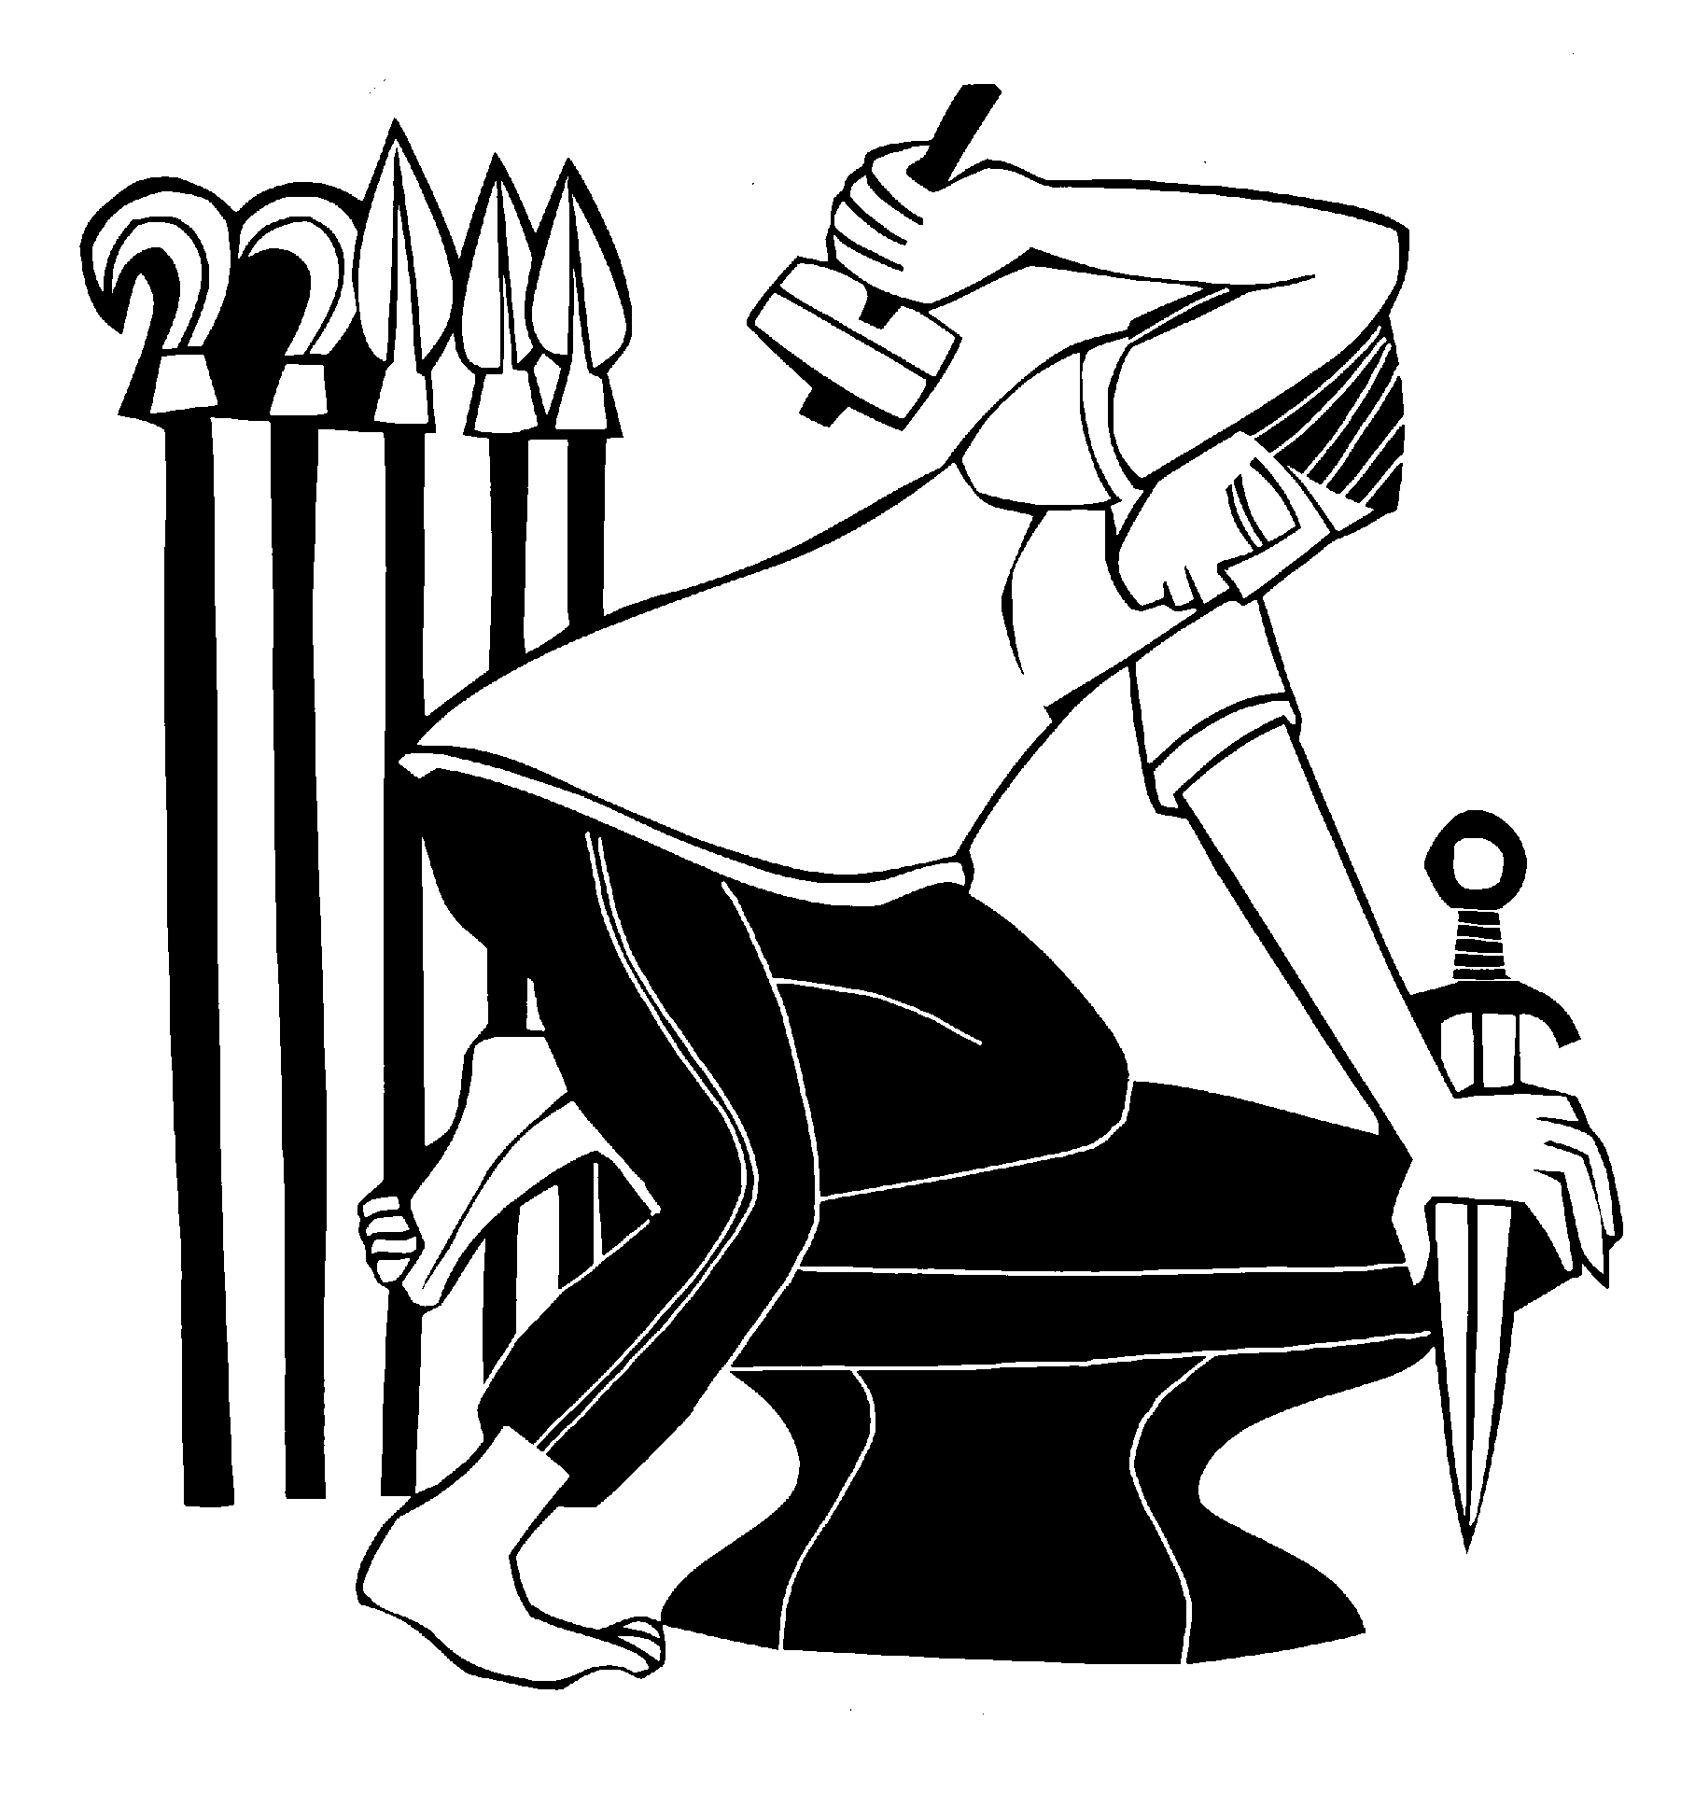

LIGHTING OF THE ADVENT WREATH3

To introduce the song, the refrain and verse play. At this time, the first candle is lit. The congregation then sings the refrain, verse 1, and the refrain again. During the final refrain, the children may come forward for the children’s message.

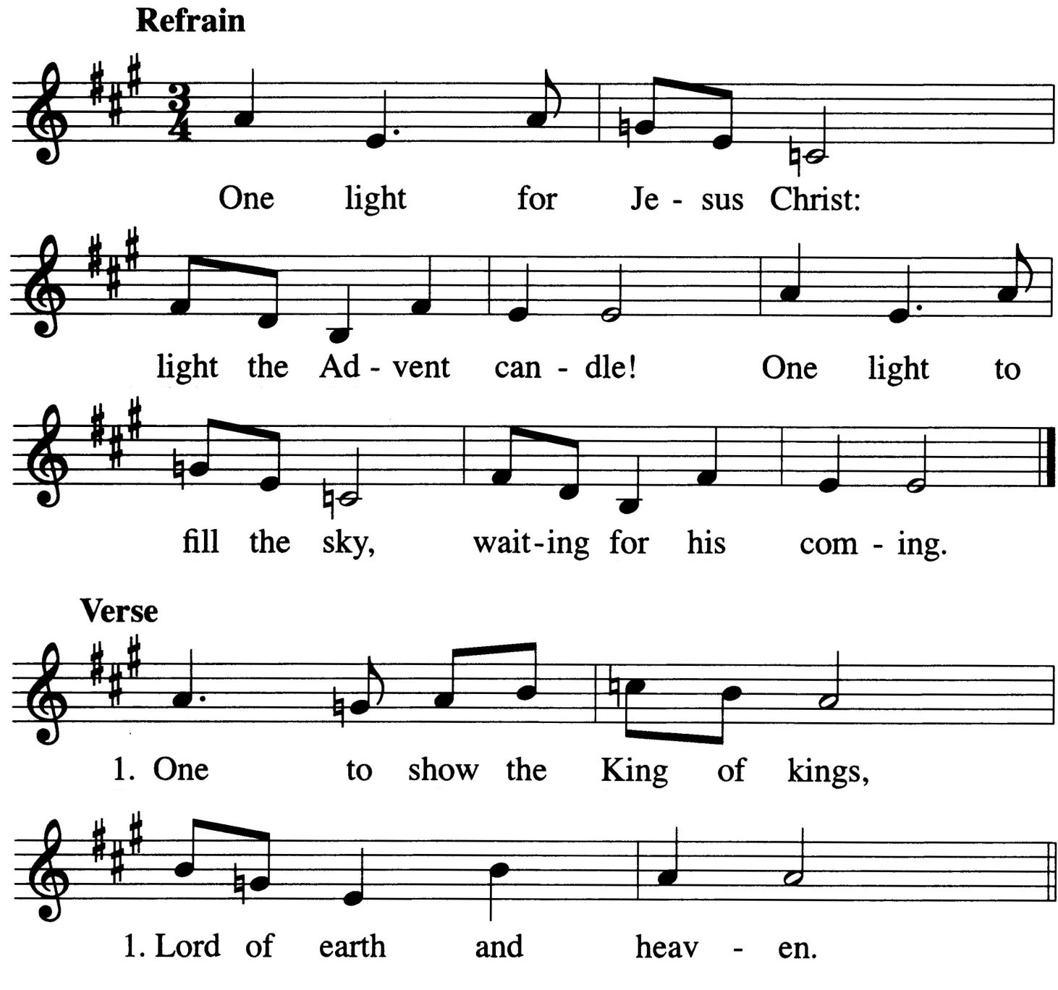

CHILDREN’S MESSAGE

- The Advent Wreath is a combination of two very common symbols: light and the fir tree. From the early centuries of Christianity it has been the practice to represent Christ by a burning candle. The fir tree has a long history of religious use. No doubt the Advent Wreath was suggested by the Christmas tree. It seems that the Advent Wreath originated a few hundred years ago among the Lutherans of eastern Germany. A wreath of evergreens, made in various sizes, was either suspended from the ceiling or placed on a table. Four candles representing the four Sundays of Advent were fastened to the wreath. Eventually the use of the Advent Wreath became widespread and moved also from the home into the church. The general symbolism of the Advent Wreath lies in the growing light of the wreath, increasing each week as we approach the birthday of Jesus, the Light of the world.

SECOND LESSON Romans 13:11-14
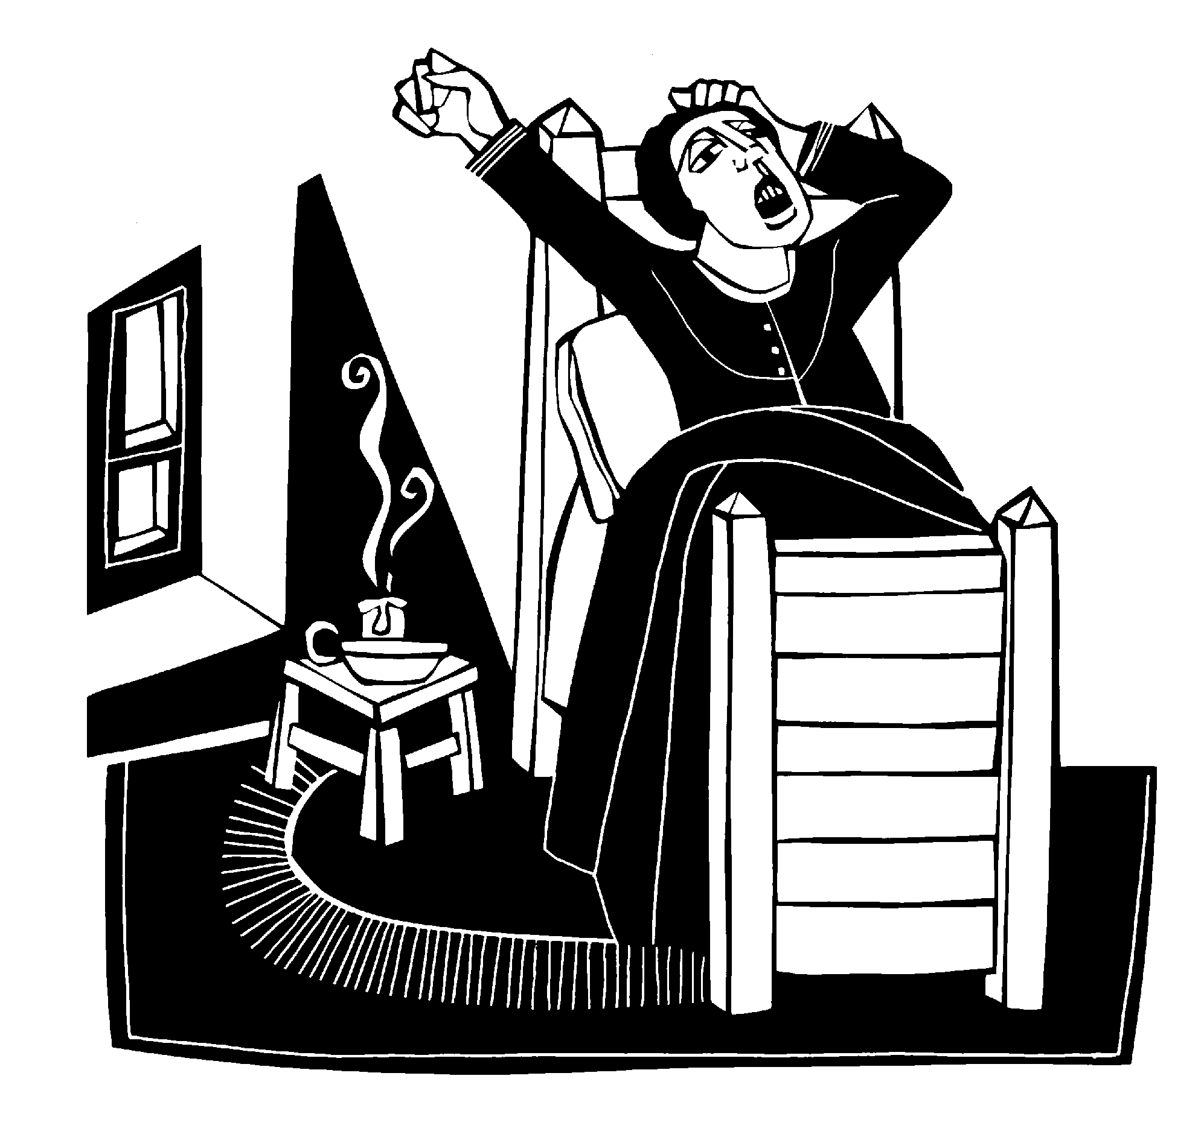11And do this, understanding the present time. The hour has come for you to wake up from your slumber, because our salvation is nearer now than when we first believed. 12The night is nearly over; the day is almost here. So let us put aside the deeds of darkness and put on the armor of light. 13Let us behave decently, as in the daytime, not in orgies and drunkenness, not in sexual immorality and debauchery, not in dissension and jealousy. 14Rather, clothe yourselves with the Lord Jesus Christ, and do not think about how to gratify the desires of the sinful nature.

VERSE OF THE DAY Psalm 85:7
M: Refrain
C: Refrain
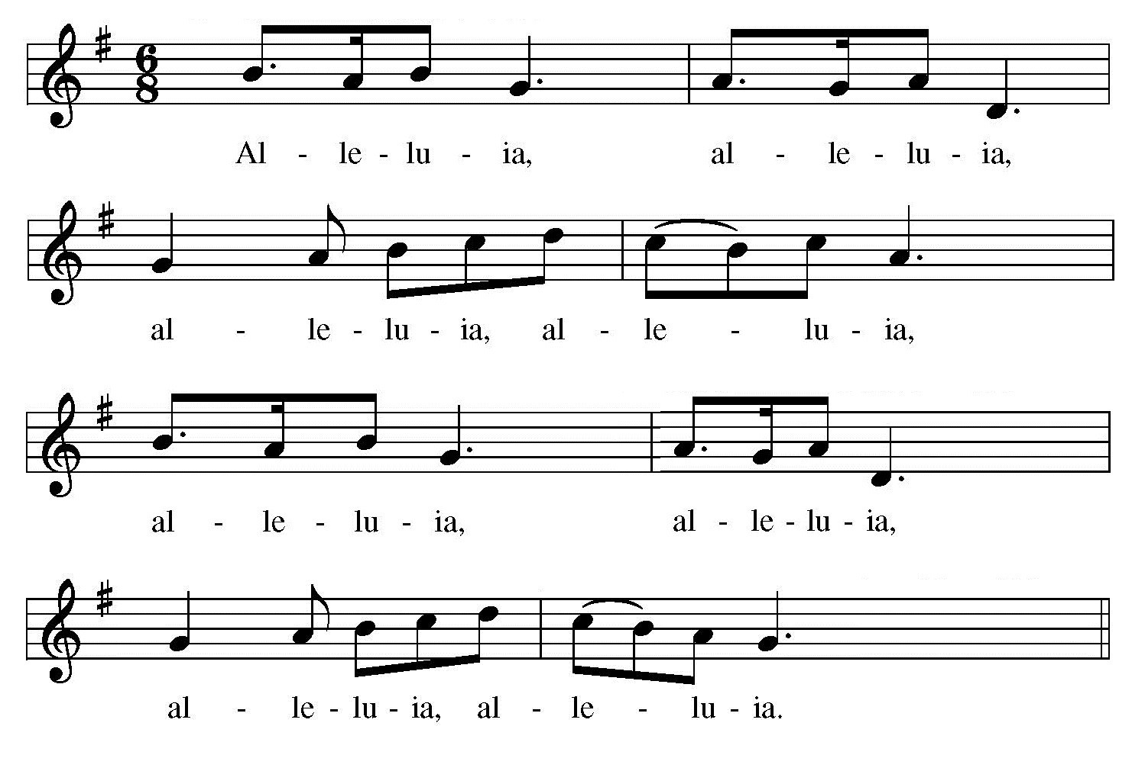
M: Show us, Lord, your love; show us, Lord, your love; And grant us your salvation. Alleluia.
C: Refrain

GOSPEL Matthew 24:36-44
36"No one knows about that day or hour, not even the angels in heaven, nor the Son, but only the Father. 37As it was in the days of Noah, so it will be at the coming of the Son of Man. 38For in the days before the flood, people were eating and drinking, marrying and giving in marriage, up to the day Noah entered the ark; 39and they knew nothing about what would happen until the flood came and took them all away. That is how it will be at the coming of the Son of Man. 40Two men will be in the field; one will be taken and the other left. 41Two women will be grinding with a hand mill; one will be taken and the other left.
42"Therefore keep watch, because
you do not know on what day your Lord will come. 43But understand this: If the owner of the house had known at what time of night the thief was coming, he would have kept watch and would not have let his house be broken into. 44So you also must be ready, because the Son of Man will come at an hour when you do not expect him.

M: This is the Gospel of our Lord.

C: Praise be to you, O Christ! 4

- At the conclusion of the three lessons, the congregation speaks directly to Christ, acknowledging that they believe Christ to be truly present in worship. For Jesus promised, “Where two or three come together in my name [i.e. gathered around the Word], there am I with them” (Matthew 18:20).

HYMN 2 Savior of the Nations, Come
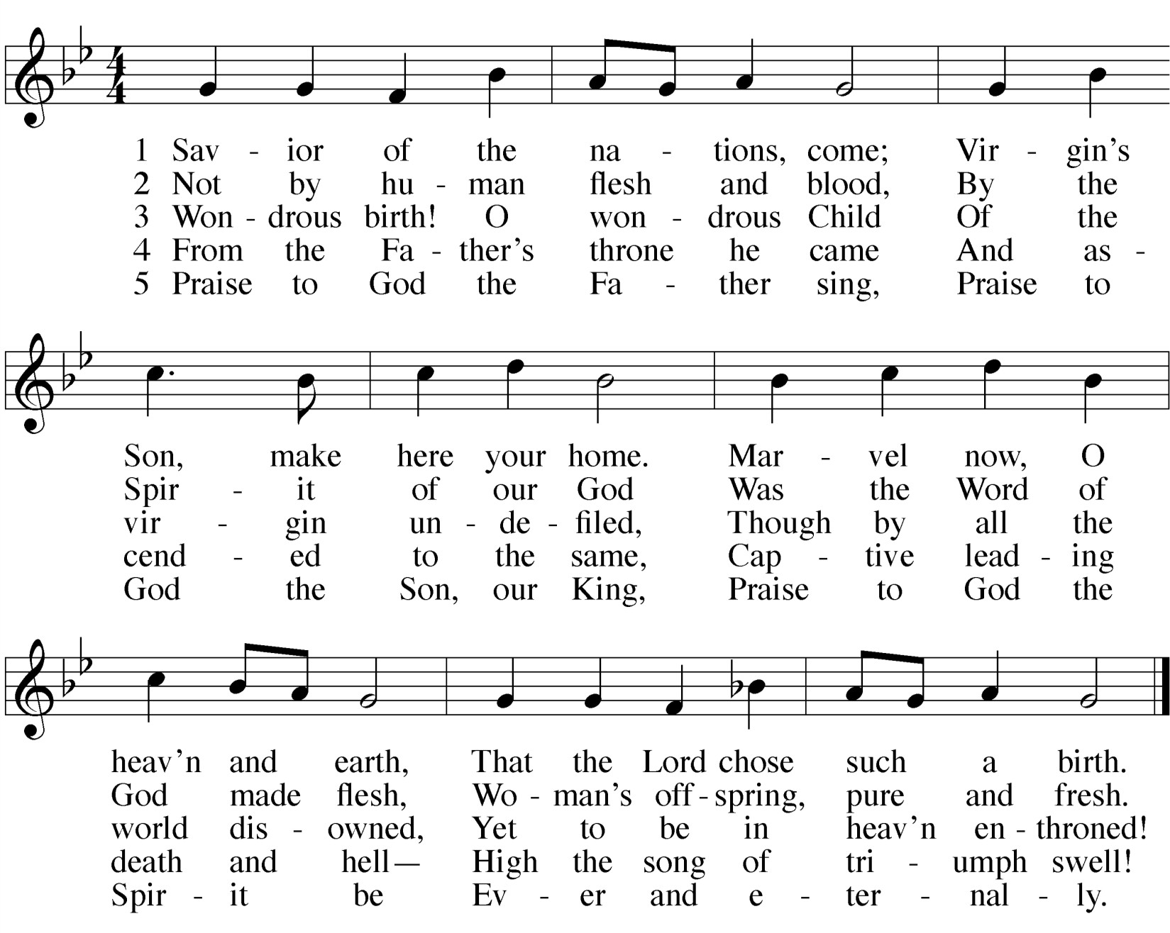

SERMON

CONFESSION OF FAITH The Nicene Creed 5

We believe in one God, the Father, the Almighty, maker of heaven and earth,
of all that is, seen and unseen.
We believe in one Lord Jesus Christ, the only Son of God, eternally begotten of the Father,
God from God, Light from Light, true God from true God, begotten, not made,
of one being with the Father. Through him all things were made.
For us and for our salvation, he came down from heaven, was incarnate of the Holy Spirit and the virgin Mary, and became fully human.
For our sake he was crucified under Pontius Pilate. He suffered death and was buried.
On the third day he rose again in accordance with the Scriptures.
He ascended into heaven
and is seated at the right hand of the Father.
He shall come again in glory to judge the living and the dead, and his kingdom will have no end.
We believe in the Holy Spirit, the Lord, and giver of life,
who proceeds from the Father and the Son,
who in unity with the Father and the Son is worshiped and glorified, who has spoken through the prophets.
We believe in one holy Christian and apostolic Church. We acknowledge one baptism for the forgiveness of sins.
We look for the resurrection of the body and the life of the world to come. Amen.

THANK OFFERING

- St. Paul writes, “We believe and therefore speak” (2 Corinthians 4:13). Public confession of what one believes is faith’s response to God’s saving Word. Christians composed the Nicene Creed in the fourth century to defend the Bible’s teachings that both Jesus Christ and the Holy Spirit are true God, equal to the Father in one eternal, undivided Trinity. The confession we make in church prepares us to make a similar confession of faith in the world.

 The Prayers 

OF THE CHURCH 6
Prayers and petitions are offered on behalf of the Church
M: Hear us, Lord, as we bring you our private petitions.
Silent prayer

LORD’S PRAYER
M: We bring these and all our requests to you, Father, in the name of Jesus Christ, who taught us to pray:

C: Our Father in heaven, hallowed be your name, your kingdom come,
your will be done on earth as in heaven. Give us today our daily bread.
Forgive us our sins, as we forgive those who sin against us. Lead us not into temptation,
but deliver us from evil.
For the kingdom, the power, and the glory are yours now and forever. Amen.

- In the Prayer of the Church, God’s people do the work of priests, making intercession for themselves, for others, and for the world. We ask our Heavenly Father to work things out for our eternal best.

 The Sacrament 
We follow the historic Christian practice of close communion. We ask that only members of Beautiful Savior Lutheran or one of our sister congregations partake of the sacrament. If you are not a member, please speak to one of the pastors before communing.

OPENING SENTENCES 7
M: The Lord be with you.

C: And also with you.
M: Lift up your hearts.

C: We lift them up to the Lord.
M: Let us give thanks to the Lord our God.

C: It is good and right so to do.
M: It is truly good and right that we should
at all times and in all places give you thanks,
O Lord, holy Father, almighty and everlasting God, through Jesus Christ, our Lord, whose way John the Baptist prepared when he called people to repentance
and pointed to Jesus as the Lamb of God who takes away the sin of the world. Therefore with all the saints on earth and hosts of heaven,
we praise your holy name and join their glorious song.

- The opening sentences (sometimes known as “the preface”) of the Lord’s Supper are among the oldest in the Christian liturgy. Already in the first century, believers would use these words to begin the celebration of the Sacrament. While we could use whatever words we wanted to begin the Lord’s Supper, using these words unites us with those ancient Christians.

After a brief musical introduction, the congregation sings “Holy, Holy, Holy.”

HOLY, HOLY, HOLY
Sanctus8
Isaiah 6:3; Matthew 21:9

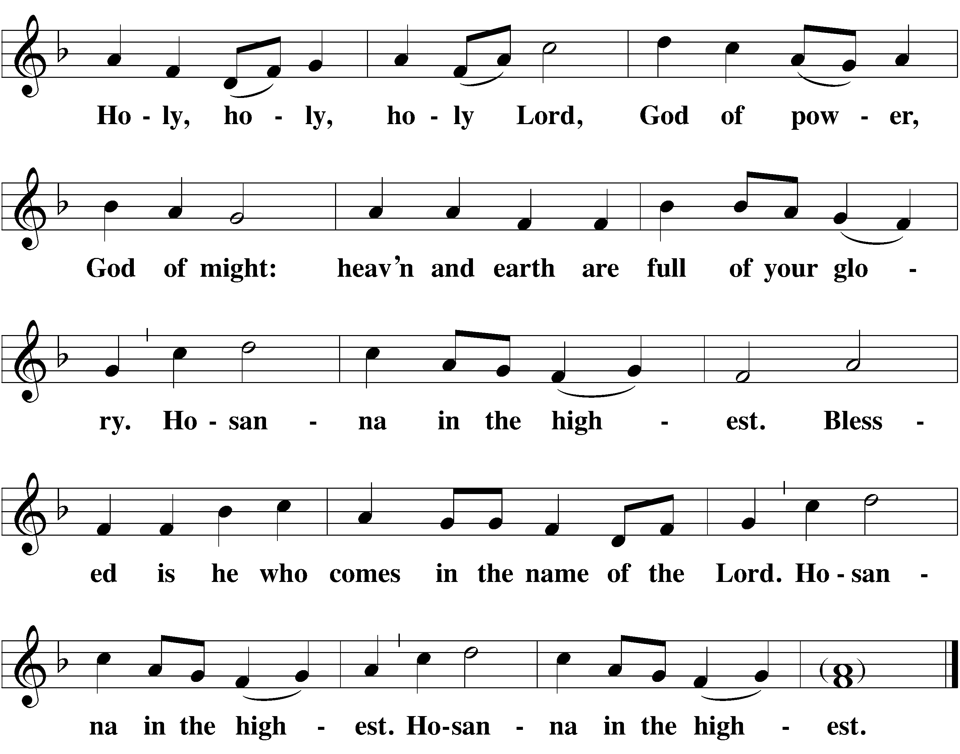C:

- Sanctus means “holy.” This canticle combines the song that the seraphim (six-winged angels) sang to Isaiah with the song the believers sang to Jesus on Palm Sunday. The angels sang the triple “holy,” giving glory to our Triune God. And believers shouted “Hosanna,” which means “Save us!” as Jesus entered into Jerusalem to face the cross. The two songs combine well, for it is in saving us that God has most clearly revealed his glory. The Sanctus has been used in celebration of the Lord’s Supper since the second century.

WORDS OF INSTITUTION

M: Our Lord Jesus Christ, on the night he was betrayed, took bread; and when he had given thanks, he broke it and gave it to his disciples, saying, “Take and eat; this is my  body, which is given for you. Do this in remembrance of me.”
Then he took the cup, gave thanks, and gave it to them, saying, “Drink from it, all of you; this is my  blood of the new covenant, which is poured out for you for the forgiveness of sins. Do this, whenever you drink it, in remembrance of me.”
The peace of the Lord be with you always.
C: Amen.

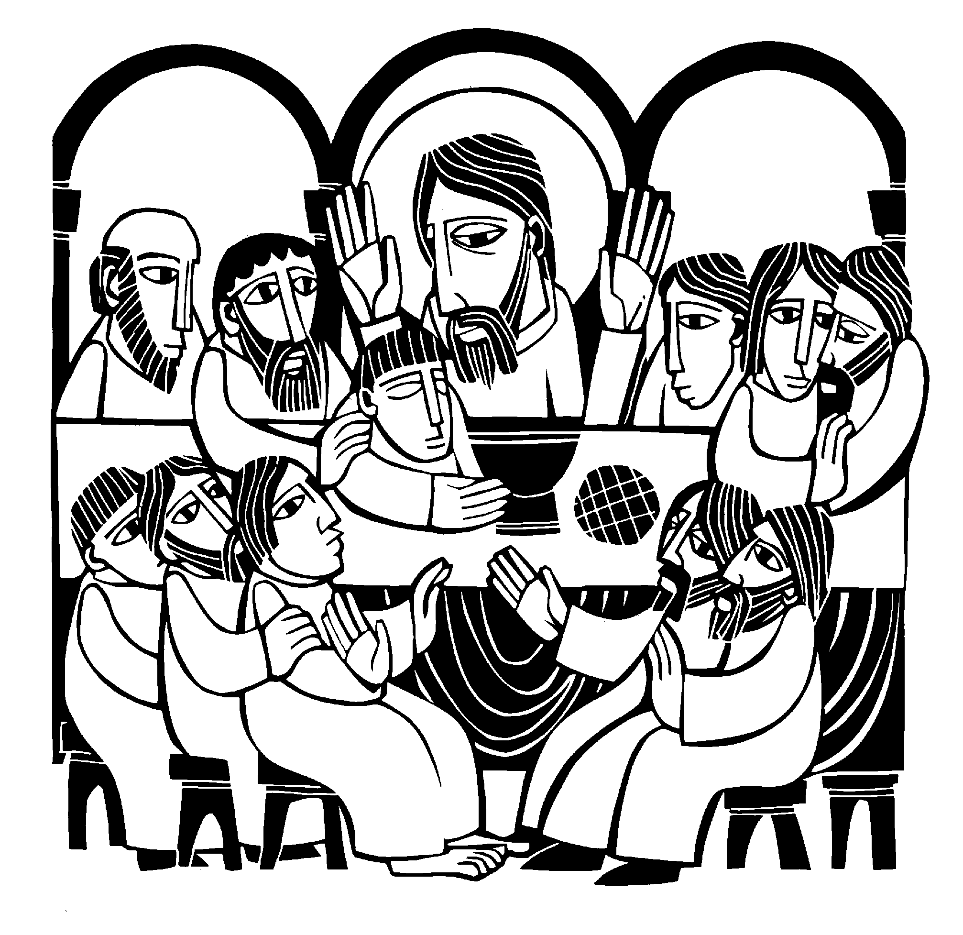

After a brief musical introduction, the congregation joins in singing “Oh Christ, Lamb of God.” While the congregation is singing this canticle, the usher will direct the first table of communicants to come forward.

O CHRIST, LAMB OF GOD
Agnus Dei 9
John 1:29

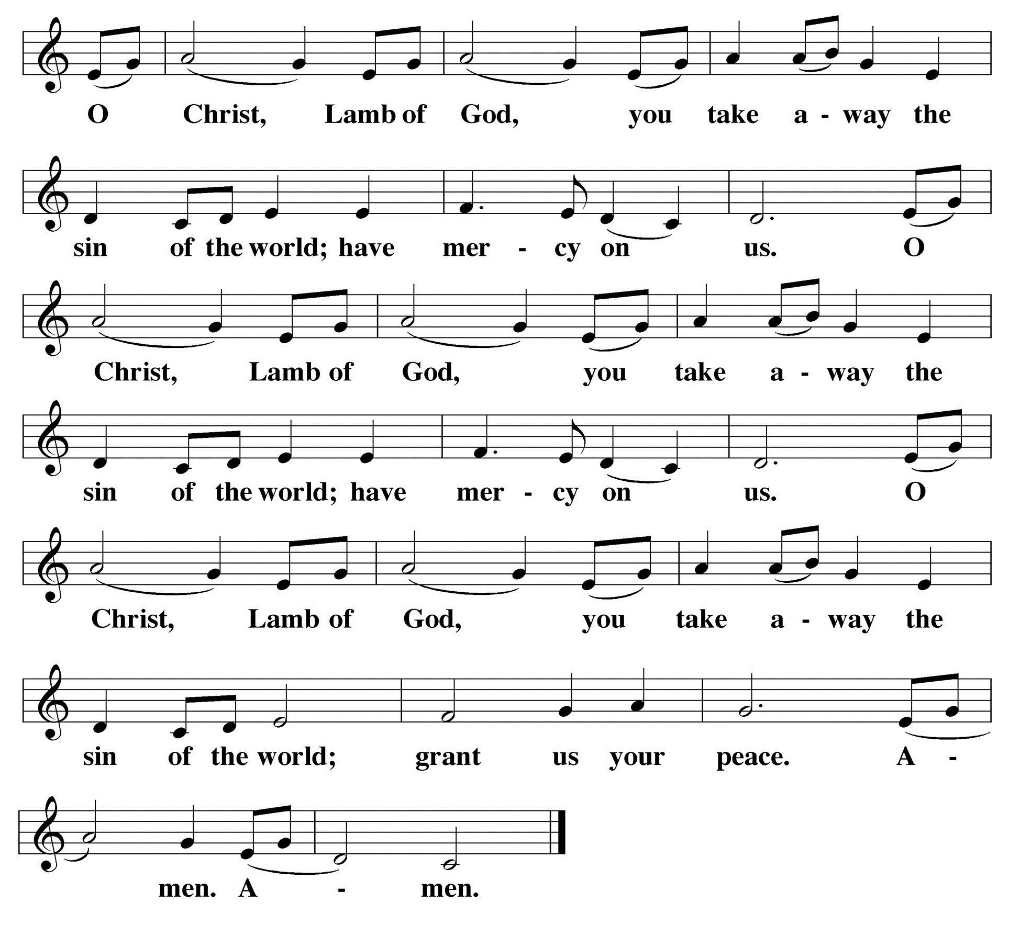C:

- John the Baptist declared Jesus to be God’s Lamb (Agnus Dei), who was offered as a sacrifice for sin once for all.

DISTRIBUTION — After the first group of communicants receives the Lord’s Supper, the
congregation will join in singing the distribution hymns:

HYMN 25 The King Shall Come

Verses 1 and 2 — Soloist
- The King shall come when morning dawns And light triumphant breaks,
When beauty gilds the eastern hills And life to joy awakes—

- Not as of old a little child To bear and fight and die,
But crowned with glory like the sun That lights the morning sky.

Verses 3, 4, and 5 — ALL
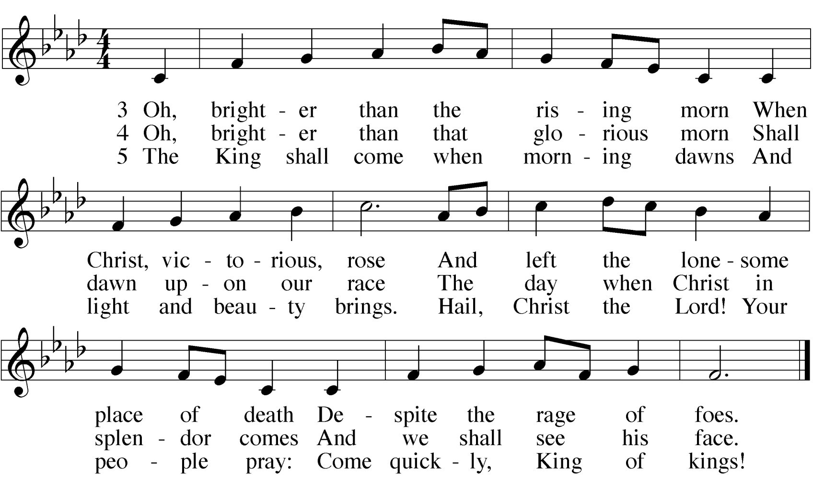

HYMN 9 Jesus, Your Church with Longing Eyes
Verses 1 and 2 — Soloist
1 Jesus, your Church with longing eyes For your expected coming waits. When will the promised light arise And glory beam from heaven’s gates?

2 E’en now, when tempests round us fall And wintry clouds o’ercast the sky, Your words with pleasure we recall And know that our redemption’s nigh.

Verses 3, 4, and 5 — ALL
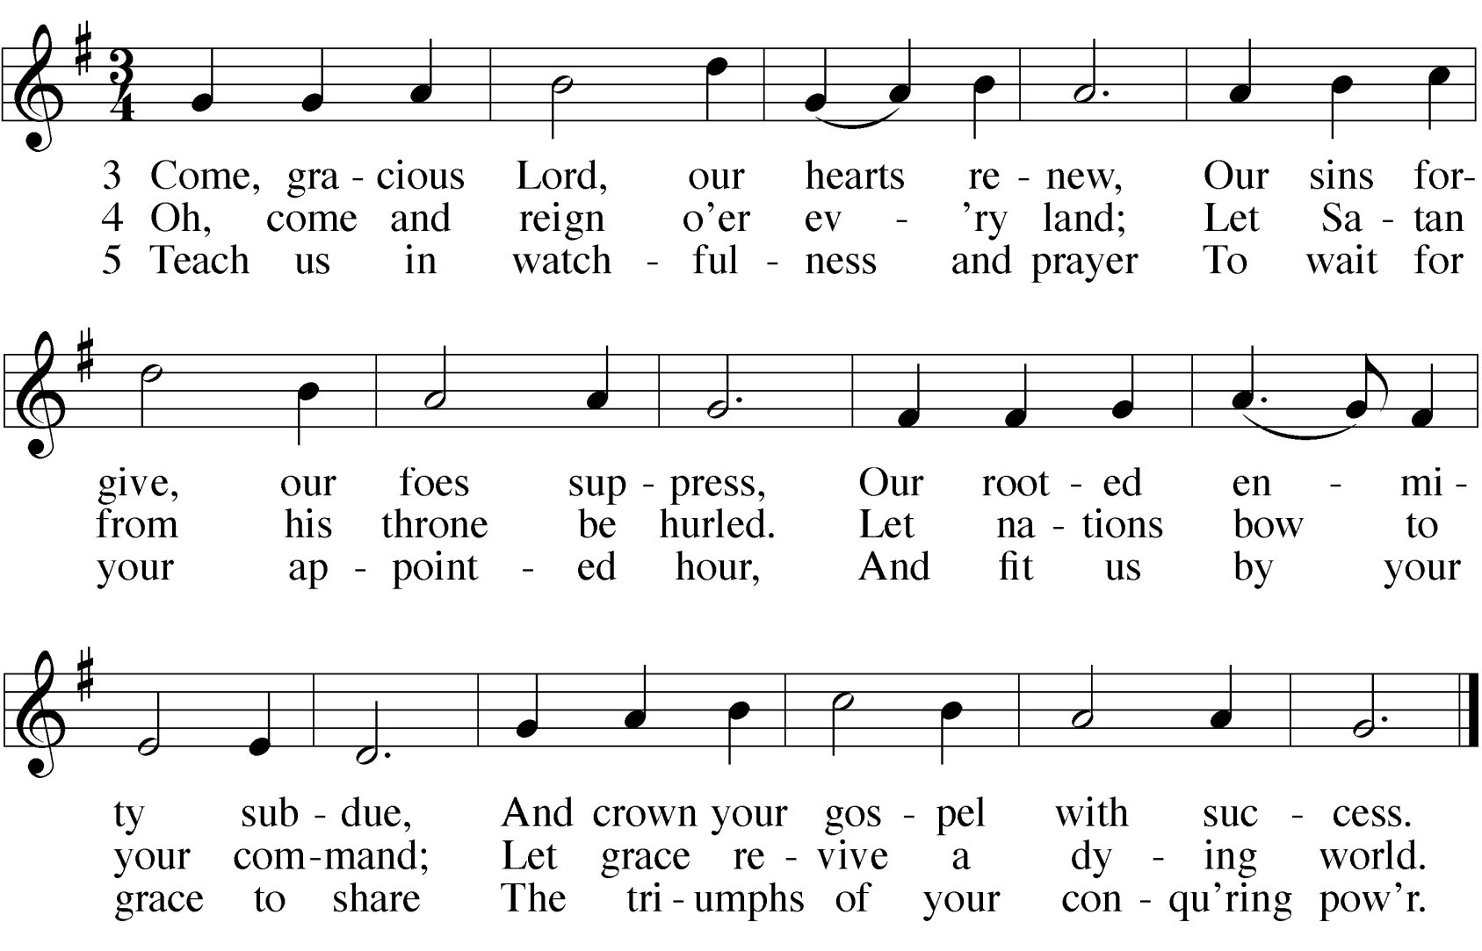

CLOSING PRAYER
M: We give you thanks, O Lord,
for the foretaste of the heavenly banquet
that you have given us to eat and to drink in this sacrament. Through this gift you have fed our faith,
nourished our hope,
and strengthened our love.
By your Spirit help us to live as your holy people until that day when you will receive us as your guests at the wedding supper of the Lamb,
who lives and reigns with you and the Holy Spirit, one God, now and forever.

C: Amen.

THE BLESSING
M: Brothers and sisters, go in peace. Live in harmony with one another. Serve the Lord with gladness.
The Lord bless you and keep you.
The Lord make his face shine on you and be gracious to you. The Lord look on you with favor and give  you peace.

C: Amen.

HYMN 12 Hark the Glad Sound! The Savior Comes
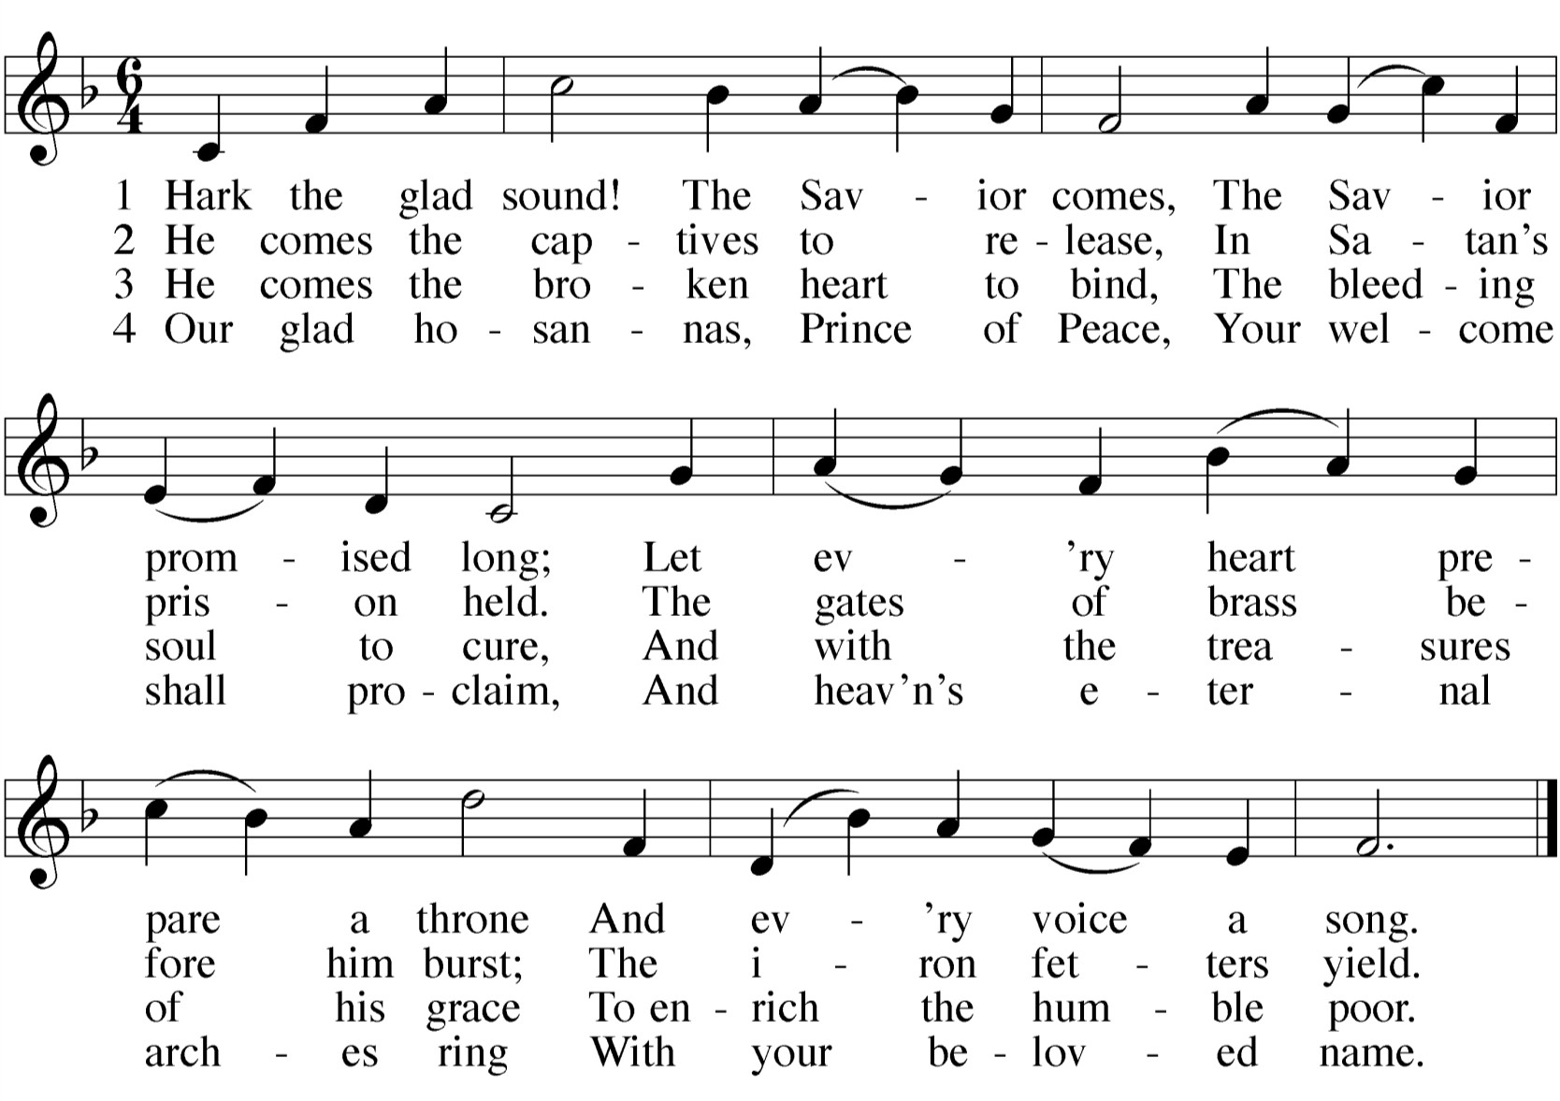

24

All music is either public domain or reprinted under put your license info here if necessary

Awake, O Sleeper: Advent Gathering Rite
Text and Tune: Francis Patrick O’Brien © 2001 GIA Publications, Inc.

Advent Wreath Song
Text and Tune: Paul Inwood © 2005 GIA Publications, Inc.

Advent Gospel Acclamation
Music: Andrew Wright © 1999 Andrew Wright. Published by OCP.

Savior of the Nations, Come
Text: Ambrose German version: Martin Luther Tune: Geystliche gesangk Buchleyn, Wittenberg Setting © 1999 Kermit Moldenhauer

The King Shall Come
Text: John Brownlie
Tune: Repository of Sacred Music, Part Second, Harrisburg Setting © 1969 Concordia Publishing House

Jesus, Your Church With Longing Eyes
Text: William H. Bathurst
Tune: Andachtige Haus-Kirche, Nurnberg Setting © 1993 Elfred Bloedel

Hark the Glad Sound! The Savior Comes
Text: Philip Doddridge Tune: Thomas Haweis

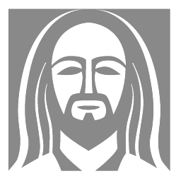
www.ourbeautifulsavior.com

