Third Sunday in Advent December 15, 2013

PREPARE THE WAY FOR THE LORD
PREPARE THE WAY BY PROCLAIMING GOOD NEWS

EVANGELICAL LUTHERAN CHURCH

elcome! Thank you for joining us for worship this morning. In our service we gather before our almighty God to offer him our worship and praise. We also gather to strengthen ourselves through the
W
study of God’s holy and powerful word.

 Restrooms are located in the hallway directly opposite the entrance to the sanctuary.

 Cry-room. If you have a young child or nursing infant and are in need of a cry-room, you will find it to the right as soon as you exit the sanctuary. A speaker there allows you to hear the service.

 Staffed nursery. We offer a staffed nursery for ages 2 to 5 and special needs children. It is located to the left of the entry foyer, near the kitchen window.

 Connection cards are found inside each worship folder. We ask that before worship or during the offering, you fill those out, front and back. You can return the card either in the offering plate or in the connection card basket you will find at the exit of the church after worship.

Summerville campus
720 Old Trolley Road Summerville, SC 29485 843.873.5522
bselc.office@gmail.com
Moncks Corner campus
Foxbank Plantation Road Moncks Corner, SC 29461 843.826.4057
Staff
Kyle Burmeister, Pastor 262.365.7123 (cell) pastorburmeister@gmail.com
Jonathan Hein, Pastor 843.860.1838 (cell) pastorhein@gmail.com
Jonathan Quinn, Pastor 843.826.4057 (home)
revjquinn@gmail.com
Nathan Loersch, Vicar 920.342.4723 (cell) vicarloersch@gmail.com

www.ourbeautifulsavior.com

WORSHIP NOTES
THE SEASON OF ADVENT
Advent is a Latin word that means “coming.” The season of Advent is the four week period before Christmas that the Church uses to remember the “coming” of the Christ. We celebrate that he came once as a baby in Bethlehem, and that he will come again at the end of time.

OUR WORSHIP SERIES
This is a busy time of year. There is much to do to prepare for the celebration of Jesus’ birth. However, more important than celebrating Jesus’ first coming is being prepared for his second coming on the Last Day. Christmas is only important because of what it means for us at the end of time. In this worship series, we make the connection between Christ’s first coming as Savior and his second coming as Judge. Our worship follows this pattern.

PREPARE THE WAY FOR THE LORD
First Sunday in Advent | Prepare, for the Lord will come again unexpectedly
Second Sunday in Advent | Prepare the way with sincere repentance
Third Sunday in Advent | Prepare the way by proclaiming good news
Fourth Sunday in Advent | Prepare the way. Immanuel comes!

OUR THEME FOR TODAY
Prepare the way by proclaiming good news. The early church gave the title “Gaudete” to the third Sunday in Advent. The word simply means, “Rejoice!” When you are joyful about something, you share that good news. Think of the custom of the family Christmas letter. Many families will send out letters during these holidays, summarizing the joyful family news of the past year: the birth of a grandchild, a new job, etc. If such joyful events are considered worthy of sharing, how much more the good news that the Son of God came into our world to save us from sins! Moreover, he is coming again to take believers to an eternity of glory. That is good news believers need to hear again and again. It is a message that we with joyful faith yearn to share with a world that is in desperate need of some good news.
The joyful nature of this Sunday is illustrated by the lone, rose colored candle on the Advent wreath. It hints of the joyful birth that we are soon to celebrate.

Order of Service for
THE SEASON OF ADVENT

AWAKE, O SLEEPER
Minister: Refrain
Congregation: Refrain

 The Gathering 

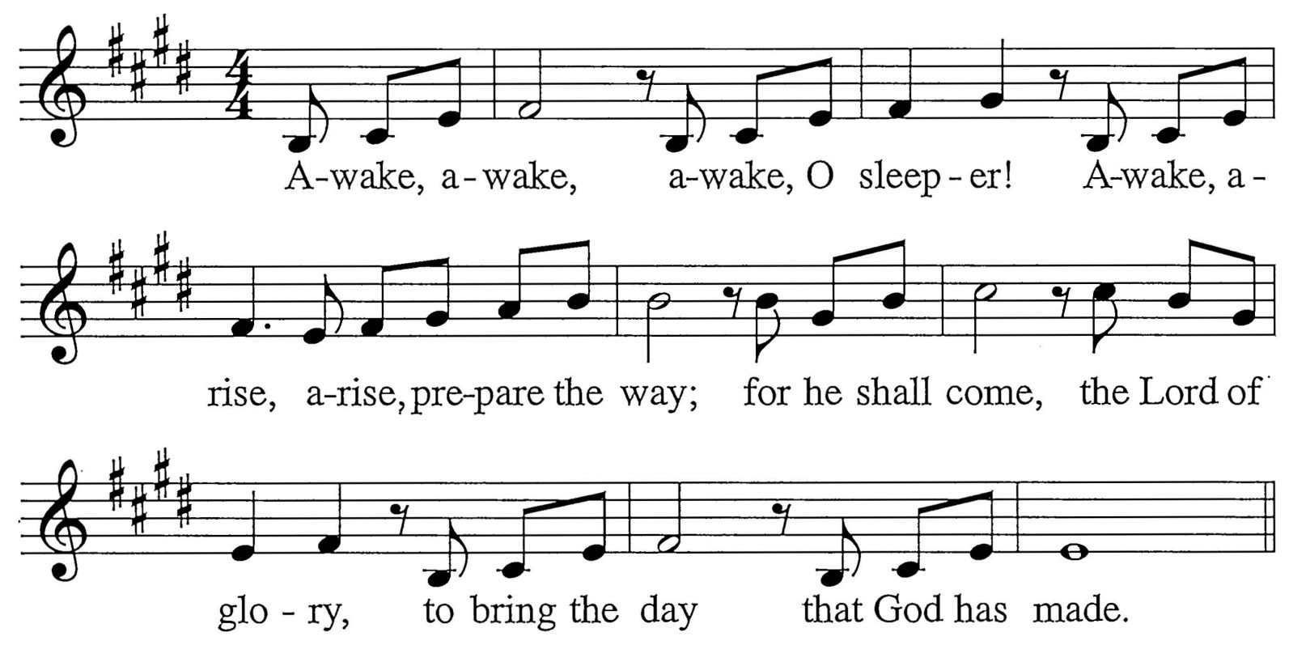

M: Land that is parched shall bloom and rejoice. The desert shall break into song.
Coming in splendor is Jesus the Lord, the one for whom we long.
C: Refrain
M: See how the farmer who nurtures the soil patiently waits for its yield. Wait for the Lord with all of your heart; God’s face shall be revealed.
C: Refrain
M: Go and proclaim what you see and you hear: the dead have been raised to new life.
Great are the deeds of our wonderful Lord, the God of pow’r and might.
C: Refrain

INVOCATION
M: In the name of the Father and of the Son  and of the Holy Spirit.

C: Amen.
M: Look! Christ is coming with the clouds.

C: Every eye will see him, even those who pierced him. Revelation 1:7

CONFESSION OF SINS
M: Lest that Day surprise us unprepared, let us make confession of our sins, imploring our heavenly Father to have mercy on us for the sake of Jesus Christ.
Silence for personal confession
M: You came to call us from darkness into light: Lord have mercy.

C: 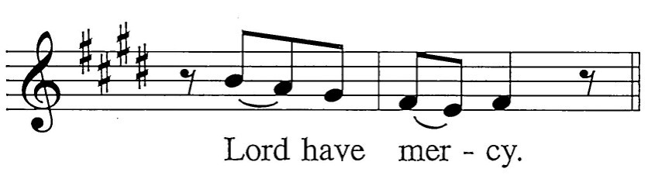
M: You came to visit your people with peace: Christ have mercy.

C: 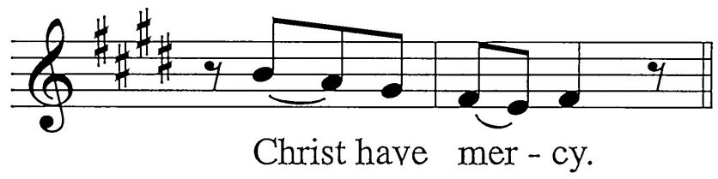
M: You will return and our joy will be full: Lord have mercy.

C:
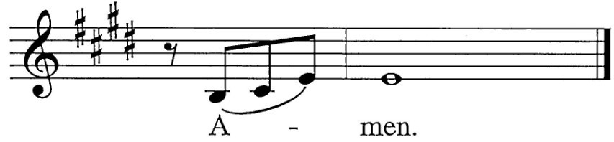M: May almighty God have mercy on us, forgive us our sins and bring us to everlasting life. Amen.

C:

ABSOLUTION
M: God, our heavenly Father, has been merciful to us and has given his only Son to be the atoning sacrifice for our sins. Therefore, as a called servant of Christ and by his authority, I forgive all your sins in the name of the Father and of the Son  and of the Holy Spirit.

C: Amen!
The Rite of Holy Baptism may take place here.
M: In the peace of forgiveness, let us praise the Lord.
C: Final Refrain

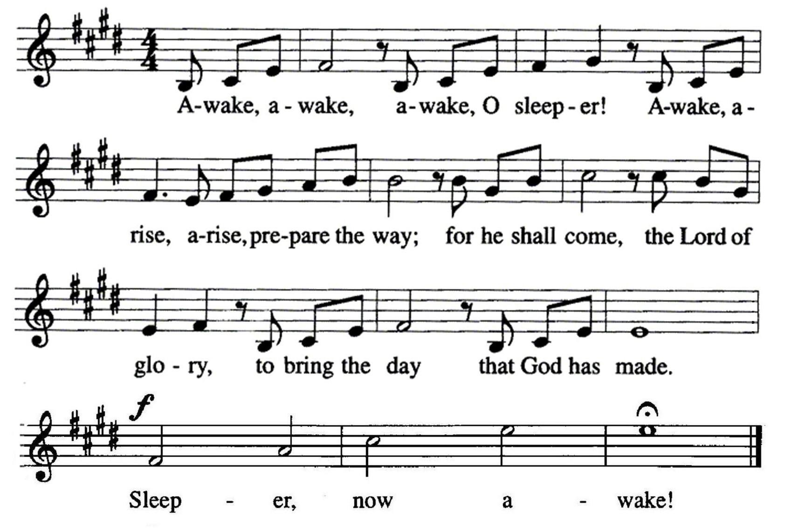

PRAYER OF THE DAY
 The Word 

M: Hear our prayers, Lord Jesus Christ, and come with the good news of your mighty deliver- ance. Drive the darkness from our hearts and fill us with your light; for you live and reign with the Father and the Holy Spirit, one God, now and forever.

C: Amen.

FIRST LESSON Isaiah 35:1-10
1 The desert and the parched land will be glad; the wilderness will rejoice and blossom. Like the crocus, 2 it will burst into bloom; it will rejoice greatly and shout for joy.
The glory of Lebanon will be given to it, the splendor of Carmel and Sharon;
they will see the glory of the LORD, the splendor of our God.
3 Strengthen the feeble hands, steady the knees that give way;
4 say to those with fearful hearts,
"Be strong, do not fear; your God will come,
he will come with vengeance; with divine retribution
he will come to save you."
5 Then will the eyes of the blind be opened and the ears of the deaf unstopped.
6 Then will the lame leap like a deer, and the mute tongue shout for joy.
Water will gush forth in the wilderness and streams in the desert.
7 The burning sand will become a pool,
the thirsty ground bubbling springs. In the haunts where jackals once lay,
grass and reeds and papyrus will grow.
8 And a highway will be there;
it will be called the Way of Holiness. The unclean will not journey on it;
it will be for those who walk in that Way; wicked fools will not go about on it.
9 No lion will be there,
nor will any ferocious beast get up on it; they will not be found there.
But only the redeemed will walk there,
10 and the ransomed of the LORD will return.
They will enter Zion with singing; everlasting joy will crown their heads. Gladness and joy will overtake them, and sorrow and sighing will flee away.

LIGHTING OF THE ADVENT WREATH
To introduce the song, the refrain and verse play. At this time, three candles are lit. The congregation then sings the refrain, then the three verses all in a row, and then the refrain again. During the final refrain, the children may come forward for the children’s message.
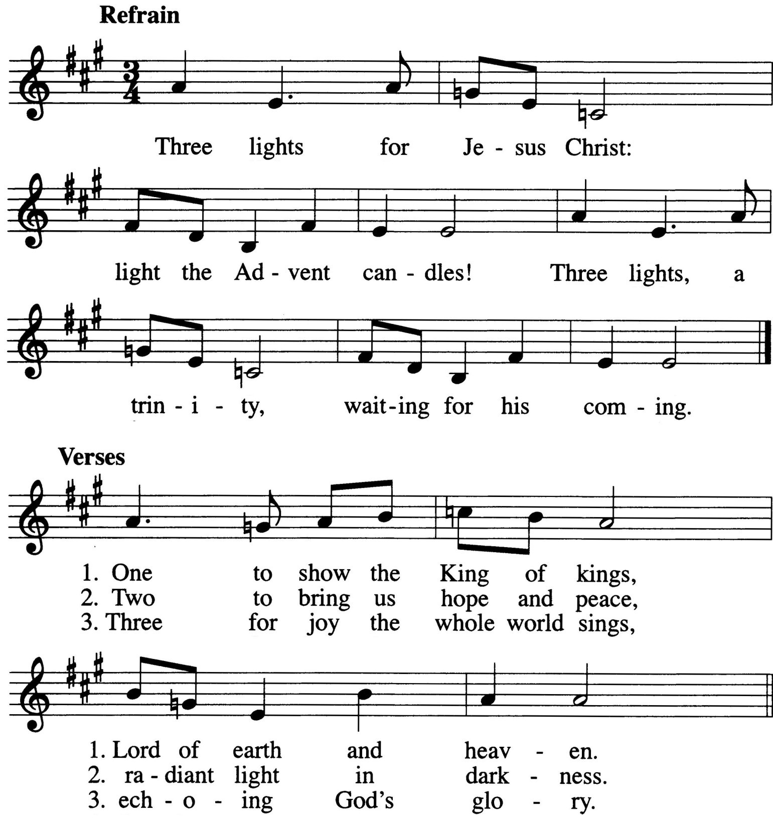

CHILDREN’S MESSAGE

SECOND LESSON James 5:7-11
7Be patient, then, brothers, until the Lord's coming. See how the farmer waits for the land to yield its valuable crop and how patient he is for the autumn and spring rains. 8You too, be patient and stand firm, because the Lord's coming is near. 9Don't grumble against each other, brothers, or you will be judged. The Judge is standing at the door!
10Brothers, as an example of patience in the face of suffering, take the prophets who spoke in the name of the Lord. 11As you
know, we consider blessed those who have persevered. You have heard of Job's perseverance and have seen what the Lord finally brought about. The Lord is full of compassion and mercy.

VERSE OF THE DAY Luke 4:18
M: Refrain
C: Refrain
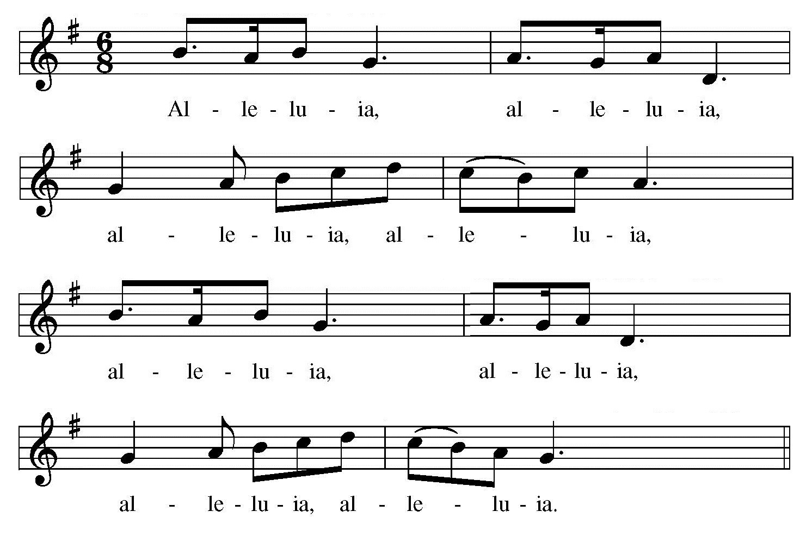
M: The Spirit of the Lord is upon me, because he has anointed me to bring glad tidings to the poor. Alleluia!
C: Refrain

GOSPEL Matthew 11:2-11
2When John heard in prison what Christ was doing, he sent his disciples 3to ask him, "Are you the one who was to come, or should we expect someone else?"
4Jesus replied, "Go back and report to John what you hear and see: 5The blind
receive sight, the lame walk, those who have leprosy are cured, the deaf hear, the dead are raised, and the good news is preached to the poor. 6Blessed is the man who does not fall away on account of me."
7As John's disciples were leaving, Jesus began to speak to the crowd about John:
"What did you go out into the desert to see? A reed swayed by the wind? 8If not, what did you go out to see? A man dressed in fine clothes? No, those who wear fine clothes are in kings' palaces. 9Then what did you go out to see? A prophet? Yes, I tell you, and more than a prophet. 10This is the one about whom it is written:
“ ‘I will send my messenger ahead of you, who will prepare your way before you.’
11I tell you the truth: Among those born of women there has not risen anyone greater
than John the Baptist; yet he who is least in the kingdom of heaven is greater than he.”

M: This is the Gospel of our Lord.

C: Praise be to you, O Christ!

HYMN 14 Arise, 0 Christian People

1; I
l A | rise, |  | 0 | Chris | - tian | peo | pi e! |  | Pre
2 Pre | pare |  | the | way | be | fore | hi m; |  | Pre
3 The | h um |  | ble | heart | and | low | ly |  | God
4 Pre pare my heart, Lord Je sus; Turn
; E a I J J I J r a J

1
r a I

I

pare your - sel ves to - day. Pre pare to greet the pare for hi m the best. Cast out what wou ld of - rais - es up on high; Be n eath his feet In
n ot from me a - side, And hel p me to re -

1; I F
Sav | ior, | Who | takes | your | sins | a - way. |  | To
fend | him , | This | great, | this | heav 'n | - l y guest. |  | Make
ter | ror | The | haugh | - ty | soul | shall lie. |  | The
ceive | you | This | bless | ed | Ad | vent - tide. |  | From

a I a

1; a r E
- J I a

u s by grace a l on e The truth and
straigh t, | make | plain | the | way: | The | low |  | l y
heart | sin | - cere | and | right, | That | heeds |  | God 's
stall and man ger l ow Come now to
; F I - J I F r J

1
light | were | giv |  | en; | The |  | prom | ised | Lord | from
val | leys | rais |  | i ng, | The |  | height s | of | pride | a -
i n | v i - | ta |  | ti on | And |  | makes | true | prep | a -
dwell w ith - In me; I'll sing your prais es
; I F a I a I

1 I
heav | en | To | all | the | world | i s | shown.
bas | i n g, | Hi s | path | all | e | ven | l ay.
ra | ti on - | It | i s | the | Lord's | de | l ight.
glad | l y | And | forth | your | gl o | - ry | show.

SERMON

CONFESSION OF FAITH The Apostles’ Creed

I believe in God, the Father almighty, maker of heaven and earth.
I believe in Jesus Christ, his only Son, our Lord, who was conceived by the Holy Spirit,
born of the virgin Mary, suffered under Pontius Pilate,
was crucified, died, and was buried. He descended into hell.
The third day he rose again from the dead. He ascended into heaven,
and is seated at the right hand of God the Father almighty. From there he will come to judge the living and the dead.
I believe in the Holy Spirit,
the holy Christian Church, the communion of saints,
the forgiveness of sins,
the resurrection of the body, and the life everlasting. Amen.

THANK OFFERING

 The Prayers 

THE PRAYER OF THE CHURCH
Prayers and petitions are offered on behalf of the Church.
M: Hear us, Lord, as we bring you our private petitions.
Silent prayer
M: Into your hands we commend all for whom we pray, trusting in your mercy, through Jesus Christ, our Lord.

C: Amen.
THE LORD’S PRAYER
M: Lord, remember us in your kingdom, and teach us to pray:

C: Our Father in heaven, hallowed be your name, your kingdom come,
your will be done on earth as in heaven. Give us today our daily bread.
Forgive us our sins, as we forgive those who sin against us. Lead us not into temptation,
but deliver us from evil.
For the kingdom, the power, and the glory are yours now and forever. Amen.

THE BLESSING
M: Brothers and sisters, go in peace. Live in harmony with one another. Serve the Lord with gladness.
The Lord bless you and keep you.
The Lord make his face shine on you and be gracious to you. The Lord look on you with favor and give  you peace.

C: Amen.

HYMN 21 Hosanna to the Coming Lord

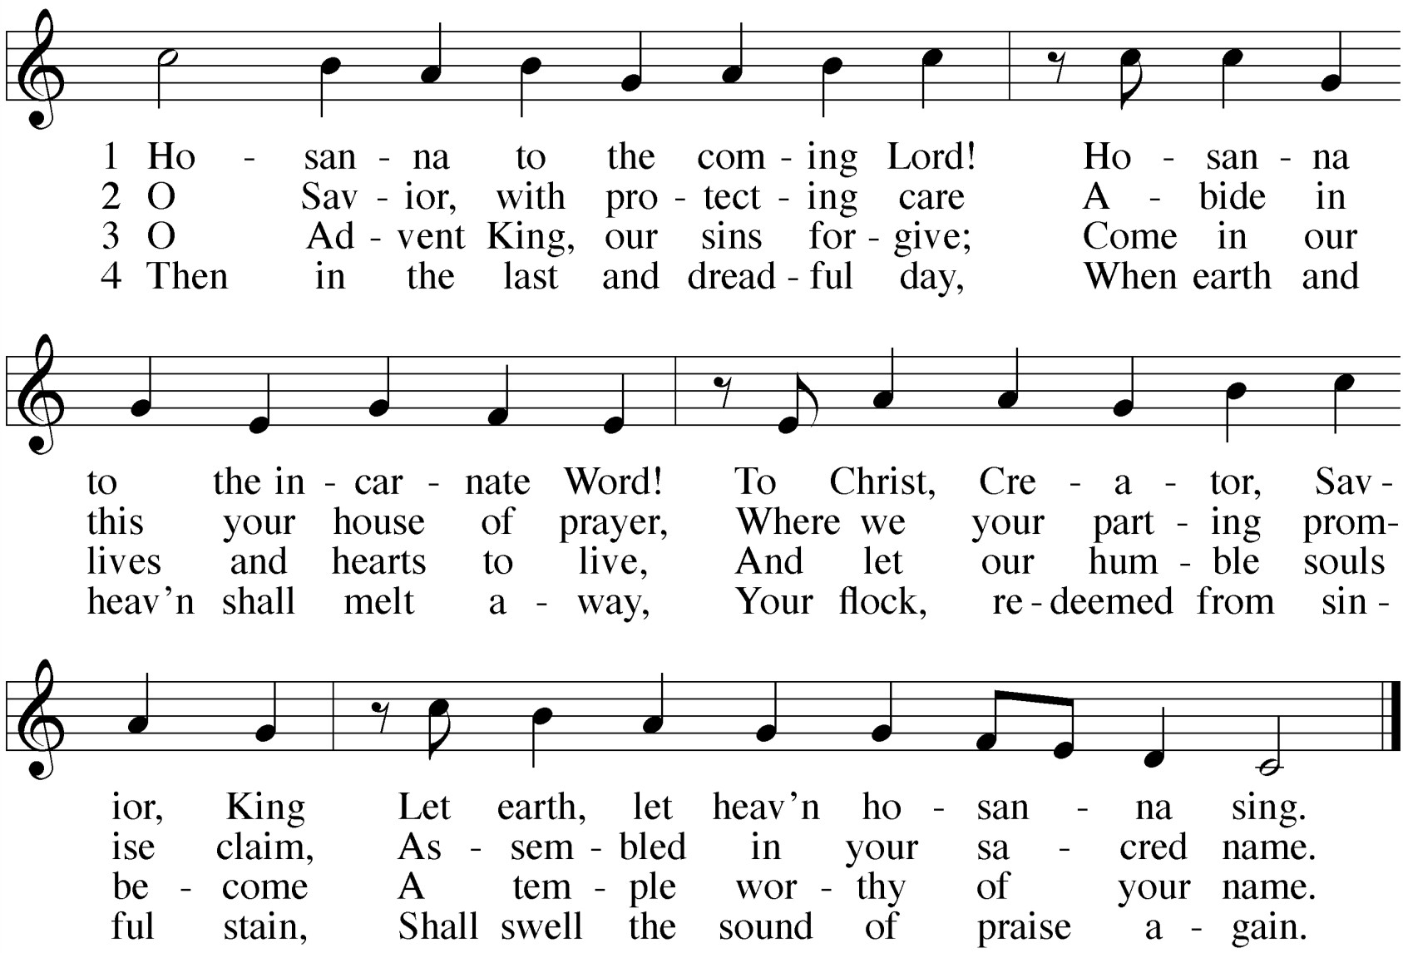

16

All music is either public domain or reprinted under put your license info here if necessary

Awake, O Sleeper: Advent Gathering Rite
Text and Tune: Francis Patrick O’Brien © 2001 GIA Publications, Inc.

Advent Wreath Song
Text and Tune: Paul Inwood © 2005 GIA Publications, Inc.

Advent Gospel Acclamation
Music: Andrew Wright © 1999 Andrew Wright. Published by OCP.

Arise, O Christian People
Text: Valentin Thilo
Tune: New Catechismus Gesangbuchlein, Hamburg Setting © 1993 Kermit Moldenhauer

Hosanna to the Coming Lord
Text: Reginald Heber
Tune: Schumann, Geistliche lieder auffs new gebessert

www.ourbeautifulsavior.com

