20

All music is either public domain or reprinted by permission

Oh, Come, All Ye Faithful
Text and Tune: John F. Wade

Angels We Have Heard on High
Text and Tune: Nouveau recuiel de cantiques

Psalm 96: Today Is Born a Savior
Text: Lectionary for the Mass © 1997, Internatnial Committee on English in the Liturgy Tune: Francis Patrick O’Brien © 2002 GIA Publications, Inc.

From Heaven Above to Earth I Come
Text: Martin Luther
Tune: Schumann, Geistliche lieder auffs new gebessert

Let All Together Praise Our God
Text and tune: Nikolaus Herman

Now Sing We, Now Rejoice
Text: Latin hymn, 14th century Tune: German melody, 14th century

www.ourbeautifulsavior.com

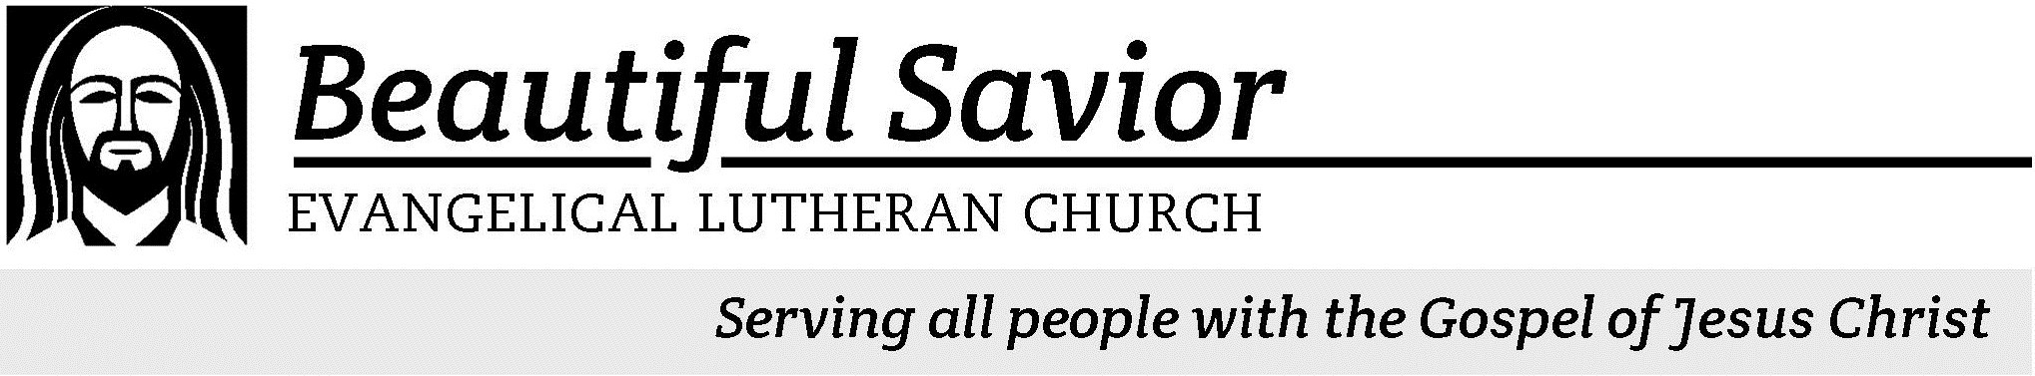

elcome! We are glad that you have joined us to celebrate the birth of the Christ child. Our service is printed for you in its entirety in this worship
W
folder. If you need anything, please speak to an usher at the rear of the sanctuary.

 Restrooms are located in the hallway directly opposite the entrance to the sanctuary.

 Cry-room If you have a young child or nursing infant and are in need of a cry-room, you will find it to the right as soon as you exit the sanctuary. A speaker there allows you to hear the service.

 Staffed nursery We offer a staffed nursery for children ages 2 to 6. It is located to the left of the entry foyer, near the kitchen window.

 Connection cards are found inside each worship folder. We ask that before worship or during the offering you fill those out, front and back. You can return the card either in the offering plate or in the connection card basket you will find at the exit of the church after worship.

 Gift bags for children will be distributed after worship. Please be sure to pick one up on your way out of the building.

HYMN Now Sing We, Now Rejoice

Summerville campus
720 Old Trolley Road Summerville, SC 29485 843.873.5522
bselc.office@gmail.com
Moncks Corner campus
Foxbank Plantation Road Moncks Corner, SC 29461 843.826.4057
Staff
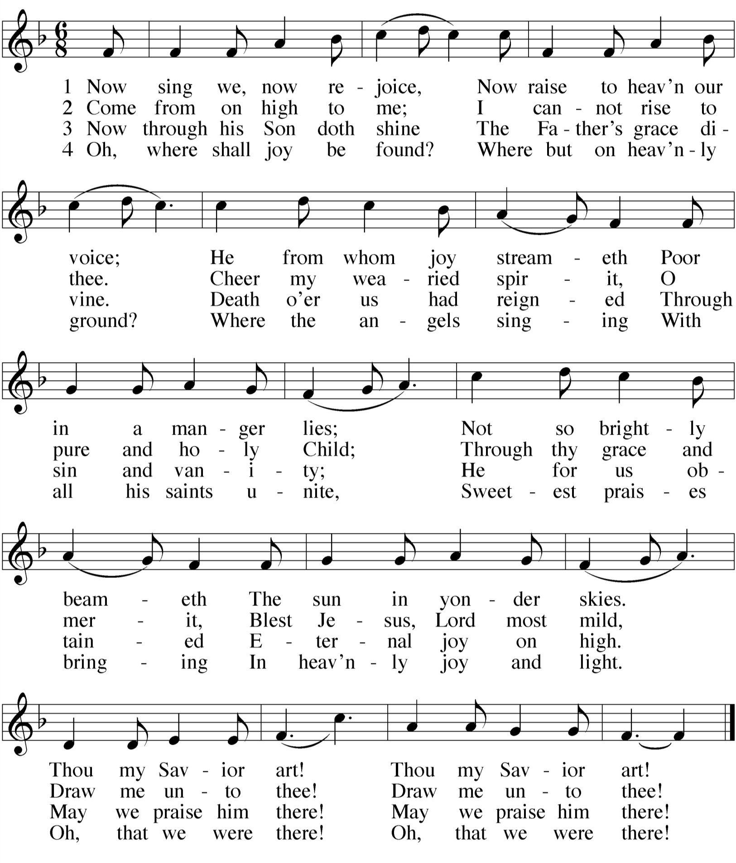Kyle Burmeister, Pastor 262.365.7123 (cell) pastorburmeister@gmail.com
Jonathan Hein, Pastor 843.771.9618 (home) pastorhein@gmail.com
Jonathan Quinn, Pastor 843.826.4057 (home)
revjquinn@gmail.com
Nathan Loersch, Vicar 920.342.4723 (cell) vicarloersch@gmail.com

www.ourbeautifulsavior.com

CHRISTMAS EVE December 24, 2013 at 5:00PM

Special prayers and petitions maybe be included
M: Hear us now, O Lord, as we bring you our private petitions.
Silent prayer

THE LORD’S PRAYER
M: Father, we bring these prayers before you this Christmas and always, confident that you will hear and answer them. For it was your only Son who taught us to pray:

C: Our Father in heaven, hallowed be your name, your kingdom come,
your will be done on earth as in heaven. Give us today our daily bread.
Forgive us our sins, as we forgive those who sin against us. Lead us not into temptation,
but deliver us from evil.
For the kingdom, the power, and the glory are yours now and forever.
Amen.

THE BLESSING
M: Brothers and sisters, go in peace. Live in harmony with one another. Serve the Lord with gladness.
The Lord bless you and keep you.
The Lord make his face shine on you and be gracious to you. The Lord look on you with favor and  give you peace.

C: Amen.
OUR THEME FOR THIS NIGHT
Born to save us. Think about those words. What do they imply? They imply that we all need saving. Is that why you came here tonight, because you feel a great threat hanging over you — something from which you need saving? Probably not. We tend to celebrate Christmas out of custom. It provides a chance to gather with family and sing our favorite carols. And we love the story of God come to earth in this humble way, born of a virgin and placed in a manger. And yet, the angels told the shepherds this child was born to save us. “Today in the town of David a Savior has been born.” Thus, one cannot really celebrate Christmas unless he understands what it is he needs saving from… and how this newborn child provides that salvation.

THE SEASON OF CHRISTMAS
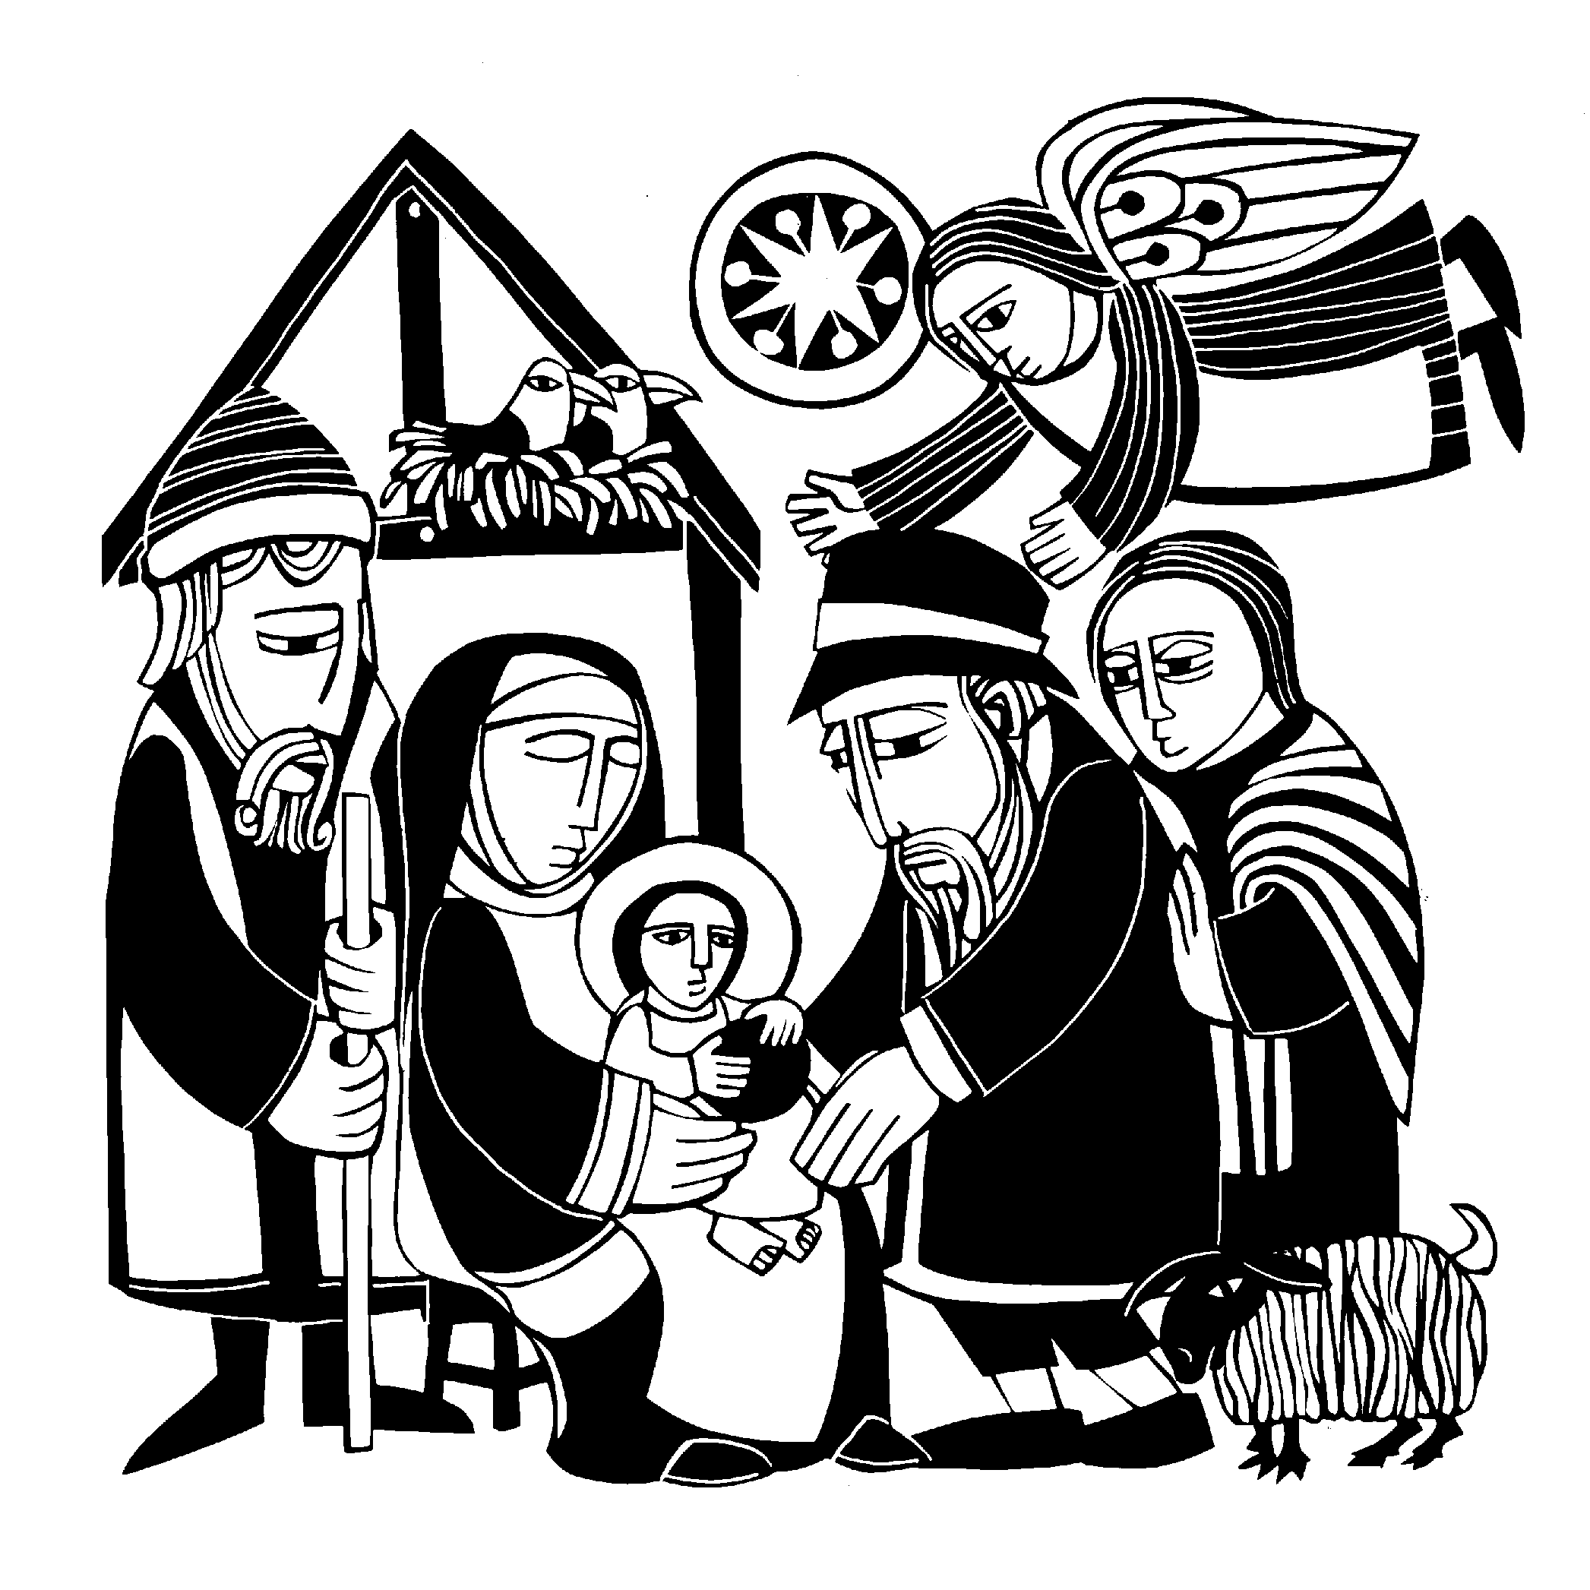For over a thousand years the Christian world has marked the passing of time from the year of Jesus' birth. Recognizing his coming into the world as the central event in the story of humankind, Christians count the years before his birth as B.C. (Before Christ) and the years after his birth as A.D. (Anno Domini, the Year of Our Lord).
An event so important wasn’t just celebrated for a day or two.
Early Christmas would celebrate Christmas for twelve days. (You are perhaps familiar with the song The Twelve Days of Christmas. Our celebration of Christ’s birth will follow that ancient pattern. Here are other opportunities to worship in this Christmas season.
- Tuesday, December 24 at 7:00PM — Lessons and Carols — Using only the light of
candles, we celebrate Christ’s birth in a service of song and scripture.
- Wednesday, December 25 at 10:30AM —- The Festival of the Nativity — In a celebratory service we ponder some of the most profound words in scripture, found in the Gospel of St. John, chapter 1.
- Sunday, December 29 at 10:30AM — God Cares Dearly for His Children — We close out the year by talking about the blessings and rights we enjoy as God’s adopted children.
- Sunday, January 5 at 10:30AM — Wise Men Seek Him — Christmas ends on this day, known as Epiphany, “the Gentile Christmas.” On this day we commemorate the way God guided Gentiles to their salvation with a special star.

ORDER OF SERVICE

CALL TO WORSHIP
 The Gathering 
 The Prayers 
PRAYER OF THE CHURCH

M(inister): In the name of the Father, and of the  Son, and of the Holy Spirit.

C(ongregation): Amen.
M: The people who walked in darkness have seen a great light.

C: The light shines in the darkness,
but the darkness has not understood it.
M: Those who dwelt in the land of deep darkness, on them light has shined.

C: We have seen the glory of the Christ, the glory of the only Son of the Father, full of grace and truth.
M: For to us a child is born, to us a Son is given.

C: In him was life,
and that life was the light of men.
M: O Loving God,
you once caused this holy night to shine with the brightness of the true Light.
Turn our thoughts toward Bethlehem and the Christ-child, born to save us.
May the words of Scripture we hear tonight remind us again that the old story is ever so new.
May the hymns and carols we sing tonight reveal to us again the mystery of his birth. May all who have known that Light on earth come to the full measure of its joys in heaven.

C: Help us, O Lord, in our worship this night. Amen.
M: Oh gracious and almighty Father, we praise you that you kept your ancient promises by sending your everlasting Son in human flesh.

C: On this holy night, receive our thanks and devotion, our songs and prayers.
M: You sent Jesus as a lowly child to demonstrate your concern for all, the weak and lonely, the troubled and frightened, the timid and helpless. No one is overlooked by your ever-seeking eyes. No one is excluded from your upholding arms. No one is denied the comfort and help of your outstretched hand.

C: Bless us with a childlike faith in the divine assurance that you love and care for us always.
M: You sent Jesus as the Savior of the world to deliver all from the curse of sin, the power of death, and the torment of hell. He took our place. He was born under the law to set us free. He became the innocent lamb of sacrifice. He came to die and rise again in order that we might live eternally. Firmly implant this good news in our hearts, and fill us with an eager desire to spread the Word concerning what we have heard tonight.

C: May all who hear the message, in every nation under heaven, be amazed and believe what is told them about the child.
M: You sent Jesus as the Light of the world to drive out all darkness that would rob us of the full life that you intend for us. May the “joy that will be for all people” be our joy. May the “peace on earth to all on whom his favor rests” be our peace. May the treasure that Mary pondered in her heart be our treasure.

C: For today in the town of David, a Savior has been born to us. He is Christ, the Lord.
Amen.

SERMON

Sermon Theme

HYMN Oh, Come, All Ye Faithful

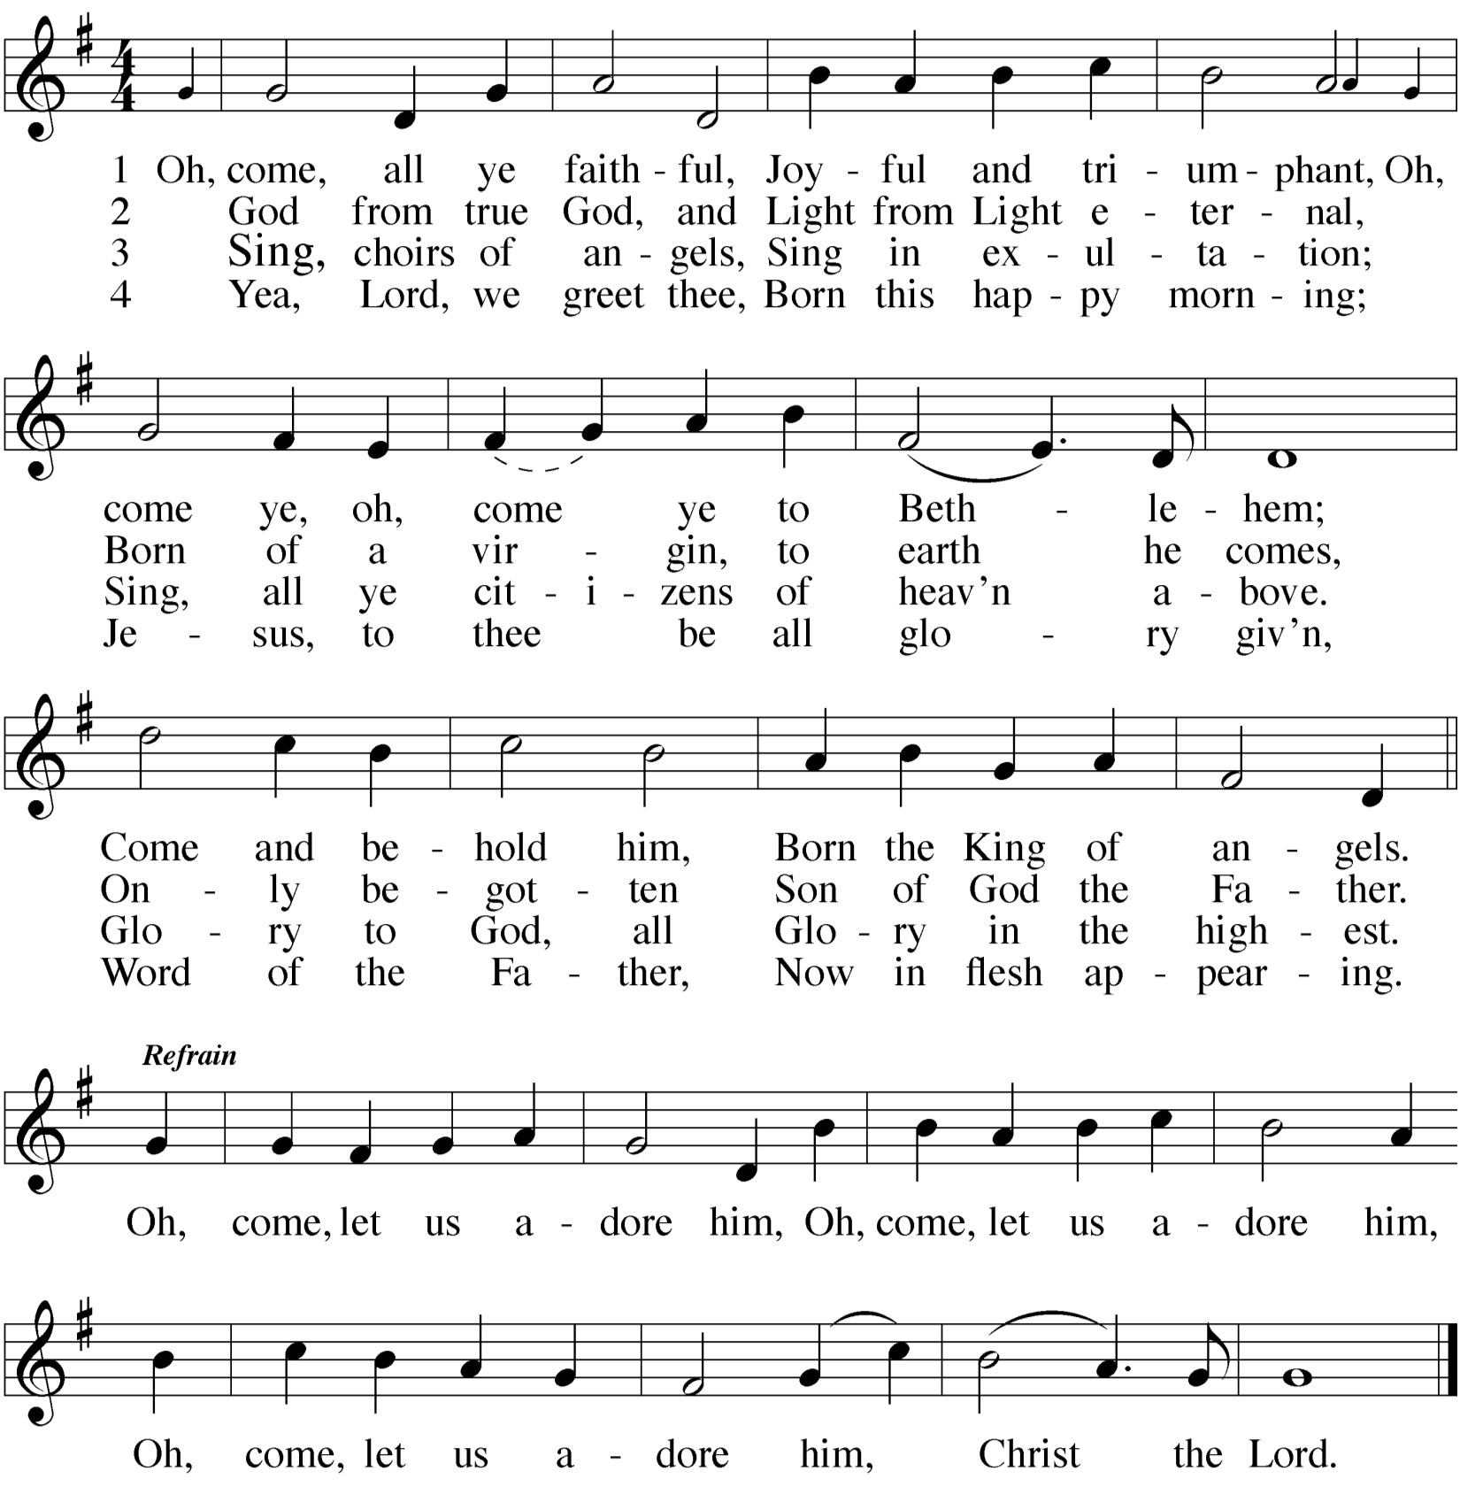RESPONSE Let All Together Praise Our God
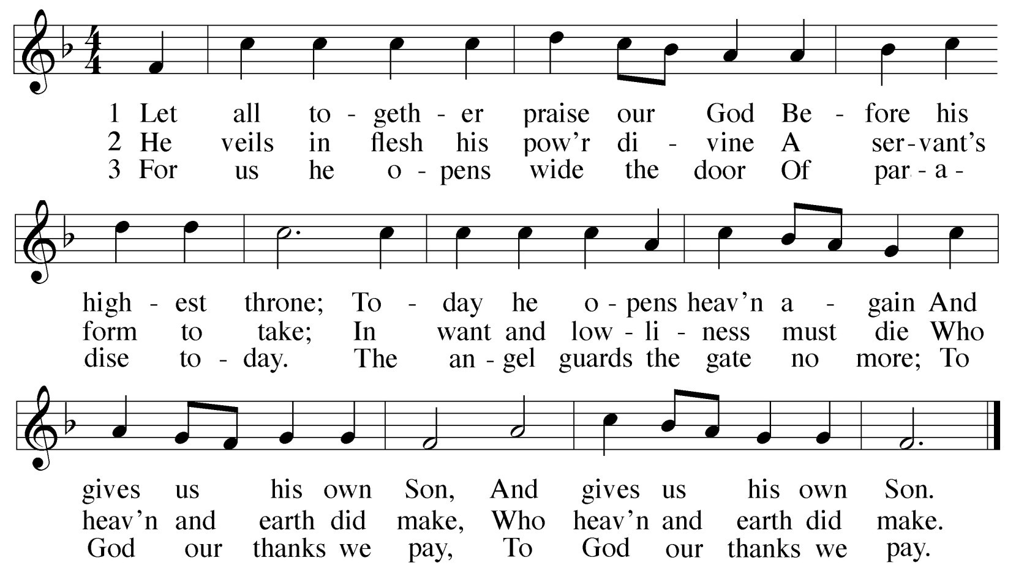

THANK OFFERING
The members of our congregation have joined together to do the Lord’s work in this community and around the world. Visitors need not feel obligated to participate in this offering which supports our ministry.
At this time, if you have not yet done so, we ask you to please fill out the Connection Card that came with this worship folder. You can place it in the offering plate or drop it in the basket as you exit church.

CONFESSION OF SINS
M: Dear friends, let us approach God with a true heart and confess our sins, asking him in the name of our Lord Jesus Christ to forgive us.

C: Lord of life, I confess that I am by nature dead in sin.
For faithless worrying and selfish pride, For sins of habit and sins of choice,
for the evil I have done and the good I have failed to do, You should cast me away from your presence forever.
O Lord, I am sorry for my sins. Forgive me, for Jesus' sake.
M: Glory to God in the highest!
In love that astounds us, the eternal God sent his one and only Son
to live among us, to obey as we could not, and to suffer what we deserved. In Christ there is indeed peace on earth
In him God extends his good will to all people. He was born to save us. Because of Christ and by his authority, I say to you what God himself says: In Christ your sins are forgiven!

C: Glory to God in the highest! Amen.

Verse 6 (ALL): How glad we’ll be to find it so!
Then with the shepherds let us go To see what God for us has done In sending us his own dear Son.

Verse 7 (Women): Welcome to earth, O noble Guest,
Through whom the sinful world is blest! You came to share my misery
That you might share your joy with me.

Verse 8 (Men): Were earth a thousand times as fair
And set with gold and jewels rare, It would be far too poor and small A cradle for the Lord of all.

Verse 9 (ALL): Ah, dearest Jesus, holy Child,
Prepare a bed, soft, undefiled
Within my heart, made clean and new, A quiet chamber kept for you.

Verse 10 (ALL): My heart for very joy must leap;
My lips no more can silence keep. I, too, must sing with joyful tongue That sweetest ancient cradle song:

Verse 11 (ALL): Glory to God in highest heaven,
Who unto us his Son has given! While angels sing with pious mirth A glad new year to all the earth.

After a brief musical introduction, we join to sing:

HYMN OF THE DAY From Heaven Above to Earth I Come
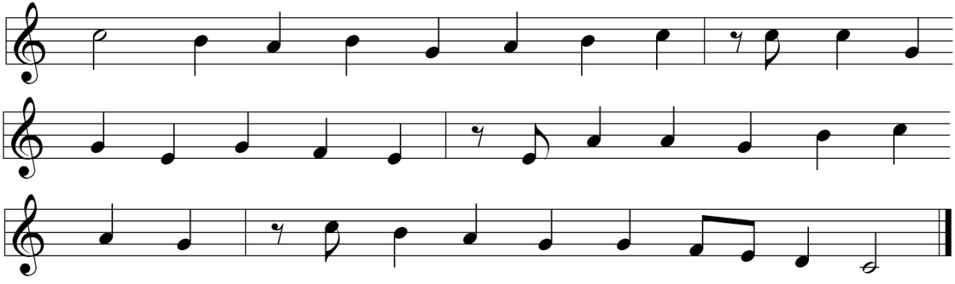

Verse 1 (Cantor): “From heav’n above to earth I come
To bear good news to ev’ry home; Glad tidings of great joy I bring, Whereof I now will say and sing.

Verse 2 (Cantor): “To you this night is born a child
Of Mary, chosen virgin mild; This little child of lowly birth Shall be the joy of all the earth.

Verse 3 (Cantors): “This is the Christ, our God most high,
Who hears your sad and bitter cry; He will himself your Savior be From all your sins to set you free.

Verse 4 (Choir): “He will on you the gifts bestow
Prepared by God for all below,
That in his kingdom, bright and fair, You may with us his glory share.

Verse 5 (Choir): “These are the signs which you shall mark:
The swaddling cloths and manger dark. There you will find the infant laid
By whom the heav’ns and earth were made.”

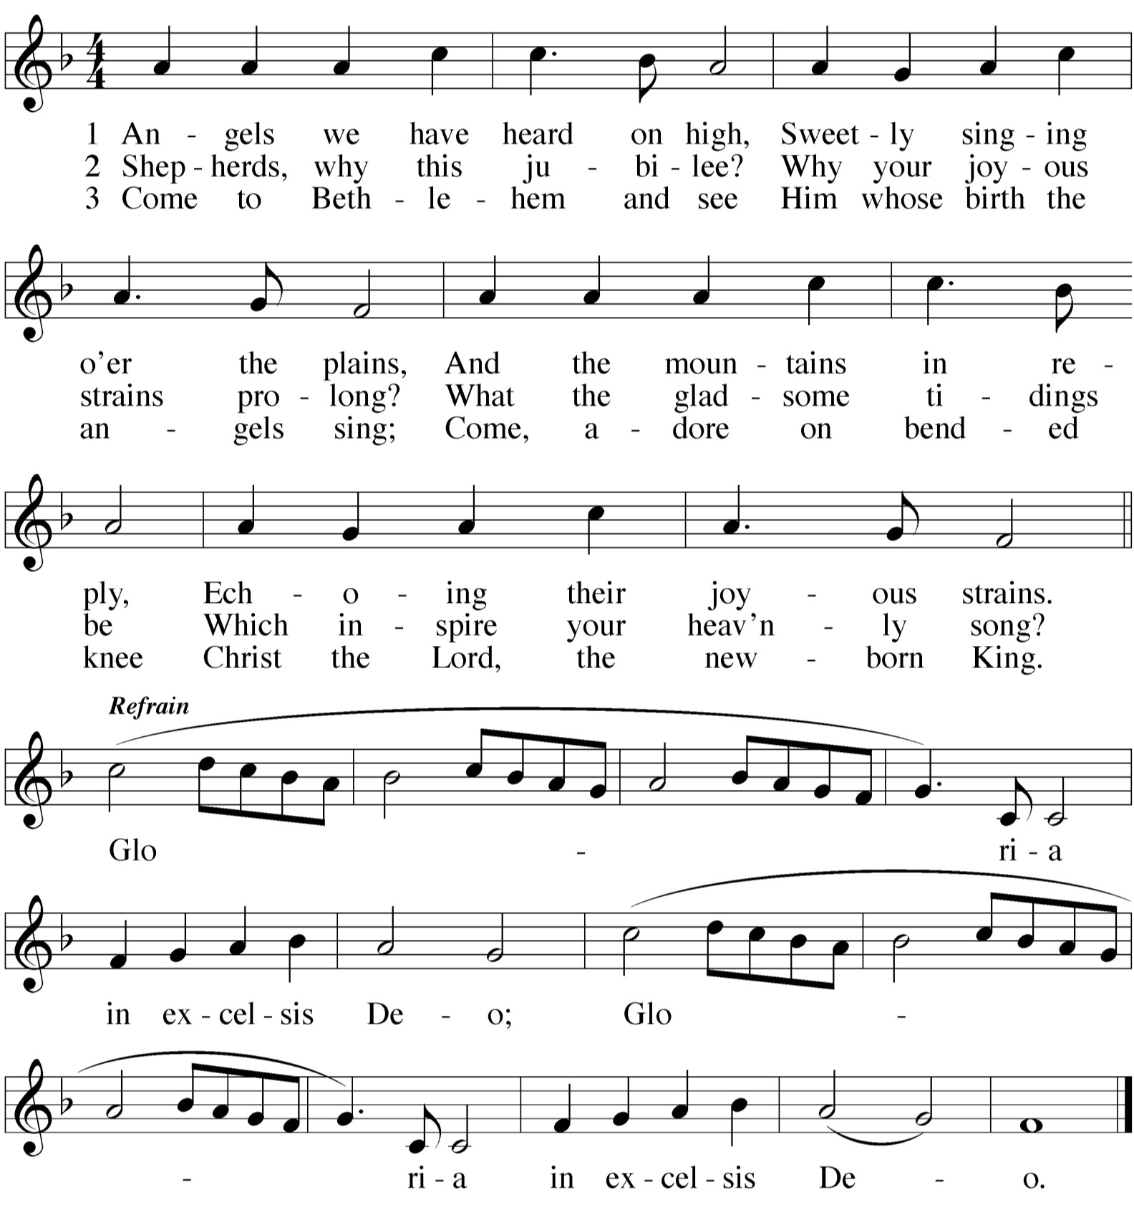HYMN Angels We Have Heard on High

GOSPEL LESSON Luke 2:1-20
1In those days Caesar Augustus issued a decree that a census should be taken of the entire Roman world. 2 (This was the first census that took place while Quirinius was governor of Syria.) 3 And everyone went to his own town to register.
4 So Joseph also went up from the town of Nazareth in Galilee to Judea, to Bethlehem the town of David, because he belonged to the
5

 The Word 
house and line of David.
He went there to register with Mary, who was

PRAYER OF THE DAY
M: Almighty God,
you made this holy night shine with the brightness of the true light. Grant that as we have known on earth the wonder of that light,
we may also behold him in all glory in the life to come; through your only Son, Jesus Christ our Lord,
who lives and reigns with you and the Holy Spirit, one God, now and forever.

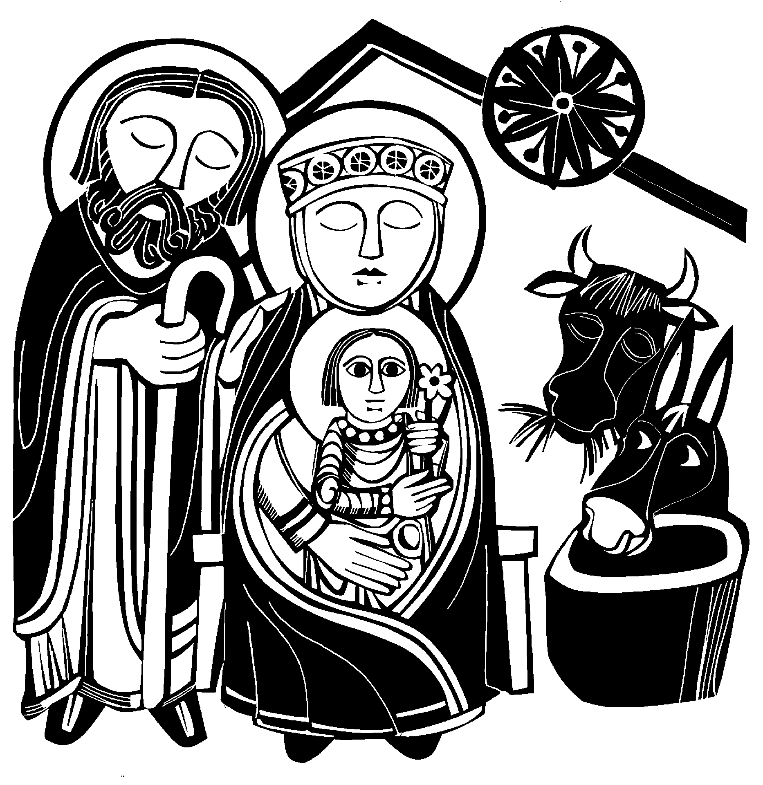C: Amen.
pledged to be married to him and was expecting a child. 6 While they were there, the time came for the baby to be born, 7 and she gave birth to her firstborn, a son. She wrapped him in cloths and placed him in a manger, because there was no room for them in the inn.
8 And there were shepherds living out in the fields nearby, keeping watch over their flocks at night. 9 An angel of the Lord appeared to them,
and the glory of the Lord shone around them, and they were terrified. 10 But the angel said to them, “Do not be afraid. I bring you good news of great joy that will be for all the people. 11 Today in the town of David a Savior has been born to you; he is Christ, the
Lord. 12 This will be a sign to you: You will find a baby wrapped in
cloths and lying in a manger.”
13 Suddenly a great company of the heavenly host appeared with the angel, praising God and saying,
14 “Glory to God in the highest,
and on earth peace to men on whom his favor rests.”
15 When the angels had left them and gone into heaven, the
shepherds said to one another, “Let’s go to Bethlehem and see this thing that has happened, which the Lord has told us about.”
16 So they hurried off and found Mary and Joseph, and the baby, who was lying in the manger. 17 When they had seen him, they spread the word concerning what had been told them about this child, 18 and all who heard it were amazed at what the shepherds said to them. 19 But Mary treasured up all these things and pondered them in her heart. 20 The
shepherds returned, glorifying and praising God for all the things they had heard and seen, which were just as they had been told.

M: This is the Gospel of our Lord.

C: Praise be to you, O Christ!

CAROL To Thee My Heart I Offer
Sung by the children’s choir.

To thee my heart I offer,
O Christ-child sweet and dear, Upon thy love relying; Oh, be thou ever near!
Take thou my heart and give me thine, And let it be forever mine,
O Jesus, holy, undefiled, My Savior meek and mild.

My heart within is glowing, O Christ-child sweet and dear. I love thee, Lord and Savior;
Oh, be thou ever near!
I see thee in a manger laid, Near cattle resting unafraid; I see thy deep humility
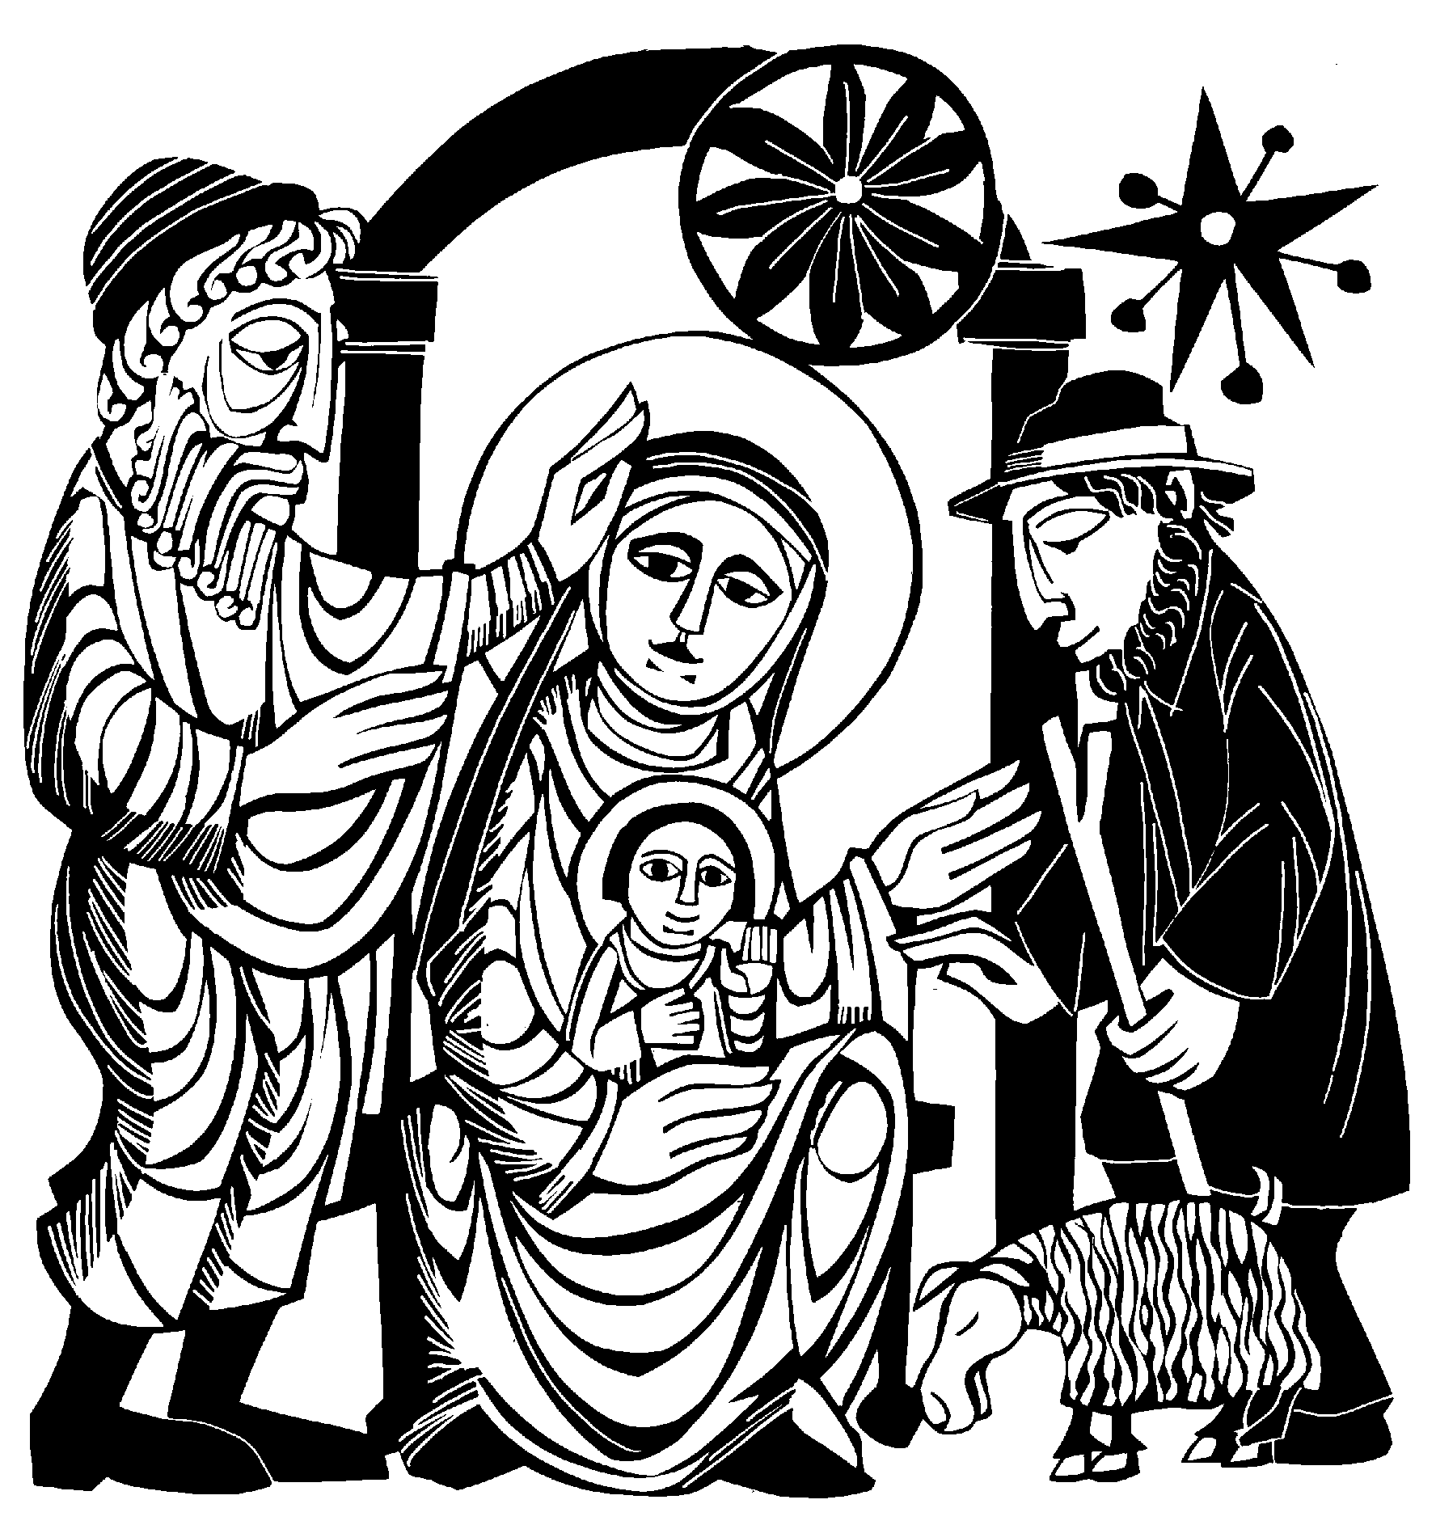And lowly bow to thee.

FIRST LESSON Isaiah 9:2-7
2 The people walking in darkness have seen a great light;
on those living in the land of the shadow of death a light has dawned.
3 You have enlarged the nation and increased their joy;
they rejoice before you
as people rejoice at the harvest,
as men rejoice when dividing the plunder.
4 For as in the day of Midian’s defeat,
you have shattered the yoke that burdens them, the bar across their shoulders,
the rod of their oppressor.
5 Every warrior’s boot used in battle
and every garment rolled in blood will be destined for burning,
will be fuel for the fire.
6 For to us a child is born, to us a son is given,
and the government will be on his shoulders.
And he will be called
Wonderful Counselor, Mighty God, Everlasting Father, Prince of Peace.
7 Of the increase of his government and peace there will be no end.
He will reign on David’s throne
and over his kingdom,
establishing and upholding it with justice and righteousness from that time on and forever.
The zeal of the LORD Almighty will accomplish this.

PSALM OF THE DAY Psalm 96
Choir: Refrain
ALL: Refrain
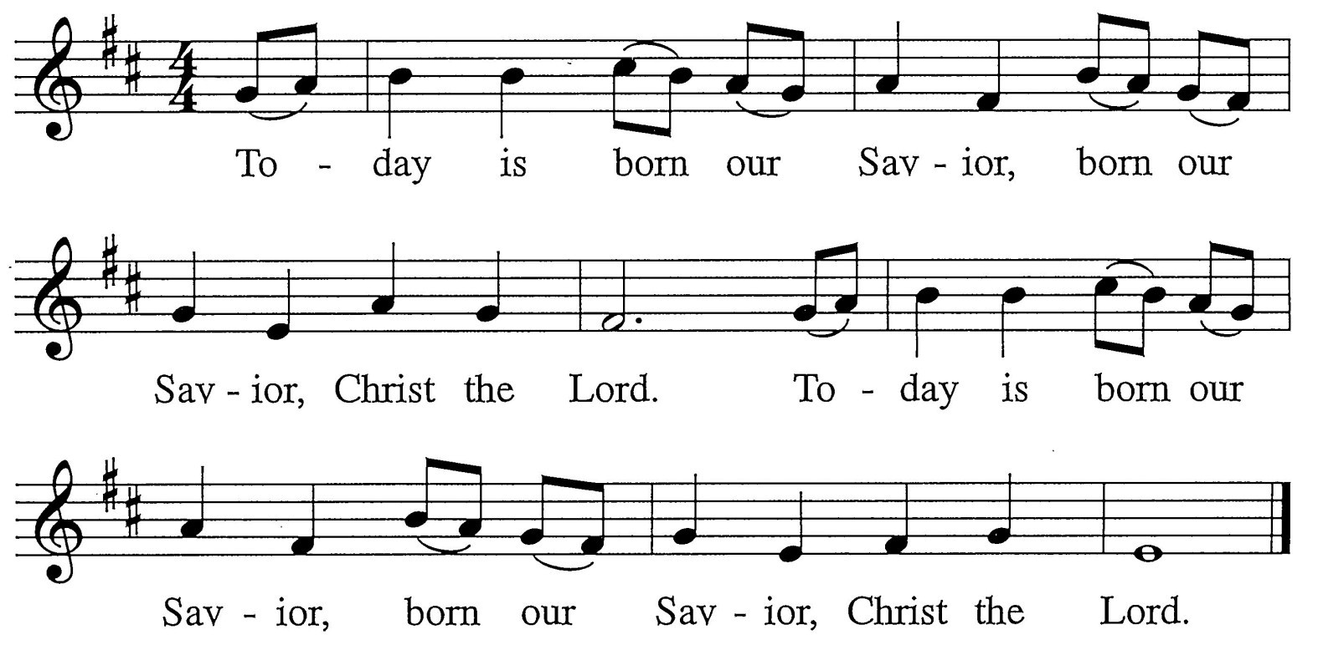

Choir: Sing to the Lord a new song; sing to the Lord, all you lands.
Sing to the Lord; bless God’s name. Bless the name of God.
ALL: Refrain
Choir: Tell of his salvation day after day. Tell God’s glory among the nations; Among all peoples tell God’s wondrous deeds.
ALL: Refrain
Choir: Heaven and earth be glad in the lord; seas and plains resound in our God.
Trees of the forest exult with joy! Bless the name of God.
ALL: Refrain
Choir: They shall exult before the Lord, for God comes to rule the earth.
God shall rule with faithfulness, faithfulness and justice.
ALL: Refrain

SECOND LESSON Titus 2:11-14

11 For the grace of God that brings salvation has appeared to all men.
12 It teaches us to say “No” to
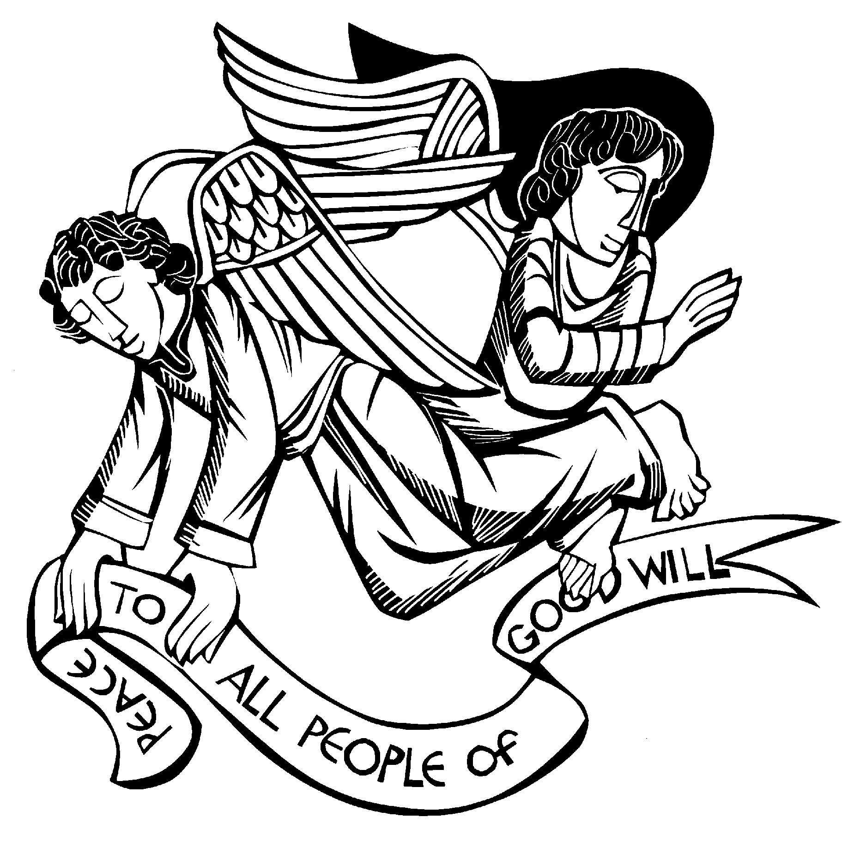ungodliness and worldly passions, and to live self-controlled, upright and godly lives in this present age, 13 while we wait for the blessed hope—the glorious appearing of our great God and Savior, Jesus Christ, 14 who gave himself for us to redeem us from all wickedness and to purify for himself a people that are his very own, eager to do what is good.

