- 1 -

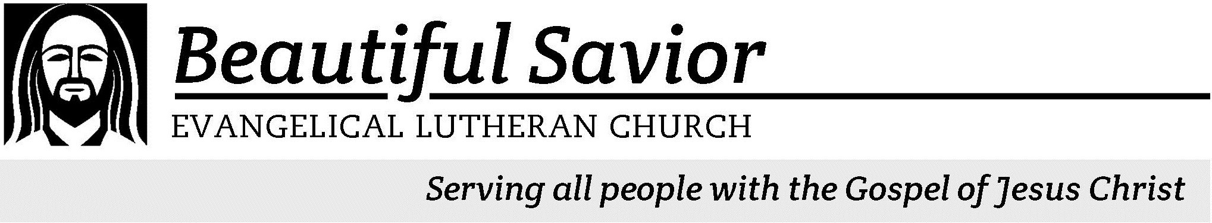

elcome! We are glad that you have joined us to celebrate the birth of the Christ child. Our service is printed for you in its entirety in this worship folder. If you need anything, please speak to an usher at the rear of the sanctuary.
W

 Restrooms are located in the hallway directly opposite the entrance to the sanctuary.

 Cry-room If you have an young child or nursing infant and are in need of a cry-room, you will find it to the right as soon as you exit the sanctuary. A speaker there allows you to hear the service.

 Staffed nursery We offer a staffed nursery for children ages 2 to 6. It is located to the left of the entry foyer, near the kitchen window.

 Connection cards are found inside each worship folder.We ask that before worship or during the offering you fill those out, front and back. You can return the card either in the offering plate or in the connection card basket you will find at the exit of the church after worship.

 Gift bags for children will be distributed after worship. Please be sure to pick one up on your way out of the building.

Christmas Eve December 24th, 2013 at 7:00PM

A SERVICE OF LESSONS & CAROLS
Our worship this evening is an adaptation of the
Lessons and Carols service traditionally held at King's College, Cambridge, England, on December 24th every year. Lessons and Carols was first held on Christmas Eve, 1918. It was planned by Eric Milner-White, who at the age of thirty-four had just been appointed Dean of King’s College after experience as an army chaplain.
The lessons for tonight have been used for almost 100 years to recall God’s promise to send a Savior, as well as that promise’s fulfillment.
The carols that are historically used in this service are carefully chosen because of their relationship to the lesson they follow.

CANDLES
We worship tonight by the light of hundreds of candles. When lighting the candles, tip the unlit candle and leave the lit candle vertical. That way, all wax will be caught by the wax guard. Parents, please help your children to keep their candle vertical.

+ Order of Service +

Preservice music

ONCE IN ROYAL DAVID’S CITY

Verse 1 - Soloist
Once in royal David’s city Stood a lowly cattle shed, Where a mother laid her baby In a manger for his bed: Mary was that mother mild, Jesus Christ her little child.
Verse 2 - Choir
He came down to earth from heaven Who is God and Lord of all,
And his shelter was a stable, And his cradle was a stall;
With the poor and mean and lowly Lived on earth our Savior holy.

Verses 3 & 4 - ALL
But our eyes at last shall see him Through his own redeeming love, For that child, so dear and gentle, Is our Lord in heav’n above;
And he leads his children on To the place where he is gone.

Not in that poor, lowly stable With the oxen standing by Shall we see him, but in heaven, Set at God’s right hand on high.
Then like stars his children crowned All in white, his praise will sound.

Cecil Frances Alexander wrote Once in Royal David’s City as a way for her grandchildren to review the catechism. The original version had many stanzas which recalled the Ten Commandments. The verses that are commonly known today echo some thoughts of the Apostle’s Creed. The tune IRBY was composed by Henry J. Gauntlett in 1849 as four-part setting for children. Once in Royal David’s City became popular to a large extent from its use as the opening hymn for the annual service of Lessons and Carols held at Kings College in Cambridge, England. It is customary that the first stanza is sung by a soloist.

EXHORTATION AND PRAYER
M: Dear people of God, in this Christmas season, it is our duty and delight to hear again the message of the angels and, in heart and mind, to go to Bethlehem and see this thing which has come to pass, which the Lord has made known to us
— the Christ Child lying in a manger, born to save us.
Let us read and learn in Holy Scripture the story of the loving purposes of God from the first days after our fall into sin to the glorious redemption brought to us by this holy child.
But first, let us pray for people all over the world who would delight with us to know the good news of Jesus Christ and who would join with us in singing his praises. Let us pray for the people of our community and our church.
And, because this would please the Lord, let us remember in his name the poor and helpless, the cold, the hungry and the oppressed, the sick and those who are sad, the lonely and the unloved, and the elderly and the little children. We especially remember all those who do not know the Lord Jesus, those who do not love him, and those who by unrepentant sin have grieved his heart of love.
Finally, let us remember before God all those who rejoice with us in heaven, who live in greater light than we, that multitude which no one can number, whose hope was in the Word made flesh, who died in faith, and who live before the throne of God and praise him each day in his temple. We confess that we are united with them as we are united with one another.
To sum up all these petitions, let us pray as Christ himself taught us:

C: Our Father in heaven, hallowed be your name, your kingdom come,
your will be done on earth as in heaven. Give us today our daily bread.
Forgive us our sins, as we forgive those who sin against us. Lead us not into temptation,
but deliver us from evil.
For the kingdom, the power, and the glory are yours now and forever.
Amen.

THE FIRST LESSON Genesis 3:8-15
First lector, how they serve your church: Example—John Smith, councilman

Then the man and his wife heard the sound of the LORD God as he was walking in the garden in the cool of the day, and they hid from
the LORD God among the trees of the garden. But the LORD God called to the man, “Where are you?”
He answered, “I heard you in the garden, and I was afraid because I was naked; so I hid.”
And he said, “Who told you that you were naked? Have you eaten from the tree that I commanded you not to eat from?”
The man said, “The woman you put here with me — she gave me some fruit from the tree, and I ate it.”
Then the LORD God said to the woman, “What is this you have done?”
The woman said, “The serpent deceived me, and I ate.”
So the LORD God said to the serpent, “Because you have done this,
“Cursed are you above all livestock and all the wild animals!
You will crawl on your belly and you will eat dust
all the days of your life.
And I will put enmity
between you and the woman,
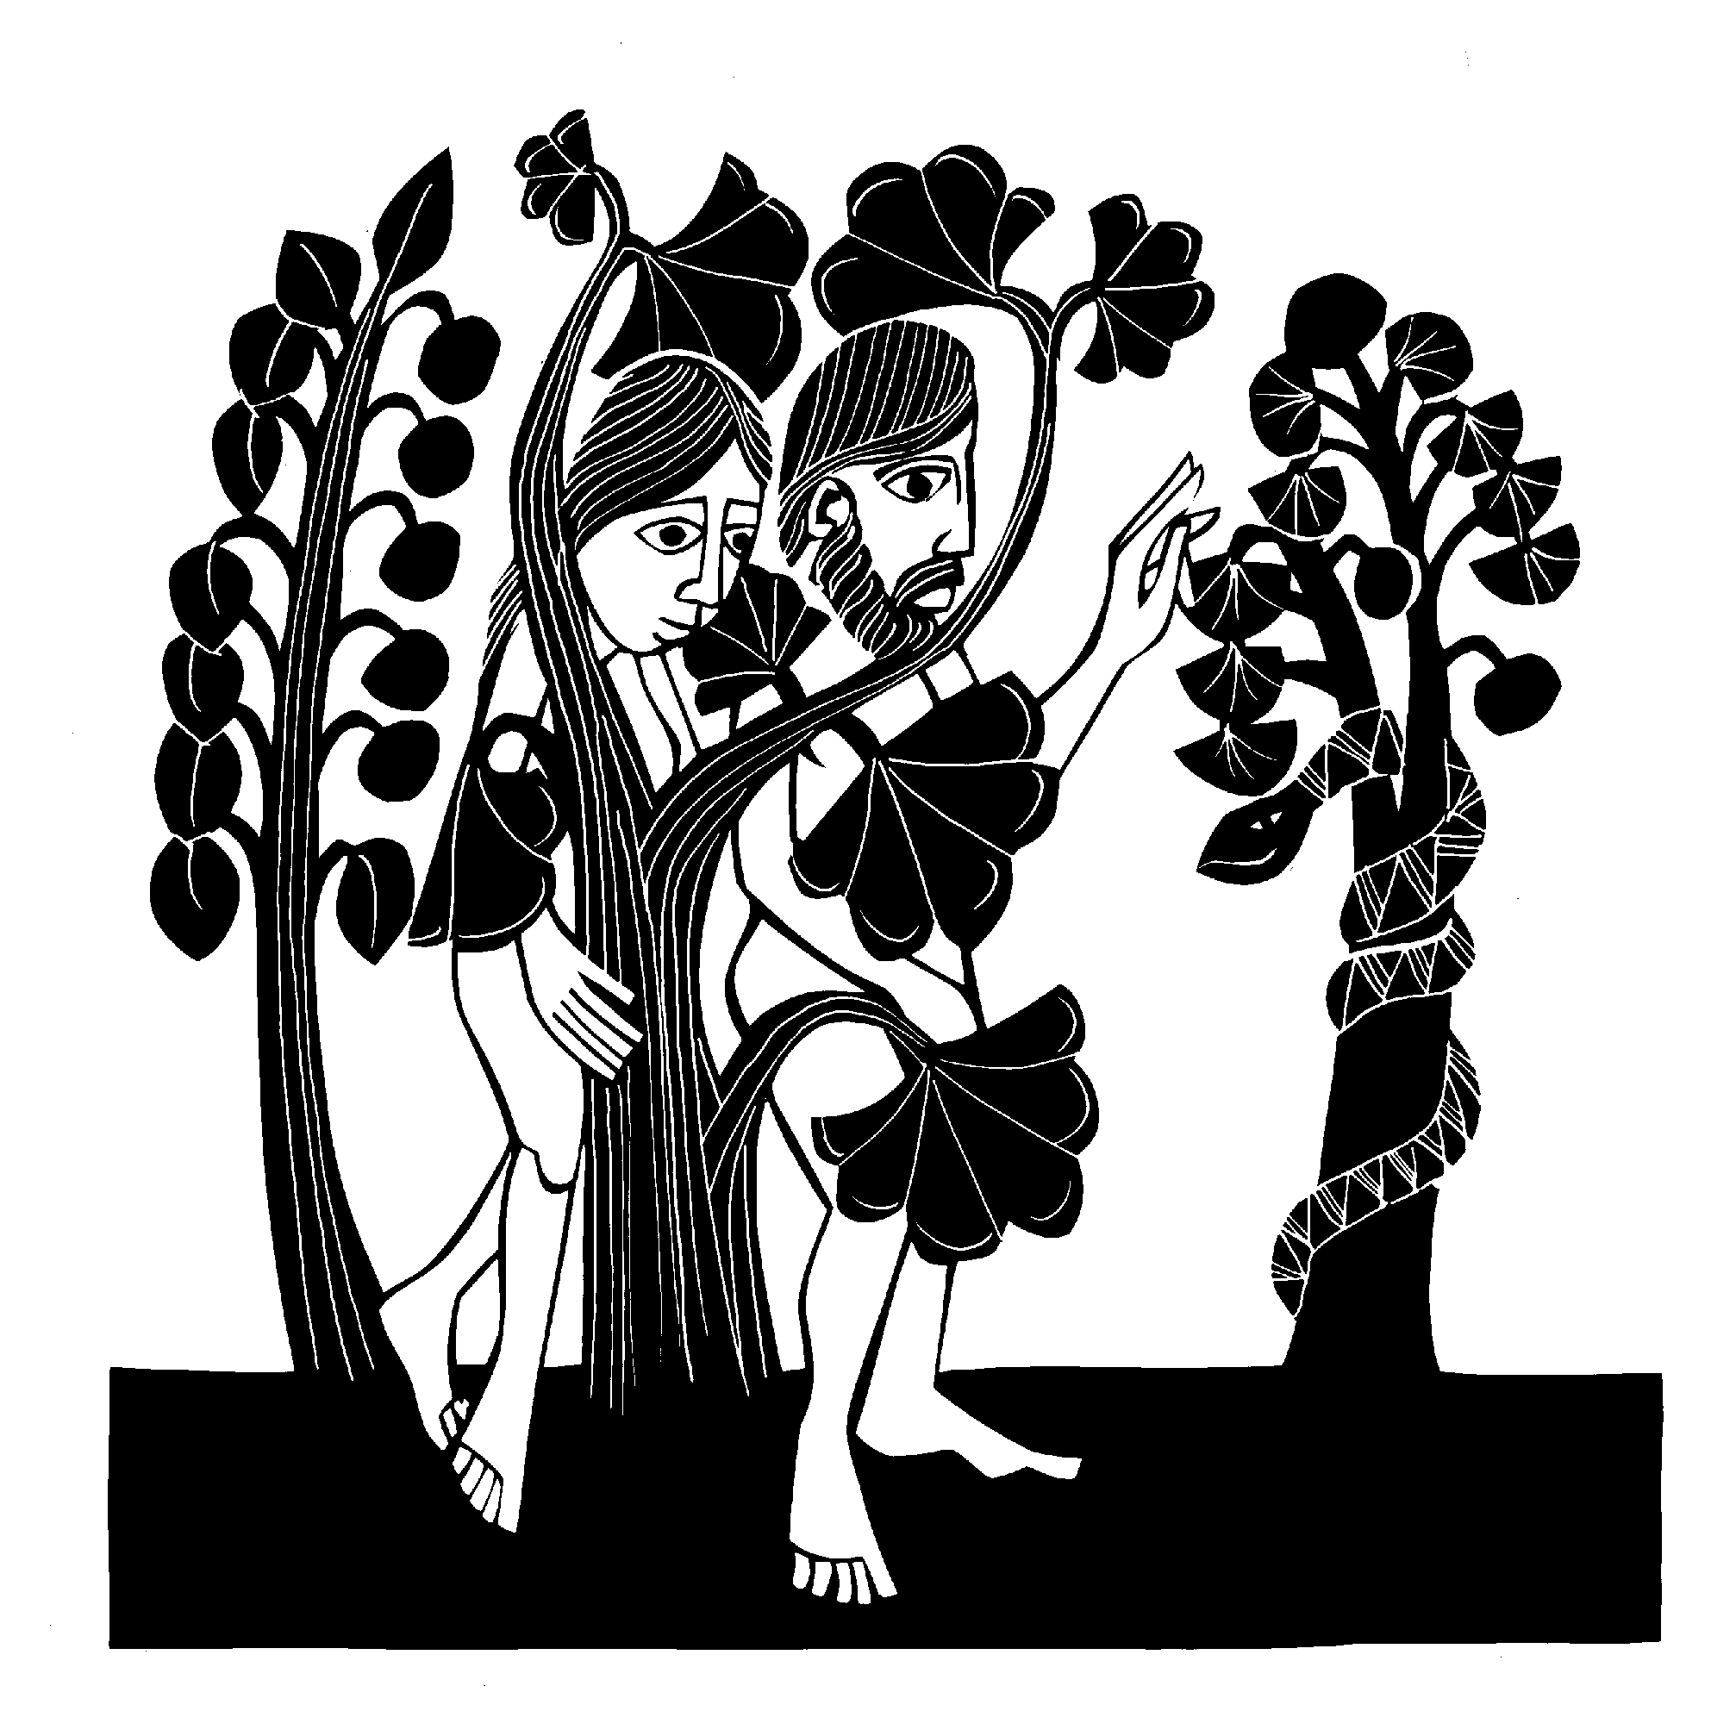and between your offspring and hers; he will crush your head,
and you will strike his heel.”

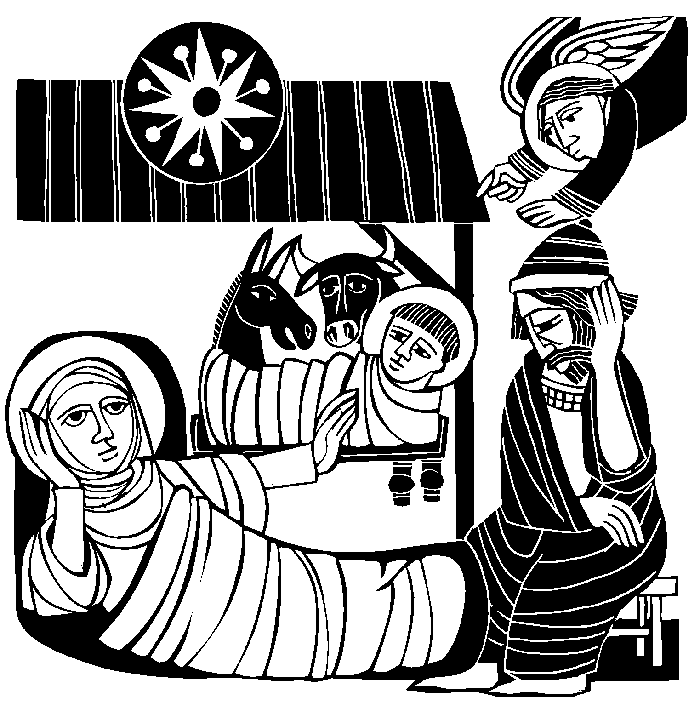LET THE EARTH NOW PRAISE THE LORD
Let the earth now praise the Lord, Who has truly kept his word,
And at last to us did send
Christ, the sinner’s help and friend.
Welcome, O my Savior, now! Joyful, Lord, to you I bow.
Come into my heart, I pray; Oh, prepare yourself a way.
Crush for me the serpent’s head That, set free from doubt and dread, I may cling to you in faith,
Safely kept through life and death.
And, when you shall come again As a glorious king to reign,
I with joy may see your face, Freely ransomed by your grace.

Heinrich Held was born in Guhrau, Silesia (now Góra, Poland) in 1620. He studied law at several notable universities in the region, and eventually became a lawyer in his hometown. He was one of the best Silesian hymn writers, living and writing in the difficult time of the Thirty Years’ War, during which Lutherans were sorely oppressed. Held published Let the Earth Now Praise the Lord in 1657.
The tune, NUN KOMM, DER HEIDEN HEILAND, is an adaptation of a plainsong melody from the 12th century. It was a favorite of J.S. Bach, seeing use in several compositions in his Clavierübung and Orgelbüchlein, as well as Cantatas 36 and 62.

THE SECOND LESSON Genesis 22:15-18
Second lector, how they serve your church

The angel of the LORD called to Abraham from heaven a second time and said, "I swear by
myself, declares the LORD, that because you have done this and have not withheld your son, your only son, I will surely bless
you and make your descendants as numerous as the stars in the
sky and as the sand on the seashore.Your descendants will take possession of the cities of their enemies, and through your offspring all nations on earth will be blessed, because you have obeyed me."

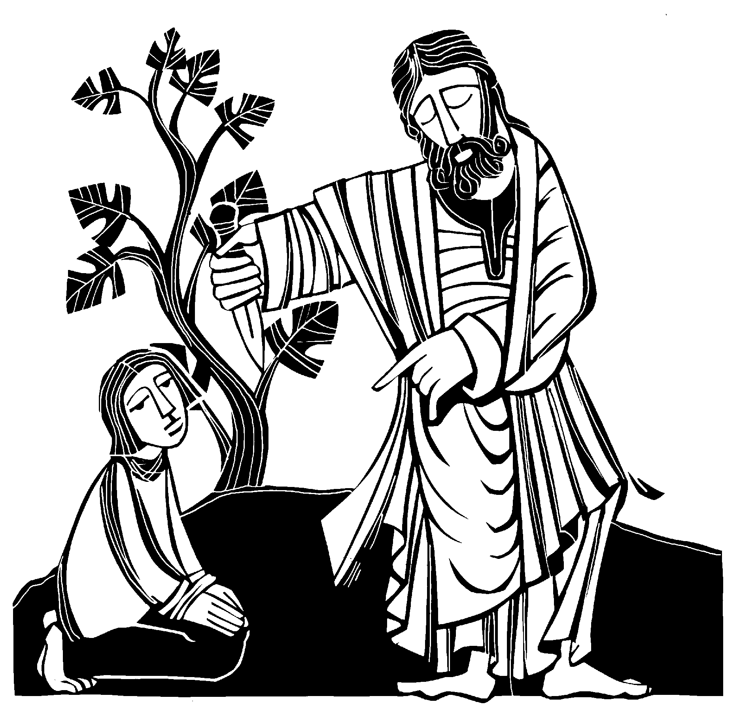

OF THE FATHER’S LOVE BEGOTTEN
Verse 1 (cantor): Of the Father’s love begotten
Ere the worlds began to be, He is Alpha and Omega,
He the source, the ending he,
Of the things that are, that have been, And that future years shall see Evermore and evermore.

Verse 2 (choir): Oh, that birth forever blessed
When the virgin, full of grace, By the Holy Ghost conceiving, Bore the Savior of our race;
And the babe, the world’s Redeemer, First revealed his sacred face Evermore and evermore.

Verse 3 (ALL): Let the heights of heav’n adore him,
Angel hosts his praises sing, Pow’rs, dominions* bow before him And extol our God and King.
Let no tongue on earth be silent, Ev’ry voice in concert ring Evermore and evermore.

* Names for ranks of angels. See Ephesians 1:21

Of the Father’s Love Begotten is the Christian Church’s oldest Christmas hymn. It was written by Aurelius Clemens Prudentius in the early 400’s as part of his “Liber Cathemerinon,” which contained twelve long poems, one for each hour of the day, recalling Christological truths. The tune DIVINUM MYSTERIUM is a plainsong melody from a Sanctus trope that dates from 10th century Italy.

THE THIRD LESSON Isaiah 9:2,6-7
Third lector, how they serve your church

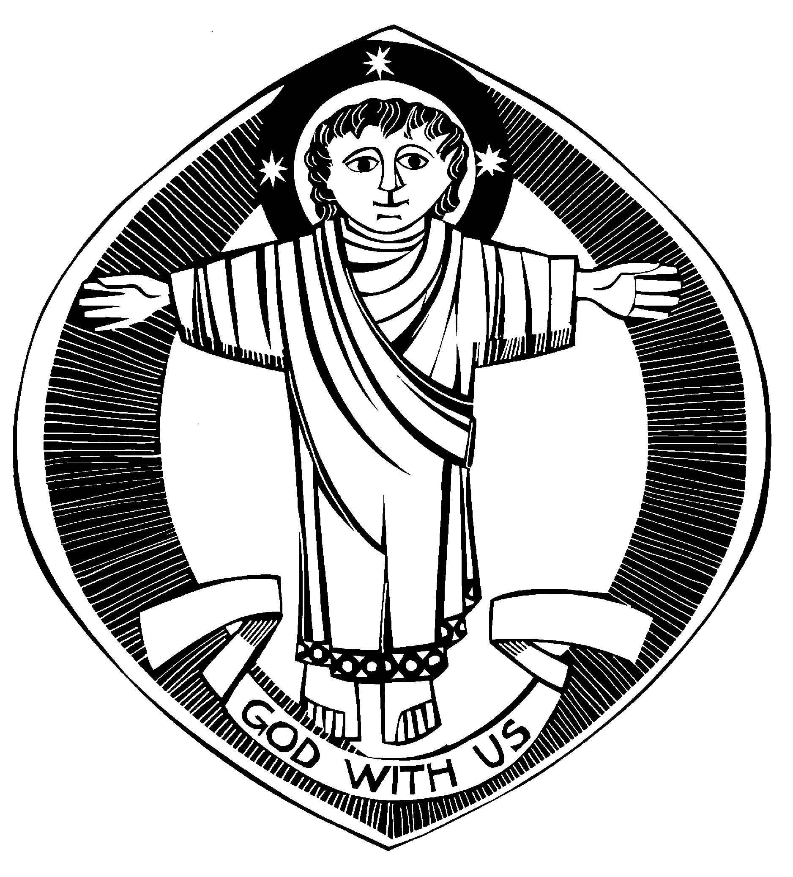The people walking in darkness have seen a great light;
on those living in the land of the shadow of death a light has dawned.
For to us a child is born, to us a son is given,
and the government will be on his shoulders.
And he will be called Wonderful Counselor,
Mighty God, Everlasting Father,
Prince of Peace.
Of the increase of his government and peace there will be no end.
He will reign on David’s throne and over his kingdom,
establishing and upholding it with justice and righteousness
from that time on and forever.
The zeal of the LORD Almighty will accomplish this.

HARK! THE HERALD ANGELS SING

Hark! The herald angels sing,“Glory to the newborn King; Peace on earth and mercy mild, God and sinners reconciled!” Joyful, all you nations rise; Join the triumph of the skies; With th’angelic host proclaim, “Christ is born in Bethlehem!” Hark! The herald angels sing,“Glory to the newborn King!”

Christ, by highest heav’n adored, Christ the everlasting Lord, Late in time, behold him come, offspring of a virgin’s womb. Veiled in flesh the Godhead see, Hail th’incarnate Deity!
Pleased as man with us to dwell, Jesus, our Immanuel. Hark! The herald angels sing,“Glory to the newborn King!”

Hail the heav’nly Prince of Peace! Hail the Sun of Righteousness! Light and life to all he brings, Ris’n with healing in his wings.
Mild he lays his glory by, Born that we no more may die, Born to raise us from the earth, born to give us second birth. Hark! The herald angels sing,“Glory to the newborn King!”

Charles Wesley was the younger brother of Anglican clergyman, John Wesley. Whereas John stuck largely to theology (and is generally credited as being the founder of the Methodist movement), Charles stuck primarily to hymn writing. He penned Hark! The Herald Angels Sing, which was first printed in Hymns and Sacred Poems in 1739. It quickly became extremely popular. The tune associated with Hark! The Herald Angels Sing is titled MENDELSSOHN. It comes from the second chorus of Felix Mendelssohn’s Festgasang an die Kunstler, written in 1840 to celebrate the 400th anniversary of Johannes Gutenberg’s invention of movable type.
Mendelssohn did not think the tune appropriate for a sacred text. He wrote that it was too “soldier-like” to convey Scriptural truth. Nevertheless, in 1855 Dr. William H. Cummings adapted the tune MENDELSSOHN to fit Wesley’s text. The result is arguably the most popular Christmas hymn of all time.

THE FOURTH LESSON Micah 5:2-4
Fourth lector, how they serve your church

But you, Bethlehem Ephrathah,
though you are small among the clans of Judah, out of you will come for me
one who will be ruler over Israel, whose origins are from of old, from ancient times.
Therefore Israel will be abandoned
until the time when she who is in labor gives birth, and the rest of his brothers return
to join the Israelites.
He will stand and shepherd his flock in the strength of the LORD,
in the majesty of the name of the LORD his God. And they will live securely, for then his greatness will reach to the ends of the earth.

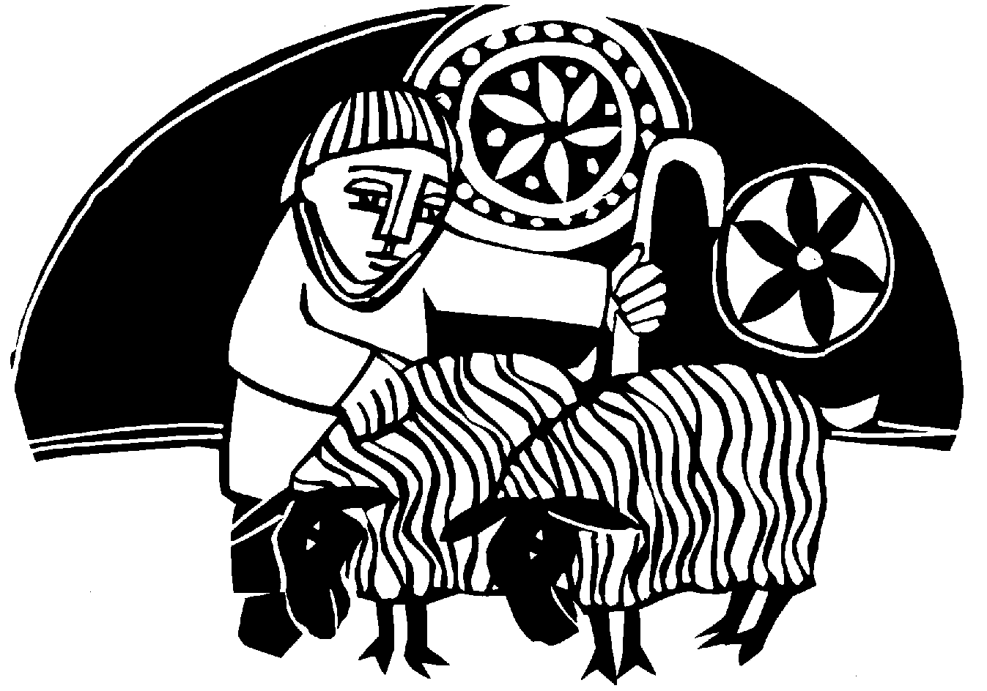

O LITTLE TOWN OF BETHLEHEM
ALL: O little town of Bethlehem, How still we see thee lie!
Above thy deep And dreamless sleep The silent stars go by. Yet in thy dark streets shineth The everlasting light.
The hopes and fears of all the years Are met in thee tonight.

Men: For Christ is born of Mary,And, gathered all above,
While mortals sleep,The angels keep Their watch of wond’ring love. O morning stars, together Proclaim the holy birth,
And praises sing To God the King And peace to all the earth!

Women: How silently, how silently The wondrous gift is giv’n!
So God imparts To human hearts The blessings of his heav’n. No ear may hear his coming, But in this world of sin
Where meek souls will Receive Him still,The dear Christ enters in.

ALL: O holy Child of Bethlehem, Descend to us, we pray; Cast out our sin And enter in; Be born in us today.
We hear the Christmas angels The great glad tidings tell; O come to us,Abide with us, Our Lord Immanuel!

O Little Town of Bethlehem was written by clergyman Phillips Brooks in December 1868, inspired by a recent trip he took to the Holy Land. In his journal of that trip he wrote, “After an early dinner, we took our horses and rode into Bethlehem. It is situated on an eastern ridge of hills, a good-looking town. Before dark, we rode out to the field where they say the shepherds saw the angels.” The hymn was first printed in leaflet form and sung by Pastor Brooks’s Sunday school — six teachers and 36 children — at Holy Trinity Church in Philadelphia. A copy of the original handwritten hymn text remains in Holy Trinity’s archives to this day.

THE FIFTH LESSON Luke 1:26-35,38
Fifth lector, how they serve your church

In the sixth month, God sent the angel Gabriel to Nazareth, a town in Galilee, to a virgin pledged to be married to a man named Joseph, a descendant of David.The virgin’s name was Mary. The angel went to her and said, “Greetings, you who are highly favored! The Lord is with you.”
Mary was greatly troubled at his words and wondered what kind of greeting this might be. But the angel said to her, “Do not be afraid, Mary, you have found favor with God. You will be with child and give birth to a son, and you are to give him the name Jesus. He will be great and will be called the Son of the Most High.The Lord God will give him the throne of his father David, and he will reign over the house of Jacob forever; his kingdom will never end.”
“How will this be,” Mary asked the angel, “since I am a virgin?”
The angel answered, “The Holy Spirit will come upon you, and the power of the Most High will overshadow you. So the holy
one to be born will be called the Son of God.
“I am the Lord’s servant,” Mary answered. “May it be to me as you have said.” Then the angel left her.

GENTLE MARY LAID HER CHILD
Sung by the CHOIR
Gentle Mary laid her child Lowly in a manger;
There he lay, the undefiled, To the world a stranger.
Such a babe in such a place—

Can he be the Savior?
Ask the saved of all the race Who have found his favor.
Angels sang about his birth;
Wise men sought and found him. Heaven’s star shone brightly forth, Glory all around them.
Shepherds saw the wondrous sight, Heard the angels singing.
All the plains were lit that night; All the hills were ringing.

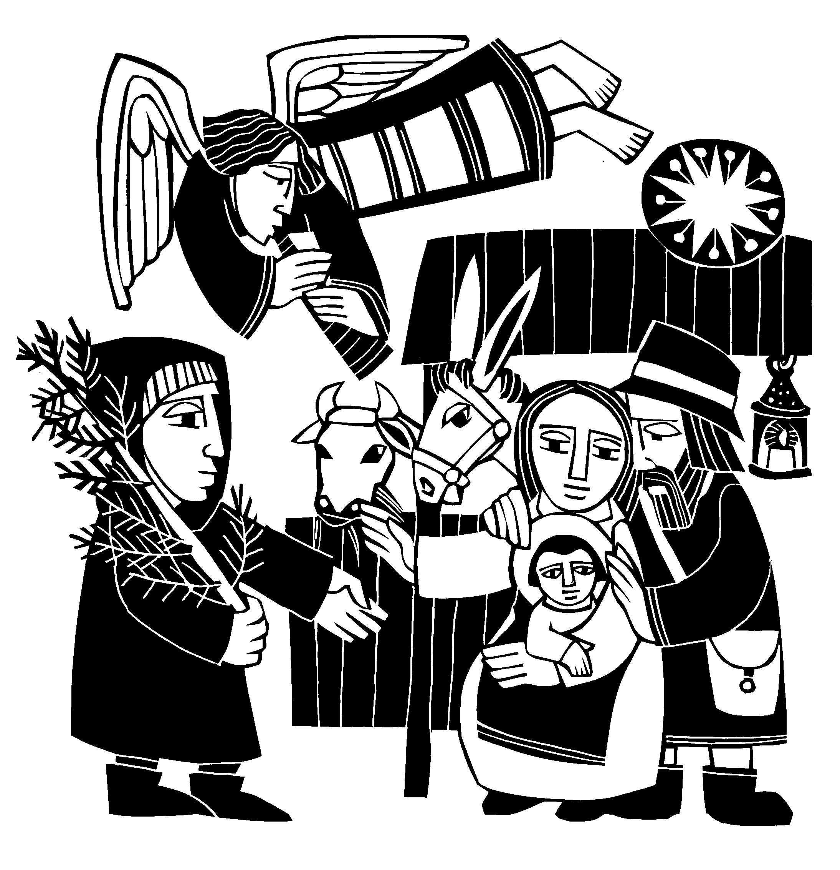Gentle Mary laid her child Lowly in a manger;
He is still the undefiled, But no more a stranger.
Son of God, of humble birth, Beautiful the story;
Praise his name in all the earth, Hail the King of glory!

In 1919, this hymn by Joseph Simpson Cook was awarded first prize in a Christmas carol competition sponsored by a Christian periodical in Toronto. It was first published in The Hymnary of the United Church of Canada. The tune, TEMPUS ADEST FLORIDUM, was first published in Piae Cantiones, a valuable collection of medieval sacred and secular songs.

THE SIXTH LESSON Matthew 1:18-25
Sixth lector, how they serve your church

This is how the birth of Jesus Christ came about: His mother Mary was pledged to be married to Joseph, but before they came together, she was found to be with child through the Holy Spirit. Because Joseph her husband was a righteous man and did not want to expose her to public disgrace, he had in mind to divorce her quietly.
But after he had considered this, an angel of the Lord appeared to him in a dream and said, “Joseph son of David, do not be afraid to take Mary home as your wife, because what is conceived in her is from the Holy Spirit. She will give birth to a son, and you are to give him the name Jesus, because he will save his people from their sins.”
All this took place to fulfill what the Lord had said through the prophet: “The virgin will be with child and will give birth to a son, and they will call him Immanuel” — which means, “God with us.”
When Joseph woke up, he did what the angel of the Lord had commanded him and took Mary home as his
wife. But he had no union with her until she gave birth to a son. And he gave him the name Jesus.

AWAY IN A MANGER
Away in a manger, no crib for a bed,
The little Lord Jesus laid down his sweet head.
The stars in the bright sky looked down where he lay, The little Lord Jesus asleep on the hay.
The cattle are lowing, the baby awakes, But little Lord Jesus, no crying he makes.
I love you, Lord Jesus; look down from the sky. And stay by my side until morning is nigh.
Be near me, Lord Jesus; I ask you to stay Close by me forever and love me, I pray.
Bless all the dear children in your tender care, And take us to heaven to live with you there.

In 1887, Jarmes R. Murray in Dainty Songs for Little Lads and Lasses called Away in a Manger “Martin Luther’s Cradle Hymn” and claimed Luther wrote this hymn for his children in the sixteenth century. However, other musical historians have claimed that is a myth, and date the hymn closer to the late 1800’s, and possibly American in origin. The hymn has been set to many different tunes.

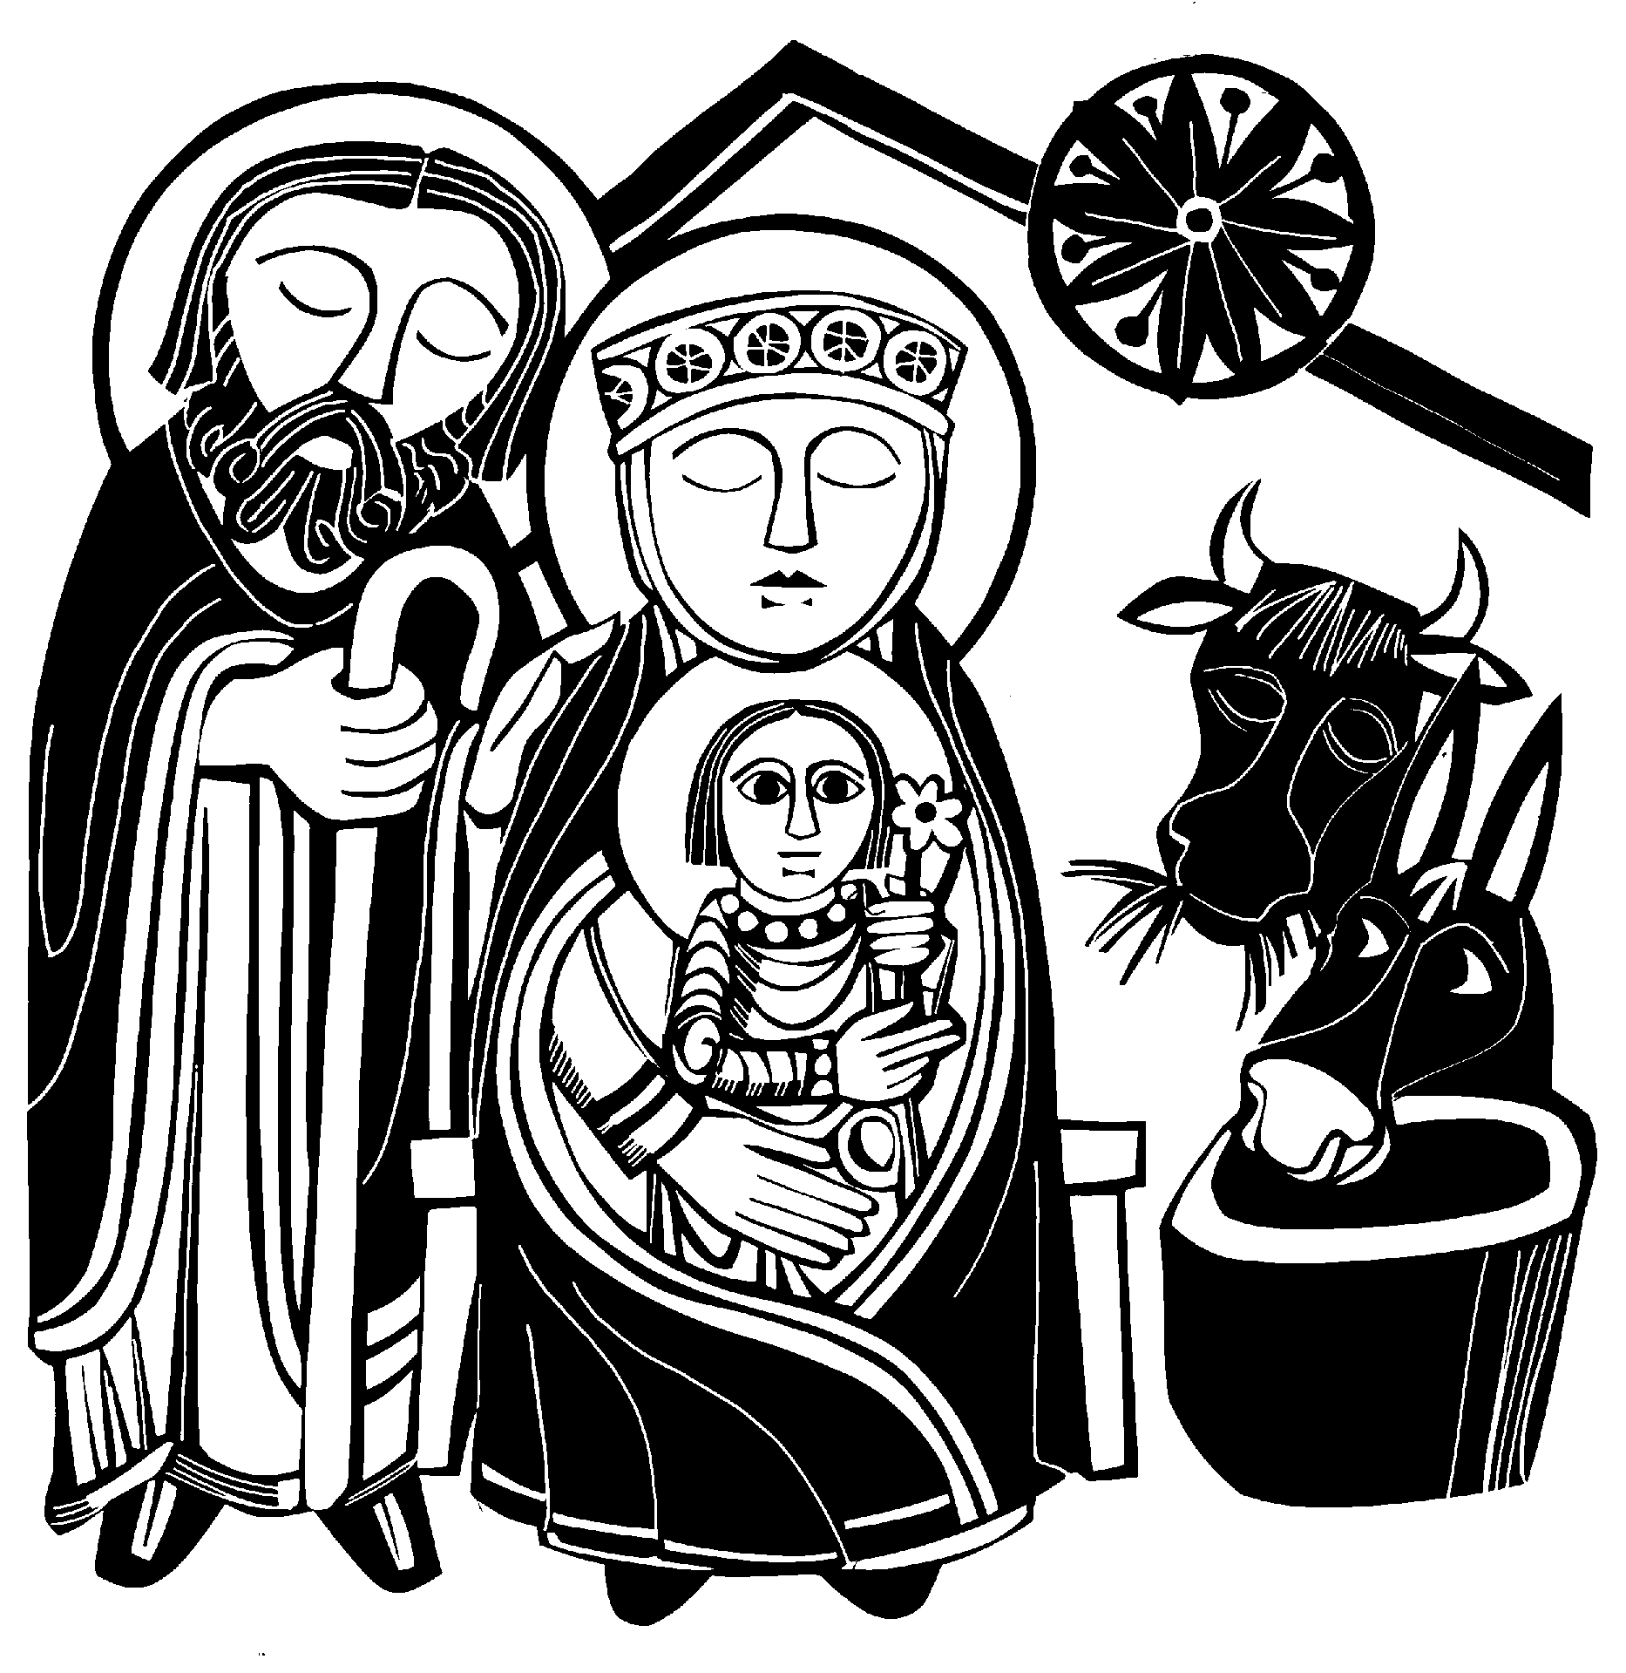

THE SEVENTH LESSON Luke 2:8-20
Your pastor, pastor

And there were shepherds living out in the fields nearby, keeping watch over their flocks at night. An angel of the Lord appeared to them, and the glory of the Lord shone around them, and they were terrified. But the angel said to them, “Do not be afraid. I bring you good news of great joy that will be for all the people. Today in the town of David a Savior has been born to you; he is Christ the
Lord. This will be a sign to you:You will find a baby wrapped in cloths and lying in a manger.”
Suddenly a great company of the heavenly host appeared with the angel, praising God and saying,
“Glory to God in the highest,
and on earth peace to men on whom his favor rests.”
When the angels had left them and gone into heaven, the shepherds said to one another, “Let’s go to Bethlehem and see this thing that has happened, which the Lord has told us about.”
So they hurried off and found Mary and Joseph, and the baby, who was lying in the manger. When they had seen him, they spread the word concerning what had been told them about this child, and all who heard it were amazed at what the shepherds said to them. But Mary treasured up all these things and pondered them in her heart. The shepherds returned, glorifying and praising God for all the things they had heard and seen, which were just as they had been told.

WHAT CHILD IS THIS

What child is this who, laid to rest, On Mary’s lap is sleeping?
Whom angels greetWith anthems sweet, While shepherds watch are keeping?
This, this is Christ the King,
Whom shepherds guard and angels sing; Haste, haste, to bring him laud,
The babe, the Son of Mary!
Why lies he in such mean estate Where oxen now are feeding?
Good Christians, fear; For sinners here The silentWord is pleading.
Nails, spear shall pierce him through; The cross he’ll bear for me, for you.
Hail, hail theWord made flesh, The babe, the Son of Mary.
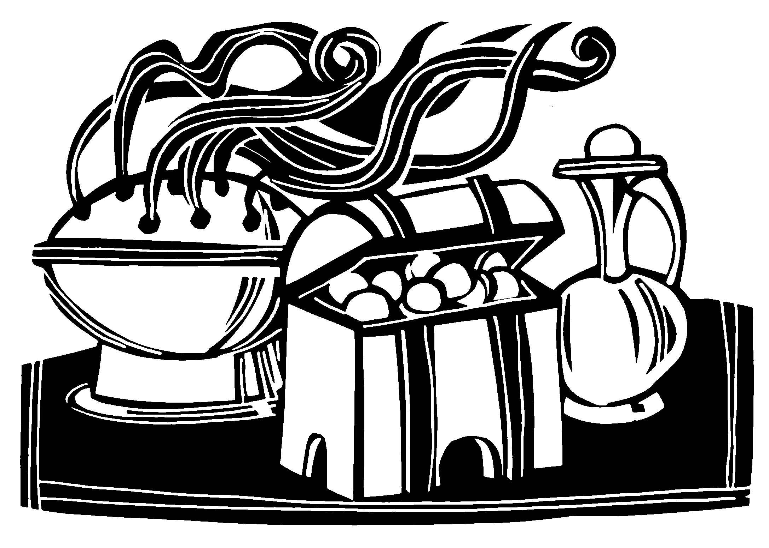So bring him incense, gold and myrrh, Come peasant, king to own him.
The King of kings salvation brings, Let loving hearts enthrone him.
Raise, raise a song on high, The virgin sings her lullaby. Joy, joy for Christ is born, The babe, the Son of Mary.

William Chatterton Dix was the son of a surgeon and a writer. At the age of twenty-nine he was struck with a near fatal disease and spent many months in bed, during which time William turned to writing himself. He penned a number of Christmas hymns, including What Child Is This and As With Gladness Men of Old. He wrote What Child Is This to fit the popular and enduring tune GREENSLEEVES. This tune originates from the early 16th century during the reign of King Henry VIII. It is mentioned in William Shakespeare’s The Merry Wives of Windsor.

THANK OFFERING
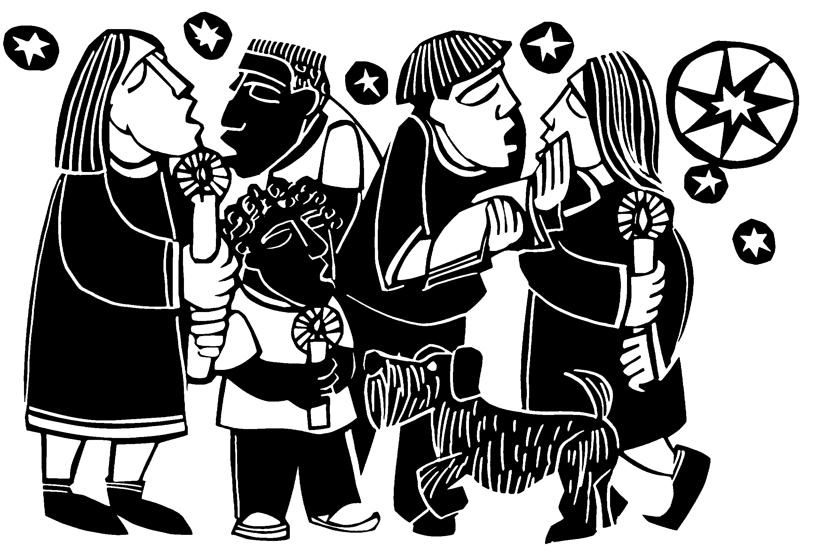During the offering, acolytes will come to your pew and light the candle nearest the center aisle. Please then light the candle next to you until all the candles are lit in the pew. When all the candles are lit, the lights will be dimmed. Remember to tip the unlit candle and leave the lit candle vertical.

CLOSING PRAYER
M: O God,
who makes us glad with the yearly remembrance of the birth of your only Son, Jesus Christ;
grant that, as we joyfully receive him as our Redeemer, so may we also behold him with sure confidence
when he shall come to be our judge;
who lives and reigns with you and the Holy Spirit, one God, now and forever.

C: Amen.

BLESSING
M: May he who by his incarnation
gathered things earthly and heavenly into one,
fill us with such joy that comes with the knowledge of the forgiveness of sins and the hope of eternal life.
And the blessing of God Almighty
— the Father, the  Son, and the Holy Spirit — be upon you and remain with you always.

C: Amen.

NIGHT OF SILENCE / SILENT NIGHT MEDLEY

The ADULT CHOIR sings the first two verses of Night of Silence.
Cold are the people, winter of life. We tremble in shadows this cold endless night. Frozen in the snow lie roses sleeping — Flowers that will echo the sunrise.
Fire of hope is our only warmth. Weary, its flame will be dying soon.

Voice in the distance, call in the night, on wind you enfold us; you speak of the light. Gentle on the ear you whisper softly, rumors of a dawn so embracing.
Breathless love awaits darkened souls. Soon we will know of the morning!

Interlude / Lighting of the candles

The CHILDREN’S CHOIR sings and signs the first verse of Silent Night.
Silent night! Holy night! All is calm, all is bright,
Round yon virgin mother and child. Holy Infant, so tender and mild, Sleep in heavenly peace, Sleep in heavenly peace.

The CONGREGATION sings verse two of Silent Night.

Silent night! Holy night! Shepherds quake at the sight. Glories stream from heaven afar; Heav'nly hosts sing, Alleluia; Christ, the Savior, is born! Christ, the Savior, is born!

The CONGREGATION sings verse three of Silent Night,
while the CHOIR sings verse three of Night of Silence.

Silent night! Holy night! Son of God,
love's pure light
Radiant beams from thy holy face With the dawn of redeeming grace, Jesus, Lord, at thy birth,
Jesus, Lord, at thy birth.
Spirit among us, Sing like the star!
Your light that guides shepherds and kings from afar.
Shimmer in the sky so empty, lonely.
Rising in the warmth
of your Sons’ love.
Star unknowing of night and day,

Silent Night is the undoubtedly the most beloved of all the “cradle carols,” those quieter Christmas hymns which remind one of a song a new mother might sing to her infant. It was written in 1818 by Joseph Mohr, assistant priest in St. Nikolaus Church in Oberndorf, a small village in Upper Austria. It is believed that Mohr began writing the hymn late the evening of December 23rd. He had been summoned to the home of a humble woodcutter to bless a baby that had recently been born. On his way home, he contrasted that scene with the birth of Christ in a humble stable. The thought inspired him to write the poem Stille Nacht, which he finished about 4AM. After a few hours of sleep, Mohr rose and took the poem to the office of Franz Gruber, who was both Mohr’s best friend and the organist at St. Nikolaus, and asked him to set the poem to music for use in that evening’s Christmas Eve service. Within a few hours, Gruber had sketched in a melody and simple harmony. Since the organ at St. Nikolaus was broken, Gruber’s arrangement was for guitar.
The tune quickly spread over Germany and Austria. A touring family of singers, the Raniers, sang it for the Emperor of Austria, the Czar of Russia, Queen Victoria of England, Napoleon III, and in 1839 presented it in New York City before the Alexander Hamilton memorial.
All this came from a simple poem and guitar tune that were written in about twelve hours on Christmas Eve day.

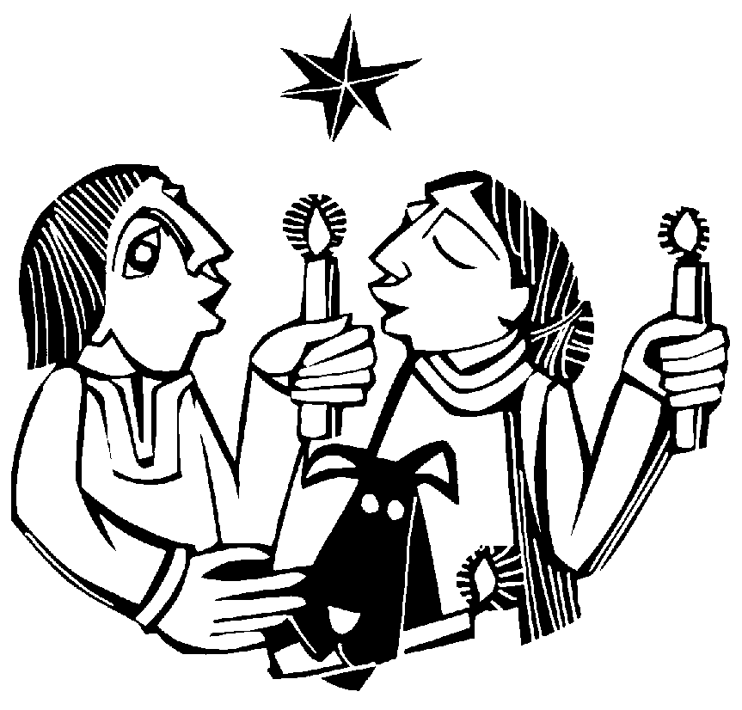

SERVING THIS EVENING
Here is where you can list those who served as lectors, instrumentalists, etc.

Artwork is from Clip Art for Church Year A by Steve Erspamer copyright Liturgical Training Publications All Rights Reserved

THE TWELVE DAYS OF CHRISTMAS
We thank you for joining us this evening, and hope you can join us again sometime this Christmas season.
You are probably familiar with the song The Twelve Days of Christmas. It is aptly named.The early Christian church would celebrate Christmas for twelve days.The Season of Christmas begins on December 25th with the great Festival of the Nativity. On January 6th, the Festival of Epiphany brings the season of Christmas to an end.
Wednesday, December 25 at 10:30AM

The Festival of the Nativity
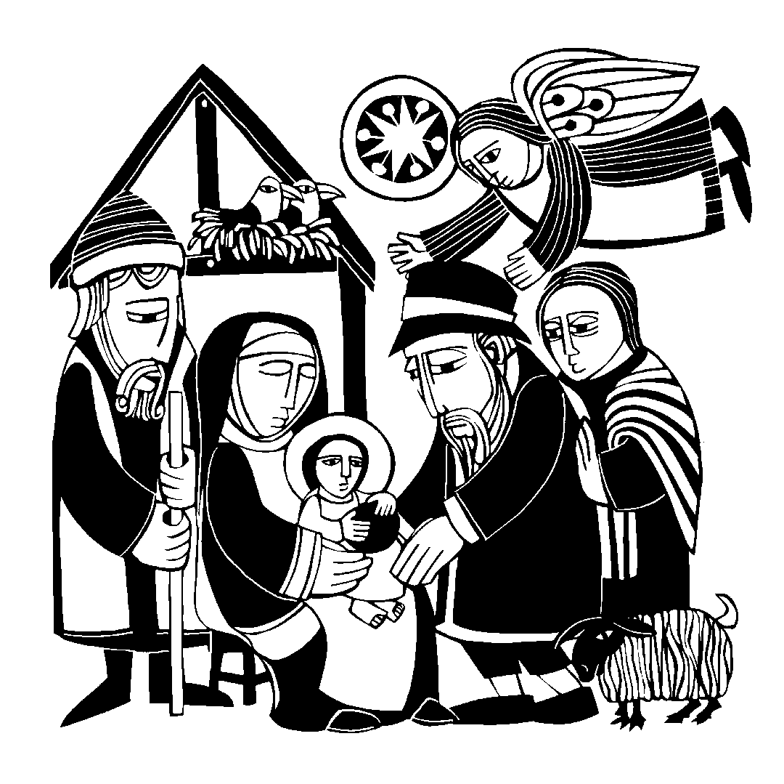In a celebratory service we ponder some of the most profound words in Scripture, found in the Gospel of St. John, chapter 1. Worship includes the
celebration of Holy Communion. Personal preparation for Holy Communion may be found on page 156 of the hymnal.

Sunday, December 29 at 10:30AM

God Cares Dearly for His Children
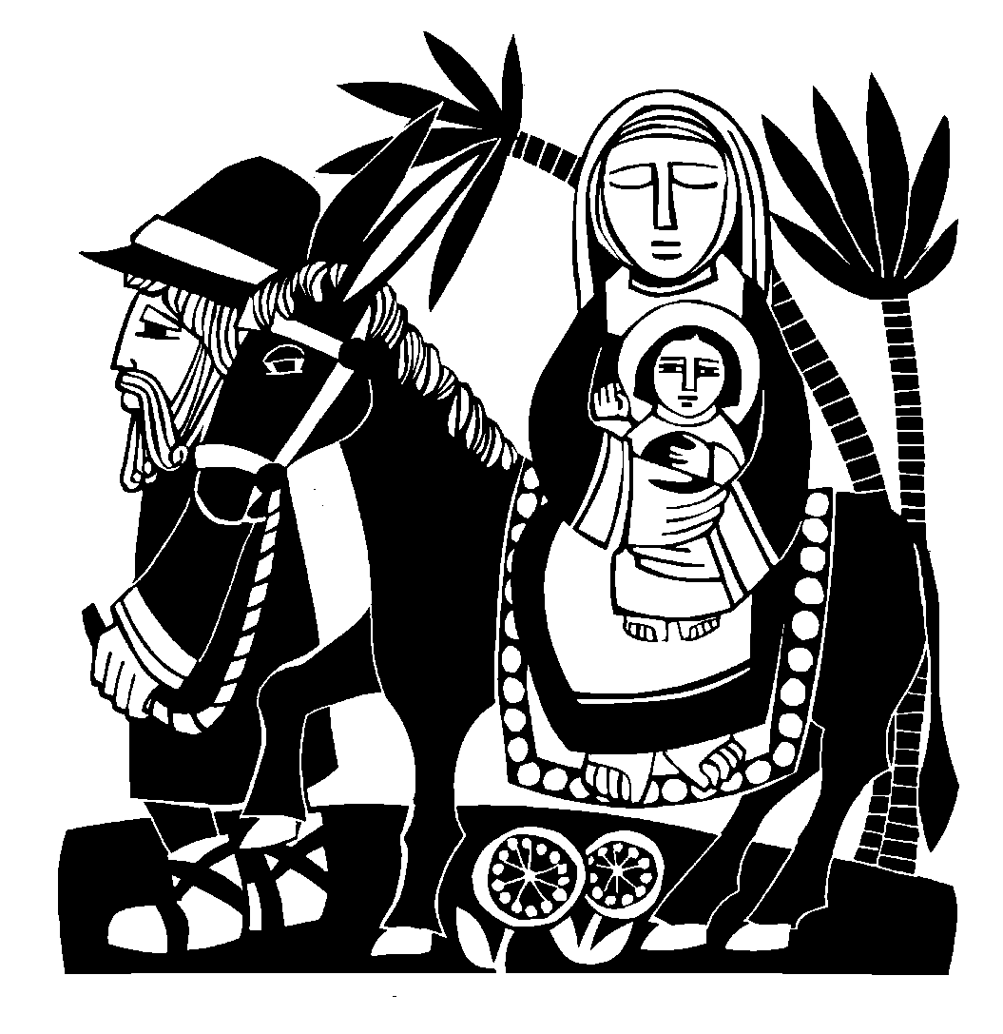Christmas means that we have “the full rights of sons.” The “full rights” of a first born son is a concept unfamiliar to us. But in Jesus’ day, that was a huge deal! We close out the year by talking about the blessings and rights we enjoy as God’s adopted children.

Sunday, January 5 at 10:30AM

Wise Men Seek Him
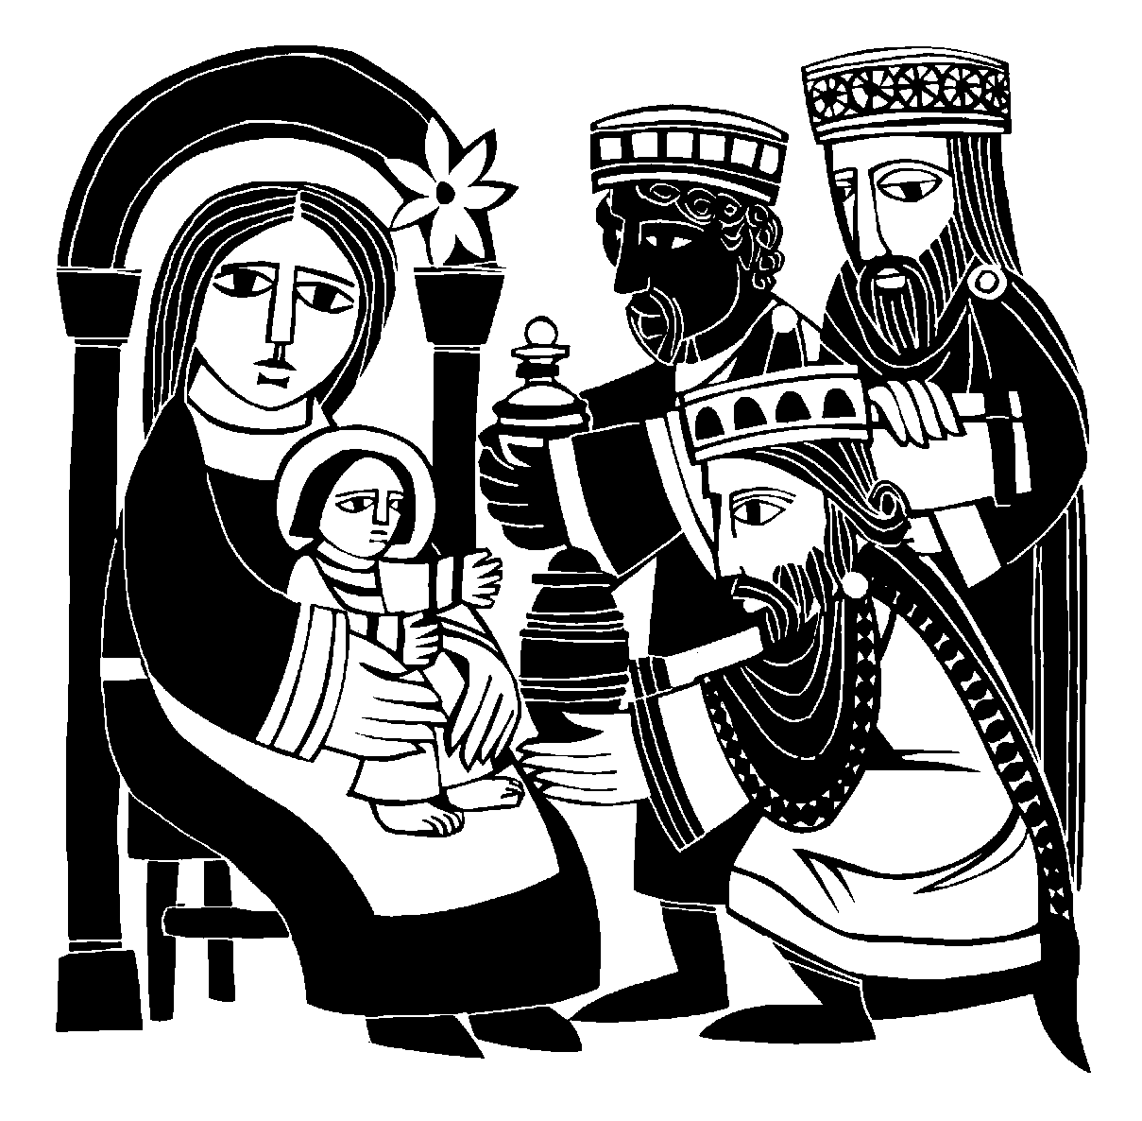Christmas ends on this day, known as Epiphany, “the Gentile Christmas.” On this day we commemorate the way God guided Gentiles to their salvation with a special star. Worship includes the celebration of Holy Communion.

- 24 -

www.ourbeautifulsavior.com

