Christmas Day December 25, 2013

24

All music is either public domain or reprinted by permission.

When Christmas Morn Is Dawning
Text: Abel Burckhardt © 1978 Lutheran Book of Worship
Tune: German folk tune, c. 1800

Christmas Gloria
Setting by Daniel W. Laginya © 2011 GIA Publications

Psalm 98: All the Ends of the Earth
Setting by Lynn Trapp © 2002 GIA Publications

Christmastime Alleluia
Setting by James J. Chepponis based on ADESTE FIDELES
© 1997 GIA Publications

Joy to the World
Text: Isaac Watts Tune: George F. Handel

Holy, Holy, Holy
© 2008 Northwestern Publishing House

O Christ, Lamb of God
© 2008 Northwestern Publishing House

See in Yonder Manger Low Text: Edward Caswall Tune: John Goss

Come, Your Hearts and Voices Raising
Text: Paul Gerhardt
Tune: Ein Schlesich singebuchlein

Oh, Rejoice, All Christians, Loudly
Text: Christian Keimann Tune: Andreas Hammerschmidt

www.ourbeautifulsavior.com
THE FESTIVAL OF THE NATIVITY

EVANGELICAL LUTHERAN CHURCH

HYMN Oh, Rejoice, All Christians, Loudly

elcome! Thank you for joining us for worship this morning. In our service we gather before our almighty God to offer him our worship and praise.
W
We also gather to strengthen ourselves through the study of God’s holy and powerful word.

 Restrooms are located in the hallway directly opposite the entrance to the sanctuary.

 Cry-room. If you have a young child or nursing infant and are in need of a cry-room, you will find it to the right as soon as you exit the sanctuary. A speaker there allows you to hear the service.

 Staffed nursery. We offer a staffed nursery for ages 2 to 5 and special needs children. It is located to the left of the entry foyer, near the kitchen window.

 Connection cards are found inside each worship folder. We ask that before worship or during the offering, you fill those out, front and back. You can return the card either in the offering plate or in the connection card basket you will find at the exit of the church after worship.

Summerville campus
720 Old Trolley Road Summerville, SC 29485 843.873.5522
bselc.office@gmail.com
Moncks Corner campus
Foxbank Plantation Road Moncks Corner, SC 29461 843.826.4057
Staff
Kyle Burmeister, Pastor 262.365.7123 (cell) pastorburmeister@gmail.com
Jonathan Hein, Pastor 843.860.1838 (cell) pastorhein@gmail.com
Jonathan Quinn, Pastor 843.826.4057 (home)
revjquinn@gmail.com
Nathan Loersch, Vicar 920.342.4723 (cell) vicarloersch@gmail.com

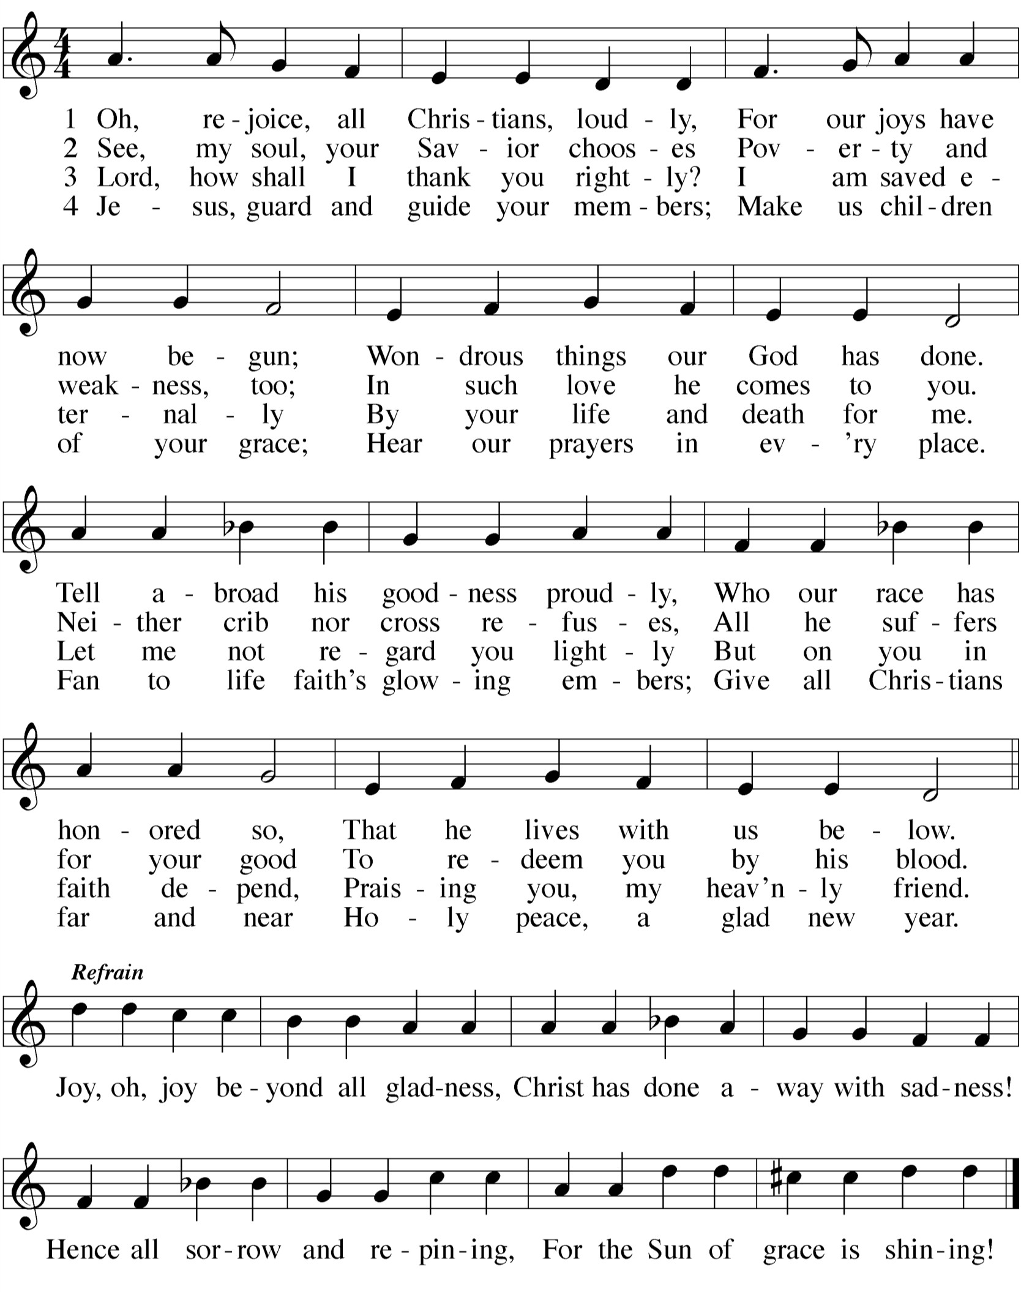www.ourbeautifulsavior.com

CLOSING PRAYER
M: O God the Father, source of all goodness,
in your loving kindness you sent your Son to share our humanity.
We thank you that through him
you have given us pardon and peace in this sacrament.
We also pray that you will not forsake us
but will rule our hearts and minds by your Holy Spirit so that we willingly serve you day after day,
through Jesus Christ, our Lord,
who lives and reigns with you and the Holy Spirit, one God, now and forever.

C: Amen.

THE BLESSING
M: Brothers and sisters, go in peace. Live in harmony with one another. Serve the Lord with gladness.
The Lord bless you and keep you.
The Lord make his face shine on you and be gracious to you. The Lord look on you with favor and  give you peace.

C: Amen.
WORSHIP NOTES
THE SEASON OF CHRISTMAS
You are probably familiar with the carol The Twelve Days of Christmas. While that carol isn’t religious, its title does capture the fact that on Christmas Day the Christian Church begins a twelve day celebration.
Historically, the celebration of Christmas didn’t begin until Christmas Eve. That was the night homes were decorated with trees and tinsel. (It is the secularization of Christmas and the desire to have a longer shopping season that has pushed the “beginning” of Christmas back into November.) Christmas Eve often consisted of a vigil, either at church or in the home, that was quiet and muted. Then, come Christmas Day, all Christians would gather in church as a joyous celebration began. Families would continue to worship (and, yes, give gifts) for twelve straight days. The celebration of Christmas would end with the Festival of the Epiphany, marking the appearance of the Wise Men.

THE FESTIVAL OF THE NATIVITY
Nativus is Latin for “birth.” By the fourth century, the early Christian Church had set December 25th as the day to celebrate the birth of Christ. Along with Easter, it quickly became one of the major celebrations in the Church Year. It always included celebration of the Lord’s Supper. This is seen in the word Christmas, which is simply short for “Christ’s Mass.”

ORDER OF SERVICE

 The Gathering 

HYMN When Christmas Morn is Dawning

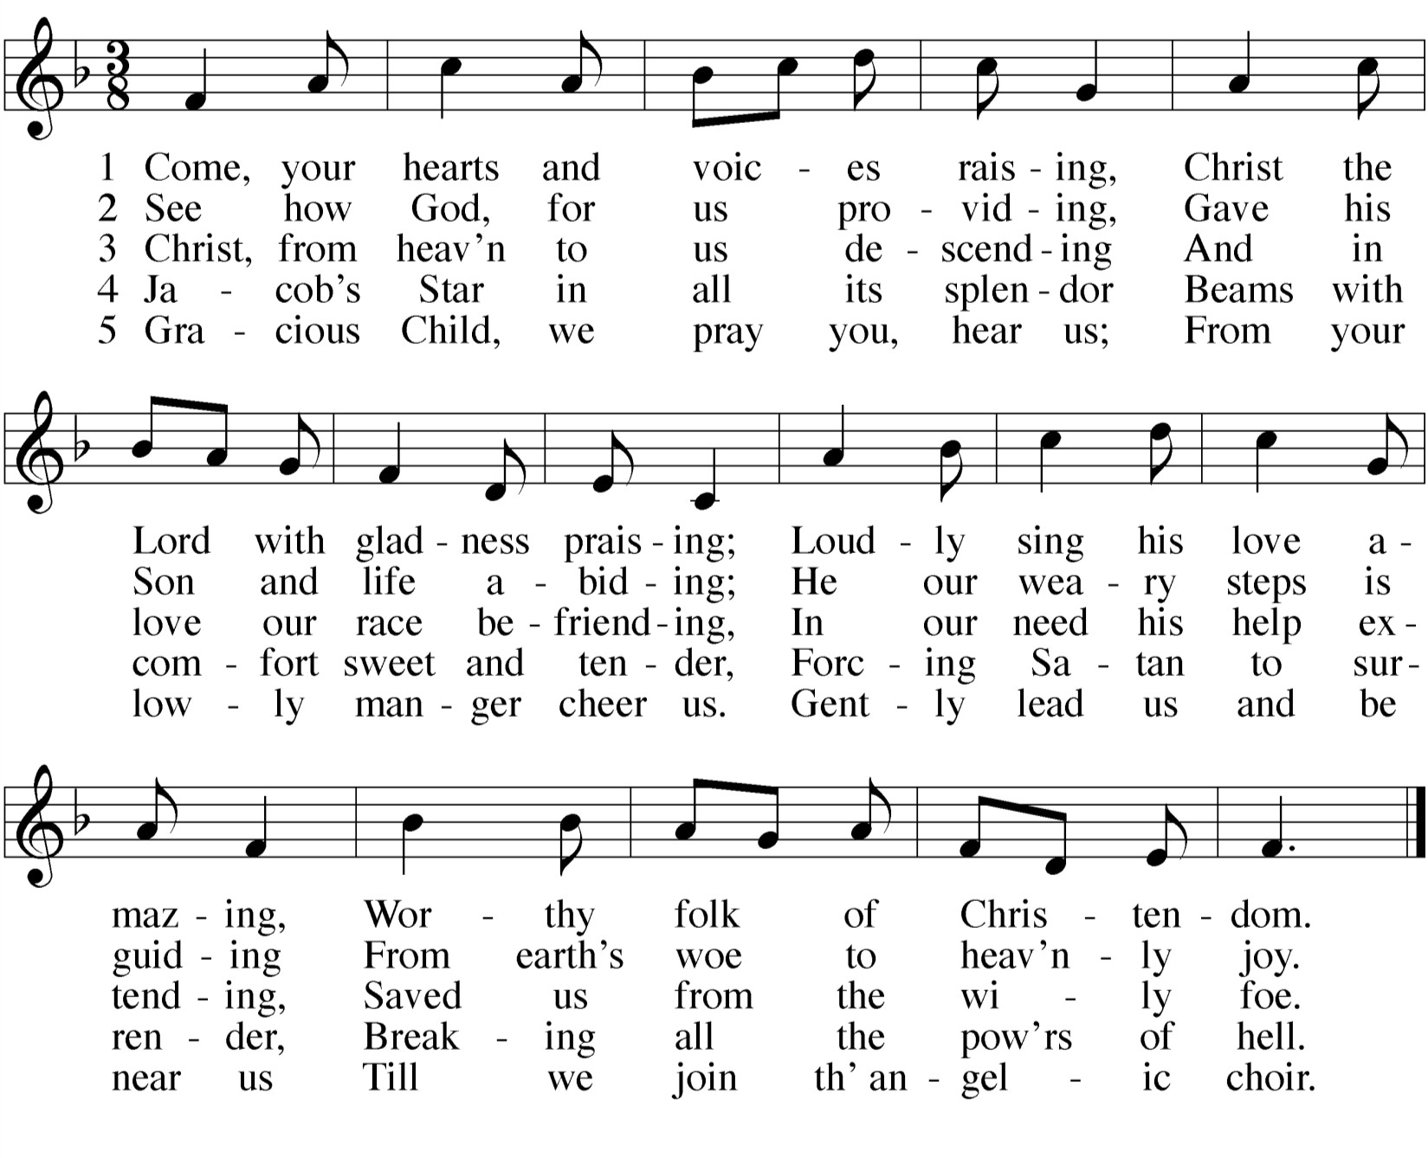HYMN Come, Your Hearts and Voices Raising

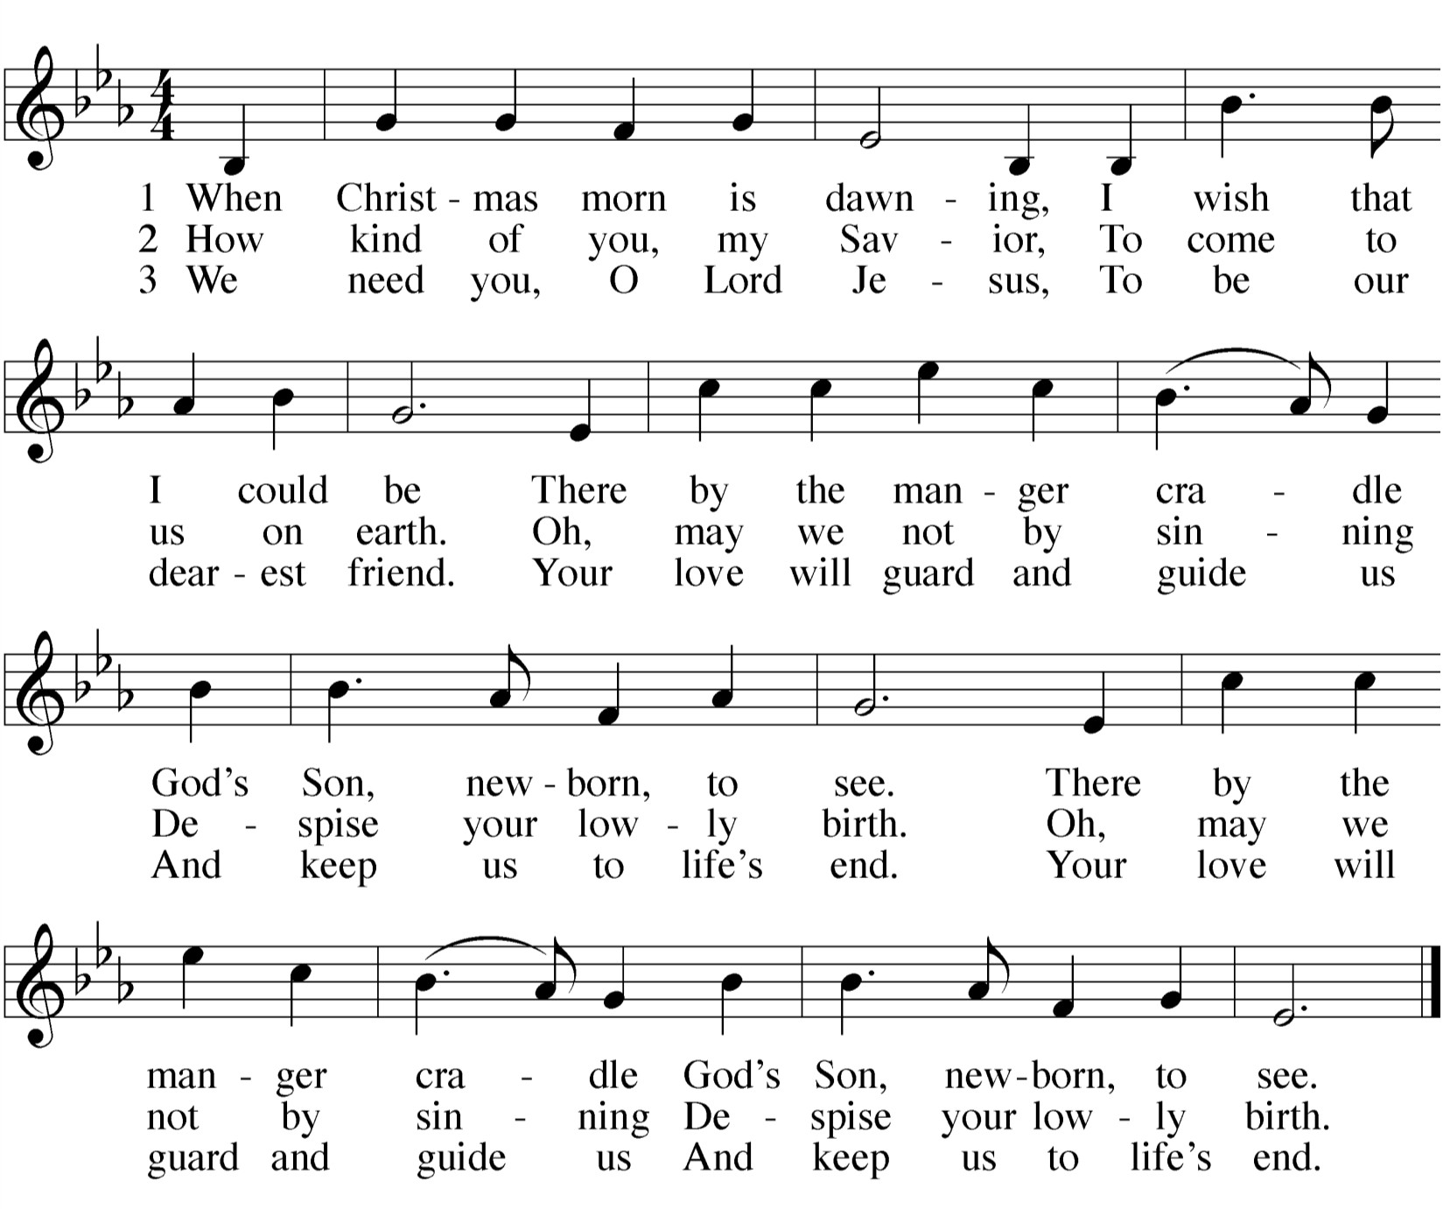

DISTRIBUTION — After the first group of communicants receives the Lord’s Supper, the congregation will join in singing the following.

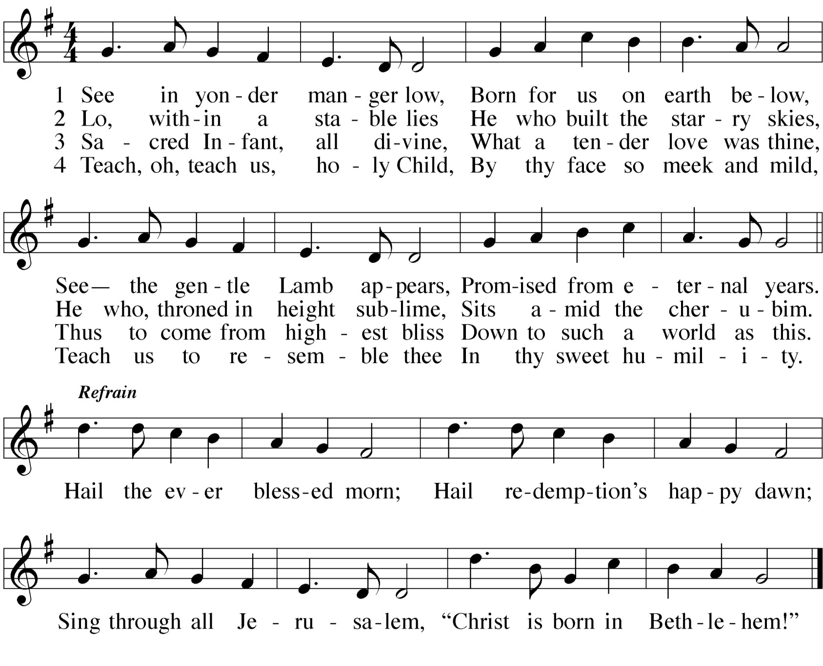HYMN See in Yonder Manger Low

INVOCATION
M: The grace of our Lord  Jesus Christ, and the love of God,
and the fellowship of the Holy Spirit be with you all.

C: And also with you.

CHRISTMAS LITANY
M: Come, let us sing for joy to the Lord;
Let us shout aloud to the Rock of our salvation. Psalm 95:1

C: O Lord, our Lord, how majestic is your name in all the earth!
You have set your glory above the heavens. Psalm 8:1
M: Give thanks to the Lord of lords,
to him who alone does great wonders,
who by his understanding made the heavens, who spread out the earth upon the waters, who made the great lights –
the sun to govern the day, the moon and stars to govern the night. Psalm 136

C: Great is our Lord and mighty in power;
his understanding has no limit. Psalm 147:5
M: But our iniquities have separated us from our God;
our sins have hidden his face from us, so that he will not hear. We look for light, but all is darkness;
for brightness, but we walk in deep shadows.
We look for deliverance, but it is far away. Isaiah 59:2,9

C: For our offenses are many in his sight, and our sins testify against us.
Our offenses are ever with us, and we acknowledge our iniquities. Isaiah 59:12

After a brief musical introduction, the congregation joins in singing “Oh Christ, Lamb of God.” While the congregation is singing this canticle, the usher will direct the first table of communicants to come forward.

M: The Lord is compassionate and gracious, slow to anger, abounding in love.
He will not always accuse,
nor will he harbor his anger forever; he does not treat us as our sins deserve
or repay us according to our iniquities. Psalm 103:8-10

C: From the rising of the sun to the place where it sets,
the name of the Lord is to be praised. Psalm 113:3
M: “The days are coming,” declares the Lord,
“when I will raise up to David a righteous Branch,
a King who will reign wisely and do what is just and right in the land. In his days Judah will be saved and Israel will live in safety.
This is the name by which he will be called: The Lord our Righteousness.” Jeremiah 23:5,6

C: Prepare the way for the Lord,
make straight paths for him. Matthew 3:3
M: Do not be afraid.
I bring you good news of great joy that will be for all the people. Today in the town of David a Savior has been born to you;
he is Christ the Lord. Luke 2:10,11

C: Let the name of the Lord be praised, both now and forevermore. Alleluia! Psalm 113:2
O CHRIST, LAMB OF GOD

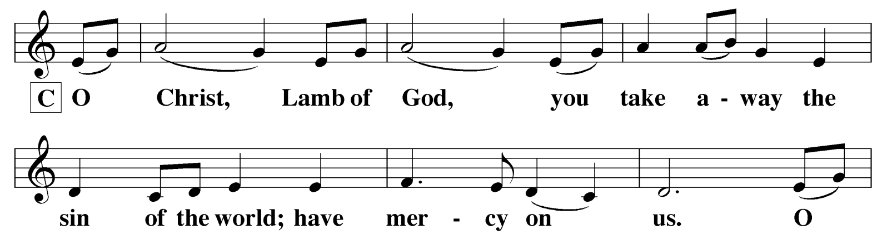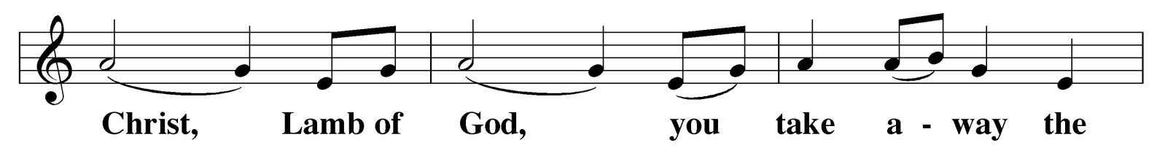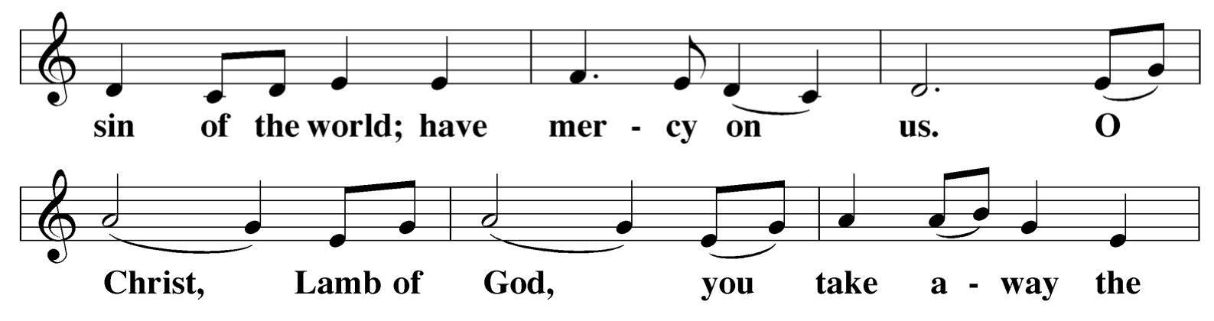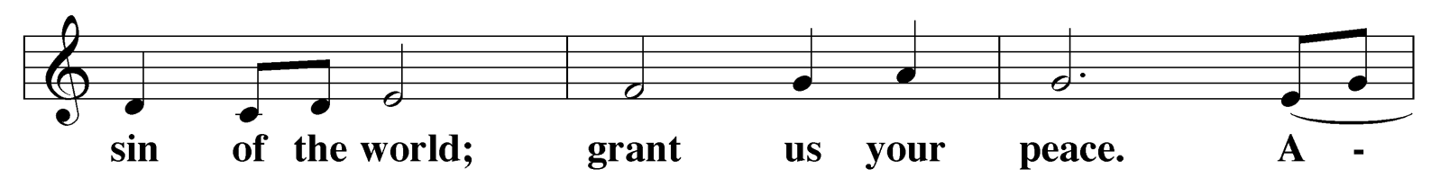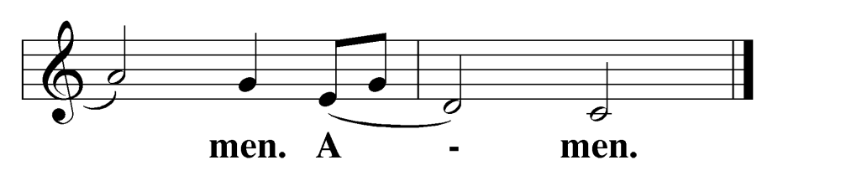C:

GLORIA IN EXCELSIS
The choir will sing the verses. The refrain is identical to the refrain in the familiar Christmas carol, “Angels We Have Heard on High.”

WORDS OF INSTITUTION

M: Our Lord Jesus Christ,
on the night he was betrayed, took bread; and when he had given thanks, he broke it and gave it to his disciples, saying,
“Take and eat; this is my  body, which is given for you.
Do this in remembrance of me.”
Then he took the cup, gave thanks, and gave it to them, saying,
Choir: Glory to God in the highest, and on earth peace to people of good will.
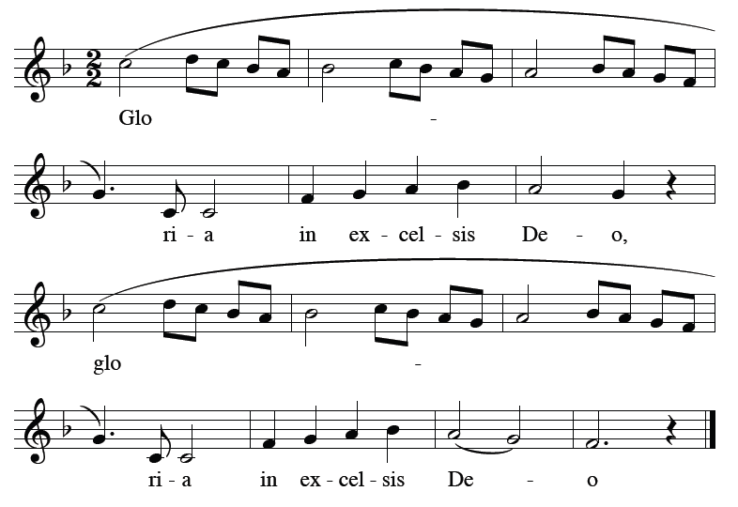ALL: Refrain

“Drink from it, all of you;
this is my  blood of the new covenant, which is poured out for you
for the forgiveness of sins.
Do this, whenever you drink it,
in remembrance of me.”
The peace of the Lord be with you always.

C: Amen.

Choir: We praise you. We bless you. We adore you. We glorify you. We give you thanks for your great glory, Lord God, heavenly King, O God, almighty Father.
ALL: Refrain
Choir: Lord Jesus Christ, only begotten Son, Lord God, Lamb of God, Son of the Father, you take away the sins of the world; have mercy on us. You take away the sins of the world; receive our prayer. You are seated at the right hand of the Father; have mercy on us.
ALL: Refrain
Choir: For you alone at the Holy One. You alone are the Lord. You alone at the Most High, Jesus Christ, with the Holy Spirit, in the glory of God the Father. Amen.
ALL: Refrain

 The Word 

PRAYER OF THE DAY
M: Almighty God,
grant that the birth of your only Son in the flesh
may set us free from our old bondage under the yoke of sin. Pour out your Holy Spirit into the world,
so that the message of the babe born in Bethlehem
might change the lives and destinies of many more people; through Jesus Christ our Lord,
who lives and reigns with you and the Holy Spirit, one God, now and forever.

C: Amen.

After a brief musical introduction, the congregation sings “Holy, Holy, Holy.”

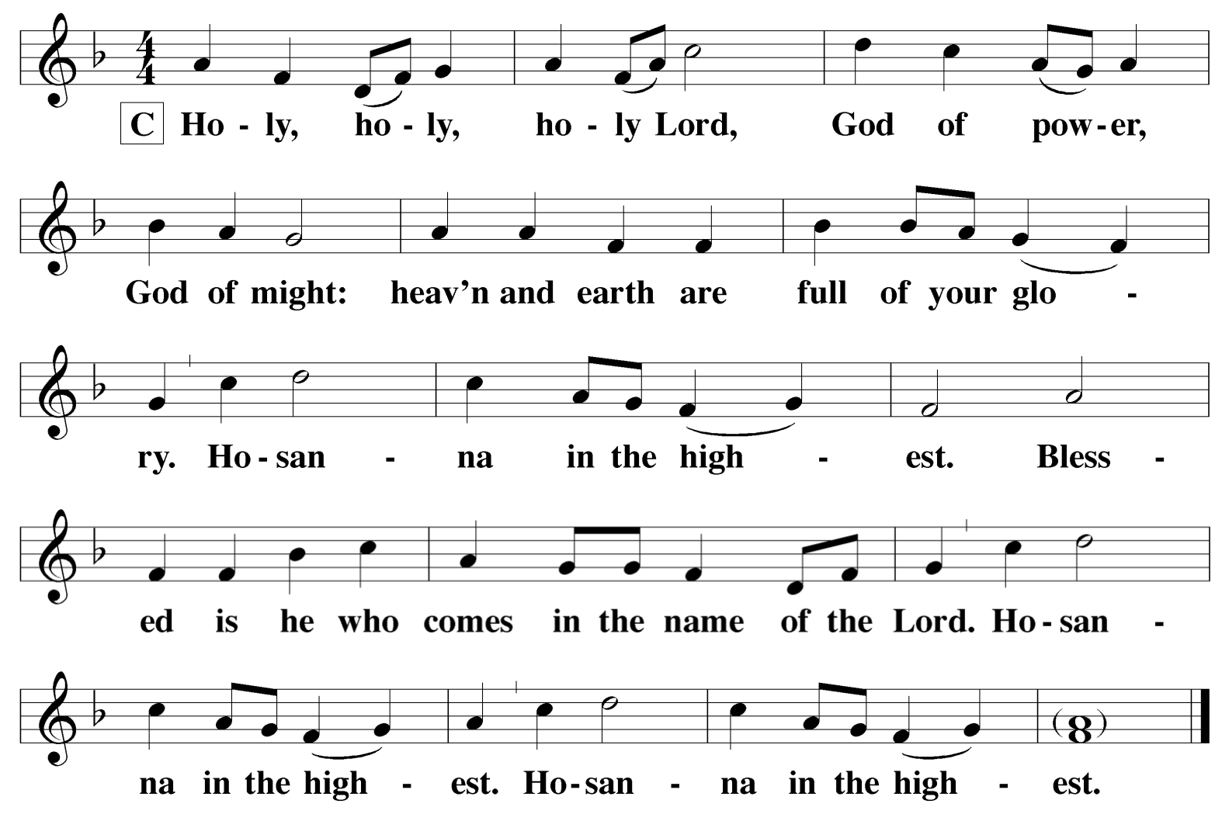HOLY, HOLY, HOLY

C:

FIRST LESSON Isaiah 52:7-10

7 How beautiful on the mountains are the feet of those who bring good news, who proclaim peace, who bring good tidings, who proclaim salvation, who say to Zion, "Your God reigns!"
8 Listen! Your watchmen lift up their
voices; together they shout for joy. When the LORD returns to Zion, they will see it with their own eyes.
9 Burst into songs of joy together, you ruins of Jerusalem, for the LORD has comforted his
people, he has redeemed Jerusalem.
10 The LORD will lay bare his holy arm in the sight of all the nations, and all the ends of
the earth will see the salvation of our God.

PSALM OF THE DAY Psalm 98

 The Sacrament 
We follow the historic Christian practice of close communion. We ask that only members of Beautiful Savior Lutheran or one of our sister congregations partake of the sacrament. If you are not a member, please speak to one of the pastors before communing.

OPENING SENTENCES
M: The Lord be with you.

C: And also with you.
M: Lift up your hearts.

C: We lift them up to the Lord.
M: Let us give thanks to the Lord our God.

C: It is good and right so to do.
M: It is truly good and right that we should
at all times and in all places give you thanks,
O Lord, holy Father, almighty and everlasting God, through Jesus Christ, our Lord, for in the wonder and mystery of his birth you have opened our eyes
to the glory of your grace and renewed in our hearts the fervor of your love. Therefore with all the saints on earth and hosts of heaven,
we praise your holy name and join their glorious song.
Choir: Refrain
ALL: Refrain

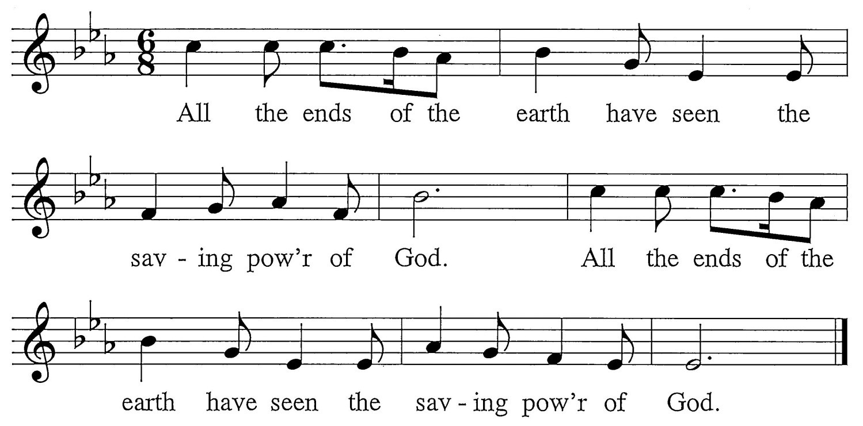

Choir: Sing to the Lord a new song, for he has done wondrous deeds.
His right hand has won vict’ry for him, his holy arm.
ALL: Refrain
Choir: The Lord has made his salvation known, his justice revealed to the nations,
remembering his kindness and faithfulness t’ward Israel.
ALL: Refrain
Choir: All the ends of the earth have seen the saving power of God.
Sing joyfully to the Lord, all you lands. Break into song; sing praise!
ALL: Refrain
Choir: Sing praise to the Lord with the harp, with the harp and melodious song, With trumpets and the sound of the horn. Sing joyfully to our king.
ALL: Refrain

 The Prayers 

SECOND LESSON Hebrews 1:1-9

1In the past God spoke to our forefathers through the prophets at many times and in various ways, 2but in these last days he has spoken to us by his Son, whom he appointed heir of all things, and through whom he made the universe. 3The Son is the radiance of God’s glory and the exact representation of his being, sustaining all things by his powerful word. After he had provided purification for sins, he sat down at the right hand of the Majesty in heaven. 4So he became as much superior to the angels as the name he has inherited is superior to theirs.
5For to which of the angels did God ever say,
“You are my Son;
today I have become your Father”?
Or again,
“I will be his Father, and he will be my Son”?
6And again, when God brings his firstborn into the world, he says,
“Let all God’s angels worship him.”
7In speaking of the angels he says,
“He makes his angels winds, his servants flames of fire.”
8But about the Son he says,
“Your throne, O God, will last for ever and ever, and righteousness will be the scepter of your kingdom. 9You have loved righteousness and hated wickedness;
therefore God, your God, has set you above your
companions by anointing you with the oil of joy.”
M: On this holy day, dear Father, we rejoice to hear the good news of great joy that a Savior has been born for us. For fulfilling your prophecies and in the fullness of time sending your Son to be our Savior, we give you our heartfelt thanks and praise.

C: Unto us a child is born! Unto us a Son is given!
M: What a great mystery of our faith this is: that God has become fully human for our salvation! Even though he is the all-powerful Lord of all, he is wrapped in strips of cloth and lying in a manger.

C: Help us always believe that this precious child was born as our substitute to be our Savior.
M: In the midst of our joy, we grieve for the many people in our world who do not know that Jesus has come to bring them forgiveness and healing. As the shepherds spread abroad the good news of the birth of the Savior born for all the world, may we also make use of the unique opportunities this holiday presents to tell others of what we have seen and heard concerning the child.

C: Grant that the true peace between God and fallen mankind may comfort all people.
Special prayers and intercessions may follow
M: As the angels sang out their praise, move us also to sing out our praise to you, today and every day, as the joy of Christmas remains in our hearts.

C: Glory to God in the highest! Amen.
M: Father, we bring these prayers before you this Christmas and always, confident that you will hear and answer them. For it was your only Son who taught us to pray:

C: Our Father in heaven, hallowed be your name, your kingdom come,
your will be done on earth as in heaven. Give us today our daily bread.
Forgive us our sins, as we forgive those who sin against us. Lead us not into temptation,
but deliver us from evil.
For the kingdom, the power, and the glory are yours now and forever.
Amen.

SERMON

Sermon Theme Here

CONFESSION OF FAITH Excerpts from the Athanasian Creed

It is necessary for eternal salvation truly to believe
that our Lord Jesus Christ also took on human flesh.
Now this is the true Christian faith:
We believe and confess that our Lord Jesus Christ,
God’s Son, is both God and man.
He is God, eternally begotten from the nature of the Father, and he is man, born in time from the nature of his mother, fully God, fully man, with rational soul and human flesh; equal to the Father as to his deity,
less than the Father as to his humanity; and though he is both God and man, Christ is not two persons, but one,
one, not by changing the deity into flesh, but by taking the humanity into God;
one, indeed, not by mixture of the natures, but by unity in one person;
for just as the rational soul and flesh are one human being, so God and man are one Christ.
He suffered for our salvation, descended into hell,
rose the third day from the dead.
He ascended into heaven,
is seated at the right hand of God the Father almighty, and from there will come to judge the living and the dead.
This is the true Christian faith.
Whoever does not faithfully and firmly believe this cannot be saved.

VERSE OF THE DAY Luke 2:10-11

M: Refrain
C: Refrain 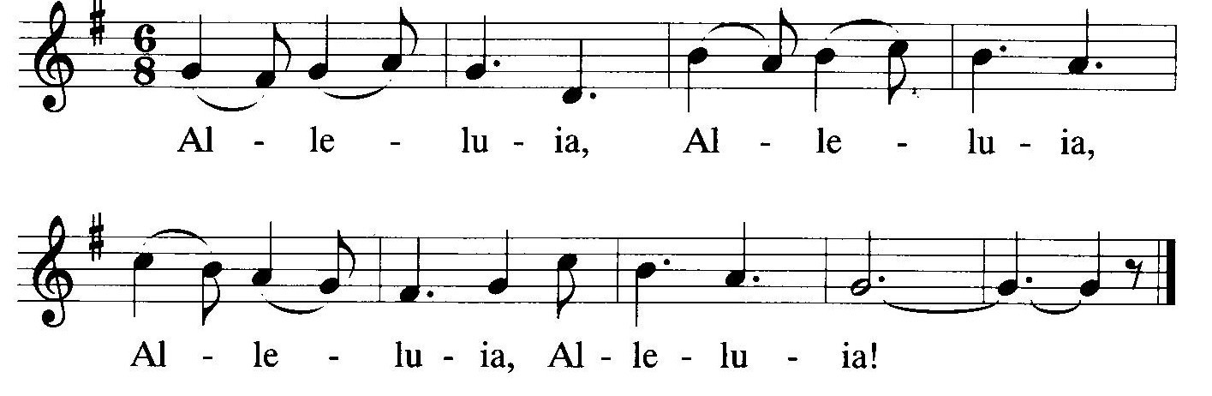
M: Good news and great joy to all the world. Today is born our Savior, Christ the Lord.
C: Refrain

THANK OFFERING
The members of our congregation have joined together to do the Lord’s work in this community and around the world. Visitors need not feel obligated to participate in this offering which supports our ministry.

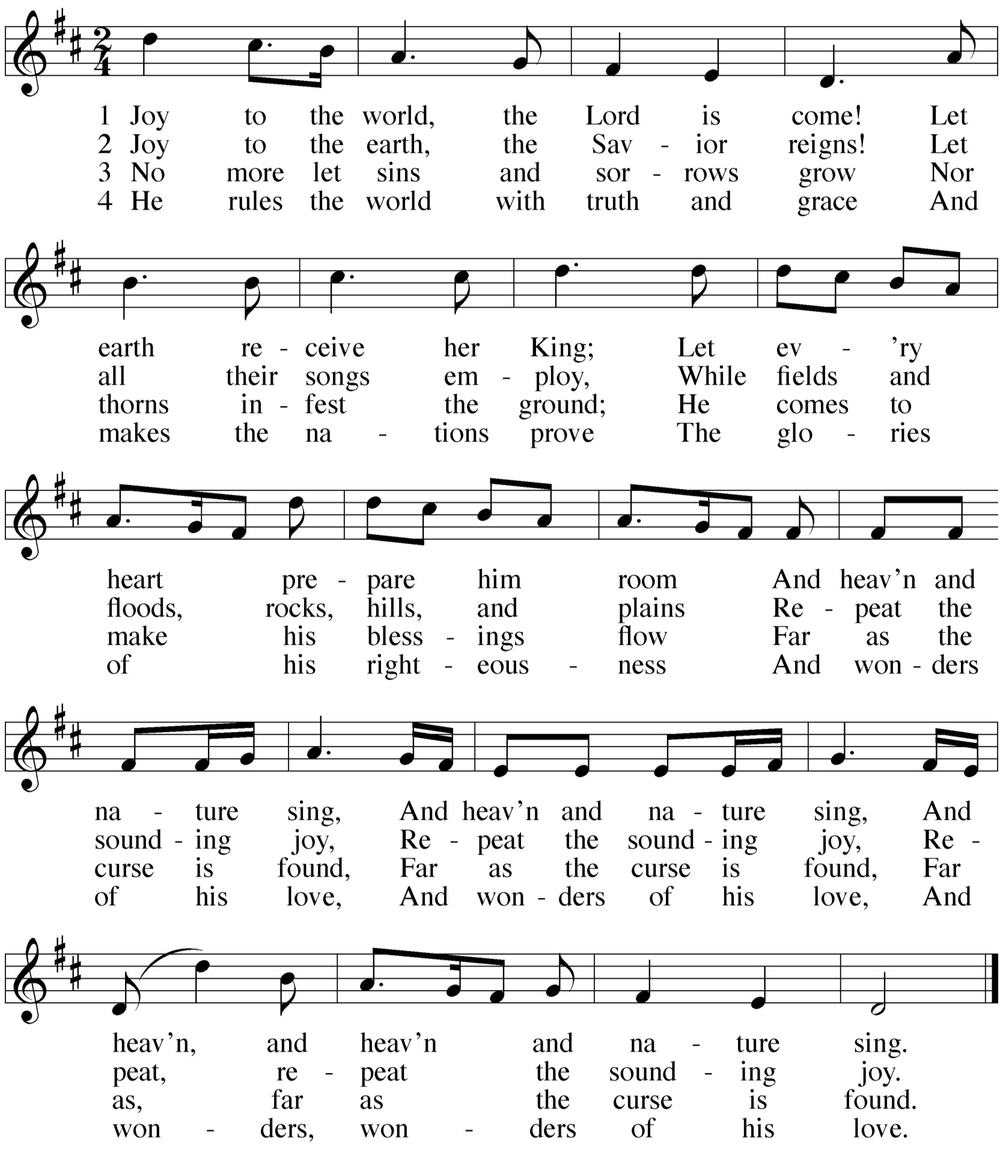GOSPEL LESSON John 1:1-14
1In the beginning was the Word, and the Word was with God, and the Word was God. 2He was with God in the beginning.
3Through him all things were made; without him nothing was made that has been made. 4In him was life, and that life was the
light of men. 5The light shines in the darkness, but the darkness has not understood it.
6There came a man who was sent from
God; his name was John. 7He came as a witness to testify concerning that light, so that through him all men might believe. 8He himself was not the light; he came only as a witness to the light. 9The true light that gives light to every man was coming into the world.
10He was in the world, and though the world was made through him, the world did not recognize him. 11He came to that which was his own, but his own did not receive him. 12Yet to
all who received him, to those who believed in his name, he gave the right to become children of God— 13children born not of natural descent, nor of human decision or a husband's will, but born of God.
14The Word became flesh and made his
dwelling among us. We have seen his glory, the glory of the One and Only, who came from the Father, full of grace and truth.

M: This is the Gospel of our Lord.

C: Praise be to you, O Christ!
HYMN OF THE DAY Joy to the World

