A Savior has been born to you. He is Christ the Lord!
Tuesday, December 24th
5:00PM — Festival Worship Service 7:00PM — Candlelight Lessons & Carols Service
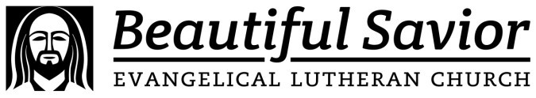
720 Old Trolley Road Summerville

Go to www.ourbeautifulsavior.com for more information.

