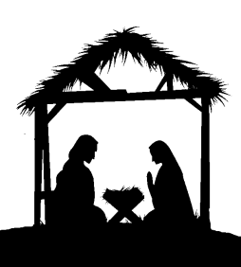This is an extremely busy season. Set aside some time each week to prepare your hearts to meet your Lord and Savior. Join us for this worship series, and we promise your Christmas will be that much more merry.

720 Old Trolley Road Summerville www.ourbeautifulsavior.com

