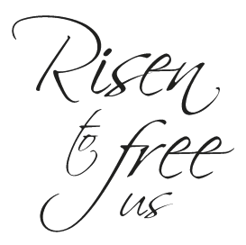Come and hear the story of the Savior who died, but is now risen to free us. God wants you to know the freedom that dawned on the first Easter morning.

720 Old Trolley Road Summerville www.ourbeautifulsavior.com

