20

Music license information here

Imposition of Ashes
Christian Worship: Occasional Services (WELS) © 2000 Northwestern Publishing House

Sign Us With Ashes
Words: Mary Louise Bringle Music: Tony Alonso
© 2009 GIA Publications, Inc.

Psalm 51: Be Merciful, O Lord
Tune: Marty Haugen ©1983 G.I.A. Publications, Inc., Chicago. All rights reserved.
Text: English translation of the Refrain from the Lectionary for the Mass,
©1969 International Committee on English in the Liturgy, Inc.

Gospel Acclamation from Mass of Light
Music: David Haas
©1988 GIA Publications, Inc.

Ash Wednesday March 5, 2014

ASHES TO ASHES, DUST TO DUST

Daily Bible Reading - Lent
The following are intended to be possible portions of Scripture for personal meditation during Lent. They have been selected to match the themes of worship throughout the Lenten season.

Ash Wed. Feb. 17
Gen. 1:1-19
Mark 1:1-13
Th Gen. 1:20-2:3
Mark 1:14-28
F Gen. 2:4-25
Mark 1:29-45
S Gen. 3:1-24
Mark 2:1-17
Lent 1 February 21
Gen. 4:1-26
Mark 2:18-28
M Gen. 6:1-7:5
Mark 3:1-19
T Gen. 7:11-8:12
Mark 3:20-35
W Gen. 8:13-9:17
Mark 4:1-20
Th Gen. 11:27-12:20
Mark 4:21-41
F Gen. 13:1-18
Mark 5:1-20
S Gen. 15:1-21
Mark 5:21-43
Lent 2 February 28
Gen. 16:1-9, 15-17:22
Mark 6:1-13
M Gen. 18:1-15
Mark 6:14-34
T Gen. 21:1-21
Mark 6:35-56
W Gen. 22:1-19
Mark 7:1-23
Th Gen. 24:1-31
Mark 7:24-37
F Gen. 24:32-52, 61-67
Mark 8:1-21
S Gen. 27:1-29
Mark 8:22-38
Lent 3 March 7
Gen. 27:30-45
Mark 9:1-13
M Gen. 29:1-30
Mark 9:14-32
T Gen. 35:1-29
Mark 9:33-50
W Gen. 37:1-36
Mark 10:1-12
Th Gen. 39:1-23
Mark 10:13-31
F Gen. 40:1-23
Mark 10:32-52
S Gen. 41:1-27
Mark 11:1-19
Lent 4 March 14
Gen. 41:28-57
Mark 11:20-33
M Gen. 42:1-34, 38
Mark 12:1-12
T Gen. 43:1-28
Mark 12:13-27
W Gen. 44:1-18, 32-34
Mark 12:28-44
Th Gen. 45:1-20, 24-28
Mark 13:1-23
F Gen. 47:1-31
Mark 13:24-37
S Gen. 49:29-50
Mark 14:1-11
Lent 5 March 21
Ex. 1:1-22
Mark 14:12-31
M Ex. 2:1-22
Mark 14:32-52
T Ex. 2:23-3:22
Mark 14:53-72
W Ex. 4:1-18
Mark 15:1-15
Th Ex. 4:19-31
Mark 15:16-32
F Ex. 5:1-6:1
Mark 15:33-47
S Ex. 7:1-25
Mark 16:1-20
Holy Week
Palm Sun. March 28
Ex. 8:1-32
Heb. 1:1-14
M Ex. 9:1-28
Heb. 2:1-18
T Ex. 9:29-10:20
Heb. 3:1-19
W Ex. 10:21-11:10
Heb. 4:1-16
Holy Thurs. April 1
Ex. 12:1-28
Heb. 5:1-14
Good Fri. April 2
Ex. 12:29-13:16
Heb. 6:1-20
Holy Sat. April 3
Ex. 13:17-14:9
Heb. 7:1-22

CLOSING HYMN — 588
Final verses are sung a cappella
Abide with Me

The Season of Lent
Ash Wednesday is the beginning of the season in the Church Year known as Lent.
The word Lent comes from an Old English word for Spring (“lengten,” the time of the year when the days grow longer). For the last 1700 years, the Church has set aside the 40 days between Ash Wednesday and Easter as a time of special preparation. It is a time of repentance and renewal.
During Lent, our rejoicing is muted as we remember our Lord’s suffering and death. But it is with a purpose: we know that the Lord who died took up his life again on Easter Sunday morning. So our 40 days of Lent are ones lived in the certain hope of the resurrection.
The color of the season is purple. Purple is the ancient color of royalty. We have this kind of king: he wore a crown of thorns, and carried a cross for us.
Thanks be to God!
For the precise counters in the congregation, the Church speaks of 40 days of Lent because they did not count the Sundays, which retained their significance as “little Easters.”

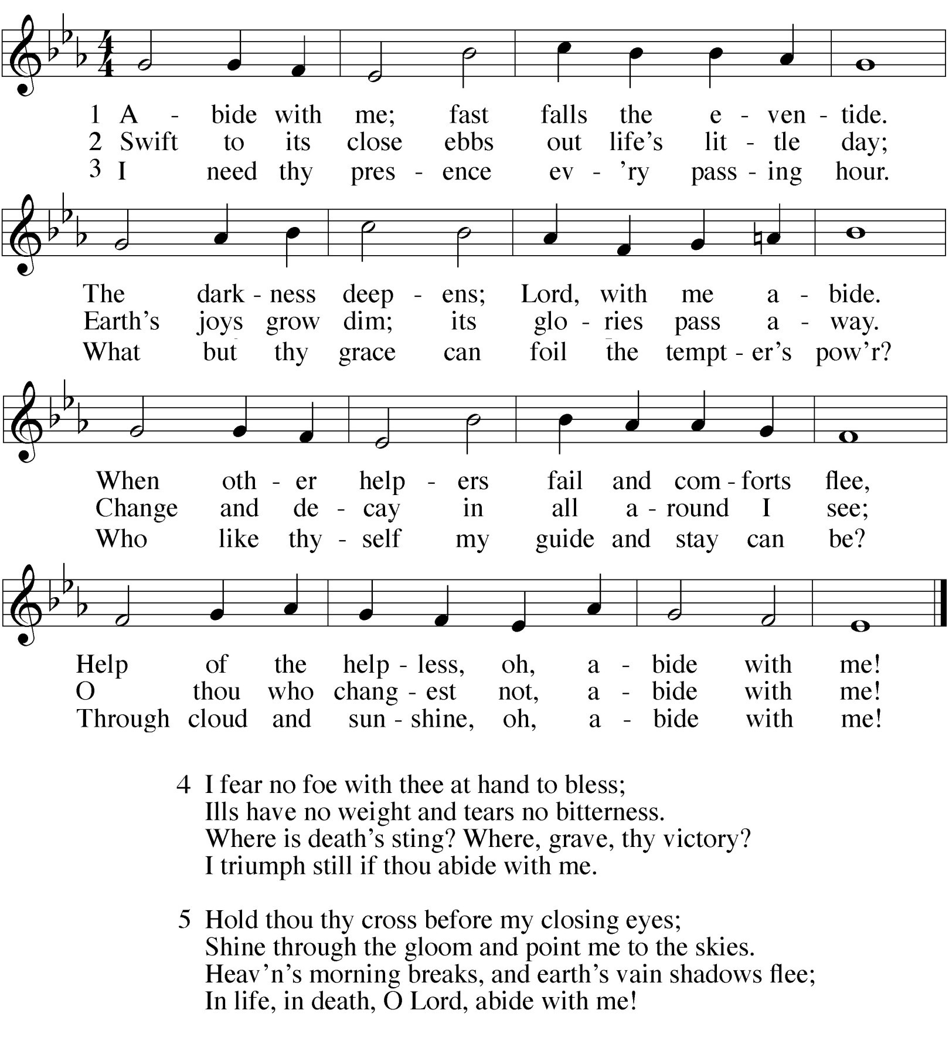Lenten Art
The cover art, produced by liturgical artist Steven Erpsamer, makes use of common Lenten symbols within the Christian church:
 Bones — Bones and skeletons were used commonly on Ash Wednesday. It is meant to remind us that because of sin, death is inevitable.
 Fish and pretzel bread — This was a common Lenten meal. By the fifth century, many Christians would engage in a “Lenten fast,” abstaining from all meats but fish. They would also shape their bread dough to look like crossed arms, the traditional posture of prayer before meals back then. The term for these little loaves of bread was pretiola, from where we get pretzel.
 Palm branches — Used in the celebratory processional of Palm Sunday, palm braches were a sign of rejoicing. In our cover art, they are on fire. That is because traditionally the ashes for Ash Wednesday are made from the burned crushed palms from the previous Lent.
Thus, our cover art pictures the cycle of Lent: Ash Wednesday, the 40 days, and Holy Week, which gives us the ashes for the following year.

A SERVICE OF REPENTANCE
This service offers the congregation a form of worship that focuses on the penitential nature of faith. Believers turn from their sin and turn to the salvation that is found only in Christ.

PRAYER OF THE CHURCH

 The Prayers 

 The Gathering 

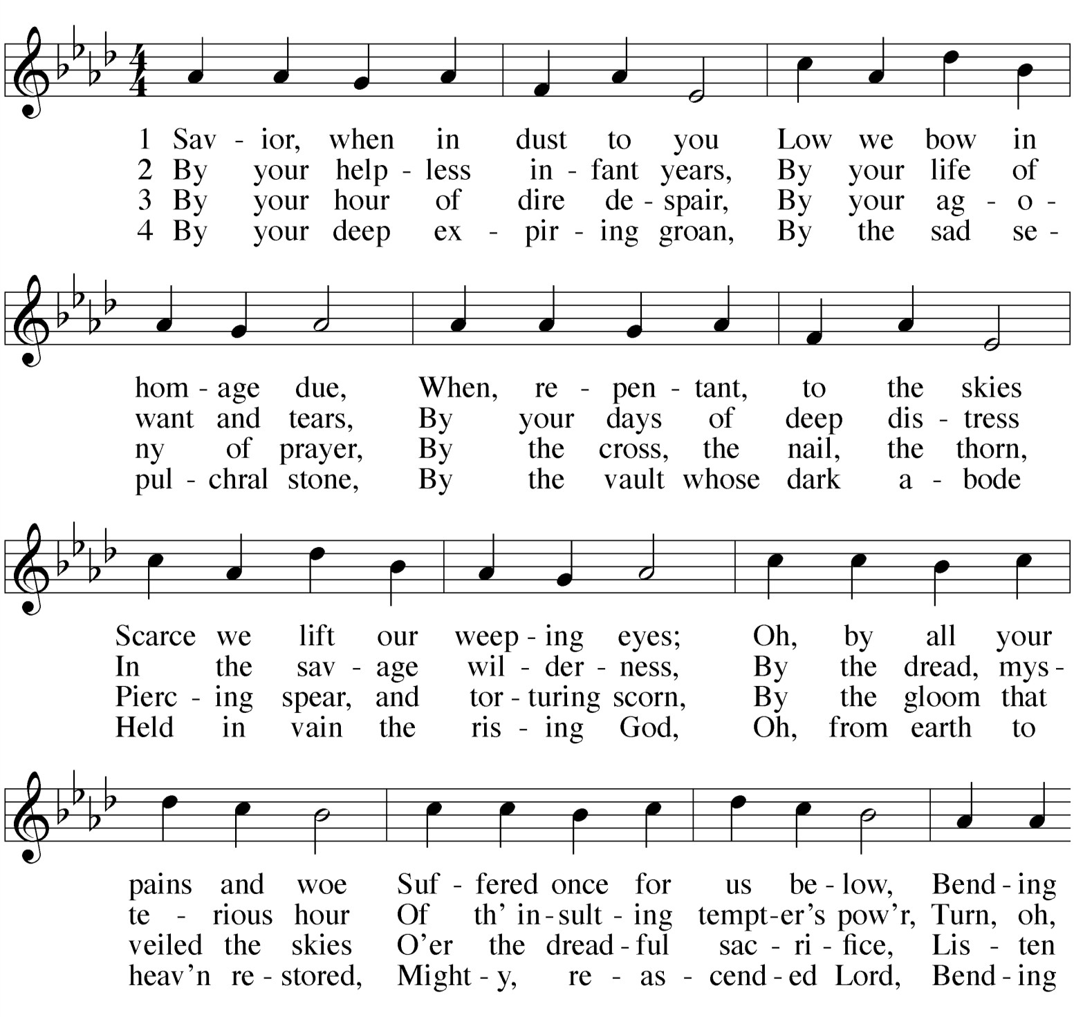OPENING HYMN — 124 Savior When In Dust To You
Prayers and petitions are offered on behalf of the Church
M: Finally, O Lord, we ask you to grant us newness of life in Jesus Christ, in whose name we bring these and all our petitions. It is he who taught us to pray.

THE LORD’S PRAYER

C: Our Father in heaven, hallowed be your name, your kingdom come,
your will be done on earth as in heaven. Give us today our daily bread.
Forgive us our sins, as we forgive those who sin against us. Lead us not into temptation,
but deliver us from evil.
For the kingdom, the power, and the glory are yours now and forever. Amen.

BLESSING
M: Christ give you grace to grow in holiness, to deny yourselves, take up your cross, and follow him; and the blessing of God almighty, the Father, the Son, and the Holy Spirit, be among you, and remain with you always.

C: Amen.
M: Go in peace to love and serve the Lord.

C: In the name of Christ. Amen.
M: Go in the peace of Christ.

C: Thanks be to God.

LENTEN CONFESSION OF FAITH
This is what the Bible teaches and, therefore, what we believe. We believe in Jesus Christ;
He is the true God from all eternity — almighty, all-knowing, present in all places.
He is a man from Nazareth —
weak in the flesh, fearful of future sorrow, tortured by pain.
He was tempted like us, yet like we will never know.
But he triumphed over temptation;
he refrained from his full might and glory; he submitted humbly to the Father’s will; he chose death, to give us life.
We believe that our sins anger God, each one of them: big and small, public and private,
those that hurt others,
those that don’t appear to hurt anyone, those we don’t even remember.
We believe that Jesus lived and died for the sins of the world. He resisted every temptation;
he reached out in love, to anyone in need; he remained pure in every thought,
not just to be a good person, not just to be a good example,
but to be mankind’s perfect Savior and Substitute, to live the Law in our place,
so that the Law will not condemn us.
He submitted to shame;
he suffered unjust punishment; he sacrificed Himself,
not to prove a point,
not just to show us how to obey,
but to take mankind’s sentence for sin, as our perfect Savior and Substitute.
He is our sure hope and salvation.
This is what the Bible says; therefore, this is what we believe.

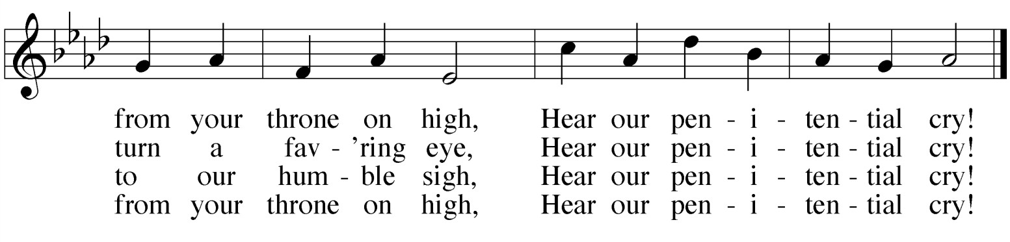

INSTRUCTION FOR THE BEGINNING OF LENT
M: Brothers and sisters in Christ, God created us to know joy in communion with him, to love all humanity, and to live in harmony with all creation. But sin separates us from God, our neighbors, and creation, and so we do not enjoy the life our Creator intended for us. By our sin we grieve our Father, who does not desire us to come under his judgment but to turn to him and live. Therefore, God in his mercy has sent our Lord Jesus Christ to take our place under the law, to suffer for us, and to die the death we deserve. God made Jesus, who had no sin, to be sin for us so that in him, we might become the righteousness of God.
During the 40 days of Lent, we fix our eyes on Jesus, the author and perfecter of our faith, who for the joy set before him endured the cross, scorning its shame, and sat down at the right hand of God. The time of Lent reminds us that to know Christ and the power of his resurrection, we must also know the fellowship of sharing in his sufferings, becoming like him in his death. As disciples of the Lord Jesus, we are called to struggle against everything that leads us away from love of God and neighbor.
I invite you, therefore, to confess your sins, ask our Father for forgiveness, and commit yourselves to this struggle. Let us be silent. Let us be still. Let us pause now for a time of reflection and self-examination.
Silence for reflection and self-examination

THANK OFFERING

CONFESSION OF SINS
M: Most holy and merciful Father,

C: We confess to you and to one another that we have sinned by our own fault, by our own grievous fault in thought, word, and deed,
by what we have done, and by what we have left undone.
M: We have not loved you with our whole heart and mind and strength.
We have not loved our neighbors as ourselves.
We have not forgiven others as we have been forgiven.

C: Have mercy on us, Lord.
M: We have been deaf to your call to serve as Christ served us.
We have not been true to the mind of Christ. We have grieved the Holy Spirit.

C: Have mercy on us, Lord.
M: We confess to you, Lord, all our past unfaithfulness. The pride, hypocrisy, and impatience in our lives

C: We confess to you, O Lord.
M: Our self-indulgent appetites and ways, our manipulation of other people

C: We confess to you, O Lord.
M: Our anger when our selfish aims are denied
and our envy of those more fortunate than ourselves

C: We confess to you, O Lord.
M: Our love of worldly goods and comforts and our dishonesty in daily life and work

C: We confess to you, O Lord.
HYMN OF THE DAY — 396 In Adam We Have All Been One
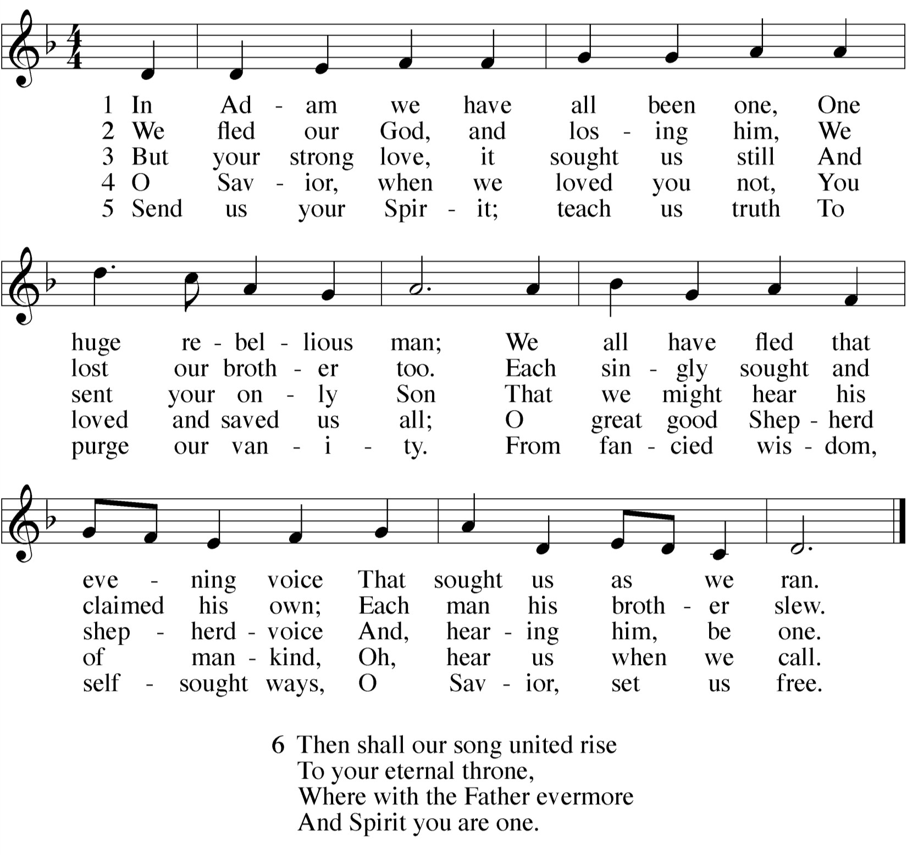

SERMON

GOSPEL Luke 18:9-14
9To some who were confident of their own righteousness and looked down on everybody else, Jesus told this parable: 10"Two men went up to the temple to pray, one a Pharisee and the other a tax collector. 11The Pharisee stood up and prayed about himself: 'God, I thank you that I am not like other men—robbers, evildoers, adulterers—or even like this tax collector. 12I fast twice a week and give a tenth of all I get.'
13"But the tax collector stood at a distance. He would not even
look up to heaven, but beat his breast and said, 'God, have mercy on me, a sinner.'
14"I tell you that this man, rather than the other, went home
justified before God. For everyone who exalts himself will be humbled, and he who humbles himself will be exalted."

M: This is the Gospel of our Lord.

C: Praise be to you, O Christ!

M: Our negligence in worship and prayer
and our failure to show the faith that is in us

C: We confess to you, O Lord.
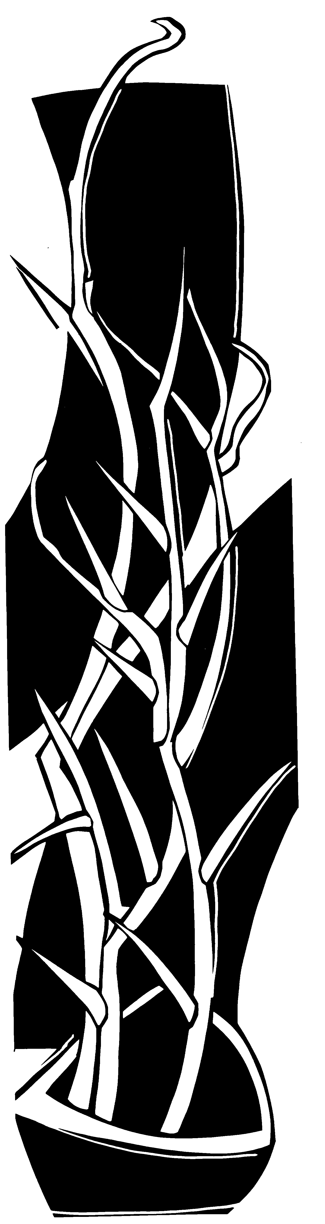M: Forgive us, Lord, for the wrongs we have done. For our blindness to human need and suffering and our indifference to injustice and cruelty,

C: Forgive us, O Lord.
M: For all false judgments,
for uncharitable thoughts toward others,
and for our prejudice and contempt for those who differ from us,

C: Forgive us, O Lord.
M: For what we think or say or do that is at variance with your will,

C: Forgive us, O Lord.
M: Restore us, good Lord,
and let your anger depart from us.

C: Hear us, Lord, for your mercy is great.

IMPOSITION OF ASHES
At this time, the usher will direct anyone who desires to receive the imposition of ashes forward.
Baptized children may come forward at their parents’ discretion.

The minister applies ashes to the forehead in the form of a small cross, saying:
M: Remember that you are dust, and to dust you shall return.
As the imposition of ashes takes place, the congregation joins in singing “Sign us with Ashes.”

S(oloist): Refrain

C(ongregation): Refrain
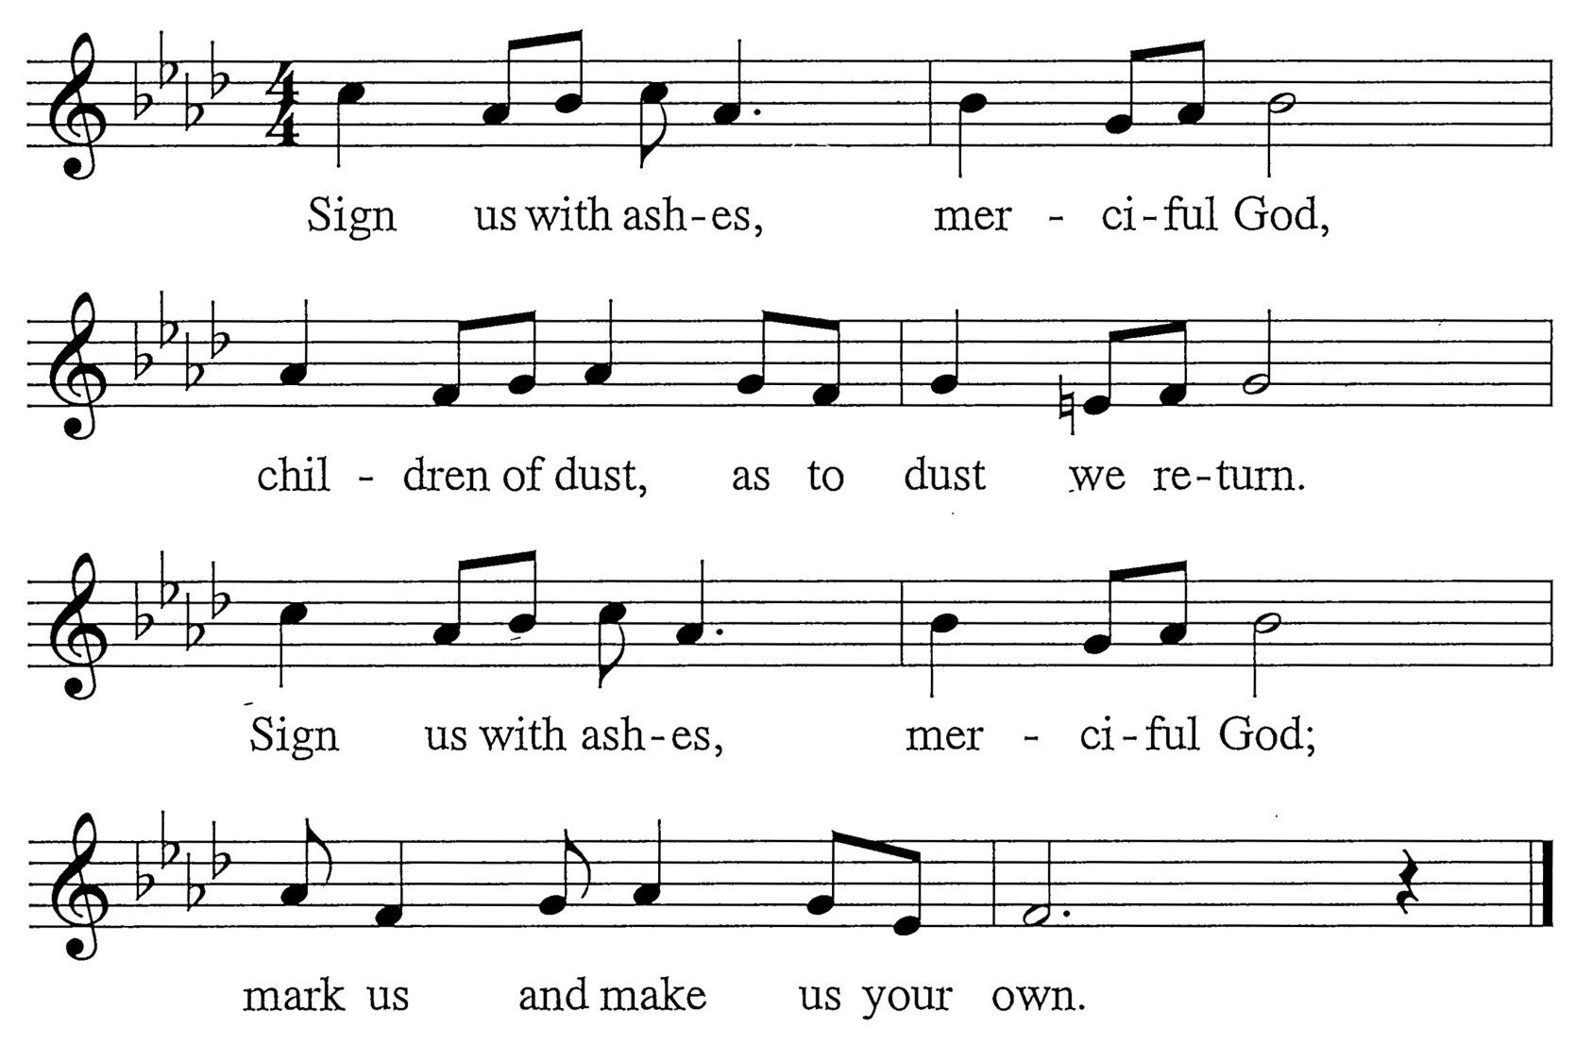
S: Surely, you alone can save us. You pay our price with your precious blood. Reaching through your great compassion, you lift up your people with love.

C: Refrain

VERSE OF THE DAY Joel 2:13

M: Refrain
C: Refrain
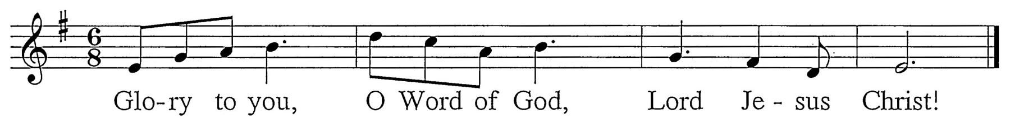

M: Return to the Lord, your God, for he is gracious, merciful, and abounding in love.
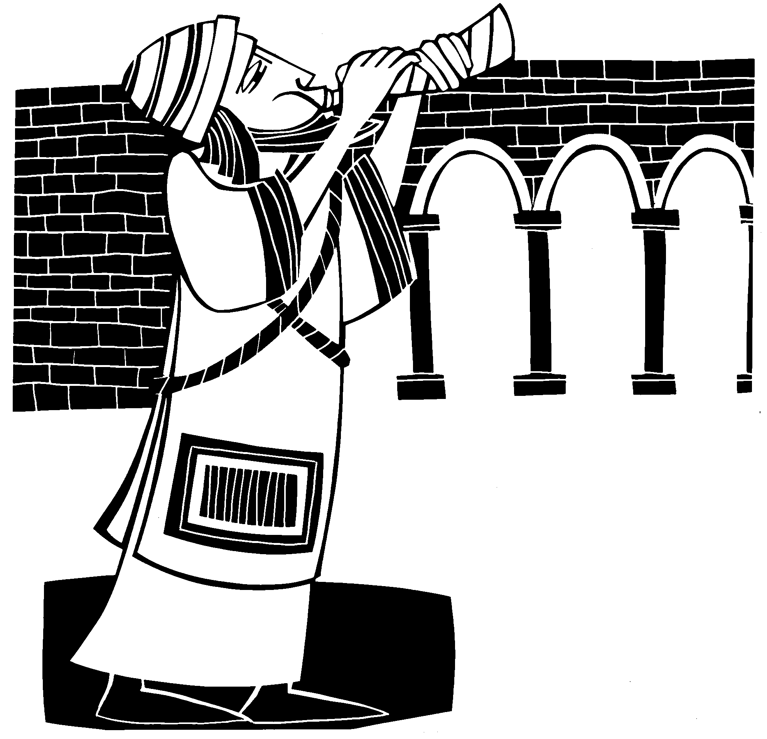C: Refrain (sung twice)

SECOND LESSON 2 Corinthians 7:8-13
8Even if I caused you sorrow by my letter, I do not regret it. Though I did regret it—I see that my letter hurt you, but only for a little while— 9yet now I am happy, not because you were made sorry, but because your sorrow led you to repentance. For you became sorrowful as God intended and so were not harmed in any way by us. 10Godly sorrow brings repentance that leads to salvation and leaves no regret, but worldly sorrow brings death. 11See what this godly sorrow has produced in you: what earnestness, what eagerness to clear yourselves, what indignation, what alarm, what longing, what concern, what readiness to see justice done. At every point you have proved yourselves to be innocent in this matter. 12So even though I wrote to you, it was not on account of the one who did the wrong or of the injured party, but rather that before God you could see for yourselves how devoted to us you are. 13By all this we are encouraged.
S: Surely, you alone uphold us. You give us strength for all our needs. Shielding with a father’s favor, you bless us with pardon and peace.

C: Refrain
S: Surely, you alone can heal us. Yours is the will to make us whole.
Soothing with a mother’s kindness, the contrite of heart, you console.

C: Refrain
S: Surely, you alone can free us. You break the bonds of guilt and sin.
Bracing, till we walk uprightly, you bolster our hope once again.

C: Refrain
S: Surely, you alone refine us. You give us grace for lives made new, Forging, through your fire and radiance, a sacrifice worthy of you.

C: Refrain
S: Surely, you alone redeem us. You fill our dust with holy breath. Bursting from the grave in glory, you rise from the ashes of death.

C: Refrain

After all who desire have received ashes, the minister says: M: Accomplish in us, O God, the work of your salvation C: That we may show forth your glory in the world. M: By the cross and suffering of your Son, O Lord,

C: Bring us with all your saints to the joy of his resurrection.

ABSOLUTION
M: Almighty God, the Father of our Lord Jesus Christ, does not desire the death of sinners
but rather that they turn from their wickedness and live. Therefore, I forgive you all your sins in the name of the Father and of the Son  and of the Holy Spirit.
During these days of Lent, let us implore God to give us renewal and his Holy Spirit.
May we continue to abide in the true faith and at the last be received by him through the merits of Jesus Christ our Lord.

C: Amen.

 The Word 
M: Almighty and merciful God,
you never despise what you have made and always forgive those who turn to you. Create in us such new and contrite hearts that we may truly repent of our sins
and obtain your full and gracious pardon; through your Son, Jesus Christ our Lord,
who lives and reigns with you and the Holy Spirit, one God, now and forever.

C: Amen.

FIRST LESSON Numbers 21:4-9
4 They traveled from Mount Hor along the route to the Red Sea, to go around Edom. But the people grew impatient on the way; 5 they spoke against God and against Moses, and said, "Why have you brought us up out of Egypt to die in the desert?
There is no bread! There is no water! And we detest this miserable food!"
6 Then the LORD sent venomous snakes among them; they bit the people and many Israelites died. 7
The people came to Moses and said, "We sinned when we spoke against the LORD and against you. Pray that the LORD will take the snakes away from us." So Moses prayed for the people.
8 The LORD said to Moses, "Make a snake and put it up on a pole; anyone who is bitten can look at
it and live." 9 So Moses made a bronze snake and put it up on a pole. Then when anyone was bitten by a snake and looked at the bronze snake, he lived.

PSALM OF THE DAY Psalm 51

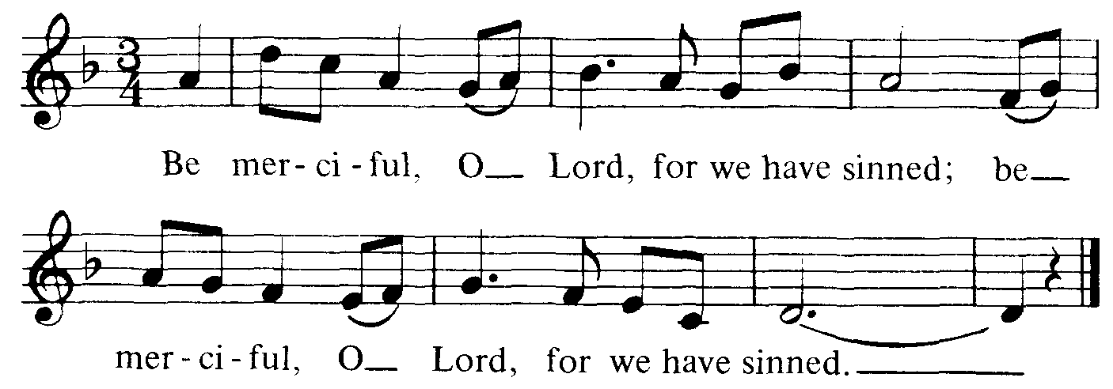M: Refrain

C: Refrain

M: Have mercy on me, God, in your kindness, in your compassion, blot out my offense.
Oh, wash me more and more from my guilt and my sorrow, and cleanse me from all of my sin.

C: Refrain
M: My offenses, truly I know them, and my sins are always before me;
Against you alone have I sinned, O Lord; what is evil in your sight I have done.

C: Refrain
M: Create in me a clean heart, O God, put your steadfast spirit within me.
Cast me not away from your presence, O Lord, and take not your Spirit from me.

C: Refrain
M: Restore to me the joy of your salvation; let your willing Spirit bear me up,
and I shall teach your way to the ones who have wandered, and bring them all home to your side.

C: Refrain

