EVENING PRAYERS
M: O Lord,
support us all the day long,
till the shadows lengthen and the evening comes and the busy world is hushed
and the fever of life is over and our work is done.
Then, in your mercy, grant us safe lodging and a holy rest and peace at the last.

C: Amen.

Special prayers and petitions may follow

THE LORD’S PRAYER
M: Hear us as we pray as Jesus taught.

C: Our Father in heaven, hallowed be your name, your kingdom come,
your will be done on earth as in heaven. Give us today our daily bread.
Forgive us our sins, as we forgive those who sin against us. Lead us not into temptation,
but deliver us from evil.
For the kingdom, the power, and the glory are yours now and forever. Amen.

BLESSING
M: The almighty and merciful Lord,
the Father, the Son and the Holy Ghost, bless us and preserve us.

C: Amen.

HYMN 590 God, Who Made the Earth and Heaven

8
Midweek Lent April 2, 2014

BAPTIZED INTO HIS DEATH
RELIVE YOUR BAPTISM EVERY DAY

elcome! Thank you for joining us for worship this evening. In our service we gather before our almighty God to offer him our worship and praise. We also gather to strengthen ourselves through
W
the study of God’s holy and powerful word.

 Restrooms are located in the hallway directly opposite the entrance to the sanctuary.

 Cry-room. If you have a young child or nursing infant and are in need of a cry-room, you will find it to the right as soon as you exit the sanctuary. A speaker there allows you to hear the service.

Lent: A Time of Catechetical Review
Already at the time of the Reformation, Lutheran churches would set aside a number of times a year to hold special services that had the singular purpose of reviewing the catechism, a summary of key Biblical teachings. The scheduling of these special services would vary somewhat from year to year, with one exception. Lent was always used as a time of catechetical review.
We follow this Lutheran tradition this Lent by gathering for special midweek services under the theme:
Baptized Into His Death
Under this theme, we will learn anew all that which God’s Word tells us about baptism. We will see how in our baptism, we were powerfully connected to Christ’s death and resurrection. We will study again what our baptism means for our daily lives. And we will rededicate ourselves to the struggle of living the new life baptism gives.

DEVOTION

THANK OFFERING

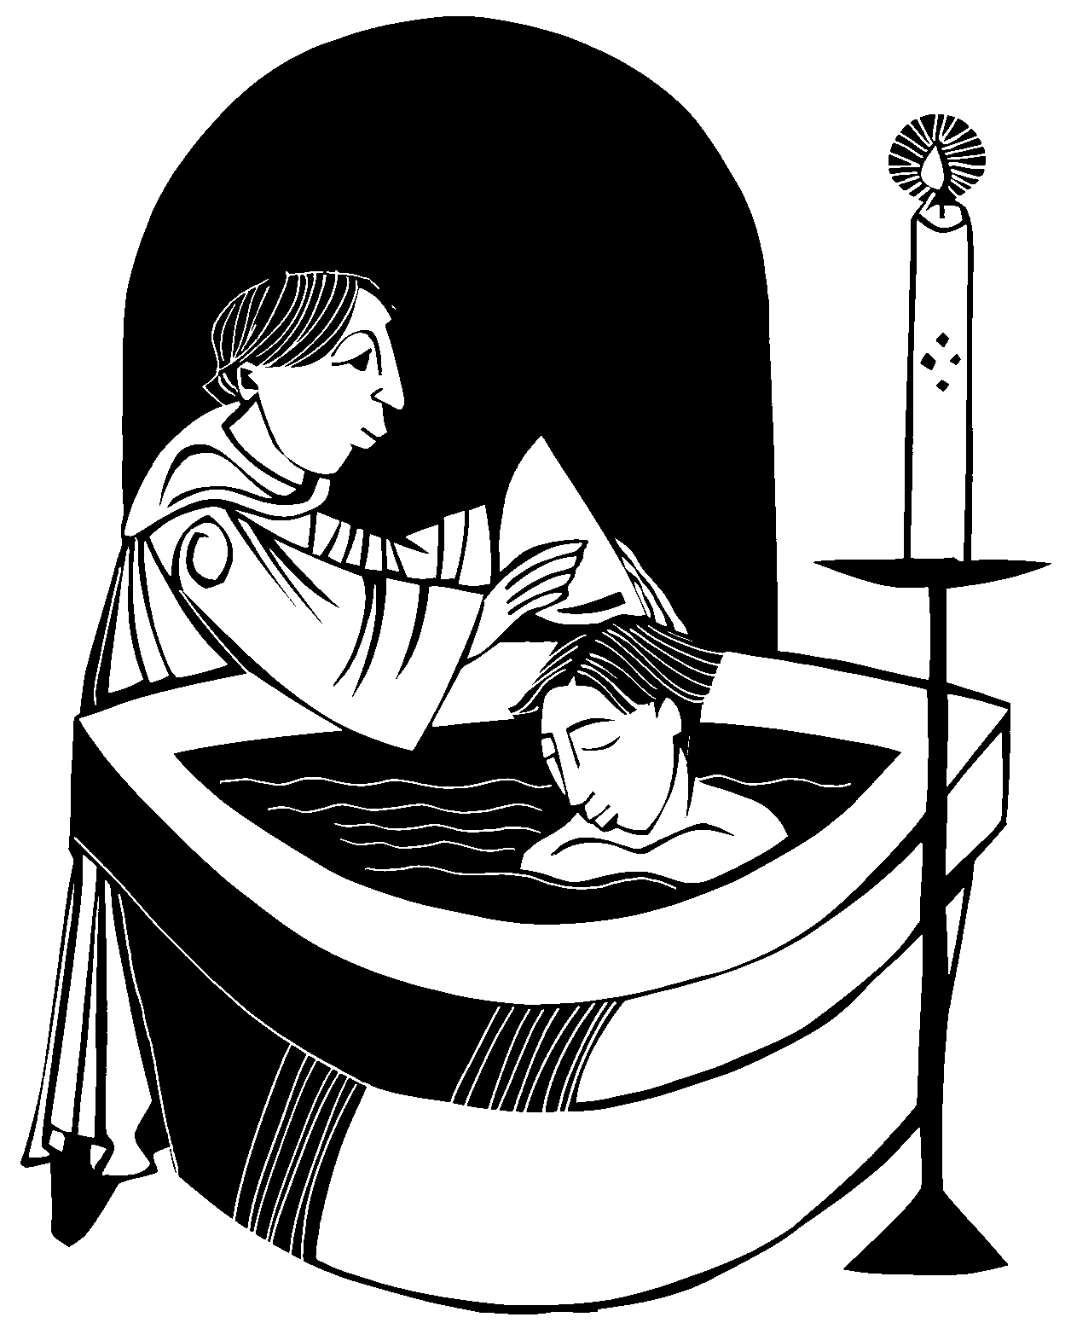We are those who have died to sin; how can we live in it any longer? Or don’t you know that all of us who were baptized into Christ Jesus were baptized into his death? We were therefore buried with him through baptism into death in order that, just as Christ was raised from the dead through the glory of the Father, we too may live a new life. Therefore do not let sin reign in your mortal body so that you obey its evil desires. Do not offer any part of yourself to sin as an instrument of wickedness, but rather offer yourselves to God as those who have been brought from death to life; and offer every part of yourself to him as an instrument of righteousness.

Romans 6:2-4,12-13

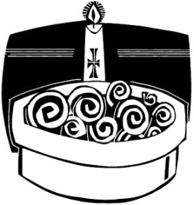ORDER OF SERVICE

PRAYER OF THE DAY
M: Let us pray.
Dear Jesus, when you suffered your passion, you suffered for all people everywhere.

C: For that we thank you and we praise you.
M: Keep us ever mindful that you continue to work out all things for our good.

C: Turn us from the ways of error and evil.
M: Guide us in all things good.

C: Forgive our faults and strengthen our faith. Amen.

PASSION READING Matthew 27:1-26
Trial before Pilate
The reading concludes as follows:
M: All of us who were baptized into Christ Jesus

C: were baptized into his death.

HYMN 117 O Dearest Jesus

INVOCATION
M: In the name of the Father, and of the  Son, and of the Holy Spirit.

C: Amen.
M: We are all one in Christ Jesus. We belong to him through faith,
heirs of the promise of the Spirit of peace. The peace of the Lord be always with you.

C: And also with you.

M: Let us pray.

PRAYER
M: We thank you, almighty God, for the gift of water to sustain, refresh and cleanse all life.
Over water the Holy Spirit moved in the beginning of creation.
Through water you led the children of Israel
from slavery in Egypt to freedom in the Promised Land.
In water your Son Jesus received the baptism of John
and was anointed by the Holy Spirit as the Messiah, the Christ, to lead us from the death of sin to newness of life.
We thank you, Father, for the water of baptism. In it we are buried with Christ in his death.
By it we share in his resurrection.
By your Spirit, enable us to relive our baptism, trough daily contrition and repentance,
that we may always walk by the light of faith
and continue for ever in the risen life of Jesus Christ our Lord; to whom with you and the Holy Spirit
be all honor and glory, now and for ever.

C: Amen.

THE NEW LIFE OF BAPTISM
M: As baptized children of our loving Father, we confess our sins without fear.

C: Father eternal, giver of light and grace,
we have sinned against you and against our neighbor,
in what we have thought, in what we have said, and in what we have done. We are sorry and ashamed, and repent of all our sins.
For the sake of your Son Jesus Christ, who died for us, forgive us all that is past; and lead us out from darkness to walk as children of light.
Amen.
Silence for personal confession
M: Almighty God, our heavenly Father,
in his great mercy has pardoned and delivered you from all your sins. May he also conﬁrm and strengthen you in all goodness,
and bring you to everlasting life; through Jesus Christ our Lord.

C: Amen.
M: Let us pray.

PRAYER
M: Almighty and ever-living God,
in baptism by water and the Spirit you have forgiven all our sins. Now let your Holy Spirit rest upon us, we pray:
the Spirit of wisdom and understanding; the Spirit of counsel and strength;
the Spirit of knowledge and true godliness;
that our delight may always be in the fear of the Lord.

C: Amen.
M: Gather us, O Lord, as your holy people.

GATHING SONG

M: Refrain

C: Refrain
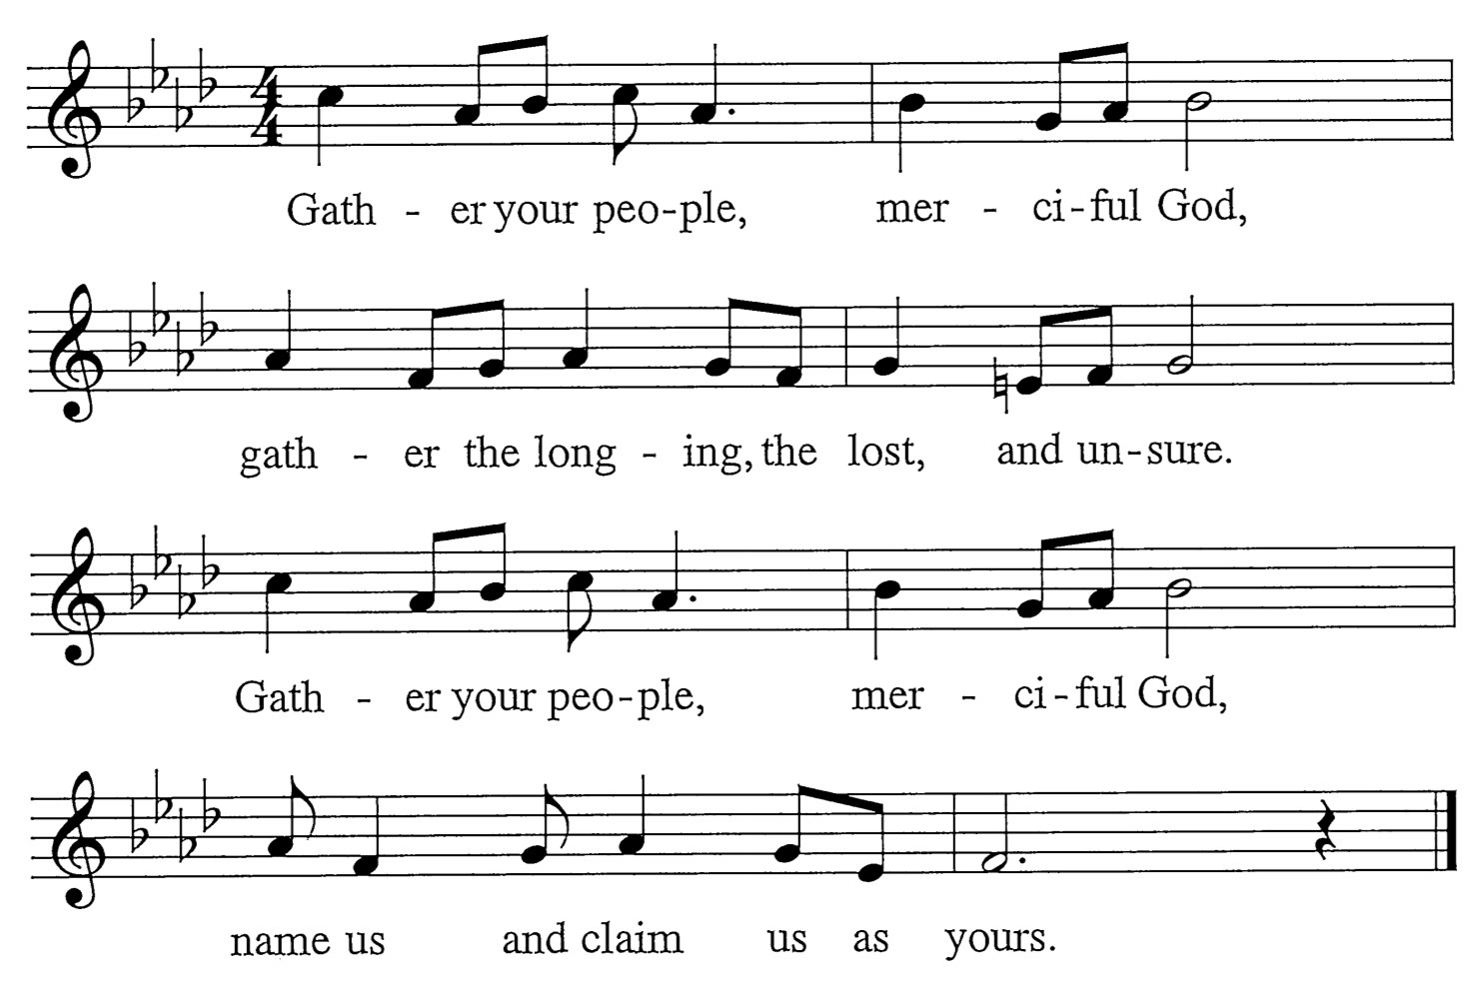
M: Surely, you alone can heal us. Yours is the will to make us whole.
Soothing with a mother’s kindness, the contrite of heart, you console.

C: Refrain
M: Surely, you alone can free us. You break the bonds of guilt and sin.
Bracing, till we walk uprightly, you bolster our hope once again.

C: Refrain

Words: Mary Louise Bringle Music: Tony Alonso
© 2009 GIA Publications, Inc. reprinted under OneLicense.net A-714740

