EVENING PRAYERS
M: Lord Jesus,
through the power of the Holy Spirit, Fill my mind even as I sleep.
Every hurt that has ever been done to me, heal that hurt.
Every hurt that I have ever caused another person, heal that hurt.
All the relationships that have been damaged in my whole life that I am not aware of, heal those relationships.
To that end, if there is anything that I need to do,
if I need to go to a person because he or she is still suffering from my hand, bring to my awareness that person.
Help me to forgive as you have forgiven me.
Remove whatever bitterness may be in my heart, Lord, and fill me wholly with your love.

C: Amen.

Special prayers and petitions may follow

THE LORD’S PRAYER
M: Hear us as we pray as Jesus taught.

C: Our Father in heaven, hallowed be your name, your kingdom come,
your will be done on earth as in heaven. Give us today our daily bread.
Forgive us our sins, as we forgive those who sin against us. Lead us not into temptation,
but deliver us from evil.
For the kingdom, the power, and the glory are yours now and forever. Amen.

BLESSING
M: The blessed and holy Trinity make you strong in faith and love, defend you on every side, and guide you in truth and peace, now and forevermore.

C: Amen.

HYMN 587 Now Rest Beneath Night’s Shadow

8
Midweek Lent April 9, 2014

BAPTIZED INTO HIS DEATH
THE RIGHT TOOL FOR THIS JOB

elcome! Thank you for joining us for worship this evening. In our service we gather before our almighty God to offer him our worship and praise. We also gather to strengthen ourselves through
W
the study of God’s holy and powerful word.

 Restrooms are located in the hallway directly opposite the entrance to the sanctuary.

 Cry-room. If you have a young child or nursing infant and are in need of a cry-room, you will find it to the right as soon as you exit the sanctuary. A speaker there allows you to hear the service.

Lent: A Time of Catechetical Review
Already at the time of the Reformation, Lutheran churches would set aside a number of times a year to hold special services that had the singular purpose of reviewing the catechism, a summary of key Biblical teachings. The scheduling of these special services would vary somewhat from year to year, with one exception. Lent was always used as a time of catechetical review.
We follow this Lutheran tradition this Lent by gathering for special midweek services under the theme:
Baptized Into His Death
Under this theme, we will learn anew all that which God’s Word tells us about baptism. We will see how in our baptism, we were powerfully connected to Christ’s death and resurrection. We will study again what our baptism means for our daily lives. And we will rededicate ourselves to the struggle of living the new life baptism gives.

DEVOTION

THANK OFFERING

Jesus said, “All authority in heaven and on earth has been given to me.
Therefore go and make disciples of all nations, baptizing them in the name of the Father and of the Son and of the Holy Spirit, and teaching them to obey everything I have commanded you.
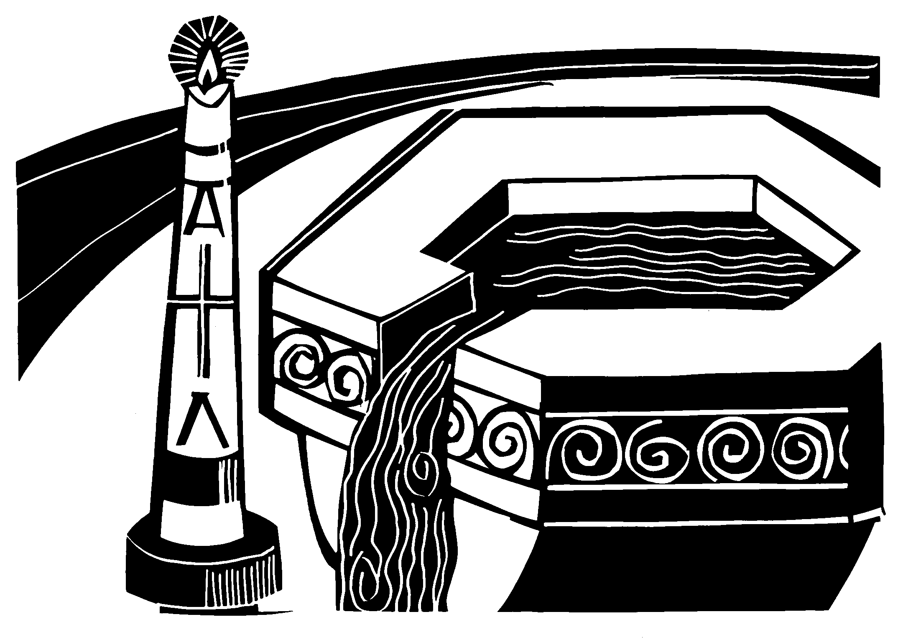And surely I am with you always, to the very end of the age.”

Matthew 28:18-20

ORDER OF SERVICE

PRAYER OF THE DAY
M: Let us pray.
O Lord God almighty,
temptations to ignore your will and Word surround us, entice us, and threaten to divide us.

C: Help us, dear Lord, that we may resist the temptations,
trust in Jesus, live in your truth, and enjoy true unity of faith. M: As you have bound us to yourself, bind us to our fellow believers, C: that we may walk together in the light of your glory. Amen.

PASSION READING Matthew 27:27-66
Death & Burial

INVOCATION
M: In the name of the Father, and of the  Son, and of the Holy Spirit.

C: Amen.
M: The LORD says, “Fear not, for I have redeemed you.
I have called you by name; you are mine.

C: When you pass through the waters, I will be with you.
When you walk through ﬁre, you shall not be burned.”
M: Glory to the Father, and to the Son, and to the Holy Spirit.

C: “Fear not, for I have redeemed you.
I have called you by name; you are mine.”
M: The Lord be with you.

C: And also with you.

PRAYER

The reading concludes as follows:
M: All of us who were baptized into Christ Jesus

C: were baptized into his death.

HYMN 127 Stricken, Smitten, and Afflicted
M: God, who as at this time
taught the hearts of your faithful people
by sending to them the light of your Holy Spirit: grant us by the same Spirit, given us in our baptism, to have a right judgment in all things
and evermore to rejoice in his holy comfort; through the merits of Christ Jesus our Savior, who is alive and reigns with you,
in the unity of the Holy Spirit, one God, now and for ever.

C: Amen.

THE NEW LIFE OF BAPTISM
M: Fellow redeemed, by your baptism
you were not only made sons and daughters of our heavenly Father, but also brothers and sisters to each other.
Rejoice in the family of believers.

C: Brothers and sisters, I rejoice with you in the new life of baptism.
Together we will give thanks and praise to God and proclaim the good news to all the world.
M: As brothers and sisters, you have a solemn responsibility to one another.
Therefore, I ask you, in the presence of God and one another, do you intend: to live among God’s faithful people,
to hear the word of God and share in the Lord’s Supper,
to proclaim the good news of God in Christ through word and deed, to serve all people, following the example of Christ,
to live according to the will of Christ, walking in all his commands, and to strive for justice and peace in all the earth,
and especially in our Christian family?

C: I do, and I ask God to help me.
M: Do you sincerely intend to love, support and pray for one another in your life in Christ?

C: I do, and I ask God to guide me.
M: Then let us pray.

PRAYER
M: Merciful Father in heaven,
We thank you for the blessing of baptism
by which you offer and grant the forgiveness of sins, life, and salvation.
Make us willing to carry out our responsibilities to those who have been baptized, so that all of us may finally come to the blessed joys of heaven,
through Jesus Christ, our Lord.

C: Amen.
M: Gather us, O Lord, as your holy people.

GATHING SONG

M: Refrain

C: Refrain
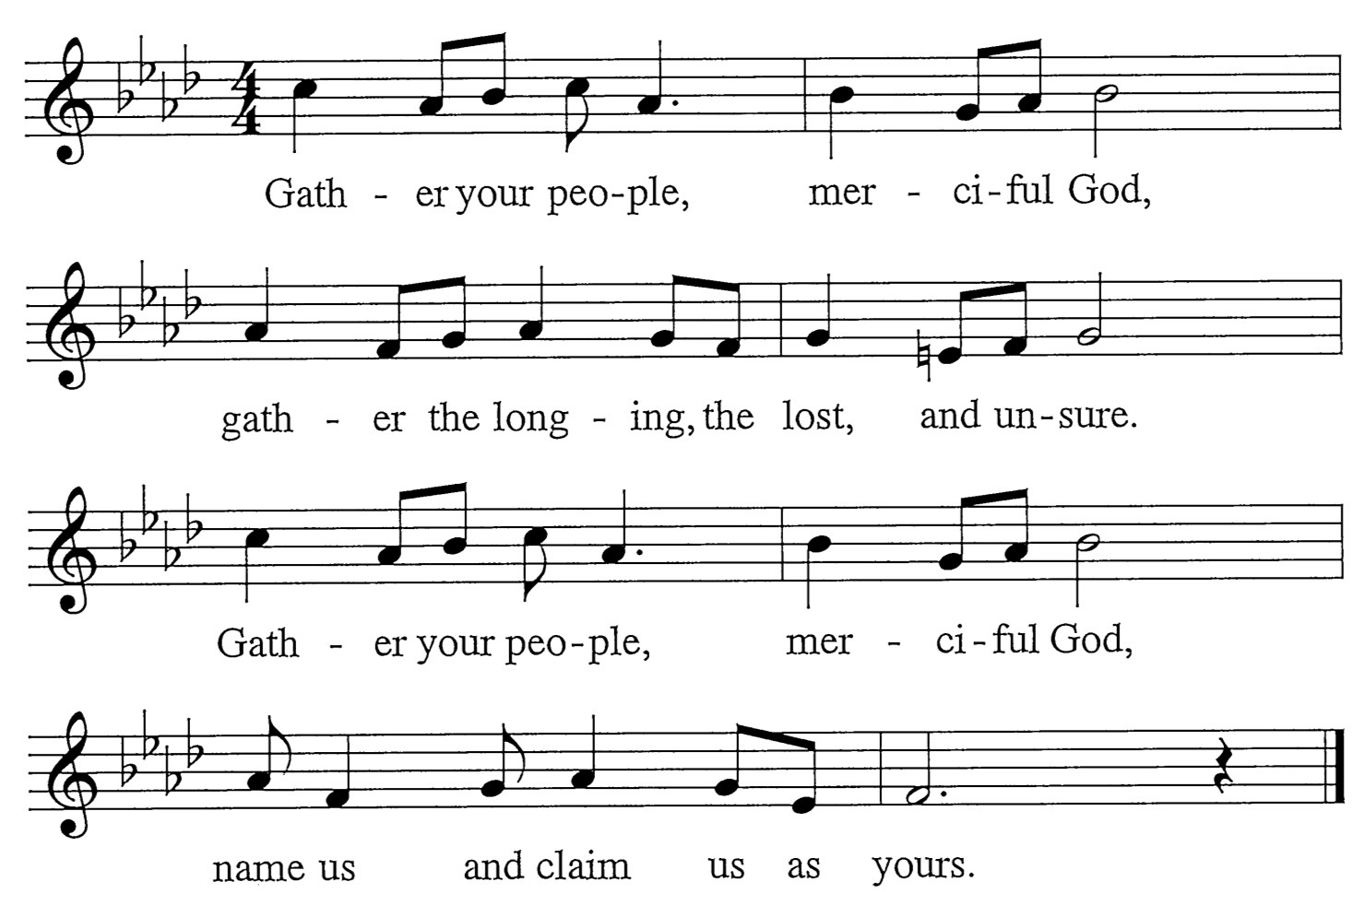
M: Surely, you alone can save us. You pay our price with your precious blood. Reaching through your great compassion, you lift up your people with love.

C: Refrain
M: Surely, you alone uphold us. You give us strength for all our needs. Shielding with a father’s favor, you bless us with pardon and peace.

C: Refrain

Words: Mary Louise Bringle Music: Tony Alonso
© 2009 GIA Publications, Inc. reprinted under OneLicense.net A-714740

