EVENING PRAYERS
M: I thank you, my heavenly Father, through Jesus Christ, your dear Son,
That you have graciously kept me this day. Forgive me all my sins,
and graciously keep me this night.
Into your hands I commend my body and soul and all things. Let your holy angel be with me,
that the wicked foe may have no power over me.

C: Amen.

Special prayers and petitions may follow

THE LORD’S PRAYER
M: Hear us as we pray as Jesus taught.

C: Our Father in heaven, hallowed be your name, your kingdom come,
your will be done on earth as in heaven. Give us today our daily bread.
Forgive us our sins, as we forgive those who sin against us. Lead us not into temptation,
but deliver us from evil.
For the kingdom, the power, and the glory are yours now and forever. Amen.

BLESSING
M: The Lord bless us,
and preserve us from all evil, and keep us in eternal life.

C: Amen.
M: Let us bless the Lord.

C: Thanks be to God.

HYMN 593 Now the Light Has Gone Away

8
Midweek Lent March 19, 2014

BAPTIZED INTO HIS DEATH
GREAT POWER & GREATER GIFT

elcome! Thank you for joining us for worship this evening. In our service we gather before our almighty God to offer him our worship and praise. We also gather to strengthen ourselves through
W
the study of God’s holy and powerful word.

 Restrooms are located in the hallway directly opposite the entrance to the sanctuary.

 Cry-room. If you have a young child or nursing infant and are in need of a cry-room, you will find it to the right as soon as you exit the sanctuary. A speaker there allows you to hear the service.

Lent: A Time of Catechetical Review
Already at the time of the Reformation, Lutheran churches would set aside a number of times a year to hold special services that had the singular purpose of reviewing the catechism, a summary of key Biblical teachings. The scheduling of these special services would vary somewhat from year to year, with one exception. Lent was always used as a time of catechetical review.
We follow this Lutheran tradition this Lent by gathering for special midweek services under the theme:
Baptized Into His Death
Under this theme, we will learn anew all that which God’s Word tells us about baptism. We will see how in our baptism, we were powerfully connected to Christ’s death and resurrection. We will study again what our baptism means for our daily lives. And we will rededicate ourselves to the struggle of living the new life baptism gives.

DEVOTION

THANK OFFERING

When the kindness and love of God our Savior appeared, he saved us, not because of righteous things we
had done, but because of his mercy. He saved us through the washing of rebirth and renewal by the Holy Spirit, whom he poured out on us generously through Jesus Christ our Savior.

Titus 3:4-6

PRAYER OF THE DAY
M: Let us pray.
Dear Lord Jesus, you came to die so that we might have a new birth.

C: Make us strong and bold to speak your truth.
M: May we never be ashamed to confess that you are the Son of God and our Savior.

C: May we be ever ready to tell others of the hope we have in you.
M: Praise be to your holy name.

C: Amen.

PASSION READING Matthew 26:36-56
Gethsemane
The reading concludes as follows:
M: All of us who were baptized into Christ Jesus

C: were baptized into his death.

HYMN 104 Go to Dark Gethsemane
ORDER OF SERVICE

INVOCATION
M: In the name of the Father, and of the  Son, and of the Holy Spirit.

C: Amen.
M: There is one body and one spirit.

C: There is one hope to which we were called;
M: one Lord, one faith, one baptism,

C: one God and Father of all.
M: Peace be with you. C: And also with you. M: Let us pray.

PRAYER
M: Almighty God,
in our baptism you have consecrated us to be temples of your Holy Spirit.
May we, whom you have counted worthy,
nurture this gift of your indwelling Spirit with a lively faith and worship you with upright lives;
through Jesus Christ our Lord.

C: Amen.

THE NEW LIFE OF BAPTISM
M: In baptism, God calls us out of darkness into his marvelous light.
To follow Christ means dying to sin and rising to new life with him. Therefore I ask:
Do you renounce the devil and all the forces that defy God?

C: I renounce them.
M: Do you reject the powers of this world that rebel against God?

C: I reject them.
M: Do you repent of the sins that separate you from God and neighbor?

C: I repent of them.
M: Do you turn to Christ as Savior and Lord?

C: I turn to Christ.
M: Christ claims you for his own. Receive the sign of his  cross.
Do not be ashamed to confess the faith of Christ cruciﬁed.

C: Fight valiantly as a disciple of Christ against sin, the world and the devil,
and remain faithful to Christ to the end of your life.

PRAYER
M: Almighty God,
deliver those you have claimed from the powers of darkness. Restore in us the image of your glory,
and lead us in the light and obedience of Christ.

C: Amen.
M: Gather us, Lord, as your holy people.

GATHING SONG

M: Refrain

C: Refrain
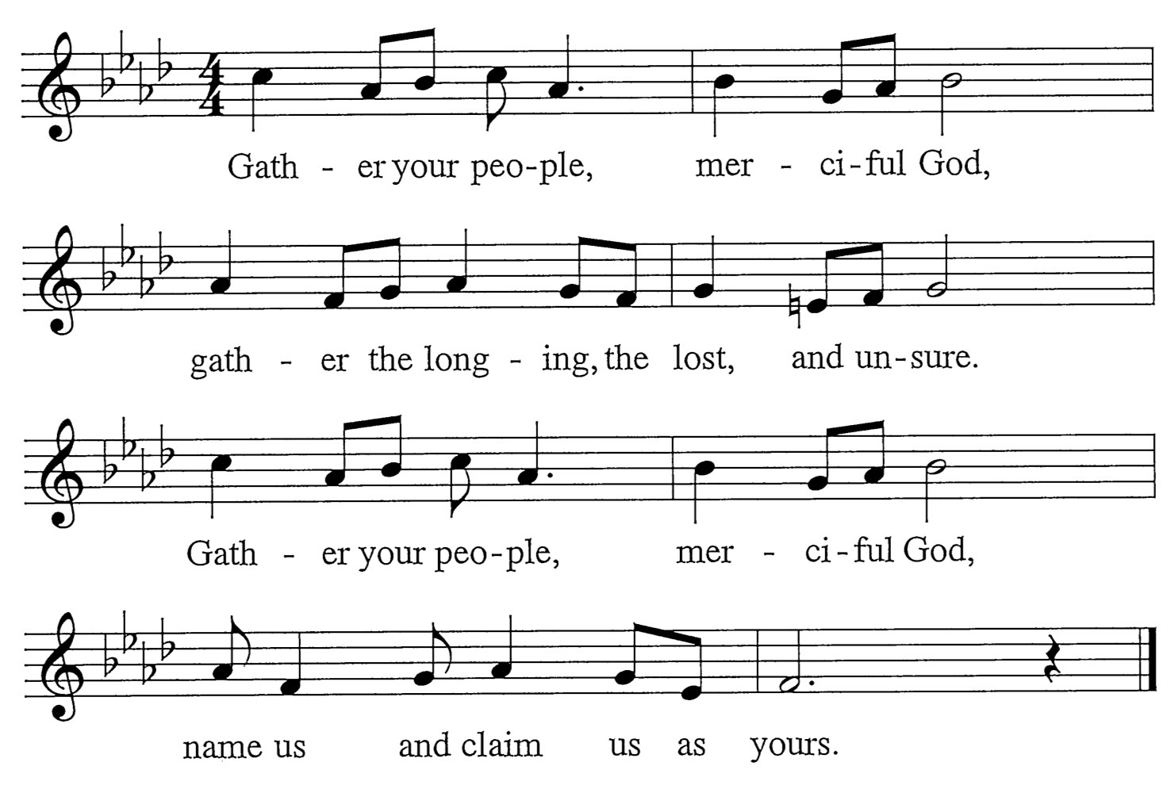
M: Surely, you alone can heal us. Yours is the will to make us whole.
Soothing with a mother’s kindness, the contrite of heart, you console.

C: Refrain
M: Surely, you alone can free us. You break the bonds of guilt and sin.
Bracing, till we walk uprightly, you bolster our hope once again.

C: Refrain

Words: Mary Louise Bringle Music: Tony Alonso
© 2009 GIA Publications, Inc. reprinted under OneLicense.net A-714740

