EVENING PRAYERS

8
M: O God our Father,
by your mercy and might the world turns safely into darkness and returns again to light. We place into your hands our unfinished tasks, our unsolved problems,
and our unfulfilled hopes,
knowing that only what you bless will prosper. To your great love and protection we commit each other and all those we love,
knowing that you alone are our great defender.

C: Amen.

Special prayers and petitions may follow

THE LORD’S PRAYER
M: Hear us as we pray as Jesus taught.

C: Our Father in heaven, hallowed be your name, your kingdom come,
your will be done on earth as in heaven. Give us today our daily bread.
Forgive us our sins, as we forgive those who sin against us. Lead us not into temptation,
but deliver us from evil.
For the kingdom, the power, and the glory are yours now and forever. Amen.

BLESSING
M: May God lead you in truth and steady your spirit.
May Christ renew your joy and strengthen your will.
May the Spirit teach you God’s hidden wisdom and fill you with songs of rejoicing. We go in peace to love and serve the Lord,

C: in the name of Christ. Amen.
Midweek Lent March 12, 2014

BAPTIZED INTO HIS DEATH
A SACRAMENT, NOT A SIGN

elcome! Thank you for joining us for worship this evening. In our service we gather before our almighty God to offer him our worship and praise. We also gather to strengthen ourselves through
W
the study of God’s holy and powerful word.

 Restrooms are located in the hallway directly opposite the entrance to the sanctuary.

 Cry-room. If you have a young child or nursing infant and are in need of a cry-room, you will find it to the right as soon as you exit the sanctuary. A speaker there allows you to hear the service.

Lent: A Time of Catechetical Review
Already at the time of the Reformation, Lutheran churches would set aside a number of times a year to hold special services that had the singular purpose of reviewing the catechism, a summary of key Biblical teachings. The scheduling of these special services would vary somewhat from year to year, with one exception. Lent was always used as a time of catechetical review.
We follow this Lutheran tradition this Lent by gathering for special midweek services under the theme:
Baptized Into His Death
Under this theme, we will learn anew all that which God’s Word tells us about baptism. We will see how in our baptism, we were powerfully connected to Christ’s death and resurrection. We will study again what our baptism means for our daily lives. And we will rededicate ourselves to the struggle of living the new life baptism gives.

DEVOTION

THANK OFFERING

The water [of the flood] symbolizes baptism that now saves you also — not the removal of dirt from the body but the pledge of a clear conscience toward God. It saves you by the resurrection of Jesus Christ, who has gone into
heaven and is at God’s right hand — with angels, authorities and powers in submission to him.

1 Peter 3:21-22

ORDER OF SERVICE

PRAYER OF THE DAY
M: Let us pray.
God of heaven, Lord of our salvation,
you came into a hostile world to bring us peace and comfort. You came to save people like us.

C: Thank you, Savior, for your sacrifice.
M: Be with us this evening in your love and keep us mindful of your forgiveness.
May we never consider your presence in our lives inconvenient,

C: but be with us by your Spirit
and guide our every step on the path of righteousness. Amen.

PASSION READING Matthew 26:1-35
Plot, Passover, & the Lord’s Supper
The reading concludes as follows:
M: All of us who were baptized into Christ Jesus

C: were baptized into his death.

HYMN 98 Jesus, I Will Ponder Now

INVOCATION
M: In the name of the Father, and of the  Son, and of the Holy Spirit.

C: Amen.
M: In Christ, God gives us water welling up for eternal life. With joy you will draw water from the wells of salvation.

C: Lord, give us this water and we shall thirst no more.
M: Let us give thanks to the Lord our God.

C: It is right to give thanks and praise.

PRAYER
M: Blessed are you, sovereign God of all. To you be glory and praise for ever. You are our light and our salvation.
From the deep waters of death
you have raised your Son to life in triumph.
Grant that all who have been born anew by water and the Spirit may daily be renewed in your image,
walk by the light of faith,
and serve you in newness of life; through your anointed Son, Jesus Christ, to whom with you and the Holy Spirit we lift our voices of praise.
Blessed be you God — Father, Son and Holy Spirit.

C: Blessed be God for ever.

THE NEW LIFE OF BAPTISM
M: Those who are baptized are called to worship and serve God. Therefore I ask you: Will you continue in the apostles’ teaching and fellowship,
in the breaking of bread, and in the prayers?

C: With the help of God, I will.
M: Will you persevere in resisting evil,
and, whenever you fall into sin, repent and return to the Lord?

C: With the help of God, I will.
M: Will you proclaim by word and example the good news of God in Christ?

C: With the help of God, I will.
M: Will you seek and serve Christ in all people, loving your neighbor as yourself?

C: With the help of God, I will.
M: Will you acknowledge Christ’s authority over human society, by prayer for the world and its leaders,
by defending the weak, and by seeking peace and justice?

C: With the help of God, I will.
M: Then let us pray.

PRAYER
M: Eternal God, our beginning and our end, preserve in your people the new life of baptism; as Christ receives us on earth,
so may he guide us through the trials of this world and enfold us in the joy of heaven,
where you live and reign, one God for ever and ever.

C: Amen.
M: Gather us, Lord, as your holy people.

GATHING SONG

M: Refrain

C: Refrain
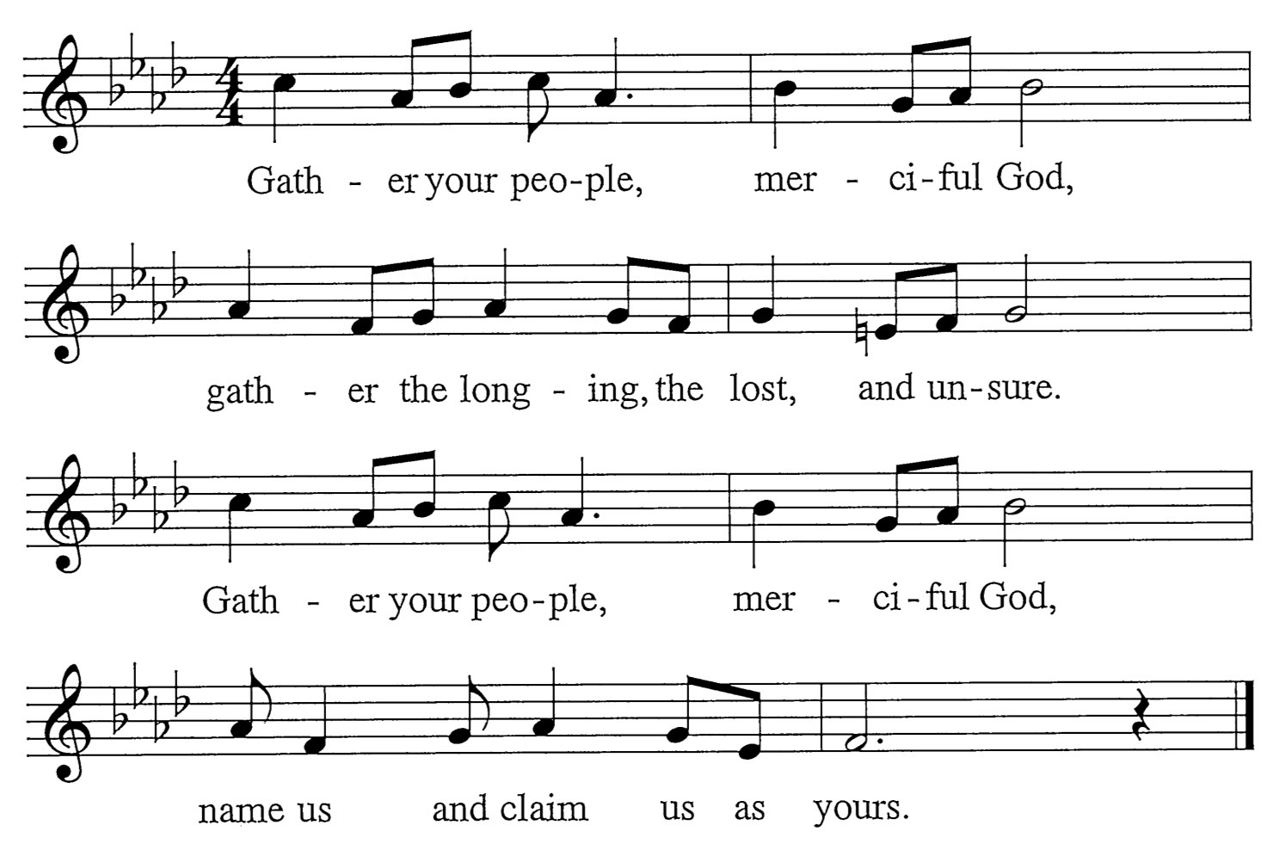
M: Surely, you alone can save us. You pay our price with your precious blood. Reaching through your great compassion, you lift up your people with love.

C: Refrain
M: Surely, you alone uphold us. You give us strength for all our needs. Shielding with a father’s favor, you bless us with pardon and peace.

C: Refrain

Words: Mary Louise Bringle Music: Tony Alonso
© 2009 GIA Publications, Inc. reprinted under OneLicense.net A-714740

