EVENING PRAYERS
M: Keep watch, dear Lord,
with those who watch or work or weep this night, and give your angels charge over those who sleep. Tend the sick,
give rest to the weary, pity the afflicted, sooth the suffering, bless the dying —
and all for your love’s sake.

C: Amen.

Special prayers and petitions may follow

THE LORD’S PRAYER
M: Hear us as we pray as Jesus taught.

C: Our Father in heaven, hallowed be your name, your kingdom come,
your will be done on earth as in heaven. Give us today our daily bread.
Forgive us our sins, as we forgive those who sin against us. Lead us not into temptation,
but deliver us from evil.
For the kingdom, the power, and the glory are yours now and forever. Amen.

BLESSING
M: The grace of our Lord Jesus Christ, and the love of God,
and the fellowship of the Holy Ghost, be with you all.

C: Amen.

HYMN 594 The Day You Gave Us, Lord, Is Ended

8
Midweek Lent March 26, 2014

BAPTIZED INTO HIS DEATH
BAPTISM IS NEEDED BY ALL

elcome! Thank you for joining us for worship this evening. In our service we gather before our almighty God to offer him our worship and praise. We also gather to strengthen ourselves through
W
the study of God’s holy and powerful word.

 Restrooms are located in the hallway directly opposite the entrance to the sanctuary.

 Cry-room. If you have a young child or nursing infant and are in need of a cry-room, you will find it to the right as soon as you exit the sanctuary. A speaker there allows you to hear the service.

Lent: A Time of Catechetical Review
Already at the time of the Reformation, Lutheran churches would set aside a number of times a year to hold special services that had the singular purpose of reviewing the catechism, a summary of key Biblical teachings. The scheduling of these special services would vary somewhat from year to year, with one exception. Lent was always used as a time of catechetical review.
We follow this Lutheran tradition this Lent by gathering for special midweek services under the theme:
Baptized Into His Death
Under this theme, we will learn anew all that which God’s Word tells us about baptism. We will see how in our baptism, we were powerfully connected to Christ’s death and resurrection. We will study again what our baptism means for our daily lives. And we will rededicate ourselves to the struggle of living the new life baptism gives.

DEVOTION

THANK OFFERING

Jesus answered, “Very truly I tell you, no one can enter the kingdom of God unless they are born of water and the Spirit. Flesh gives birth to flesh, but the Spirit gives birth to spirit. You should not be surprised at my saying, ‘You must be born again.’ The wind blows wherever it pleases. You hear its sound, but you cannot tell where it comes from or where it is going. So it is with everyone born of the Spirit.”

John 3:5-8

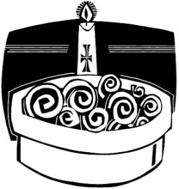ORDER OF SERVICE

PRAYER OF THE DAY
M: Let us pray.
God of grace and mercy, we bow before you in humble sorrow for our sins.

C: We are unworthy to receive the least of your blessings.
M: Lord, you gave Jesus into death for us, and for his sake you forgive us our sins.

C: May your great love for us work faithful love in us.
M: Keep us always in your care. We pray in his name.

C: Amen.

PASSION READING Matthew 26:57-75
Trial before the High Priest
The reading concludes as follows:
M: All of us who were baptized into Christ Jesus

C: were baptized into his death.

HYMN 115 He Stood before the Court

INVOCATION
M: In the name of the Father, and of the  Son, and of the Holy Spirit.

C: Amen.
M: Praise God who made heaven and earth,

C: who keeps his promise for ever.
M: Let us give thanks to the Lord our God.

C: It is right to give thanks and praise.

PRAYER
M: Almighty God, whose Son Jesus Christ was baptized in the river Jordan:
we thank you for the gift of water to cleanse us and revive us.
We thank you that through the waters of the Red Sea you led your people out of slavery
to freedom in the Promised Land.
We thank you that through the deep waters of death you brought your Son,
and raised him to life in triumph.
We thank you that in the water of our baptism you
made us one with Christ in his death and in his resurrection, to be cleansed and delivered from all sin.
Send your Holy Spirit upon us,
and raise us with Christ to full and eternal life;
for all might, majesty, authority and power are yours, now and for ever.

C: Amen.

THE NEW LIFE OF BAPTISM
M: I ask you, with the whole Christian Church, to confess your baptismal faith.
Do you believe in God the Father?

C: I believe in God, the Father almighty, creator of heaven and earth.
M: Do you believe in Jesus Christ, the Son of God?

C: I believe in Jesus Christ, God’s only Son, our Lord,
who was conceived by the Holy Spirit, born of the virgin Mary, suffered under Pontius Pilate, was crucified, died, and was buried; he descended into hell.
On the third day he rose again;
he ascended into heaven, he is seated at the right hand of the Father, and he will come to judge the living and the dead.
M: Do you believe in God the Holy Spirit?

C: I believe in the Holy Spirit,
the holy Christian Church, the communion of saints, the forgiveness of sins, the resurrection of the body, and the life everlasting. Amen.
M: Let us pray.

PRAYER
M: Almighty God,
we thank you for our fellowship in the household of faith with all who have been baptized into your name.
Keep us faithful to our baptism, and so make us ready for that day
when the whole creation shall be made perfect in your Son, our Savior Jesus Christ.

C: Amen.
M: Gather us, O Lord, as your holy people.

GATHING SONG

M: Refrain

C: Refrain
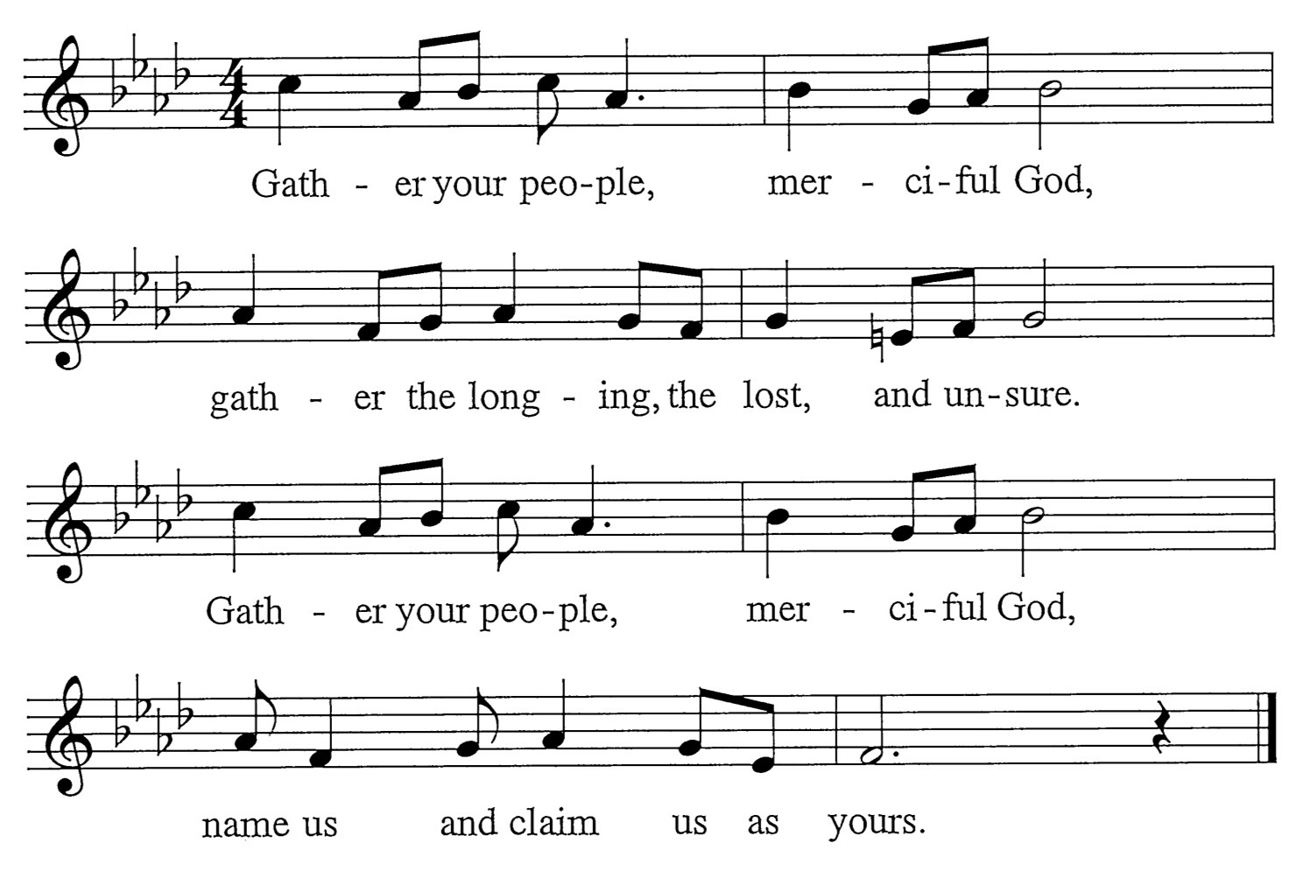
M: Surely, you alone refine us. You give us grace for lives made new, Forging, through your fire and radiance, a sacrifice worthy of you.

C: Refrain
M: Surely, you alone redeem us. You fill our dust with holy breath. Bursting from the grave in glory, you rise from the ashes of death.

C: Refrain

Words:: Mary Louise Bringle Music: Tony Alonso
© 2009 GIA Publications, Inc. reprinted under OneLicense.net A-714740

