Easter Festival Service

????? Evangelical Lutheran Church
???????, ??
“Certainly we must learn it from our own experience that no one on earth, not even the emperor, can withstand death, and yet a Christian can do it. Therefore one must regard the resurrection with other than physical eyes; otherwise one has no comfort from it. Here one must open the eyes of the heart!”

- Martin Luther
Sermon for Easter Sunday 1529

Welcome to Our Guests
(Insert specific information here.) Good morning and a blessed Easter to all of you! Welcome to this celebration of Jesus’ resurrection! We consider it a privilege to worship the living Lord with you this morning. If you have any questions regarding our Sunday services, weekly programs, Christian day school, or pre-school please talk with one of the pastors or call the church office. We look forward to meeting you.
Please come again and worship with us very soon!

Our Facilities
(Insert specific information here.) Our restrooms are located just to the left as you leave the sanctuary. The members of Trinity believe that families should be allowed to worship together. If your young one needs some “time out,” we have an audio-equipped children’s room outside of the church doors to your right. If you need anything during the service, please feel free to ask an usher.

Prayer Before Worship
O Lord, you made the dawn of this Holy Easter Day shine with the glory of our Savior’s resurrection. Grant that we, who have been raised from the death of sin by your life-giving Spirit, may worship you in sincerity and truth! In Jesus’ name. Amen.

The Resurrection of Our Lord

EASTER SUNDAY

April 20, 2014

?:?? and ??:?? a.m.

“Specific Theme Here!”

______________________________________________________________________________

Order of Service

COMMENT:
Easter is a time when we naturally want to “pull out all the stops” after the somber Season of Lent. There are potential pitfalls to pulling out the stops. Too many stops for too long can be hard on the ears by the final Amen. Instead, look for a variety of selections that use many of the musical resources the Lord has given you. Be careful to use a variety of instruments: organ and piano, loud trumpets and quiet flutes. This approach to Easter music allows for more of God’s people to participate and is for more interesting to ears in the pews.
A second pitfall comes in the area of quantity. Many parish choirs and musicians figure that they need to learn all new music every year. In reality, learning too much new music means that quality can suffer. In my years of directing parish choirs and musicians, I have aimed for three-thirds. One third of the music we sang last year. It is quickly relearned. One third of the music was sung within the last 2-4 years. It will come back to your musicians after some practice. Finally, one third of the music is brand new. This keeps your musicians stretching their capabilities.

Ringing of the Bells

Please stand as soon as the bells begin to ring.

Processional Hymn Jesus Christ Is Risen Today
Christian Worship 157

Sing every Alleluia in parts as able.
OPTION 1:
FOR A TRADITIONAL SETTING WITH INSTRUMENTS: See Richard Rose’s Hymnal Companion for Woodwinds, Brass and Percussion: Lent, Easter (CPH 976714WEB). These settings are for keyboard and as many other instruments as a congregation can muster. This would be the most accessible of the three options.
http://www.cph.org/p-4871-hymnal-companion-for-woodwinds-brass-and-percussion-lent-easter.aspx?SearchTerm=Rose
OPTION 2:
FOR A CONTEMPORARY SETTING: see Phil Magness Hymns for the Contemporary Ensemble Volume 2 (CPH 97-7096) beginning on page 30. The hymn is scored for rhythmic piano, guitar, C-instrument, B-flat instrument, or E-flat instrument (sax).
http://www.cph.org/p-5183-hymns-for-the-contemporary-ensemble-lent-easter-vol-2.aspx?SearchTerm=Magness
OPTION 3:
For a setting of the hymn that features two trumpets, organ, and soprano descant on stanza four check out S. Drummond Wolff’s setting available at http://www.morningstarmusic.com/viewitem.cfm/item_id/file_20-410-E. It is immediately downloadable as a pdf for $15.00. If two trumpets are not available, remember that one trumpet can still pull off many pieces like this. Remember, too, that a clarinet can play trumpet parts (best as a substitute for second trumpet).

Easter Dialogue

Minister: In the name of the Father and of the Son and of the Holy Spirit.

Congregation: Amen.

M: Christ is risen!

C: He is risen indeed!

M: Let us rejoice and give thanks to God for the victory our Lord Jesus Christ won by his death and resurrection. It is for us that he has triumphed.

Silence.

M: If anyone is in Christ, he is a new creation; the old has gone, the new has come!

C: Thanks be to God! He gives us the victory through our Lord Jesus Christ.

M: If we live, we live to the Lord; and if we die, we die to the Lord. So, whether we live or die, we belong to the Lord.

C: Thanks be to God! He gives us the victory through our Lord Jesus Christ.

M: We were therefore buried with him through baptism into death in order that, just as Christ was raised from the dead through the glory of the Father, we too may live a new life.

C: Thanks be to God! He gives us the victory through our Lord Jesus Christ.

M: Death has been swallowed up in victory. Where, O death, is your victory? Where, O death, is your sting?

C: Thanks be to God! He gives us the victory through our Lord Jesus Christ.

OPTION:
For a more contemporary feel, one might want to replace the Easter Dialogue with an Introit for Easter Sunday that can be found in I Have Risen: Contemporary Introits for the Easter Season (G-7656). The parts for C Instruments (G-7656INST) and Guitar (G-7656G) are sold separately. Performance directions are located on page 2 in the choral edition. This selection could also be used in place of the opening hymn as a call to worship.

http://www.giamusic.com/search_details.cfm?title_id=10484

Confession and Absolution

M: Dear friends, let us approach God with a true heart and confess our sins, asking him in the name of our Lord Jesus Christ to forgive us.

C: Lord of life, I confess that I am by nature dead in sin.
For faithless worrying and selfish pride,
For sins of habit and sins of choice,
For the evil I have done and the good I have failed to do,
You should cast me away from your presence forever.
O Lord, I am sorry for my sins. Forgive me, for Jesus’ sake.

M: Christ has died. Christ is risen. Christ will come again. In his great mercy, God made us alive in Christ even when we were dead in our sins. Hear the word of Christ through his called servant:
I forgive you all your sins in the name of the Father and of the Son (+) and of the Holy Spirit.
C: Amen.

LORD, HAVE MERCY
Kyrie

M: In peace, let us pray to the Lord.

For the well being of all people everywhere, that they may receive from you all they need to sustain body and life, hear our prayer, O Lord.

C: Lord, have mercy.

M: For the spread of your life-giving gospel throughout the world, that all who are lost in sin may be brought to faith in you, hear our prayer, O Christ.

C: Christ, have mercy.

M: For patience and perseverance in this life, that we may not lose the hope of eternal life as we await your return, hear our prayer, O Lord.

C: Lord, have mercy.

M: Lord of life, live in us that we may live for you.

C: Amen.

Canticle This Is the Feast of Victory
Christian Worship 265

M: In the peace of forgiveness, let us praise the Lord!

OPTION #1: Thanks Be to God
Christian Worship Supplement 788

Choir or soloist sings the verses. The congregation sings the refrain. The music for the refrain can be found in the Christian Worship Supplement Electronic Edition available at NPH. This is perhaps the easiest option to implement for congregations with limited musical resources.

OPTION #2:
It is proper to replace the Gloria in excelsis with the canticle Dignus est agnus during the Season of Easter. One could play This Is the Feast straight from Christian Worship 265 with choir or soloist singing the verses and the congregation singing the refrain. A well-known festival setting by Richard Hillert utilizing choir and brass can be found at http://www.cph.org/p-5484-festival-canticle-worthy-is-christ.aspx?SearchTerm=Hillert Note that a director’s score and instrumental parts are available separately.

OPTION #3: This Is the Feast
Setting by Peter Hallock

This large and festive setting of Dignus est agnus is for organ and optional brass. It can be ordered from ionianarts.com catalog #CH-1012. It is written in a contemporary-classical style.

The congregation joins the choir to sing the refrain.
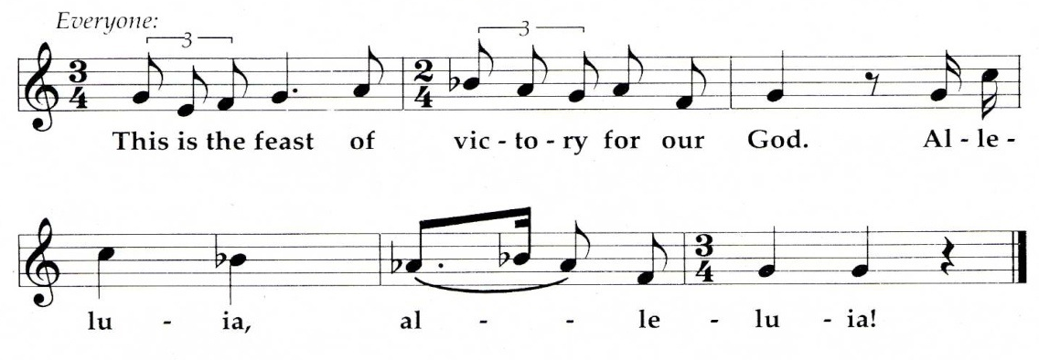

The choir sings the verses of the canticle.

Worthy is Christ, the Lamb who was slain, whose blood sets us free to be people of God. Refrain

Power, riches, wisdom, and strength, and honor, blessing, and glory are his. Refrain

Sing with all the people of God, and join in the hymn of all creation: Refrain

Blessing, honor, glory, and might be to God and the Lamb forever. Amen. Refrain

For the Lamb who was slain has begun his reign. Alleluia! Refrain

OPTION IV:
If you wish to keep the Gloria in excelsis, consider the metrical version that is found in the CWS Divine Service II. The four stanzas found on CWS p. 30 can be sung according to the tune of DUKE STREET (“I Know that My Redeemer Lives”) found below. This would be an easy opportunity to include instruments on, for instance, stanzas one and four. The Richard Rose resource that was suggested for the opening hymn (Option 1) also contains a setting of DUKE STREET for organ/keyboard and a wide variety of instruments. Beware, however: I Know that My Redeemer Lives is suggested for the closing hymn. Some repetition is a good thing especially in situations where new congregations are actively learning the basic hymns. If you chose this option for the Gloria, then choose fewer stanzas, perhaps just one or two, for the closing hymn.

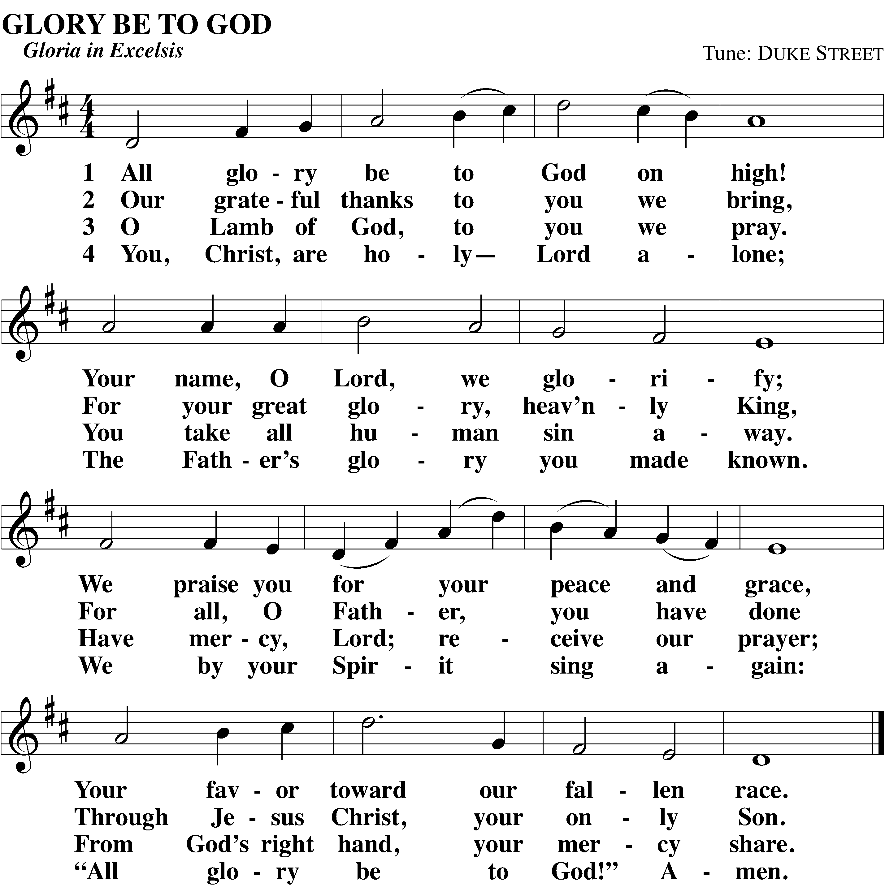

The Word of God

M: The Lord be with you.
C: And also with you.

M: Let us pray.

Almighty God, by the glorious resurrection of your Son Jesus Christ you conquered death and opened the gate to eternal life. Grant that we, who have been raised with him through baptism, may walk in the newness of life and ever rejoice in the hope of sharing his glory; through Jesus Christ our Lord, to whom, with you and the Holy Spirit be dominion and praise now and forever.

C: Amen.

Be seated

First Lesson Jonah 2:2-9 (NIV)
????????

“Eclectic approach” Scripture Lesson goes here.

Psalm of the Day Psalm 118

Settings of Psalm 118 abound. Consider the following:
OPTION 1:
For a more contemporary approach to Psalm 118, consider “Easter Alleluia” that is available at http://www.giamusic.com/search_details.cfm?title_id=4430. A flute part is included with the choir copies. A larger set of instrumental parts is also available at the GIA link immediately above. An mp3 recording of the selection is also found there. The selection goes best with piano, guitar, and flute. It is an easy sing for a parish choir. Verses 1-3 of the selection service as the Psalm of the Day.
OPTION 2:
For a more traditional approach to Psalm 118 use the setting in Christian Worship Supplement on page 57. Choir sings the verses in unison. The congregation joins in the refrains and Glory Be.

OPTION #3:
If one has recently done the Haugen setting of Psalm 118 (Option 1), the setting by Hal Hopson found in The People’s Psalter (MorningStar Music) is a good choice. This one publication contains copyable settings for almost every psalm at the reasonable price of $38.00. They are wonderfully melodic and are a wise choice for congregations that struggle with chanting the psalms. Each of the Hopson settings can be done with a soloist or choir. Many include parts for C Instruments or handbells. It is available at http://www.morningstarmusic.com/viewitem.cfm/item_id/80-786
OPTION #4:
A substantial musical presentation of Psalm 118 can be found in James Chepponis “Eastertime Psalm: Psalms for Easter, Ascension, and Pentecost.” It can be found at http://www.giamusic.com/search_details.cfm?title_id=3495. This psalm setting goes best on the organ. The brass parts are not absolutely necessary, but are a significant addition to the grandeur of the piece. A choir is definitely needed. This psalm setting enables good stewardship of time: the same music is utilized for the festivals of Ascension and Pentecost. Learn one piece; sing it three times.

Second Lesson Colossians 3:1-4 (NIV)
We are raised with Christ

“Eclectic approach” Scripture Lesson goes here.

Verse of the Day

OPTION 1:
Those desiring a grand sound to introduce the Gospel of the Lord's resurrection should consider Irish Alleluia by Richard Proulx. Parts for brass can be purchased separately. The alleluia refrain is a contagious sing. The choir sings the proper verse. http://www.giamusic.com/search_details.cfm?title_id=1463.
Choir: Refrain
C: Refrain

Choir: Speak, O Lord, your servant is list’ning; you have the words of everlasting life.
C: Refrain

Choir: Christ has become our paschal (Easter) sacrifice; let us feast with joy in the Lord.
C: Refrain

OPTION #2:
For those desiring a grand sound for the verse, but have recently done option #1, the series of Gospel Acclamations published by Augsburg would be a good investment. The series by Aaron David Miller for the Lent-Holy Trinity cycle is especially good. They may be ordered directly from Augsburg. http://store.augsburgfortress.org/store/product/2526/Gospel-Acclamations-for-Lent-Holy-Trinity.

OPTION #3:
Those desiring a hymn in place of the verse should consider having a choir or soloist chant the melody to hymn 144 with or without accompaniment. (This is a chant-based hymn so don’t sing in parts.) The congregation, accompanied by the organ, can sing the Alleluia section (the hymn's last three lines). Again, place it in the bulletin.
OPTION #4:
For those wanting to continue the contemporary approach throughout the lessons, “Easter Alleluia” (suggested for the Psalm of the Day) contains two verses that function well as the Verse of the Day (Verses four and five.) See the notes under the Psalm section for ordering and performance information. It is available at http://www.giamusic.com/search_details.cfm?title_id=4430.

Stand out of respect for the Gospel of Christ

Holy Gospel Matthew 28:1-10 (NIV)
The first visitors to the empty tomb

M: The Holy Gospel according to St. Matthew, Chapter 28.
C: Glory be to you, O Lord!

“Eclectic approach” Scripture Lesson goes here.

M: The Gospel of the Lord!
C: Praise be to you, O Christ!

Be seated

Anthem

COMMENT:
If the choir has participated throughout the service (This Is the Feast, Psalm, Verse, and Hymn of the Day), one should carefully determine if the choir has the needed time to prepare an anthem. The following anthem’s are offered for consideration:

OPTION 1:
John Behnke’s Awake, My Heart with Gladness is a rather straightforward presentation of this Lutheran Easter classic. It utilizes piano, four-part choir, and two optional flutes. It can be found at http://www.cph.org/p-6208-awake-my-heart-with-gladness.aspx?SearchTerm=98-3999. Copies are currently on sale for .80 a copy - a good musical buy.

OPTION 2:
Handel’s Hallelujah Chorus is often sung on Easter Sunday. Another Easter favorite from the Classical repertoire is Alleluia! For Christ the Lord Is Risen / Alleluia! O Praise the Lord Most Holy. It is available at http://www.cph.org/p-5473-alleluia-for-christ-the-lord-is-risen-alleluia-o-praise-the-lord-most-holy.aspx?SearchTerm=Christ%20the%20Lord. Bach was profoundly Lutheran. His music deserves to be heard by Lutheran today. This piece should be within the musical reach of many WELS choirs.

OPTION 3:
For those desiring a significant contemporary sound, Matt Maher’s Resurrection Day may work well. All that is needed can be found at http://www.ocp.org/products/89552 as a printable download. This selection perhaps would work best with parishes that already have a standing contemporary ensemble. Textually it is not deep, but the selection could serve well as an acclamation of praise to the Word that has just been heard in the Easter lessons and anticipating the Word proclaimed from the pulpit.

OPTION 4: The Tomb Is Empty
If it was not sung last year, churches should strongly consider David Haas’ The Tomb Is Empty. It can be found at http://www.giamusic.com/search_details.cfm?title_id=415 where a downloadable guitar part is also available. It is written in a fresh, contemporary style with a wide appeal. Consider "building" the piece over its five stanzas along these lines: v.1-Women sing melody, v.2-Men join in on melody, v.3-5 Choir in parts. Push the tempo and volume a little for each successive stanza.
The Tomb Is Empty
Words by Sylvia Dunstan
Setting by David Haas

The tomb is empty, is empty! Come and see where once the body lay.
Can it be true, be true that Jesus Christ is raised to life today?
Sing alleluia!

The tomb is empty, is empty! Come and hear these words of life and peace:
“He is not here, not here. He lives again in all your Galilees.”
Sing alleluia!

The tomb is empty, is empty! Come and touch the stone and folded shroud.
Christ lives indeed, indeed. Alleluia! Believers, shout aloud.
Sing alleluia!

The tomb is empty, is empty! Come and meet the risen Christ our Lord
In whom we have, we have our victory, in whom is life restored.
Sing alleluia!

The tomb is empty, is empty! Go and serve all people who long to be free!
Raise those who sleep, who sleep in tombs of fear, and give them eyes to see!
Sing alleluia!

Hymn of the Day Christ Has Arisen, Alleluia
Christian Worship Supplement 719

This hymn tune comes to us from Tanzania. It serves as a reminder that the Easter victory of Christ is a victory for the world. A concertato for this hymn was written by Dr. John Behnke for Northwestern Publishing House. It is available for download at http://online.nph.net/p-4946-christ-has-arisen-alleluia-full-score-vocal-inst-congr-pdf.aspx. Purchase of a single copies entitles you to make adequate copies for your entire musical group.

A second method of performance for churches with fewer musical resources would be to have a soloist sing stanzas three and four (the angel’s proclamation). The congregation sings stanzas 1, 2, 5, and every refrain. The hymn is easily inserted into worship folders using the CWS e-edition from NPH.

Sermon Based upon ?????
Pastor ????? ?????????

??????????

Stand

Apostles’ Creed

If communion is being celebrated, instert the Nicene Creed instead.

I believe in God, the Father almighty,
maker of heaven and earth.

I believe in Jesus Christ, his only Son, our Lord,
who was conceived by the Holy Spirit,
born of the virgin Mary,
suffered under Pontius Pilate,
was crucified, died, and was buried.
He descended into hell.
The third day he rose again from the dead.
He ascended into heaven
and is seated at the right hand of God the Father almighty.
From there he will come to judge the living and the dead.

I believe in the Holy Spirit,
The Holy Christian Church,
the communion of saints,
the forgiveness of sins,
the resurrection of the body,
and the life everlasting. Amen.

Be seated

Gathering of Our Offering
Please take a moment during the collection of the offering to sign the FRIENDSHIP REGISTER in each of the pews. Then take a moment after the service to get to know those seated around you!

If you are not a member of Trinity Lutheran, we do not want you to feel obligated to give an offering. We gather our offerings in church, because the Bible teaches that giving is an act of worship. The vast majority of our church and school ministry is carried out by what is given on Sunday morning. May the Lord bless you! And may he use our gifts to be a blessing to many others!

Offertory and Musical Offering

OPTION:
Biblical stewardship teaches that we bring the living Lord our best and only our best. The same goes for our musical offerings. Consider publishing the title of the offering music as a “Musical Offering.” Invite your musician/musicians to work toward something that will stretch their abilities. There is a wealth of music based upon the hymns of Easter. If a hymn-based selection is used, place a key stanza or two in the worship folder for people to meditate upon while the music is played.

Stand

Prayer of the Church

M: Heavenly Father, God of grace, you have brought us into a new and living hope by the resurrection of Jesus from the dead.
C: Christ is risen!

M: For as in Adam all died, so in Christ all will be made alive.
C: He is risen indeed!

M: He was delivered over to death for our sins and raised to life for our justification.
C: Alleluia!

M: We marvel at the love you showed by your willingness to sacrifice your Son to pay for our sins; we bow down in adoration at your mighty power, which raised him from the dead.
C: We praise you for sending the true Life and Light into the world.

M: Lord Jesus, God of grace, you have filled our hearts with resurrection joy by your victory over sin, death, and the grave.
C: You have conquered the darkness and given us comfort and hope.

M: With the Church of every age, we offer you unending praise, for you have crushed Satan's head and have removed our guilt.
C: You are risen!

M: Dear Savior, we who are weary and burdened come to you for rest, knowing that because of your perfect redemption there is now no condemnation for us.
C: You are risen indeed!

M: Take away our doubts and fears, and daily renew in us the joy of our salvation.
C: Alleluia!

M: Holy Spirit, God of grace, you have called us by the gospel and brought us to saving faith in our risen Lord.
C: We glorify you for opening our eyes to see the light of life.

M: Keep us with Jesus Christ in the one true faith.
C: He is risen!

M: As we journey through life, make us yearn for the day when you will give eternal life to us and all believers in Christ.
C: He is risen indeed!

Special prayers and intercessions may follow.

M: Hear us, Lord, as we bring you our private petitions.

Silent prayer

M: Work through us as we proclaim the saving message of the crucified and risen Jesus near and far, so that many others may hear your call, obtain the salvation that is in Christ Jesus, and join us before the throne of our God and of the Lamb.
C: Alleluia! For our Lord God Almighty reigns. Alleluia! Amen.

Lord’s Prayer

C: Our Father in heaven, hallowed be your name, your kingdom come, your will be done on earth as in heaven. Give us today our daily bread. Forgive us our sins, as we forgive those who sin against us. Lead us not into temptation, but deliver us from evil. For the kingdom, the power, and the glory are yours now and forever. Amen.

Be seated

Sermon Hymn Come, You Faithful, Raise the Strain
Christian Worship #142

COMMENT:
Play this hymn in a rather straight-forward manner without a variety of instruments, settings, etc. Why? If every musical selection “blows the roof off,” their total effect is minimized. Like any good piece of music, there should be louder/more-complex and softer/less-complex sections in a service to help keep the ear’s interest.

If you desire to do something special with the Sermon Hymn, take a look at Phil Magness’ Hymns for the Contemporary Ensemble: Lent/Easter. There you can find a solid contemporary setting of this hymn that can be done with as little as piano and a solo voice leading the congregation. Guitar parts, bass guitar, C-instrument, B-flat instrument, and E-flat instrumental parts are also included for ever-increasing color and complexity. It is available for purchase at http://www.cph.org/p-5183-hymns-for-the-contemporary-ensemble-lent-easter-vol-2.aspx?SearchTerm=Hymns%20for%20the%20contemporary%20ensemble.

If you desire to do something special with the Sermon Hymn with a brass/organ traditional sound, download Wolff’s concertato on this hymn from CPH. It is available at http://www.cph.org/p-23484-come-you-faithful-raise-the-strain-downloadable.aspx?SearchTerm=Gaudeamus%20Pariter. For congregations that have difficulty in fielding a brass quartet, the brass parts could be played on a second keyboard (piano). Caution: be certain the piano is tuned to the organ pitch! There is also one stanza in this concertato for organ and trumpet. This single stanza from Wolff’s could be used for stanzas one and three from CW.

Stand

Closing Prayer

M: Grant, O Lord, that the lips which here have sung your praises may continue to glorify you in the world; that the ears which have heard you speak may be open always to your Word and closed to discord; that the tongues which have confessed your name may always speak the truth without fear; that all of us who have worshiped together today may be united in true love for each other as you have loved us, through Jesus Christ, your Son, our Lord.
C: Amen.

Blessing

M: The Lord bless you and keep you.
The Lord make his face shine on you and be gracious to you.
The Lord look on you with favor and give you peace.
C: Amen.

Closing Hymn I Know That My Redeemer Lives
Christian Worship #152 (suggested stanzas 1-2, 7-8)
Sing each stanza slightly louder than the previous one.

OPTION:
A very accessible concertato can be purchased from Selah Publications at http://selahpub.com/Choral/ChoralTitles/425-401-JesusShall.html . This concertato also has a second text that is useful for Epiphany and Christ the King. Learn one concertato and cover three festivals in one year!
OPTION II:
A setting of DUKE STREET is printed in the Richard Rose volume that was referenced under the opening hymn. This is the easiest option to enable participation by several different instruments. Consider using different types of instrument for different stanzas: one stanza woodwinds, another brass, still another organ solo, etc.

OPTION III:
John Behnke has written a concertato on I Know That My Redeemer Lives that includes 2 to 3 octaves of handbells. This would be a very bright and festive close to Easter worship. The concertato is scored for SAB, organ, and trumpet. One can find it at http://www.cph.org/p-5640-i-know-that-my-redeemer-lives.aspx.

______________________________________________________________________________

TRINITY EV. LUTHERAN CHURCH + 1052 WHITEROCK AVENUE + WAUKESHA, WI
Office: 262-547-5350 www.trinitywels.com

Rev. Aaron Christie + Rev. Lawrence Gates + Rev. Scott Oelhafen
Mr. Jeff Inniger, Principal

All music and liturgical texts in this folder are reprinted with permission under OneLicense.net License #A-704382

