16

Your congregation’s license information goes here

Lenten Gathering Rite: God of Creation
Words and music: Ian Callanan
© 2009 GIA Publications, Inc.

Gospel Acclamation from Mass of Light
Music: David Haas
©1988 GIA Publications, Inc.
Third Sunday in Lent March 23, 2014

IN THE SHADOW OF THE CROSS
THE BLIND CAN FINALLY SEE

CLOSING HYMN — 379 Amazing Grace
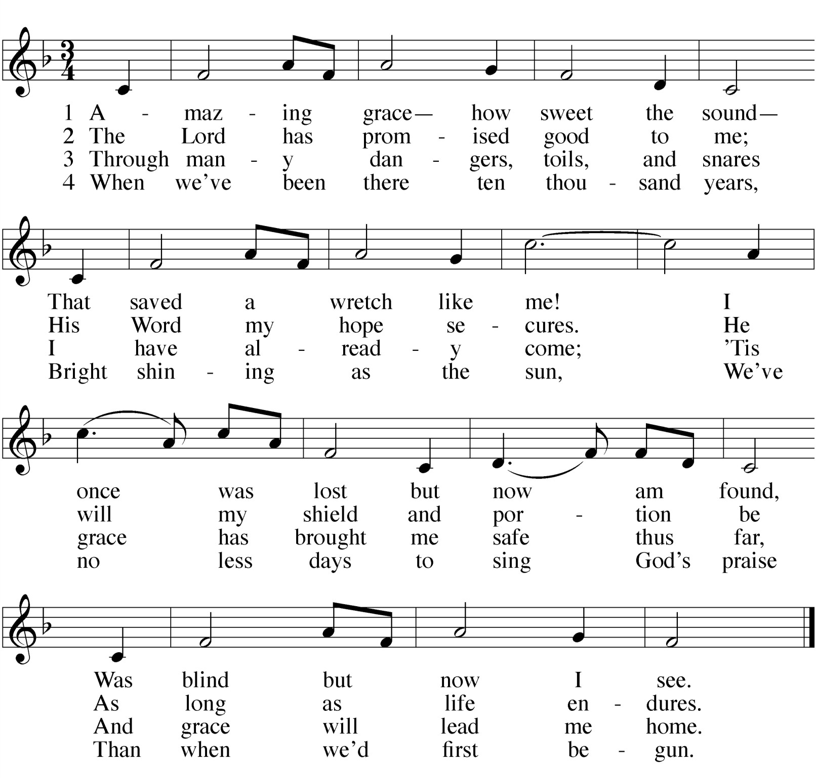

 The Prayers 

THE PRAYER OF THE CHURCH
Prayers and petitions are offered on behalf of the Church
M: Hear us now, Lord, as we bring you our private petitions.
Silent prayer
M: Almighty God, we come before you trusting that you hear our prayers. In your mercy, listen to our supplications on behalf of all for whom we pray and fulfill our desires and petitions according to your will, for we pray in Jesus’ name, and as he taught.

THE LORD’S PRAYER

C: Our Father in heaven, hallowed be your name, your kingdom come,
your will be done on earth as in heaven. Give us today our daily bread.
Forgive us our sins, as we forgive those who sin against us. Lead us not into temptation,
but deliver us from evil.
For the kingdom, the power, and the glory are yours now and forever. Amen.

THE BLESSING
M: Brothers and sisters, go in peace.
Live in harmony with one another. Serve the Lord with gladness.
The Lord bless you and keep you.
The Lord make his face shine on you and be gracious to you. The Lord look on you with favor and give you peace.

C: Amen.
WORSHIP NOTES
THE SEASON OF LENT
The word Lent comes from an Old English word for Spring (“lengten,” the time of the year when the days grow longer). For the last 1700 years, the Church has set aside the 40 days between Ash Wednesday and Easter as a time of special preparation. It is a time of repentance and renewal.
During Lent, our rejoicing is muted as we remember our Lord’s suffering and death. But it is with a purpose: we know that the Lord who died took up his life again on Easter Sunday morning. So our 40 days of Lent are ones lived in the certain hope of the resurrection.
The color of the season is purple. Purple is the ancient color of royalty. We have this kind of king: he wore a crown of thorns, and carried a cross for us. Thanks be to God!
For the precise counters in the congregation, the Church speaks of only 40 days of Lent because we do not count the Sundays, which retained their significance as “little Easters.” That is why they are called “Sundays in Lent” and not “Sundays of Lent.”
So we walk through this Lenten season, solemn but hopeful. We walk in the shadow of the cross. Our worship follows this pattern.
IN THE SHADOW OF THE CROSS
The devil is defeated The gift comes by faith
The blind can finally see Selfishness is crushed
We are raised from death to life King Jesus humbly walked
OUR THEME FOR TODAY
The blind can finally see. Blindness is a disability. Jesus cares about such physical challenges. We see that in the way that he healed the blind. However, physical blindness can be managed. Many who are physically blind lead rich, rewarding lives. A much worse condition is spiritual blindness. Spiritual blindness occurs when one cannot see the world, themselves, the future, or God accurately. Scripture says we all come into the world spiritually blind. But today we see how Christ opens our eyes so that we can finally see things as they really are.

AN ORDER OF SERVICE FOR LENT
By combining a unique confession of sins, a traditional Lenten confession of faith, and carefully chosen lessons, this order of service allows the believer to come to a full awareness of the seriousness of his or her sin, and also to joyfully remember the source of its cure.

 The Gathering 

GATHERING SONG

CONFESSION OF FAITH The Apostles’ Creed

I believe in God, the Father almighty, maker of heaven and earth.
I believe in Jesus Christ, his only Son, our Lord,
who was conceived by the Holy Spirit, born of the virgin Mary,
suffered under Pontius Pilate,
was crucified, died, and was buried. He descended into hell.
The third day he rose again from the dead.
He ascended into heaven
and is seated at the right hand of God the Father almighty. From there he will come to judge the living and the dead.
I believe in the Holy Spirit,
the holy Christian Church, the communion of saints, the forgiveness of sins,
the resurrection of the body, and the life everlasting.
Amen.

THANK OFFERING
M: | (verse 1 — sung) | God of creation, Giver of life,  be the light in our darkness; grant us peace in our strife. Show us your mercy.  Give us new birth.  You have made us your children
 |  | to bear fruit on the earth. | (to Kyrie, verse 1)
M: | (verse 2 — sung) | Lord, our Redeemer, Healer of souls,  be the hope that restores us. With your touch make us whole.  Here you speak to us through holy Word.  Send your Spirit among us
 |  | that your voice may be heard. | (to Kyrie, verse 2)
M: | (verse 3 — sung) | Spirit, most holy, Comforter blest,  be the fire that consumes us and our hearts’ welcome guest. Form us. Renew us.  Call us by name.  Raise us up from the ashes and create us again. | (to Kyrie, verse 3)

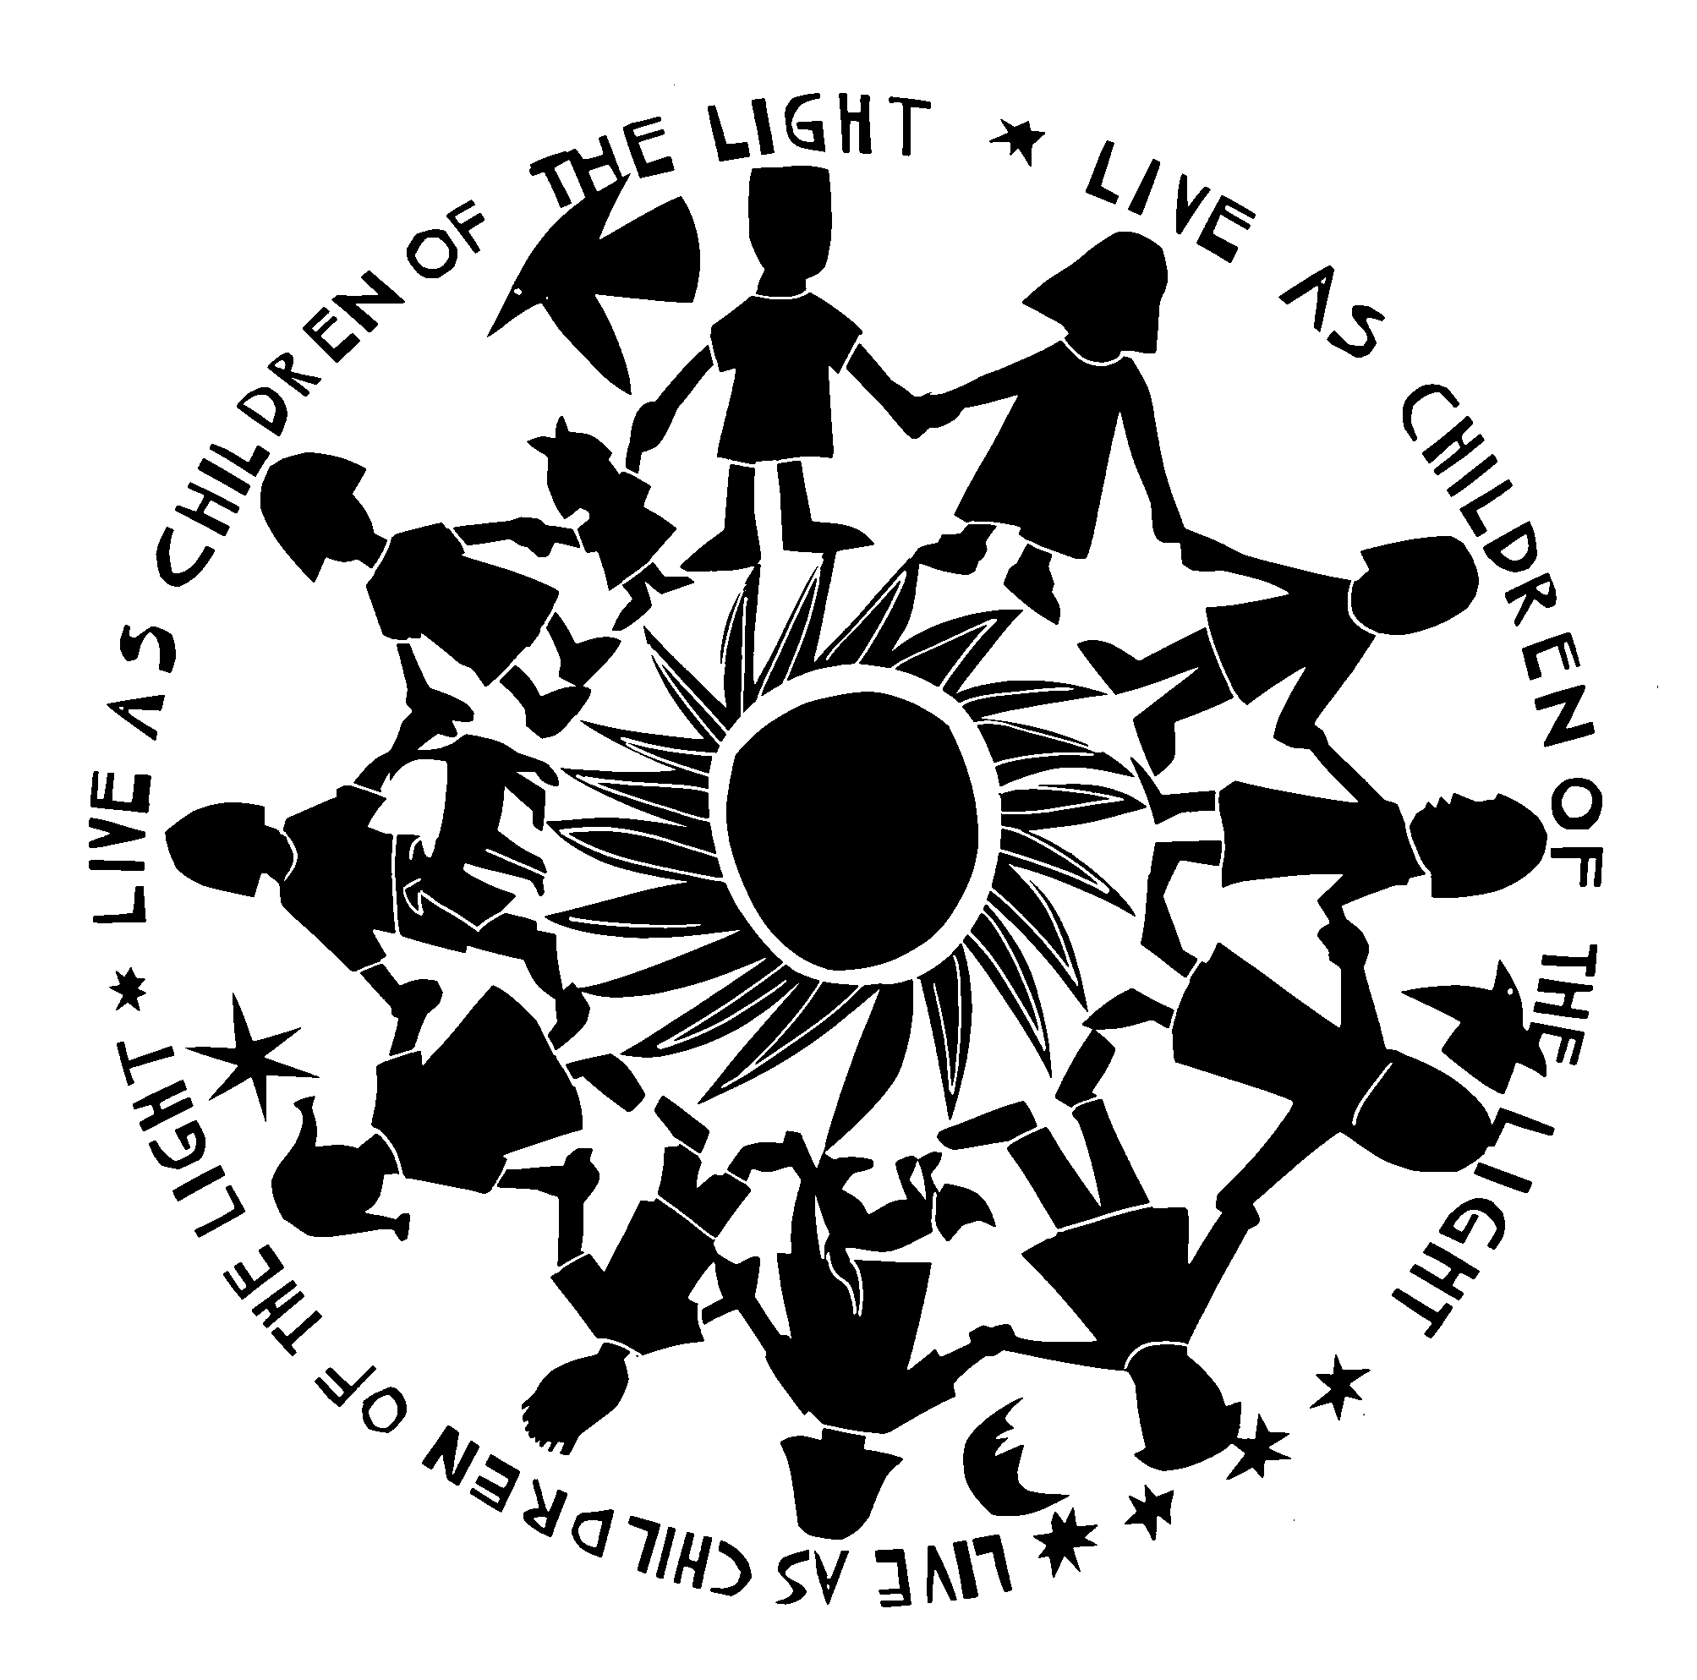

HYMN OF THE DAY — 397 Just As I Am, without One Plea
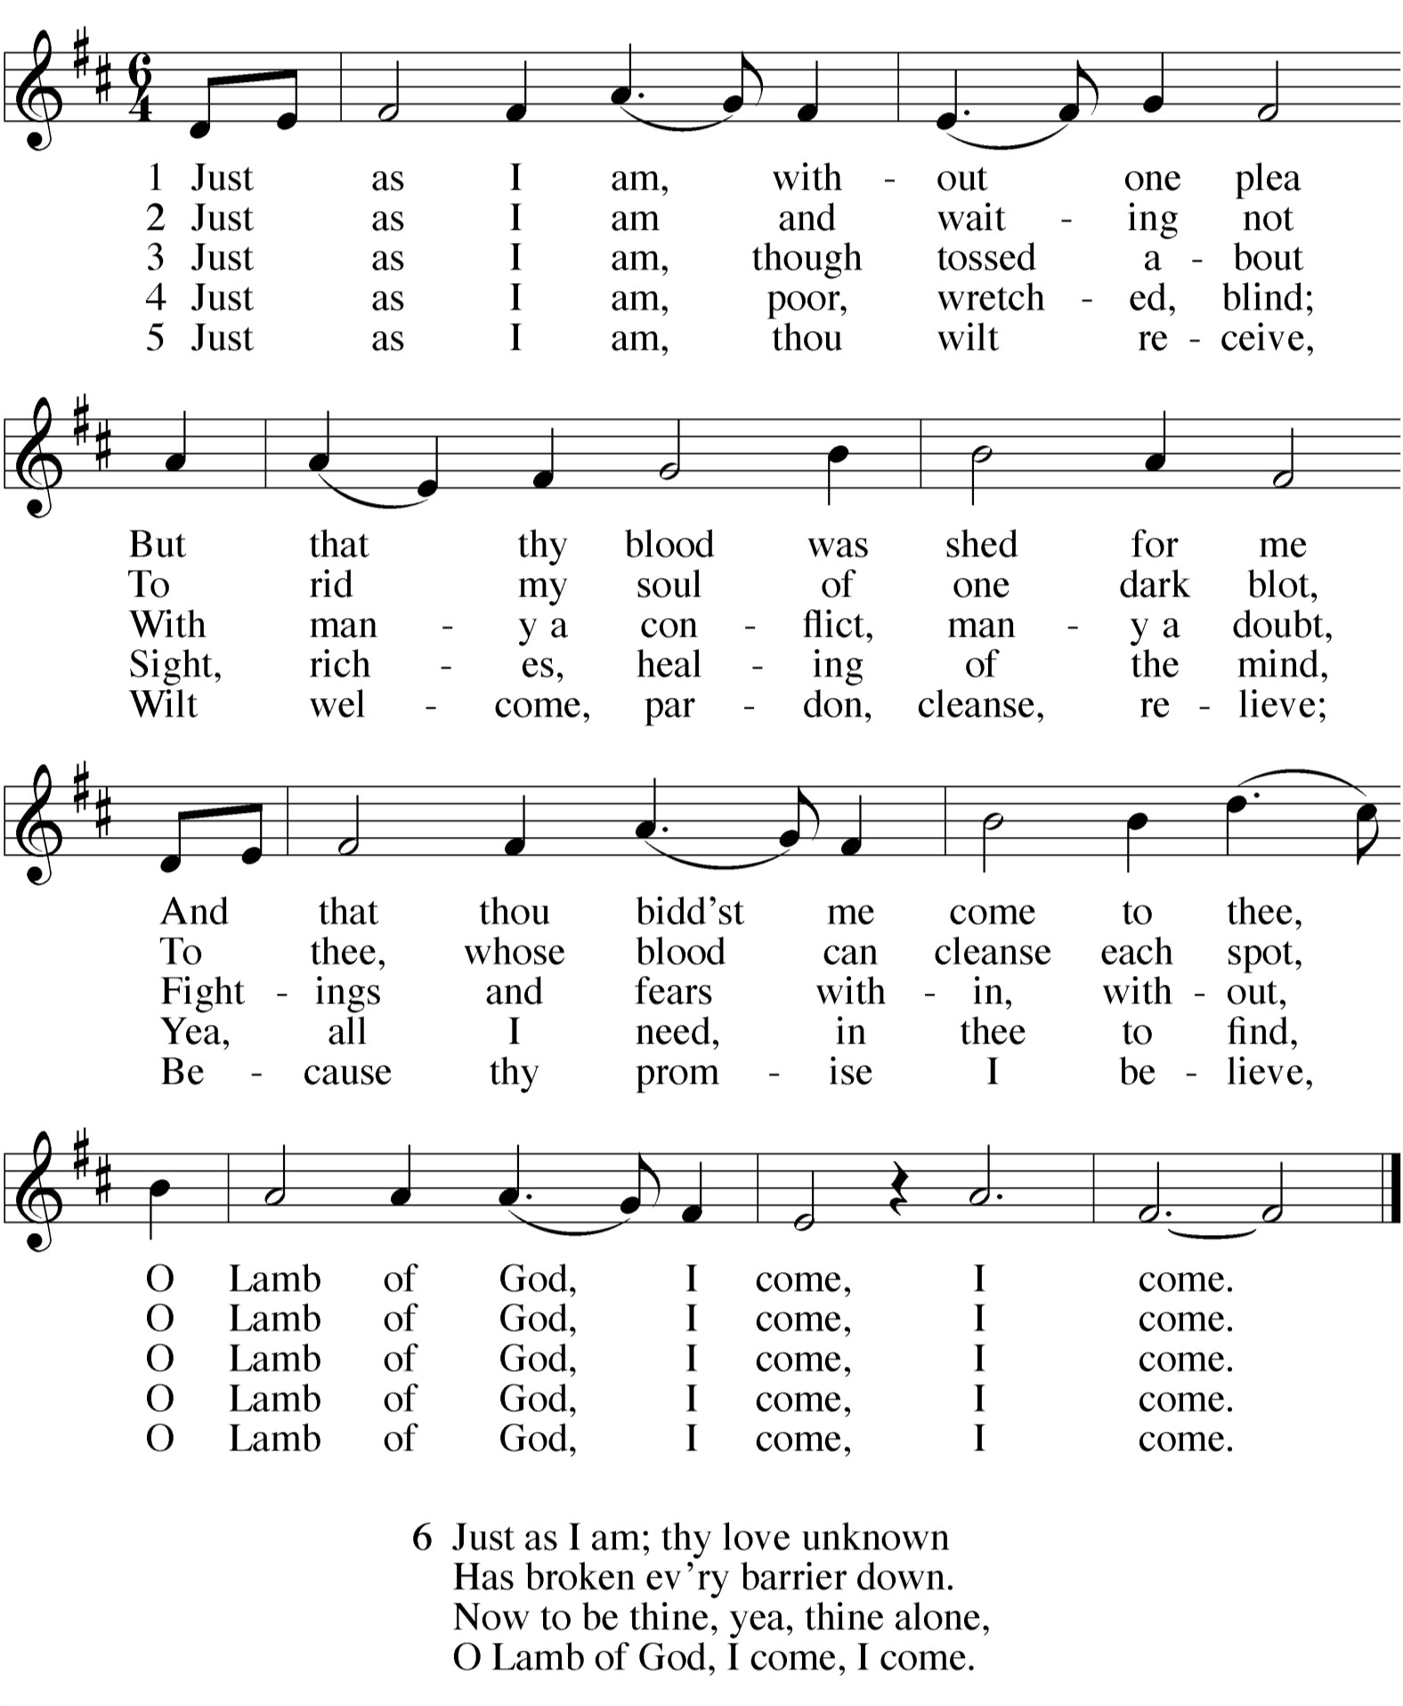

SERMON

KYRIE 1
ALL: 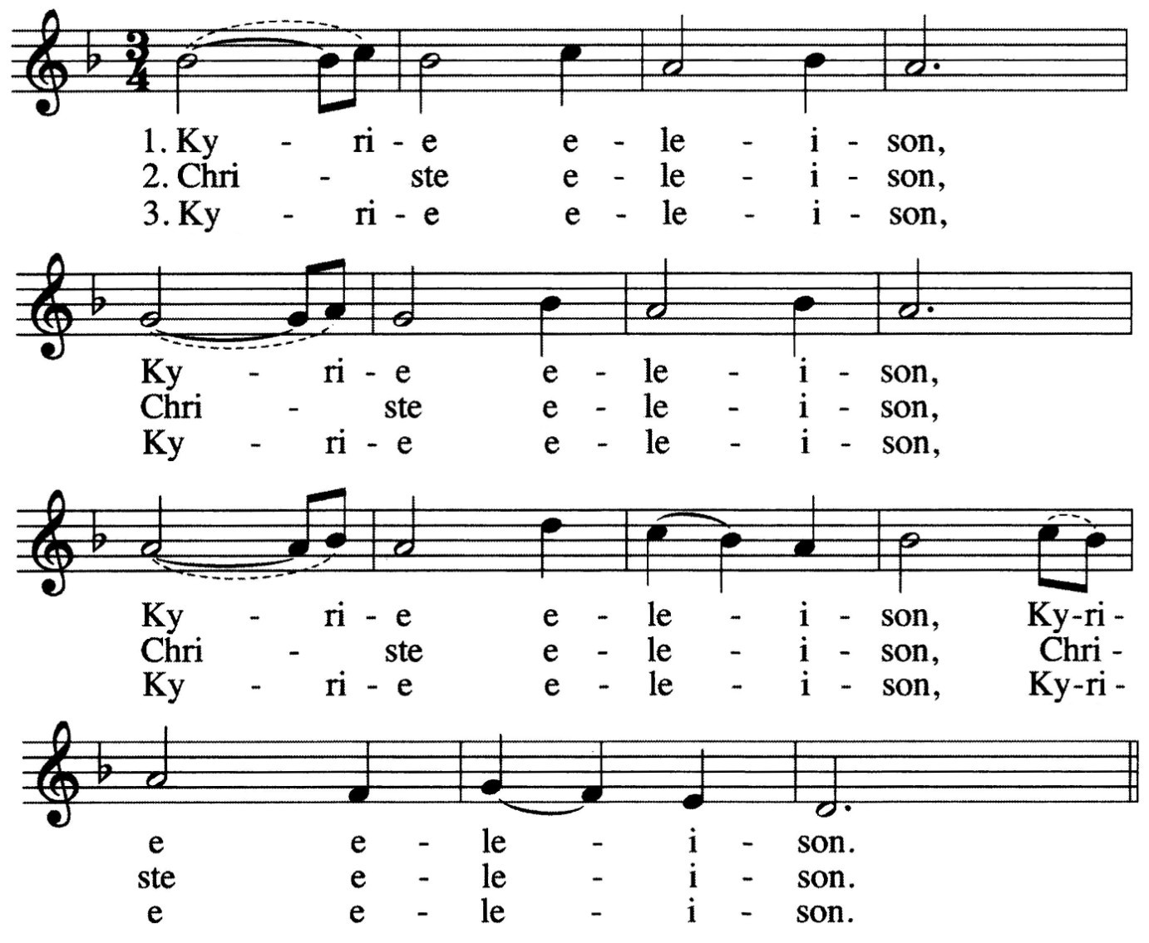

INVOCATION
M: The grace of our Lord  Jesus Christ, And the love of God,
And the fellowship of the Holy Spirit be with you all.

C: And also with you.

1 The Kyrie is one of the oldest prayers in the Christian church. Kyrie eleison means “Lord, have mercy.” It is pronounced keer-ree-ay eh-lay-i-zon. Christe elison means “Christ, have mercy.” It is pronounced chrees-stay eh-lay-i-zon.

PENITENTIAL RITE
M: Coming together as one people, we remember the times
when we have failed to live the Gospel call. We ask for the mercy of God,
who is full of gentleness and love.

M: (sung) Lord Jesus Christ, you pierce all the darkness.

GOSPEL John 9:1-7,13-17, 34-39
1As he went along, he saw a man blind from birth. 2His disciples asked him, "Rabbi, who sinned, this man or his parents, that he was born blind?"
3"Neither this man nor his parents sinned," said Jesus, "but this happened so that the work of God might be displayed in his life. 4As long as it is day, we must do the work of him who sent me. Night is coming,
5

You alone are the Light.
when no one can work.
world."
While I am in the world, I am the light of the

ALL: 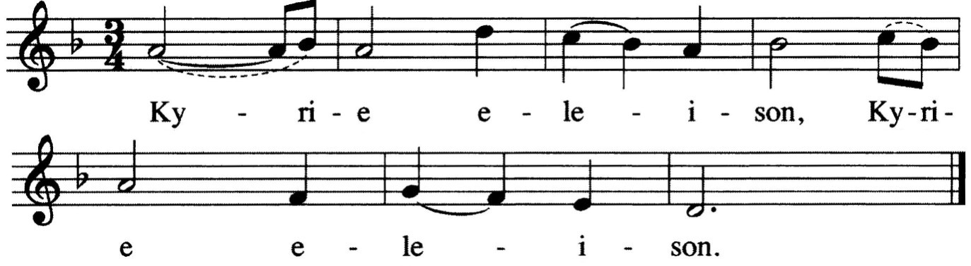
M: (sung) Lord Jesus Christ, bring healing and wholeness.
Give your people comfort.

ALL: 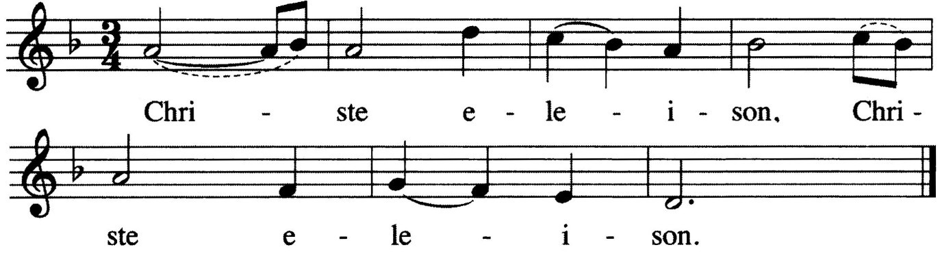
M: (sung) Lord Jesus Christ, lead the blind in your ways.
Make the rough places smooth.

ALL:
6Having said this, he spit on the ground, made some mud with the saliva, and put it on the man's eyes. 7"Go," he told him, "wash in the Pool of Siloam" (this word means Sent). So the man went and washed, and
came home seeing.
13They brought to the Pharisees the man who had been blind. 14Now
the day on which Jesus had made the mud and opened the man's eyes was a Sabbath. 15Therefore the Pharisees also asked him how he had received his sight. "He put mud on my eyes," the man replied, "and I washed, and now I see."
16Some of the Pharisees said, "This man is not from God, for he does not keep the Sabbath."
But others asked, "How can a sinner do such miraculous signs?" So they were divided.
17Finally they turned again to the blind man, "What have you to say about him? It was your eyes he opened."
The man replied, "He is a prophet."
34 To this they replied, “You were steeped in sin at birth; how dare you lecture us!” And they threw him out.
35 Jesus heard that they had thrown him out, and when he found him,
he said, “Do you believe in the Son of Man?”
36 “Who is he, sir?” the man asked. “Tell me so that I may believe in him.”
37 Jesus said, “You have now seen him; in fact, he is the one speaking with you.”
38 Then the man said, “Lord, I believe,” and he worshiped him.
39 Jesus said, “For judgment I have come into this world, so that the blind will see and those who see will become blind.”

M: This is the Gospel of our Lord.

C: Praise be to you, O Christ!

SECOND LESSON Ephesians 5:8-14
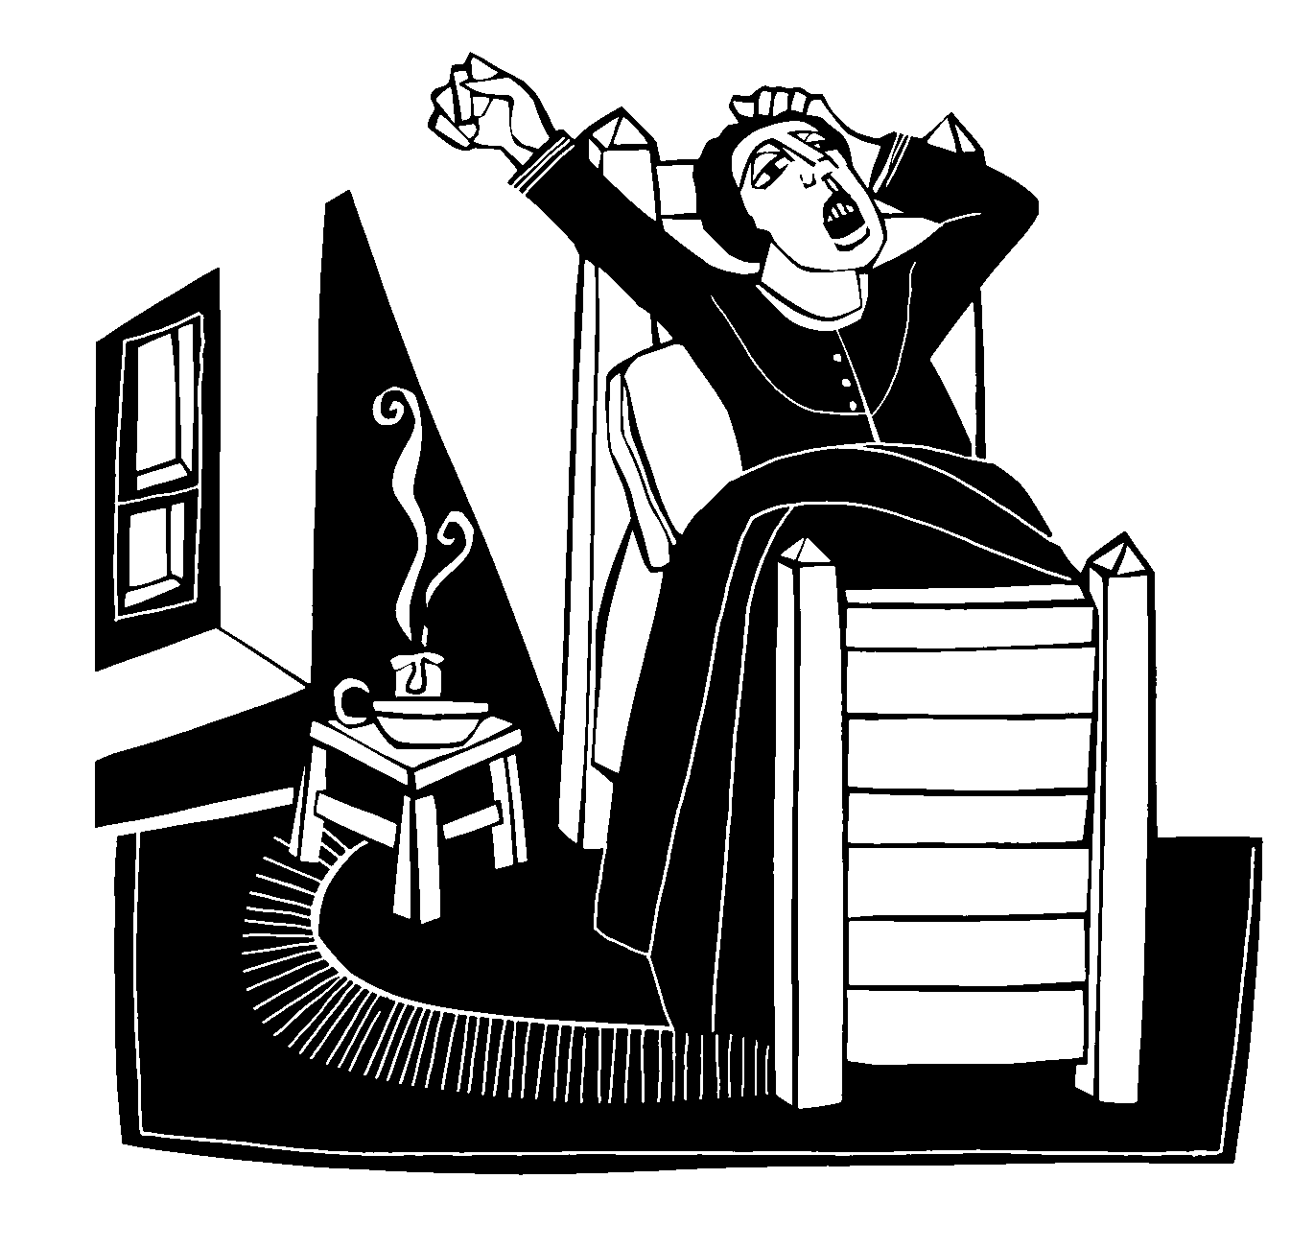8For you were once darkness, but now you are light in the Lord. Live as children of light 9(for the fruit of the light consists in all goodness, righteousness and truth) 10and find out what pleases the Lord. 11Have nothing to do with the fruitless deeds of darkness, but rather expose them. 12For it is shameful even to mention what the disobedient do in secret. 13But everything exposed by the light becomes visible, 14for it is light that makes everything visible. This is why it is said:
"Wake up, O sleeper, rise from the dead,
and Christ will shine on you."

VERSE OF THE DAY John 3:14,15

M: Refrain
C: Refrain
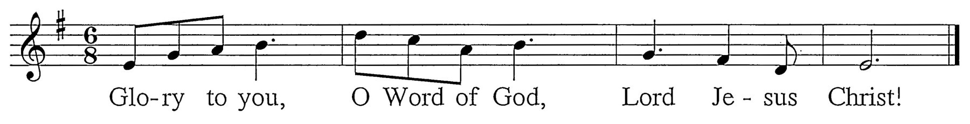
M: The Son of Man must be lifted up
so that those who believe may have eternal life.
C: Refrain (sung twice) - During this refrain, the children may come forward.

M: God Almighty has had mercy on us,
forgiven us our sins for the sake of Jesus  Christ, and opened to us life everlasting.

C: Amen.

M: (sung) Up from the ashes we now arise,
and return to our Maker who has answered our cries.
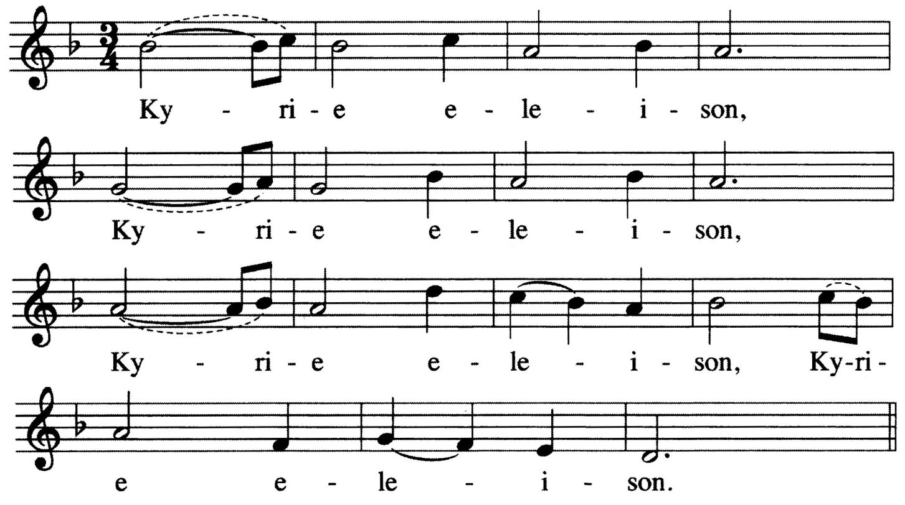Knowing God’s mercy we now stand healed, for in Jesus our Savior perfect love is revealed.

ALL:

2

CHILDREN’S MESSAGE

2 One might ask, “If the minister just proclaimed that my sins were forgiven, why would I sing ‘Lord, have mercy’ again?” It is meant to remind us that we not only need God’s mercy for forgiveness, but we also need it on an ongoing basis, that God might supply all our daily needs.

PRAYER OF THE DAY
M: Almighty God,

 The Word 

PSALM OF THE DAY Psalm 143
M: Lord, hear my prayer,

look with favor on your humble servants
and stretch out the right hand of your power to defend us against all our enemies;
through Jesus Christ, your Son, our Lord,
who lives and reigns with you and the Holy Spirit, one God, now and forever.

C: Amen.

FIRST LESSON Isaiah 42:14-21
14 "For a long time I have kept silent,
I have been quiet and held myself back. But now, like a woman in childbirth,
I cry out, I gasp and pant.
15 I will lay waste the mountains and hills and dry up all their vegetation;
I will turn rivers into islands and dry up the pools.
16 I will lead the blind by ways they have not known, along unfamiliar paths I will guide them;
I will turn the darkness into light before them and make the rough places smooth.
These are the things I will do; I will not forsake them.
17 But those who trust in idols,
who say to images, 'You are our gods,' will be turned back in utter shame.
18 "Hear, you deaf;
look, you blind, and see!
19 Who is blind but my servant,
and deaf like the messenger I send?
Who is blind like the one committed to me, blind like the servant of the LORD ?
20 You have seen many things, but have paid no attention; your ears are open, but you hear nothing."
21 It pleased the LORD for the sake of his righteousness to make his law great and glorious.

C: listen to my cry for mercy.
M: In your faithfulness and righteousness

C: come to my relief.
M: Do not bring your servant into judgment, C: for no one living is righteous before you. M: My spirit grows faint within me.

C: My heart within me is dismayed.
M: I meditate on all your works

C: and consider what your hands have done.
M: I spread out my hands to you.

C: I thirst for you like a parched land.
M: Answer me quickly, Lord; my spirit fails.

C: Do not hide your face from me.
M: Let the morning bring me word of your unfailing love,
C: for I have put my trust in you. M: Show me the way I should go, C: for to you I entrust my life.
M: Teach me to do your will, for you are my God; C: may your good Spirit lead me on level ground. M: For your name’s sake, Lord, preserve my life;

C: in your righteousness, bring me out of trouble.

