16

Your congregational license information here

Lenten Gathering Rite: God of Creation
Words and music: Ian Callanan
© 2009 GIA Publications, Inc.

Gospel Acclamation from Mass of Light
Music: David Haas
©1988 GIA Publications, Inc.
Second Sunday in Lent March 16, 2014

IN THE SHADOW OF THE CROSS
THE GIFT COMES BY FAITH

CLOSING HYMN — 402 My Faith Looks Up to Thee
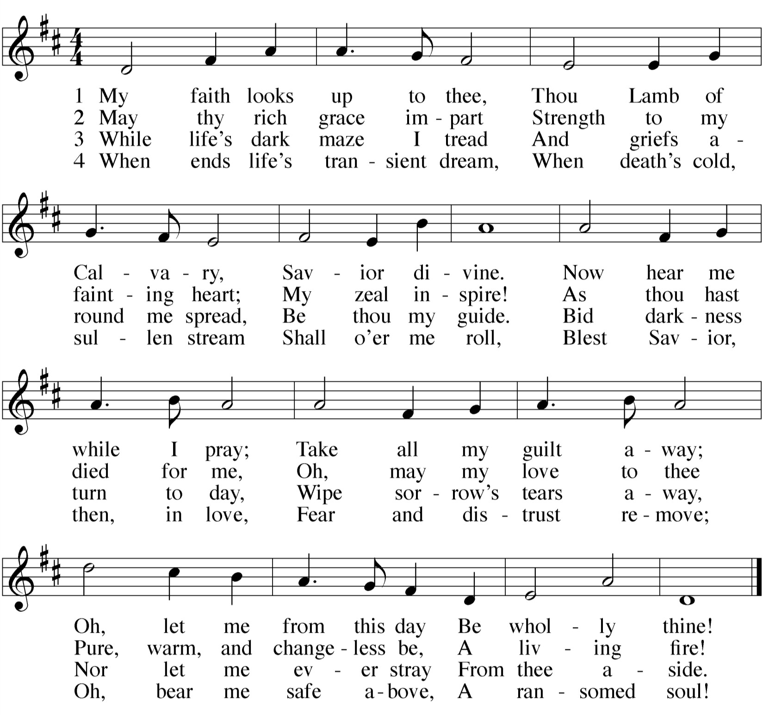

 The Prayers 

THE PRAYER OF THE CHURCH
Prayers and petitions are offered on behalf of the Church
M: Hear us now, Lord, as we bring you our private petitions.
Silent prayer
M: Almighty God, we come before you trusting that you hear our prayers. In your mercy, listen to our supplications on behalf of all for whom we pray and fulfill our desires and petitions according to your will, for we pray in Jesus’ name, and as he taught.

THE LORD’S PRAYER

C: Our Father in heaven, hallowed be your name, your kingdom come,
your will be done on earth as in heaven. Give us today our daily bread.
Forgive us our sins, as we forgive those who sin against us. Lead us not into temptation,
but deliver us from evil.
For the kingdom, the power, and the glory are yours now and forever. Amen.

THE BLESSING
M: Brothers and sisters, go in peace.
Live in harmony with one another. Serve the Lord with gladness.
The Lord bless you and keep you.
The Lord make his face shine on you and be gracious to you. The Lord look on you with favor and give you peace.

C: Amen.
WORSHIP NOTES
THE SEASON OF LENT
The word Lent comes from an Old English word for Spring (“lengten,” the time of the year when the days grow longer). For the last 1700 years, the Church has set aside the 40 days between Ash Wednesday and Easter as a time of special preparation. It is a time of repentance and renewal.
During Lent, our rejoicing is muted as we remember our Lord’s suffering and death. But it is with a purpose: we know that the Lord who died took up his life again on Easter Sunday morning. So our 40 days of Lent are ones lived in the certain hope of the resurrection.
The color of the season is purple. Purple is the ancient color of royalty. We have this kind of king: he wore a crown of thorns, and carried a cross for us. Thanks be to God!
For the precise counters in the congregation, the Church speaks of only 40 days of Lent because we do not count the Sundays, which retained their significance as “little Easters.” That is why they are called “Sundays in Lent” and not “Sundays of Lent.”
So we walk through this Lenten season, solemn but hopeful. We walk in the shadow of the cross. Our worship follows this pattern.
IN THE SHADOW OF THE CROSS
The devil is defeated
The gift comes by faith The blind can finally see Selfishness is crushed
We are raised from death to life King Jesus humbly walked
OUR THEME FOR TODAY
The gift comes by faith. Not a holy life, not acts of obedience, but simple trust in the promise of God brings the gift of living water for thirsty souls. Abraham believed God’s promise and so became not only the father of a nation, but the forefather of the Promised Seed who would bless all peoples. He had faith in God who justifies the wicked, and so God credited it to him as righteousness. By this same faith, Christ gives righteousness to all who believe.

AN ORDER OF SERVICE FOR LENT
By combining a unique confession of sins, a traditional Lenten confession of faith, and carefully chosen lessons, this order of service allows the believer to come to a full awareness of the seriousness of his or her sin, and also to joyfully remember the source of its cure.

GATHERING SONG

 The Gathering 
CONFESSION OF FAITH The Apostles’ Creed

I believe in God, the Father almighty, maker of heaven and earth.
I believe in Jesus Christ, his only Son, our Lord,
who was conceived by the Holy Spirit, born of the virgin Mary,
suffered under Pontius Pilate,
was crucified, died, and was buried. He descended into hell.
The third day he rose again from the dead.
He ascended into heaven
and is seated at the right hand of God the Father almighty. From there he will come to judge the living and the dead.
I believe in the Holy Spirit,
the holy Christian Church, the communion of saints, the forgiveness of sins,
the resurrection of the body, and the life everlasting.
Amen.

THANK OFFERING
M: | (verse 1 — sung) | God of creation, Giver of life,  be the light in our darkness; grant us peace in our strife. Show us your mercy.  Give us new birth.  You have made us your children
 |  | to bear fruit on the earth. | (to Kyrie, verse 1)
M: | (verse 2 — sung) | Lord, our Redeemer, Healer of souls,  be the hope that restores us. With your touch make us whole.  Here you speak to us through holy Word.  Send your Spirit among us
 |  | that your voice may be heard. | (to Kyrie, verse 2)
M: | (verse 3 — sung) | Spirit, most holy, Comforter blest,  be the fire that consumes us and our hearts’ welcome guest. Form us. Renew us.  Call us by name.  Raise us up from the ashes and create us again. | (to Kyrie, verse 3)

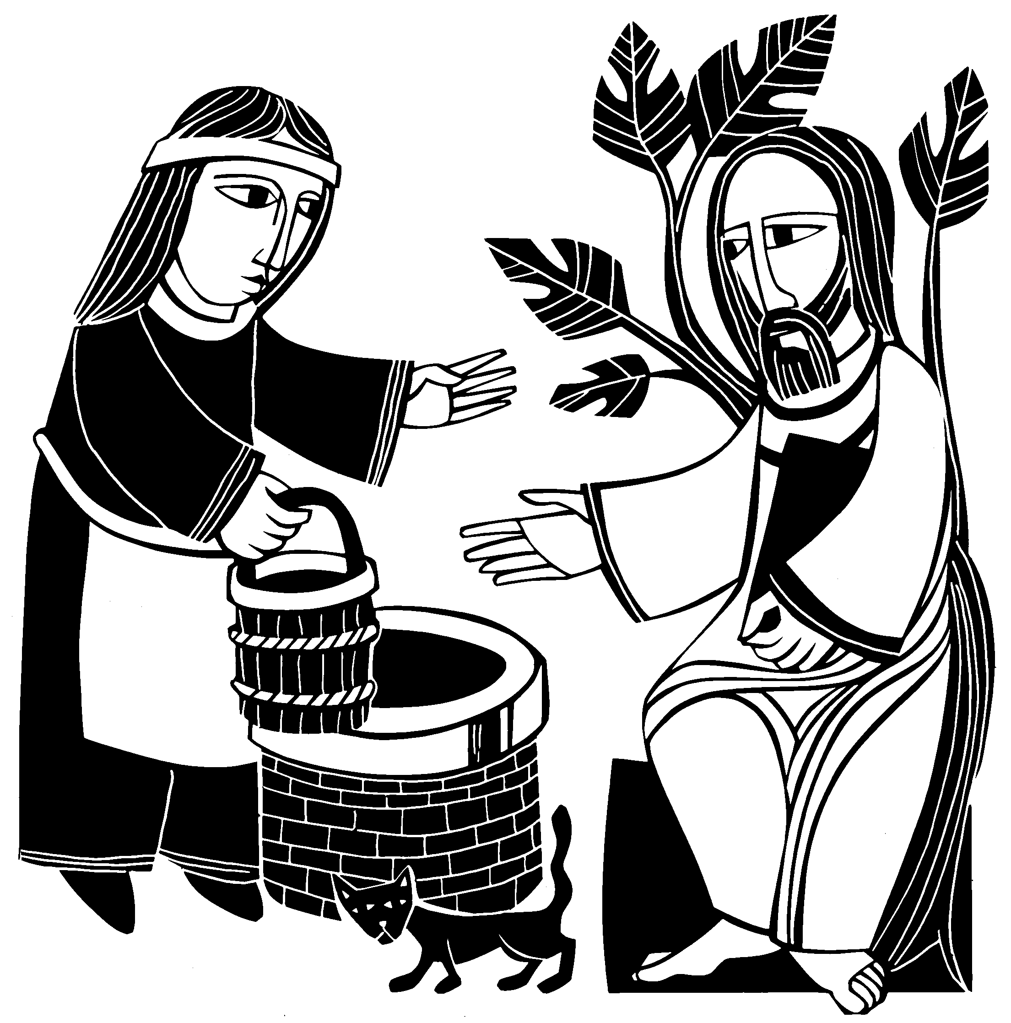

HYMN OF THE DAY — 391 God Loved the World
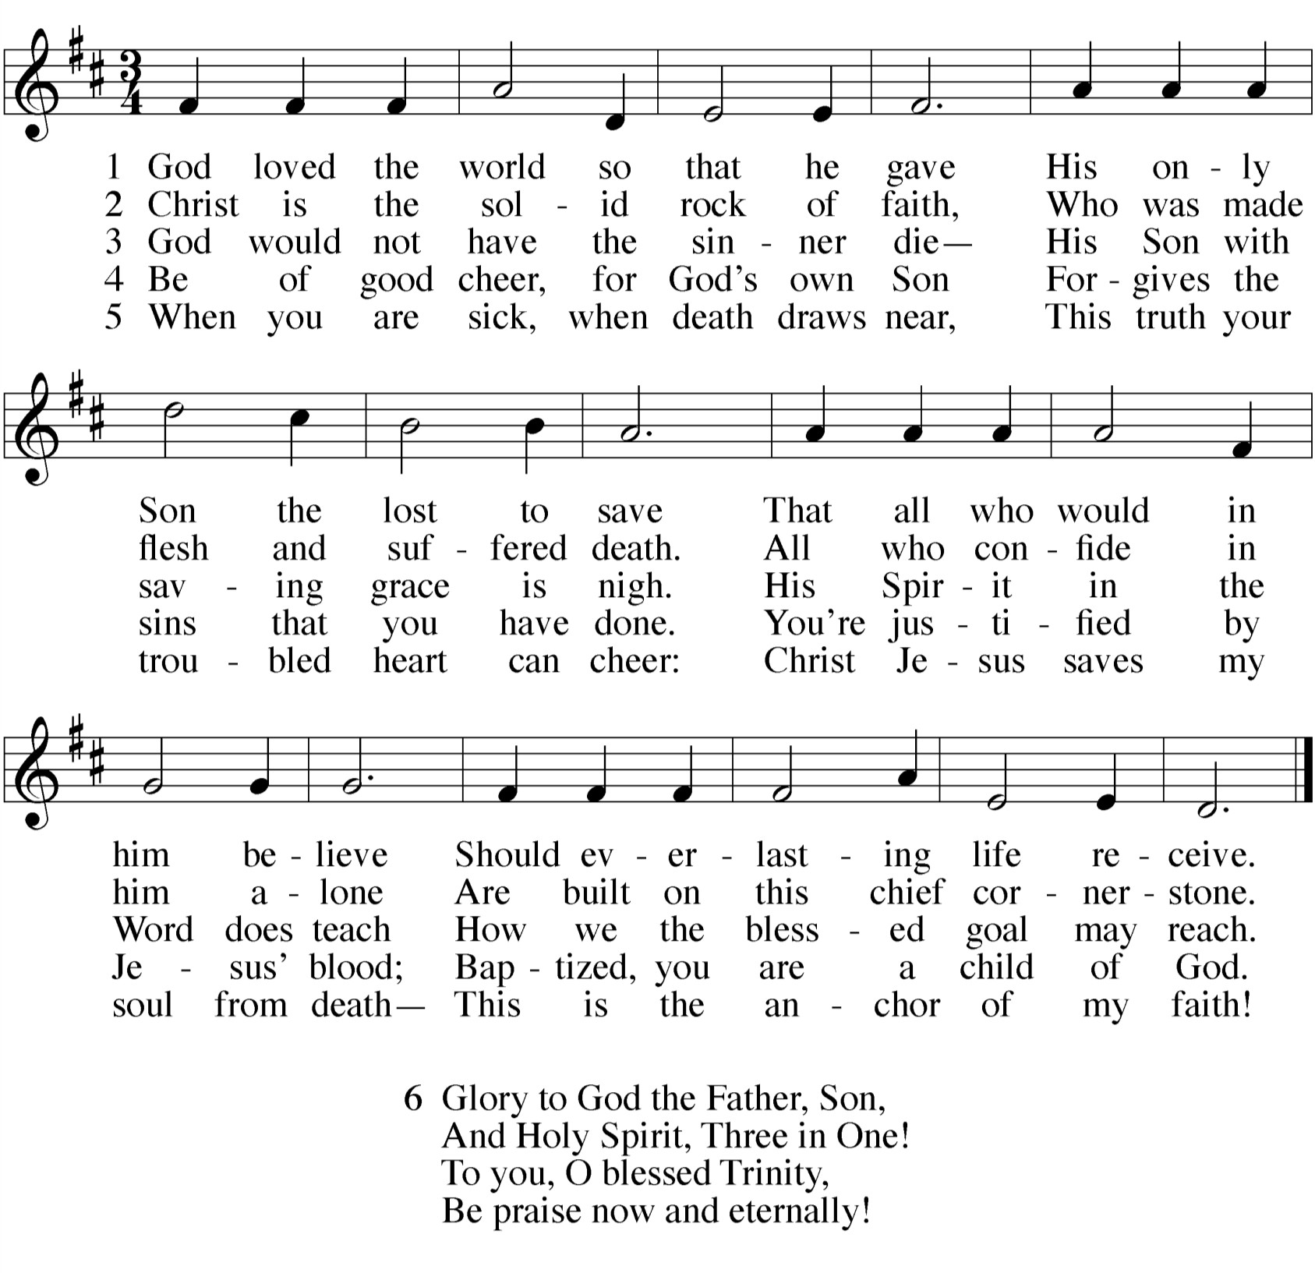

SERMON

KYRIE 1
ALL: 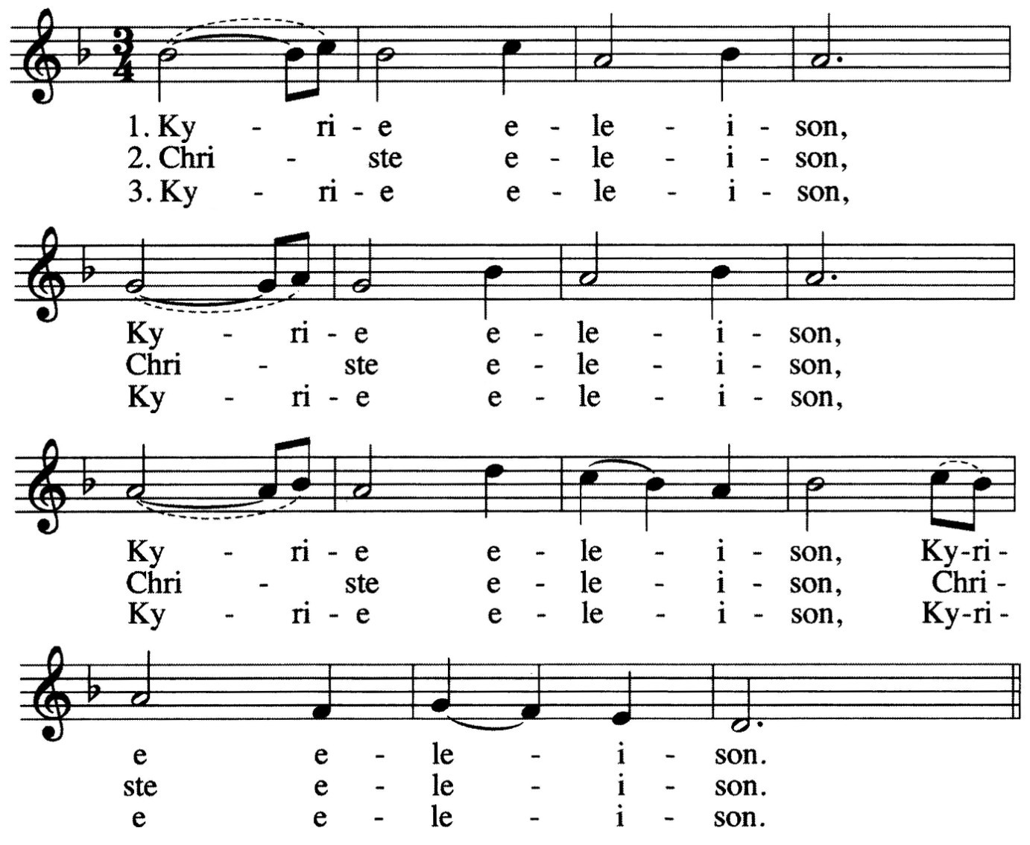

INVOCATION
M: The grace of our Lord  Jesus Christ, And the love of God,
And the fellowship of the Holy Spirit be with you all.

C: And also with you.

- The Kyrie is one of the oldest prayers in the Christian church. Kyrie eleison means “Lord, have mercy.” It is pronounced keer-ree-ay eh-lay-i-zon. Christe elison means “Christ, have mercy.” It is pronounced chrees-stay eh-lay-i-zon.

PENITENTIAL RITE
M: Coming together as one people, we remember the times
when we have failed to live the Gospel call. We ask for the mercy of God,
who is full of gentleness and love.

M: (sung) Lord Jesus Christ, you alone are righteous.
Grant your people pardon.

ALL: 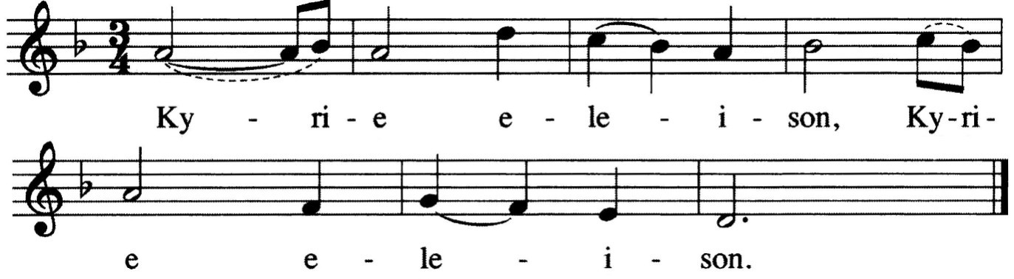
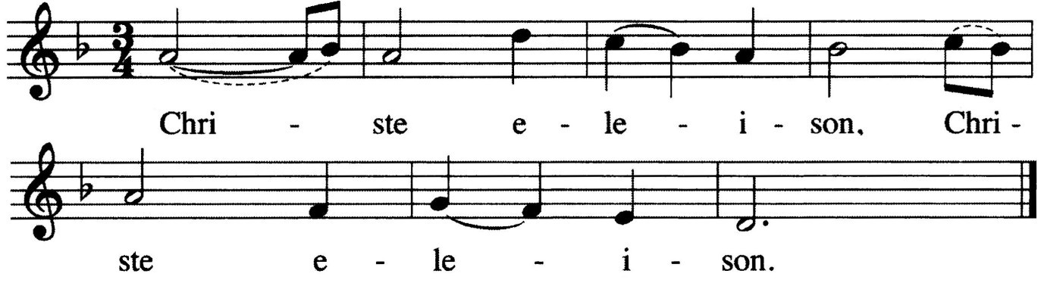M: (sung) Lord Jesus Christ, the object of our faith, give the gift of salvation.

ALL:
GOSPEL John 4:5-26
5So he came to a town in Samaria called Sychar, near the plot of ground Jacob had given to his son Joseph. 6Jacob's well was there, and Jesus, tired as he was from the journey, sat down by the well. It was about the sixth hour.
7When a Samaritan woman came to draw water, Jesus said to her, "Will you give me a drink?" 8(His disciples had gone into the town to buy food.)
9The Samaritan woman said to him, "You are a Jew and I am a Samaritan
woman. How can you ask me for a drink?" (For Jews do not associate with Samaritans.)
10Jesus answered her, "If you knew the gift of God and who it is that asks you for a drink, you would have asked him and he would have given you living water."
11"Sir," the woman said, "you have nothing to draw with and the well is deep.
Where can you get this living water? 12Are you greater than our father Jacob, who gave us the well and drank from it himself, as did also his sons and his flocks and herds?"
13Jesus answered, "Everyone who drinks this water will be thirsty again, 14but
whoever drinks the water I give him will never thirst. Indeed, the water I give him will become in him a spring of water welling up to eternal life."
15The woman said to him, "Sir, give me this water so that I won't get thirsty and have to keep coming here to draw water."
16He told her, "Go, call your husband and come back."
17"I have no husband," she replied.
Jesus said to her, "You are right when you say you have no husband. 18The fact is, you have had five husbands, and the man you now have is not your husband. What you have just said is quite true."
19"Sir," the woman said, "I can see that you are a prophet. 20Our fathers
worshiped on this mountain, but you Jews claim that the place where we must worship is in Jerusalem."
21Jesus declared, "Believe me, woman, a time is coming when you will worship the Father neither on this mountain nor in Jerusalem. 22You Samaritans worship what
23

M: (sung) Lord Jesus Christ, source of living water,
you do not know; we worship what we do know, for salvation is from the Jews.
Yet

ALL:
satisfy our deep thirst.
a time is coming and has now come when the true worshipers will worship the Father in spirit and truth, for they are the kind of worshipers the Father seeks. 24God is spirit,
and his worshipers must worship in spirit and in truth."
25The woman said, "I know that Messiah" (called Christ) "is coming. When he comes, he will explain everything to us."
26Then Jesus declared, "I who speak to you am he."
M: This is the Gospel of our Lord.

C: Praise be to you, O Christ!

SECOND LESSON Romans 4:1-5,13-17
1What then shall we say that Abraham, our forefather, discovered in this matter? 2If, in fact, Abraham was justified by works, he had something to boast about—but not before God. 3What does the Scripture say? "Abraham believed God, and it was credited to him as righteousness."
4Now when a man works, his wages are not credited to him as a
gift, but as an obligation. 5However, to the man who does not work but trusts God who justifies the wicked, his faith is credited as righteousness.
13It was not through law that Abraham and his offspring received the promise that he would be heir of the world, but through the
righteousness that comes by faith. 14For if those who live by law are heirs, faith has no value and the promise is worthless, 15because law
brings wrath. And where there is no law there is no transgression.
16Therefore, the promise comes by faith, so that it may be by grace
and may be guaranteed to all Abraham's offspring—not only to those who are of the law but also to those who are of the faith of Abraham. He is the father of us all. 17As it is written: "I have made you a father of many nations." He is our father in the sight of God, in whom he believed—the God who gives life to the dead and calls things that are not as though they were.

M: God Almighty has had mercy on us,
forgiven us our sins for the sake of Jesus  Christ, and opened to us life everlasting.

C: Amen.

M: (sung) Up from the ashes we now arise,
and return to our Maker who has answered our cries.
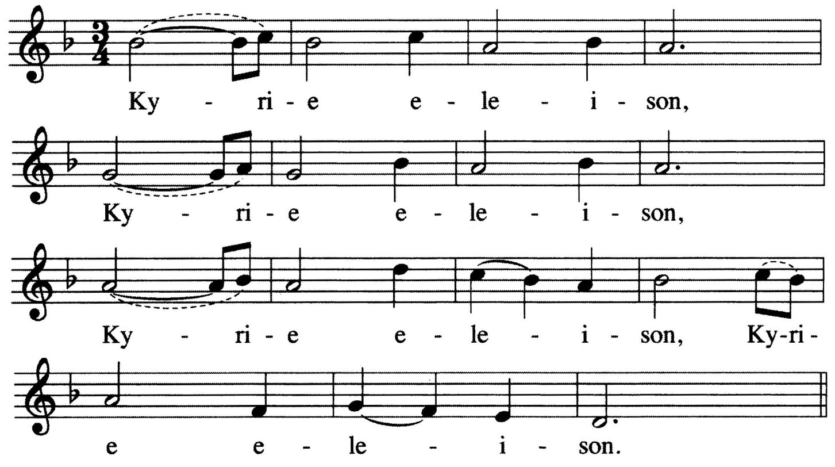Knowing God’s mercy we now stand healed, for in Jesus our Savior perfect love is revealed.

ALL:

VERSE OF THE DAY Philippians 2:8

M: Refrain
C: Refrain
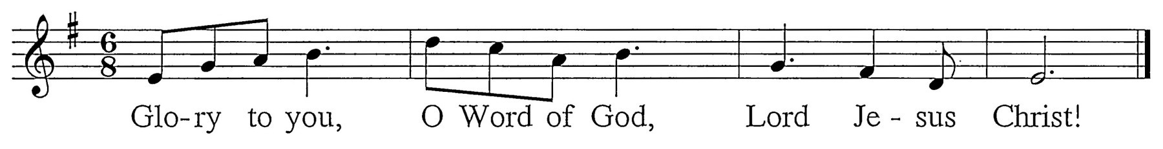
M: Jesus became obedient to death, even death upon a cross.
C: Refrain (sung twice) - During this refrain, the children may come forward.

CHILDREN’S MESSAGE

2

- One might ask, “If the minister just proclaimed that my sins were forgiven, why would I sing ‘Lord, have mercy’ again?” It is meant to remind us that we not only need God’s mercy for forgiveness, but we also need it on an ongoing basis, that God might supply all our daily needs.

 The Word 

PRAYER OF THE DAY
M: Almighty God,
you see that we have no power to defend ourselves. Guard and keep us both outwardly and inwardly from all adversities that may happen to the body
and from all evil thoughts that may assault and hurt the soul; through Jesus Christ our Lord,
who lives and reigns with you and the Holy Spirit, one God, now and forever.

C: Amen.

FIRST LESSON Genesis 12:1-8
1 The LORD had said to Abram, "Leave your country, your people and your father's household and go to the land I will show you.
2 "I will make you into a great nation and I will bless you;
I will make your name great, and you will be a blessing.
3 I will bless those who bless you,
and whoever curses you I will curse; and all peoples on earth
will be blessed through you."
4 So Abram left, as the LORD had told him; and Lot went with him. Abram was seventy-five years old when he set out from Haran. 5 He took his wife Sarai, his nephew Lot, all the possessions they had accumulated and the people they had acquired in Haran, and they set out for the land of Canaan, and they arrived there.
6 Abram traveled through the land as far as the site of the great tree of Moreh at Shechem. At that time the Canaanites were in the land. 7 The LORD appeared to Abram and said, "To your offspring I will give this
land." So he built an altar there to the LORD, who had appeared to him.
8 From there he went on toward the hills east of Bethel and pitched
his tent, with Bethel on the west and Ai on the east. There he built an altar to the LORD and called on the name of the LORD.

PSALM OF THE DAY Psalm 121
M: lift up my eyes to the mountains — C: where does my help come from? M: My help comes from the Lord,

C: the Maker of heaven and earth.
M: He will not let your foot slip —

C: he who watches over you will not slumber;
M: indeed, he who watches over Israel

C: will neither slumber nor sleep.
M: The Lord watches over you —

C: the Lord is your shade at your right hand;
M: the sun will not harm you by day,

C: nor the moon by night.
M: The Lord will keep you from all harm —

C: he will watch over your life;
M: the Lord will watch over your coming and going

C: both now and forevermore.

