24

Your congregation’s license information goes here

Lenten Gathering Rite: God of Creation
Words and music: Ian Callanan
© 2009 GIA Publications, Inc.

Gospel Acclamation from Mass of Light
Music: David Haas
©1988 GIA Publications, Inc.

Sanctus & Agnus Dei
From Divine Service I in Christian Worship Supplement
© 2008 Northwestern Publishing House
Fifth Sunday in Lent April 6, 2014

IN THE SHADOW OF THE CROSS
WE ARE RAISED FROM DEATH TO LIFE

CLOSING HYMN — 606 For Me to Live Is Jesus
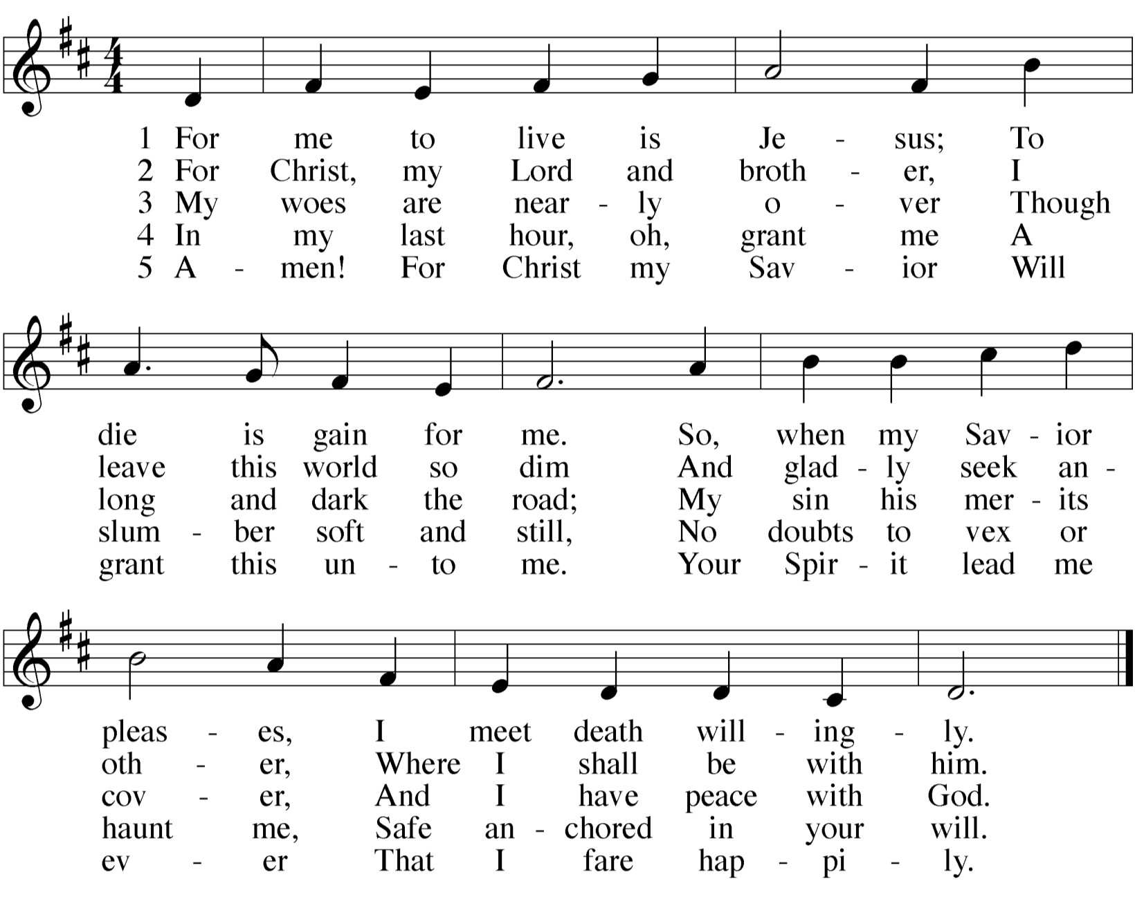

CLOSING PRAYER
M: We give you thanks, O Lord,
for the foretaste of the heavenly banquet
that you have given us to eat and to drink in this sacrament. Through this gift you have fed our faith,
nourished our hope,
and strengthened our love.
By your Spirit help us to live as your holy people until that day when you will receive us as your guests at the wedding supper of the Lamb,
who lives and reigns with you and the Holy Spirit, one God, now and forever.

C: Amen.

THE BLESSING
M: Brothers and sisters, go in peace. Live in harmony with one another. Serve the Lord with gladness.
The Lord bless you and keep you.
The Lord make his face shine on you and be gracious to you. The Lord look on you with favor and give  you peace.

C: Amen.
WORSHIP NOTES
THE SEASON OF LENT
The word Lent comes from an Old English word for Spring (“lengten,” the time of the year when the days grow longer). For the last 1700 years, the Church has set aside the 40 days between Ash Wednesday and Easter as a time of special preparation. It is a time of repentance and renewal.
During Lent, our rejoicing is muted as we remember our Lord’s suffering and death. But it is with a purpose: we know that the Lord who died took up his life again on Easter Sunday morning. So our 40 days of Lent are ones lived in the certain hope of the resurrection.
The color of the season is purple. Purple is the ancient color of royalty. We have this kind of king: he wore a crown of thorns, and carried a cross for us. Thanks be to God!
For the precise counters in the congregation, the Church speaks of only 40 days of Lent because we do not count the Sundays, which retained their significance as “little Easters.” That is why they are called “Sundays in Lent” and not “Sundays of Lent.”
So we walk through this Lenten season, solemn but hopeful. We walk in the shadow of the cross. Our worship follows this pattern.
IN THE SHADOW OF THE CROSS
The devil is defeated The gift comes by faith The blind can finally see Selfishness is crushed
We are raised from death to life King Jesus humbly walked
OUR THEME FOR TODAY
We are raised from death to life. Inside every person’s heart burns a big question. What happens when we die? You cannot find the answer to that question in a laboratory or philosophy textbook. But the Lord of Life has an answer for us. Death is not the end. It is only temporary. But just as our Savior uses his almighty power to raise us from spiritual corpses (unbelief) to spiritual life (faith), so also with his word Jesus will raise our bodies as well. He proves he can do that in the Gospel.

AN ORDER OF SERVICE FOR LENT
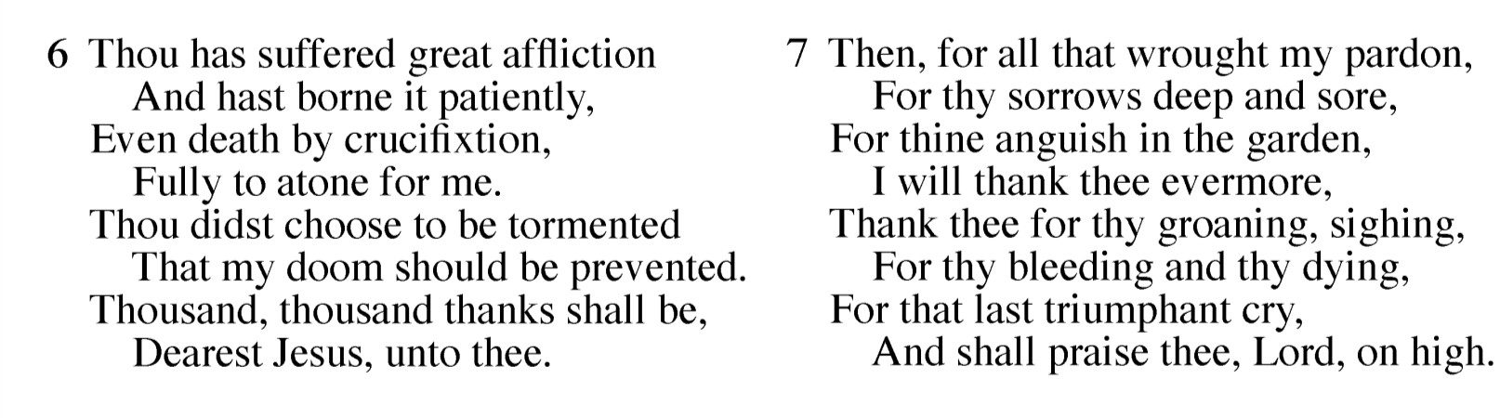By combining a unique confession of sins, a traditional Lenten confession of faith, and carefully chosen lessons, this order of service allows the believer to come to a full awareness of the seriousness of his or her sin, and also to joyfully remember the source of its cure.

 The Gathering 

GATHERING SONG

Draw Near and Take the Body of the Lord
M: | (verse 1 — sung) | God of creation, Giver of life,
 |  | be the light in our darkness; |  | HYMN | 309
 |  | grant us peace in our strife.
 |  | Show us your mercy.
 |  | Give us new birth.
 |  | You have made us your children
 |  | to bear fruit on the earth. | (to Kyrie, verse 1)
M: | (verse 2 — sung) | Lord, our Redeemer,
 |  | Healer of souls,
 |  | be the hope that restores us.
 |  | With your touch make us whole.
 |  | Here you speak to us
 |  | through holy Word.
 |  | Send your Spirit among us
 |  | that your voice may be heard. | (to Kyrie, verse 2)
M: | (verse 3 — sung) | Spirit, most holy,
 |  | Comforter blest,
 |  | be the fire that consumes us
 |  | and our hearts’ welcome guest.
 |  | Form us. Renew us.
 |  | Call us by name.
 |  | Raise us up from the ashes
 |  | and create us again. | (to Kyrie, verse 3)

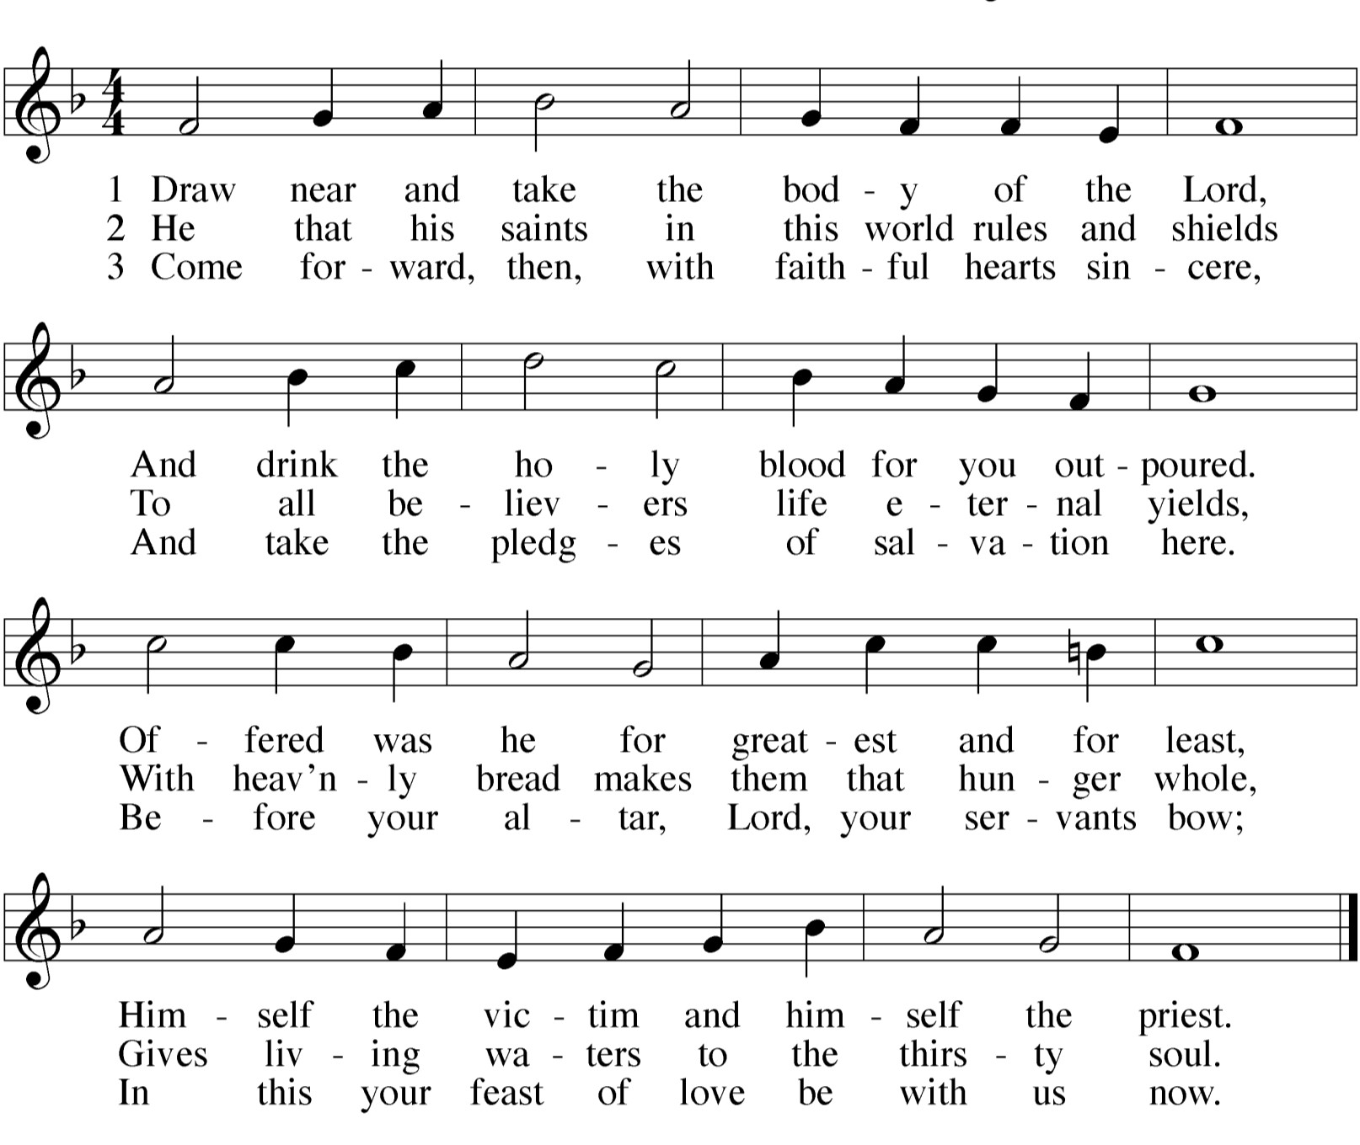

DISTRIBUTION — After the first group of communicants receives the Lord’s Supper, the
congregation will join in singing the distribution hymns:

HYMN 114 Christ, the Life of All the Living

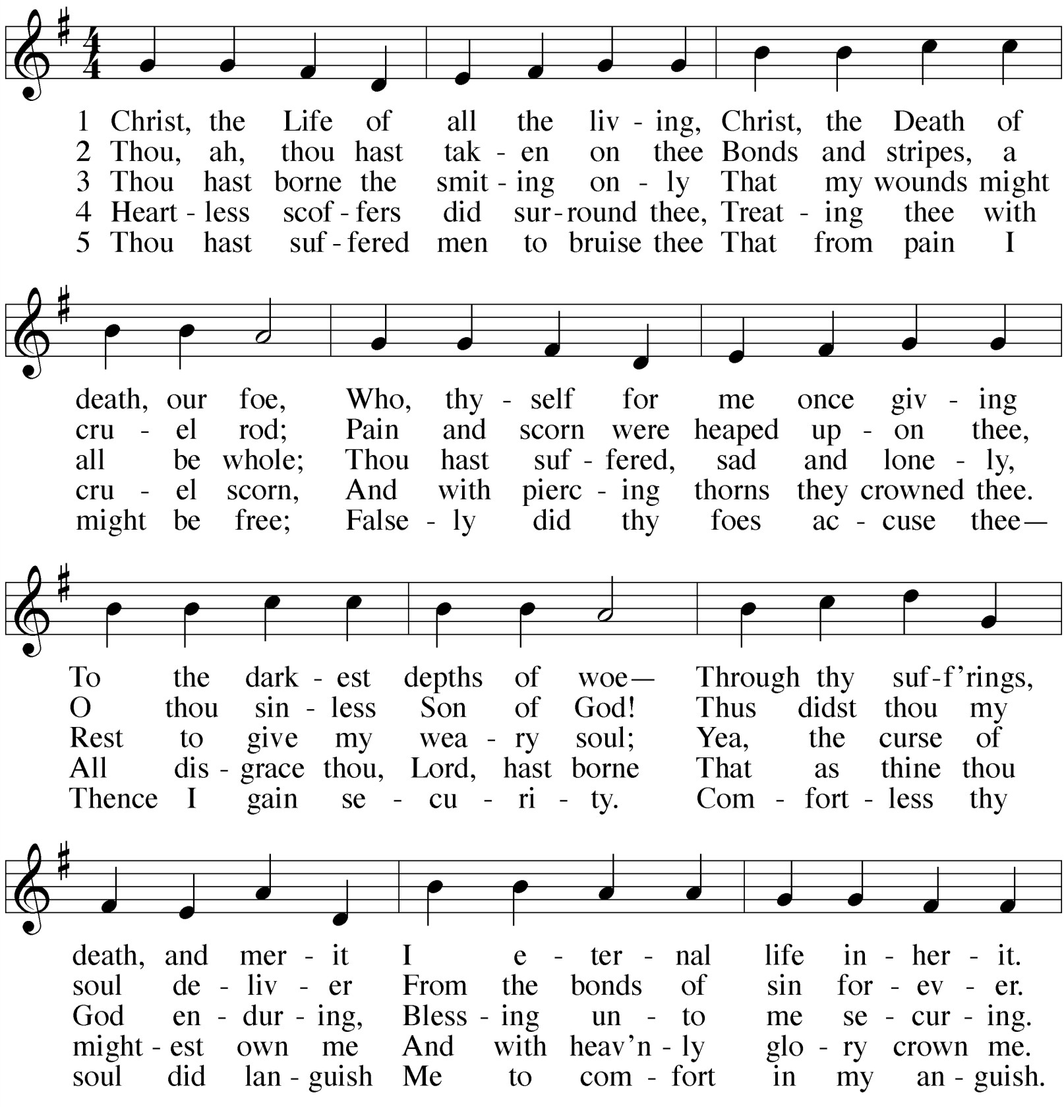
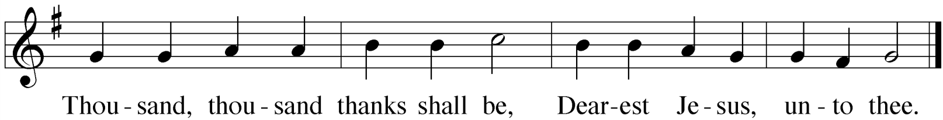Refrain

KYRIE 1
ALL: 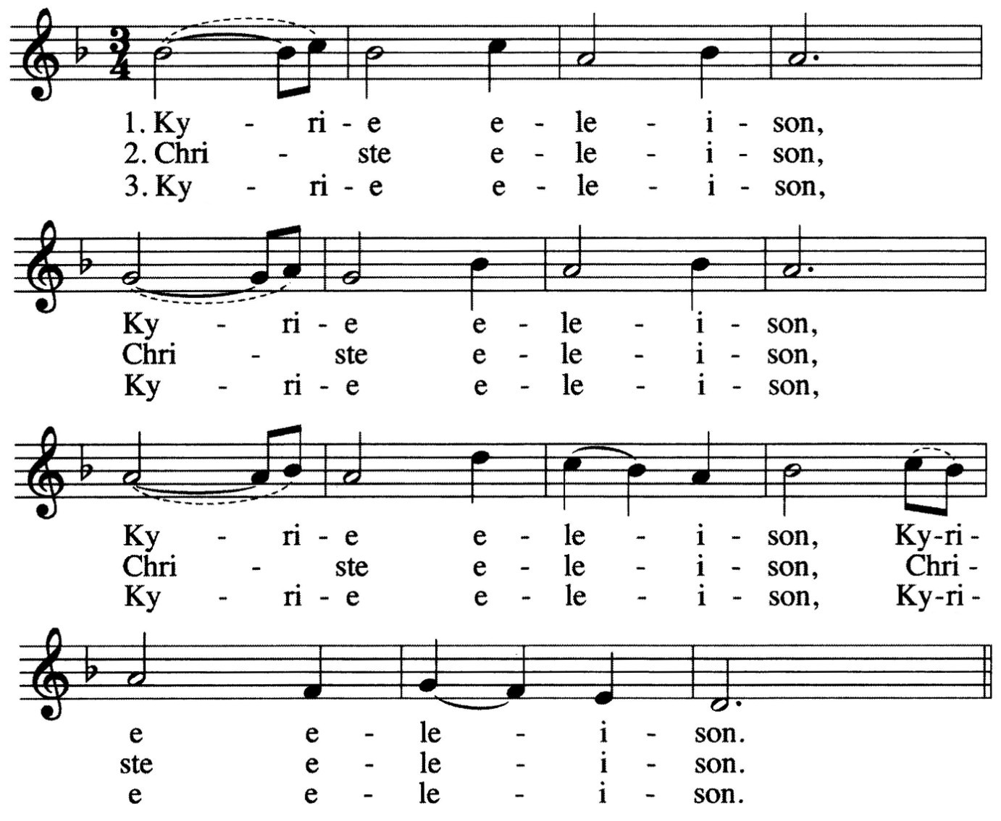

INVOCATION
M: The grace of our Lord  Jesus Christ, And the love of God,
And the fellowship of the Holy Spirit be with you all.

C: And also with you.

1 The Kyrie is one of the oldest prayers in the Christian church. Kyrie eleison means “Lord, have mercy.” It is pronounced keer-ree-ay eh-lay-i-zon. Christe elison means “Christ, have mercy.” It is pronounced chrees-stay eh-lay-i-zon.

PENITENTIAL RITE
M: Coming together as one people, we remember the times
when we have failed to live the Gospel call. We ask for the mercy of God,
who is full of gentleness and love.

After a brief musical introduction, the congregation joins in singing “Oh Christ, Lamb of God.” While the congregation is singing this canticle, the usher will direct the first table of communicants to come forward.

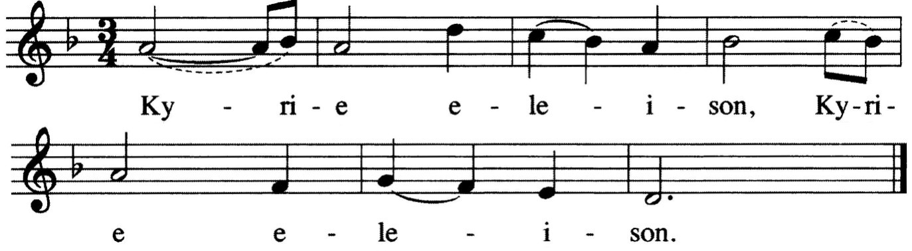M: (sung) Lord Jesus Christ, your word has great power, raising up a nation.

ALL:
O CHRIST, LAMB OF GOD
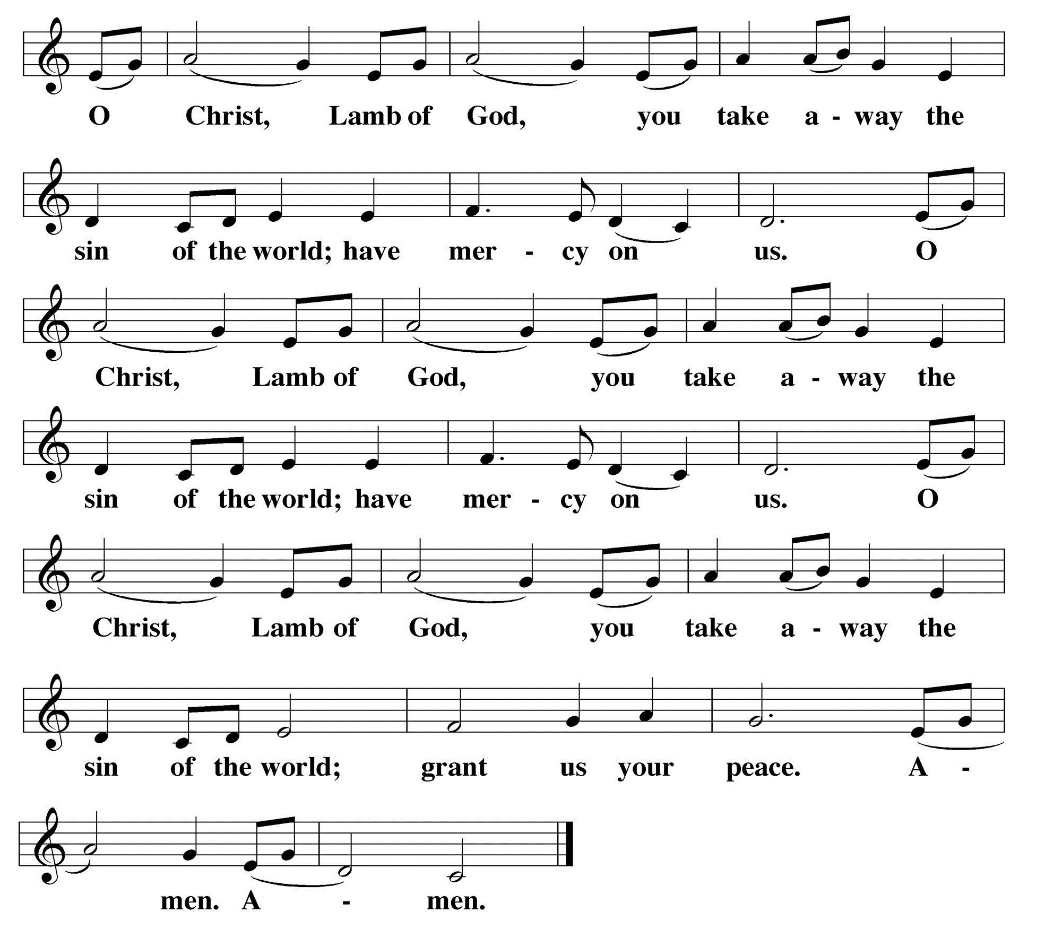Agnus Dei

C:
John 1:29

M: (sung) Lord Jesus Christ, you give us the Spirit.
Put to death our misdeeds.

ALL: 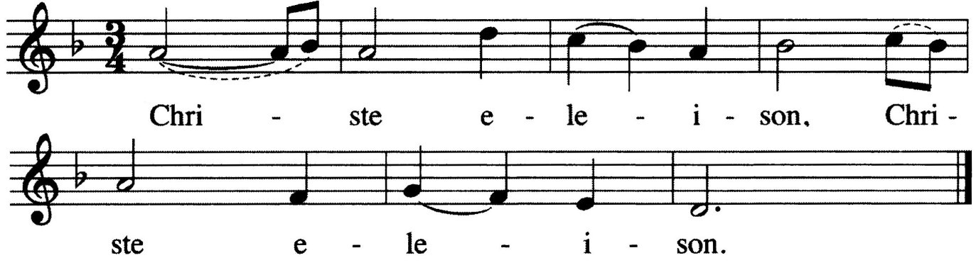
M: (sung) Lord Jesus Christ, you are resurrection.
You alone can give life.

ALL:

WORDS OF INSTITUTION

M: Our Lord Jesus Christ, on the night he was betrayed, took bread; and when he had given thanks, he broke it and gave it to his disciples, saying, “Take and eat; this is my  body, which is given for you. Do this in remembrance of me.”
Then he took the cup, gave thanks, and gave it to them, saying, “Drink from it, all of you; this is my  blood of the new covenant, which is poured out for you for the forgiveness of sins. Do this, whenever you drink it, in remembrance of me.”
The peace of the Lord be with you always.
C: Amen.
M: God Almighty has had mercy on us,
forgiven us our sins for the sake of Jesus  Christ, and opened to us life everlasting.

C: Amen.

M: (sung) Up from the ashes we now arise,
and return to our Maker who has answered our cries.
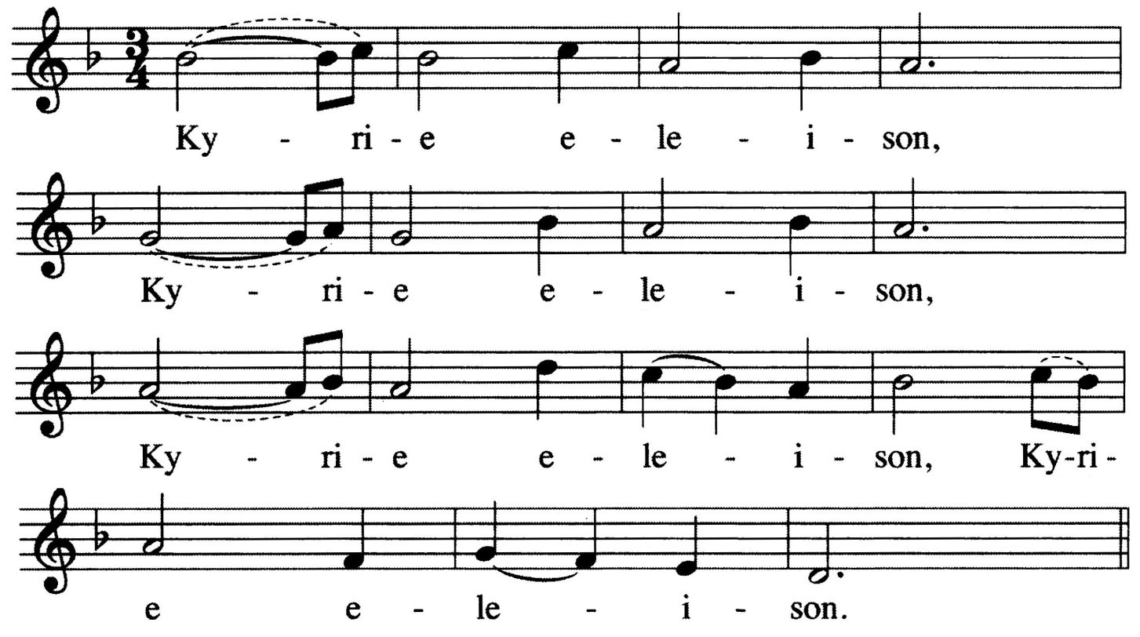Knowing God’s mercy we now stand healed, for in Jesus our Savior perfect love is revealed.

ALL:

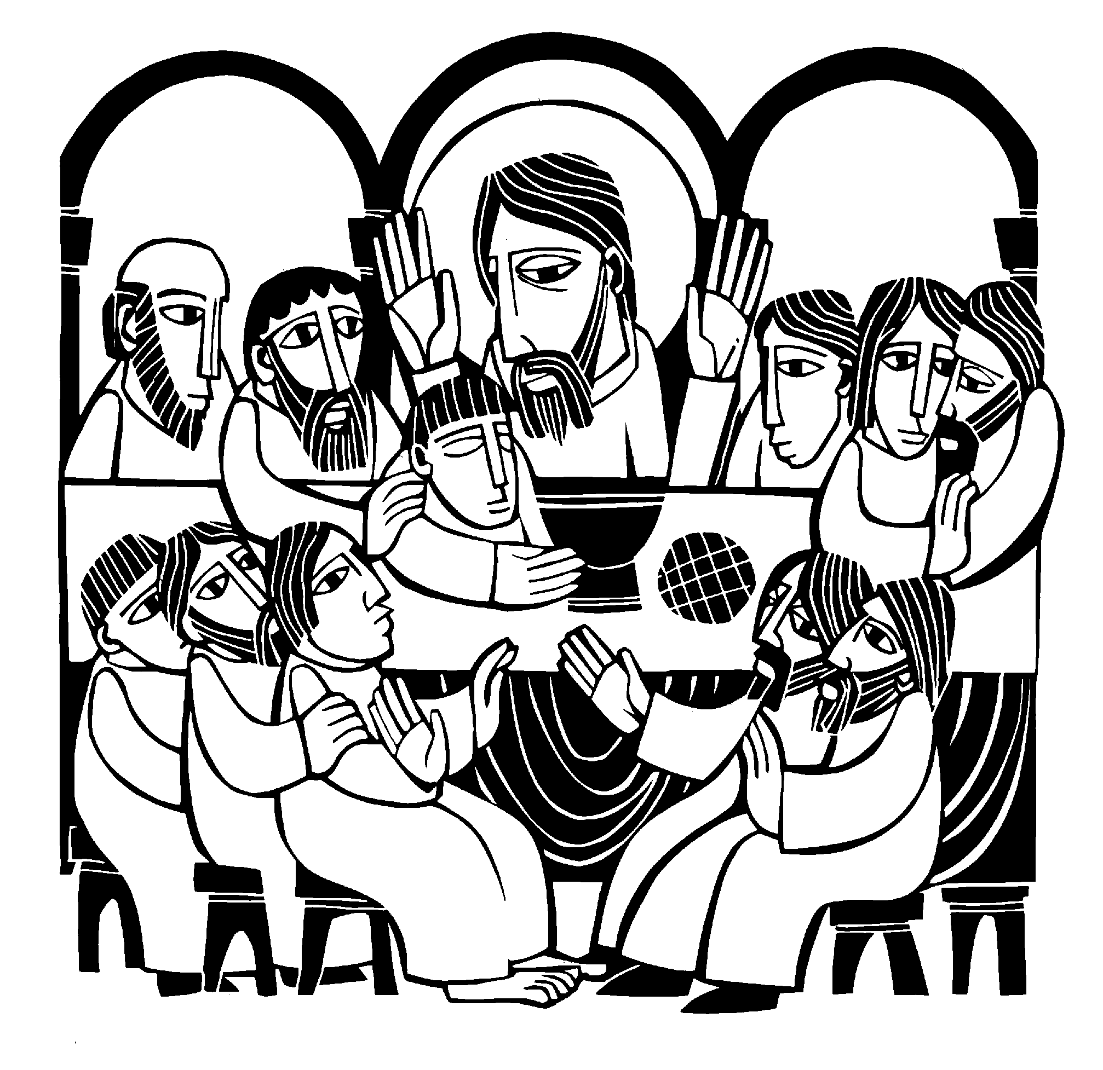
2

2 One might ask, “If the minister just proclaimed that my sins were forgiven, why would I sing ‘Lord, have mercy’ again?” It is meant to remind us that we not only need God’s mercy for forgiveness, but we also need it on an ongoing basis, that God might supply all our daily needs.

After a brief musical introduction, the congregation sings “Holy, Holy, Holy.”

PRAYER OF THE DAY
M: Eternal God and Father,

 The Word 

HOLY, HOLY, HOLY
Sanctus

Isaiah 6:3; Matthew 21:9

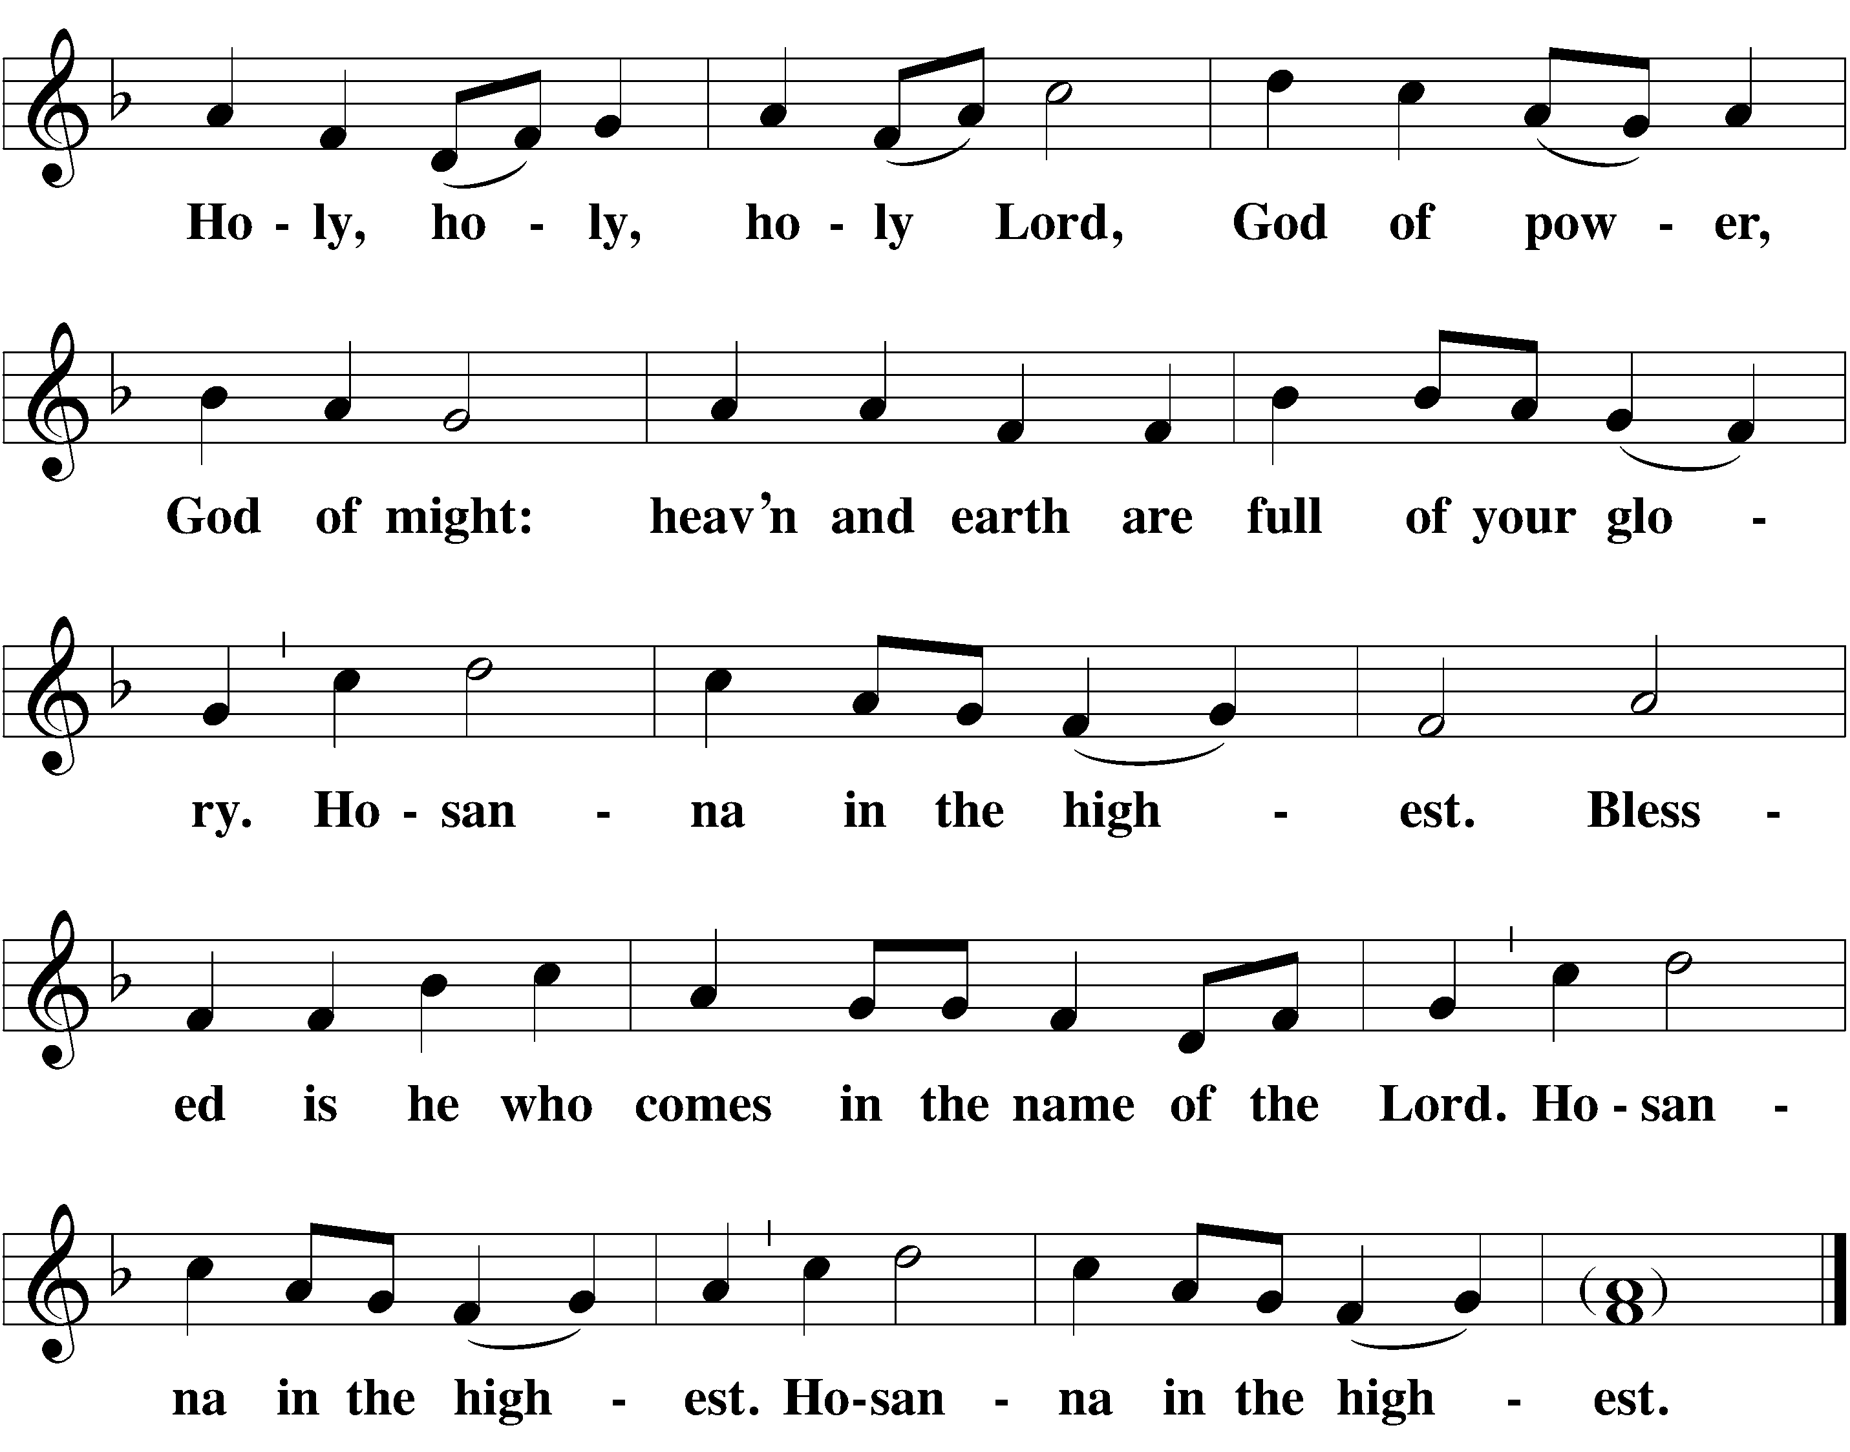help us to remember Jesus, who obeyed your will and bore the cross for our salvation
that through his anguish, pain, and death C:
we may receive forgiveness of sins and inherit eternal life; through your Son, Jesus Christ our Lord,
who lives and reigns with you and the Holy Spirit, one God, now and forever.

C: Amen.

 The Sacrament 
We follow the historic Christian practice of close communion. We ask that only members of Beautiful Savior Lutheran or one of our sister congregations partake of the sacrament. If you are not a member, please speak to one of the pastors before communing.

OPENING SENTENCES
M: The Lord be with you.

C: And also with you.
M: Lift up your hearts.

C: We lift them up to the Lord.
M: Let us give thanks to the Lord our God.

C: It is good and right so to do.
M: It is truly good and right
that we should at all times and in all places give you thanks, O Lord, holy Father, almighty and everlasting God,
through Jesus Christ, our Lord,
who brought the gift of salvation to all people by his death on the tree of the cross,
so that the devil, who overcame us by a tree would in turn by a tree be overcome.
Therefore with all the saints on earth and hosts of heaven, we praise your holy name and join their glorious song.

FIRST LESSON Ezekiel 37:1-14
1 The hand of the LORD was upon me, and he brought me out by the Spirit of the LORD and set me in the middle of a valley; it was full of bones. 2 He led me back and forth among them, and I saw a great many bones on the floor of the valley, bones that were very dry. 3 He asked me, "Son of man, can these bones live?"
I said, "O Sovereign LORD, you alone know."
4 Then he said to me, "Prophesy to these bones and say to them, 'Dry bones, hear the word of the LORD! 5 This is what the Sovereign LORD says to these bones: I will make breath enter you, and you will come to life. 6 I will attach tendons to you and make flesh come upon you and cover you with skin; I will put breath in you, and you will come to life. Then you will know that I am the LORD.' "
7 So I prophesied as I was commanded. And as I was prophesying, there was a noise, a rattling sound, and the bones came together, bone to bone. 8 I looked, and tendons
and flesh appeared on them and skin covered them, but there was no breath in them.
9 Then he said to me, "Prophesy to the breath; prophesy, son of man, and say to it, 'This is what the Sovereign LORD says: Come from the four winds, O
breath, and breathe into these slain, that they may live.'"
10 So I prophesied as he commanded me, and breath
entered them; they came to life and stood up on their feet—a vast army.
11 Then he said to me: "Son of man, these bones are
the whole house of Israel. They say, 'Our bones are dried up and our hope is gone; we are cut off.' 12 Therefore prophesy and say to them: 'This is what the Sovereign LORD says: O my people, I am going to open your graves and bring you up from them; I will bring you back to the land of Israel. 13 Then you, my people, will know that I am the LORD, when I open your graves and bring you up from them. 14 I will put my Spirit in you and you will live, and I will settle you in your own land. Then you will know that I the LORD have spoken, and I have done it, declares the LORD.' "

PSALM OF THE DAY Psalm 116
M: I love the Lord, for he heard my voice;

C: he heard my cry for mercy.
M: Because he turned his ear to me, C: I will call on him as long as I live. M: The Lord is gracious and righteous; C: our God is full of compassion.
M: The Lord protects the unwary;

C: when I was brought low, he saved me.
M: Return to your rest, my soul,

C: for the Lord has been good to you.
M: For you, Lord, have delivered me from death, C: my eyes from tears, my feet from stumbling, M: that I may walk before the Lord

C: in the land of the living.
M: What shall I return to the Lord for all his goodness to me?

C: I will lift up the cup of salvation and call on the name of the Lord.
M: I will fulfill my vows to the Lord

C: in the presence of all his people.
M: I will sacrifice a thank offering to you

C: and call on the name of the Lord. Praise the Lord!

 The Prayers 
THE PRAYER OF THE CHURCH
Prayers and petitions are offered on behalf of the Church
M: Hear us now, Lord, as we bring you our private petitions.
Silent prayer
M: Into your hands, Father, we place ourselves and all for whom we pray, trusting your mercy; through your Son, Jesus Christ our Lord, who taught us to pray.

THE LORD’S PRAYER

C: Our Father in heaven, hallowed be your name, your kingdom come,
your will be done on earth as in heaven. Give us today our daily bread.
Forgive us our sins, as we forgive those who sin against us. Lead us not into temptation,
but deliver us from evil.
For the kingdom, the power, and the glory are yours now and forever. Amen.

SERMON

CONFESSION OF FAITH The Nicene Creed

We believe in one God, the Father, the Almighty, maker of heaven and earth,
of all that is, seen and unseen.
We believe in one Lord Jesus Christ, the only Son of God, eternally begotten of his Father,
God from God, Light from Light, true God from true God, begotten, not made, of one being with the Father.
Through him all things were made.
For us and for our salvation, he came down from heaven,
was incarnate of the Holy Spirit and the virgin Mary, and became fully human.
For our sake he was crucified under Pontius Pilate.
He suffered death and was buried.
On the third day he rose again in accordance with the Scriptures.
He ascended into heaven and is seated at the right hand of the Father.
He shall come again in glory to judge the living and the dead, and his kingdom will have no end.
We believe in the Holy Spirit, the Lord, and giver of Life, who proceeds from the Father and the Son,
who in unity with the Father and the Son is worshipped and glorified, who has spoken through the prophets.
We believe in one holy Christian and apostolic Church. We acknowledge one baptism for the forgiveness of sins.
We look for the resurrection of the body and the life of the world to come.
Amen.

THANK OFFERING
SECOND LESSON Romans 8:11-19
11And if the Spirit of him who raised Jesus from the dead is living in you, he who raised Christ from the dead will also give life to your mortal bodies through his Spirit, who lives in you.
12Therefore, brothers, we have an obligation—but it is not to the sinful nature, to live according to it.
13For if you live according to the sinful nature, you will die; but if by the Spirit you put to death the
misdeeds of the body, you will live, 14because those who are led by the Spirit of God are sons of God.
15For you did not receive a spirit that makes you a
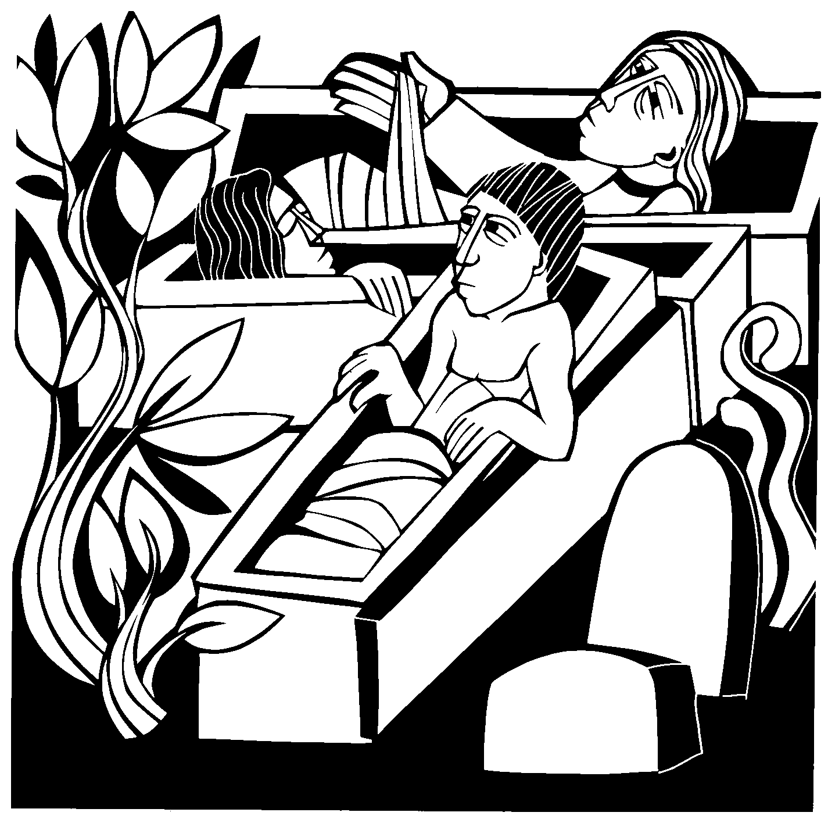slave again to fear, but you received the Spirit of sonship. And by him we cry, "Abba, Father." 16The Spirit himself testifies with our spirit that we are God's children. 17Now if we are children, then we are heirs— heirs of God and co-heirs with Christ, if indeed we share in his sufferings in order that we may also share in his glory.
18I consider that our present sufferings are not worth comparing with the glory that will be revealed
in us. 19The creation waits in eager expectation for the sons of God to be revealed.

VERSE OF THE DAY Mark 10:45

M: Refrain
C: Refrain
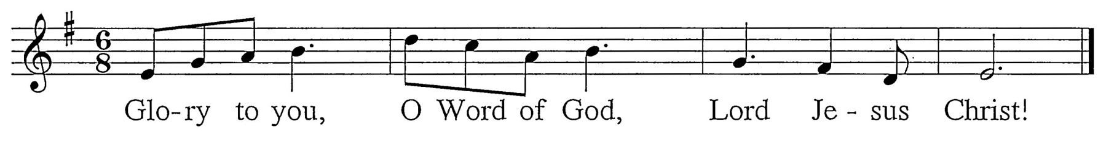
M: The Son of Man came not to be served, but to serve and to give his life as a ransom.
C: Refrain (sung twice)

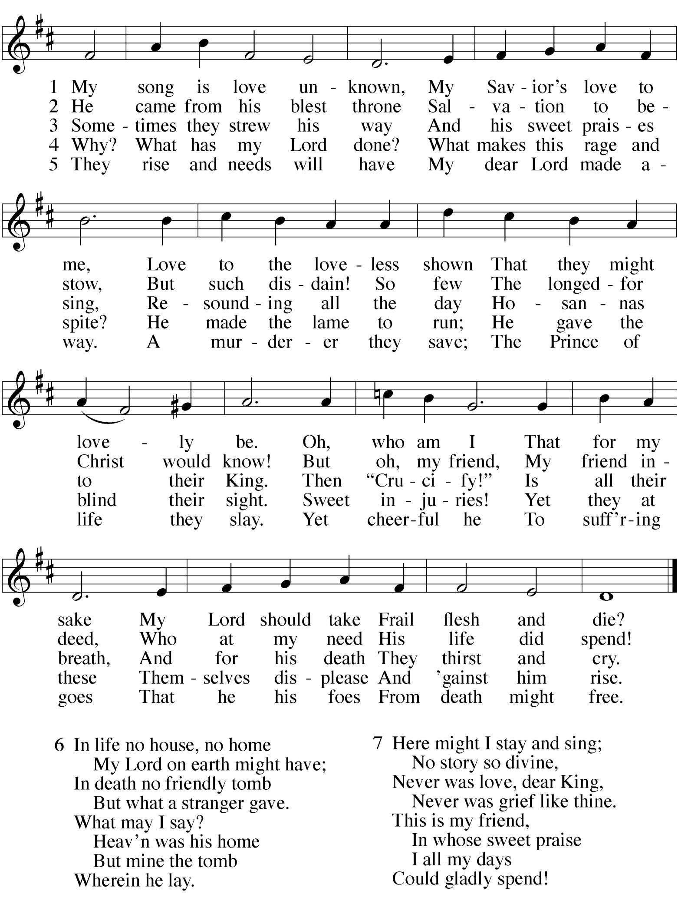GOSPEL John 11:17-27,38-45
17On his arrival, Jesus found that Lazarus had already been in the tomb for four days. 18Bethany was less than two miles from Jerusalem, 19and many Jews had come to Martha and Mary to comfort them in the loss of their brother. 20When Martha heard that Jesus was coming, she went out to meet him, but Mary stayed at home.
21"Lord," Martha said to Jesus, "if you had been here, my brother
would not have died. 22But I know that even now God will give you whatever you ask."
23Jesus said to her, "Your brother will rise again."
24Martha answered, "I know he will rise again in the resurrection at the last day."
25Jesus said to her, "I am the resurrection and the life. He who believes in me will live, even though he dies; 26and whoever lives and
believes in me will never die. Do you believe this?"
27"Yes, Lord," she told him, "I believe that you are the Christ, the Son of God, who was to come into the world."
38 Jesus, once more deeply moved, came to the tomb. It was a cave with a stone laid across the entrance. 39 “Take away the stone,” he said.
“But, Lord,” said Martha, the sister of the dead man, “by this time there is a bad odor, for he has been there four days.”
40 Then Jesus said, “Did I not tell you that if you believe, you will
see the glory of God?”
41 So they took away the stone. Then Jesus looked up and
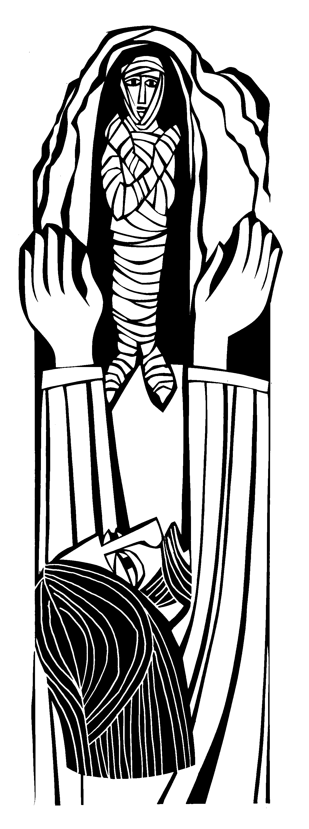said, “Father, I thank you that you have heard me. 42 I knew that you always hear me, but I said this for the benefit of the people standing here, that they may believe that you sent me.”
43 When he had said this, Jesus called in a loud voice, “Lazarus, come out!” 44 The dead man came out, his hands and feet wrapped
with strips of linen, and a cloth around his face.
Jesus said to them, “Take off the grave clothes and let him go.”
45 Therefore many of the Jews who had come to visit Mary, and had seen what Jesus did, believed in him.

M: This is the Gospel of our Lord.

C: Praise be to you, O Christ!
HYMN OF THE DAY — 110 My Song Is Love Unknown

