- 16 -

Your congregation’s license information goes here

Hosanna! Palm Sunday Processional
Words and music: Francis Patrick O’Brien
© 2001 GIA Publications, Inc.

Gospel Acclamation from Mass of Light
Music: David Haas
©1988 GIA Publications, Inc.

Sixth Sunday in Lent (Palm Sunday) April 13, 2014

IN THE SHADOW OF THE CROSS
The Sundays in Lent
“TIME TO GET SERIOUS”
KING JESUS HUMBLY WALKED

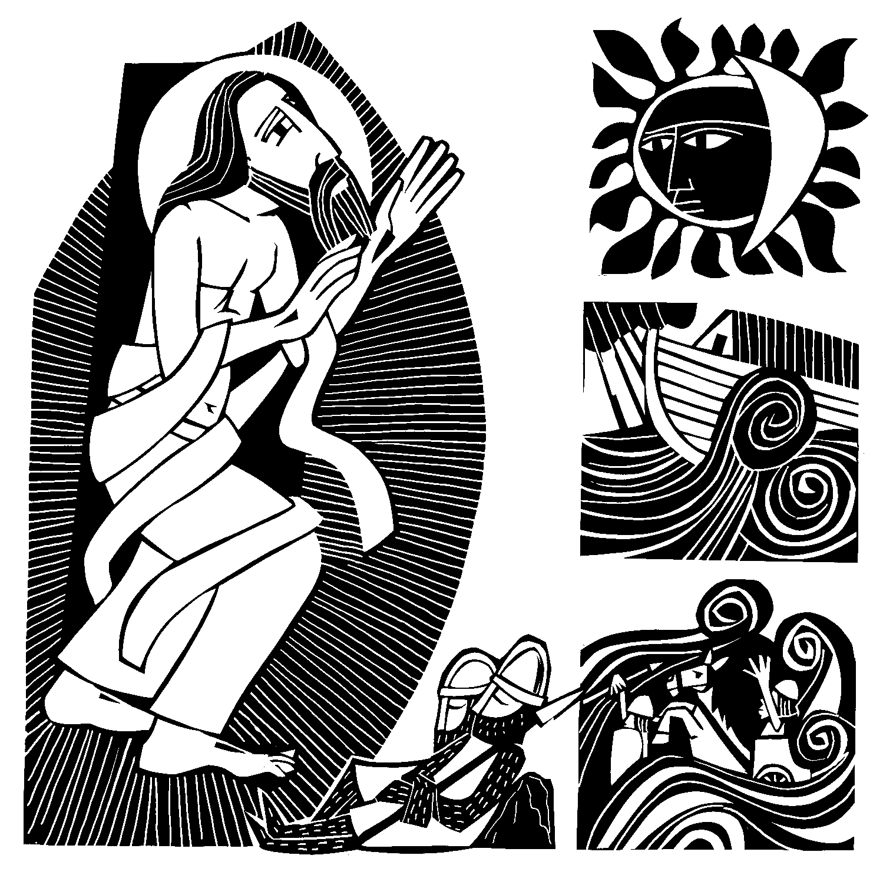HOLY WEEK SCHEDULE: THE TRIDUUM
Triduum is Latin for “three days.” For centuries the church has set aside the final three days before Easter for a time of intense personal preparation. The following three worship opportunities consist of the Triduum.

April 17 at 7:00PM
Maundy Thursday
A MEAL TO SAVE YOU

Maundy Thursday gets its name from the Latin word mandatum, the first word of the phrase "Mandatum novum do vobis ut diligatis invicem sicut dilexi vos." That phrase means: "A new commandment I give unto you, That ye love one another; as I have loved you.” Those are the words Christ spoke in the Gospel of John (13:34). Jesus explained to the apostles the significance of his command by washing their feet before he instituted the Lord’s Supper. On this first day of the Triduum, we look at the special spiritual benefits God gives us in this holy meal. Worship includes the celebration of the Lord’s Supper.

April 18 at 7:00PM
Good Friday
THE SEVEN WORDS
A SERVICE OF DARKNESS

The middle of the Triduum is Good Friday. On this day, darkness blanketed the earth from noon until 3:00PM, as our Savior endured the pains of hell, hanging from a cross. But Christ’s suffering means our salvation. In this worship service, we use the ancient custom of tenebrae, Latin for “darkness.” Throughout the service, as we meditate upon our Savior’s passion, lights are dimmed and candles snuffed. This symbolizes the ebbing of Christ’s life. The somberness of this service serves as a foil, making the joy of Easter Sunday all that much brighter.

April 19 at 9:00PM Holy Saturday THE GREAT VIGIL

The Triduum begins with a look at the Sacrament of Holy Communion on Maundy Thursday. As Saturday fades into Sunday, it ends with a look at the Sacrament of Holy Baptism. Scripture says Baptism is a means by which we receive the power and benefits of Christ’s resurrection. Already in the 2nd century AD, Christians would gather before Easter and commemorate their baptisms while waiting for dawn to rise on the empty tomb. Likewise, we gather outside the church this evening and process in behind the Paschal Candle, a reminder of our baptism. The Great Vigil includes celebration of the Lord’s Supper.

CLOSING HYMN A t the Name of Jesus
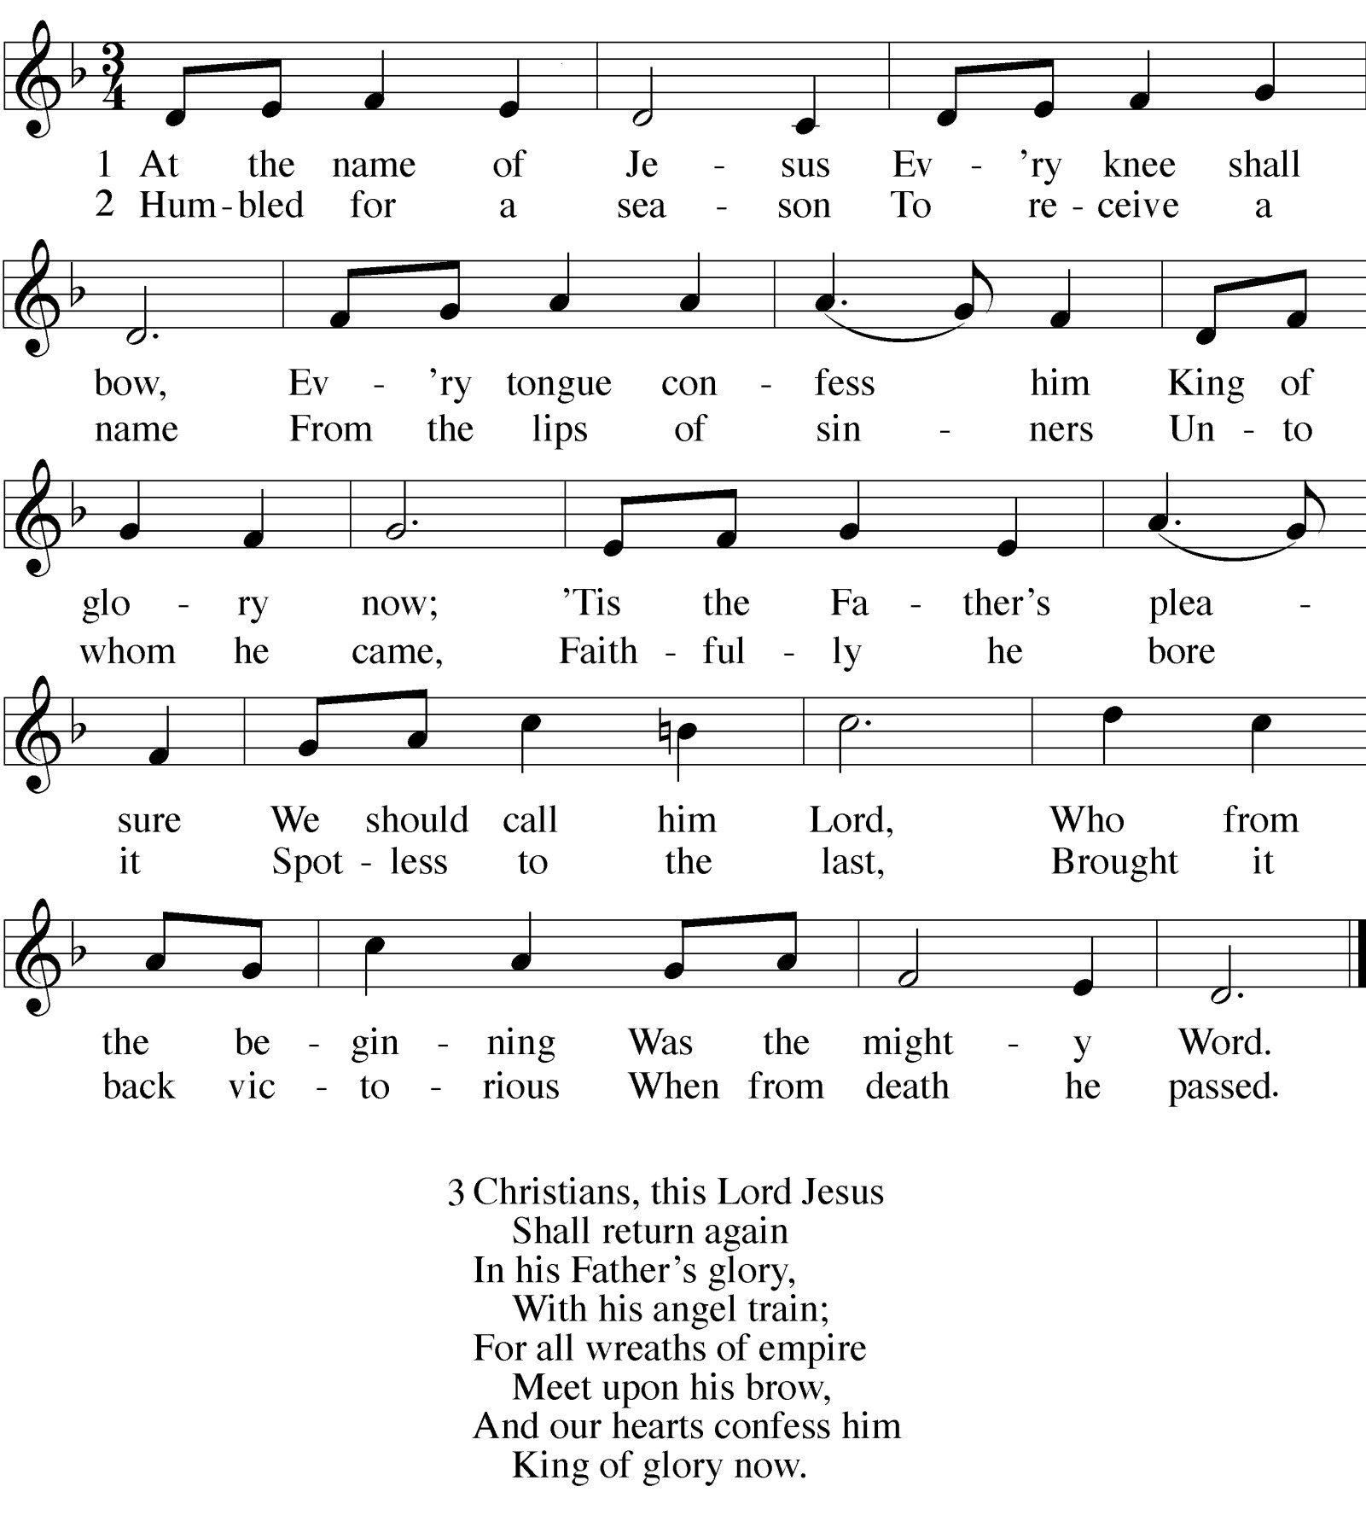

Hymn Appreciation This hymn comes from a collection written by Caroline Maria Noel in London in 1870. It was titled The Name of Jesus, and other Verses for the Sick and Lonely. It was hymns and poems meant to give special comfort to the sick and dying. Certainly, the promise of Jesus, the conqueror of sin and death, to return and take us to glory, would provide such comfort!

WORSHIP NOTES
THE SEASON OF LENT
The word Lent comes from an Old English word for Spring (“lengten,” the time of the year when the days grow longer). For the last 1700 years, the Church has set aside the 40 days between Ash Wednesday and Easter as a time of special preparation. It is a time of repentance and renewal. Our theme throughout this Lenten season is as follows:

IN THE SHADOW OF THE CROSS
The devil is defeated The gift comes by faith The blind can finally see Selfishness is crushed
We are raised from death to life King Jesus humbly walked
OUR THEME FOR TODAY
In the shadow of the cross, King Jesus humbly walked. From his birth to his death, Jesus demonstrates remarkable humility. He is King of kings. And yet when born into our world, he did not have a golden crib, but only a manger. When he rides into the royal city as a king, it is not on a stallion, but a little donkey foal. And when he, as Lord of Lord, mounts his position of authority, it is not a throne, but a cross. Why would one so great be so unspeakably humble? And what is there for us to learn in his humility?

PALM SUNDAY is the beginning of Holy Week – the most intense week of our Christian Year. Palm Sunday has been celebrated in the Christian Church since the 4th Century. 1,600 years ago believers in and around Jerusalem would retrace Jesus’ route from the Mount of Olives back into the city for worship.
THE PALM SUNDAY PROCESSIONAL is a way we demonstrate our unity with the believers that went before us, using a processional to begin our Holy Week celebration. As is customary with a worship processional, we utilize a processional cross, carried by one of our children. A processional cross symbolizes the presence of Jesus, for Jesus promised: “Where two or three come together in my name, there am I with them” (Matthew 18:20). After the procession, processional crosses are often placed near the pulpit, to symbolize that Christ is with us through his Word.

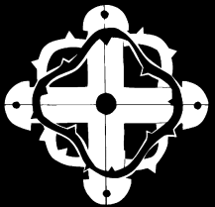AN ORDER OF SERVICE FOR LENT
By combining a unique confession of sins, a traditional Lenten confession of faith, and carefully chosen lessons, this order of service allows the believer to come to a full awareness of the seriousness of his or her sin, and also to joyfully remember the source if its cure.

 The Gathering 

PALM SUNDAY PROCESSION
Stand and face the back doors
M: The grace of our Lord  Jesus Christ and the love of God
and the fellowship of the Holy Spirit be with you.

C: And also with you.
M: Dear friends in Christ, for five weeks of Lent we have been preparing for the celebration of our Lord’s paschal mystery. Today we come together to begin the solemn celebration of Holy Week. Christ entered in triumph into his own city, to complete his work as our Messiah: to suffer, to die, and to rise again. Let us remember with devotion his entry that culminated at the empty tomb and follow him with a lively faith. United with him by Baptism, we share in his resurrection and new life.
Let us pray.
God our Father, we remember how Jesus entered Jerusalem and was welcomed as king by those who shouted “Hosanna” 1 and spread their clothing and palm branches in his path. Accept our praise and listen to our prayers as we rejoice in our triumphant King, Jesus Christ, your Son, our Lord.

C: Amen.
M: Let us go forth in peace,

C: in the name of the Lord.
The children process in. Please turn towards the cross as it passes by.

THE PRAYER OF THE CHURCH
Special prayers and petitions may be offered
M: Hear us now, Lord, as we bring you our private petitions.
Silent prayer
M: Almighty God, we come before you trusting that you hear our prayers. In your mercy, listen to our supplications on behalf of all for whom we pray and fulfill our desires and petitions according to your will, for we pray in Jesus’ name, and as he taught.

THE LORD’S PRAYER

C: Our Father in heaven, hallowed be your name, your kingdom come,
your will be done on earth as in heaven. Give us today our daily bread.
Forgive us our sins, as we forgive those who sin against us. Lead us not into temptation,
but deliver us from evil.
For the kingdom, the power, and the glory are yours now and forever. Amen.
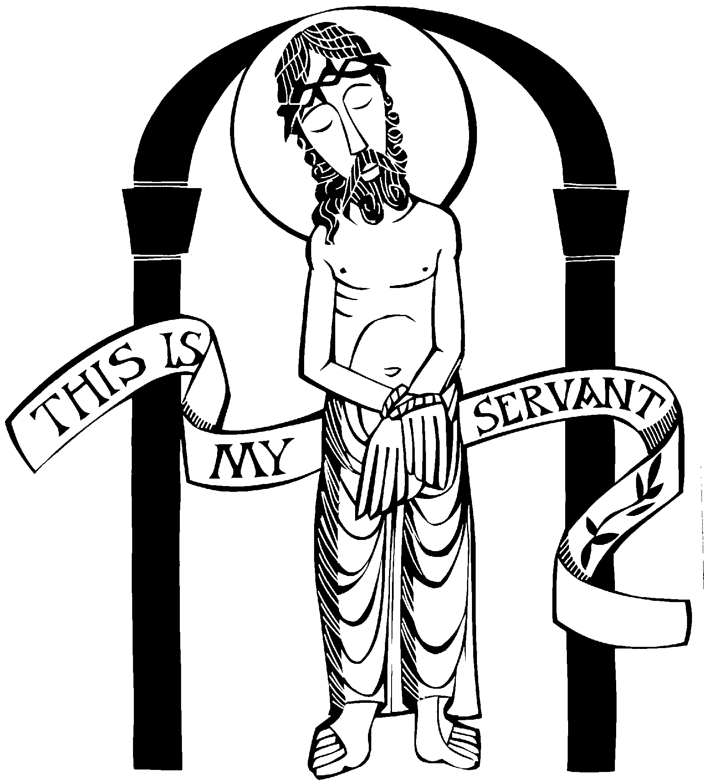
THE BLESSING 3
M: Brothers and sisters, go in peace. Live in harmony with one another. Serve the Lord with gladness.
The Lord bless you and keep you.
The Lord make his face shine on you and be gracious to you. The Lord look on you with favor and give  you peace.

C: Amen.

1 Hosanna! is the shout of praise so familiar to Palm Sunday worshipers. It literally means “Save us, we pray!” Jesus was rid- ing into Jerusalem to do just that.

7 This blessing is recorded in Numbers 6. It is what the Lord himself told Aaron, the high priest, he was to say at the end of worship. Thus, using this blessing follows a custom of believers that is three-and-a-half millennia old!

PROCESSIONAL HYMN
Hosanna in the Highest

 The Prayers 

A PRAYER OF CONFESSION
M: Merciful Father, we come before you in this solemn season of Lent. For the past five weeks, our meditation has been on your Son’s passion. And yet even in the midst of this focus, we have stumbled and failed. Every day of Lent, we have sinned in our actions, or in our speech, or in our thoughts, or in our attitudes, or — most likely — in all of these ways. Therefore, as we begin this most Holy Week, we humbly come before you, and we pray:

C: Have mercy on us. In your compassion forgive us our sins.
Blot out our transgressions. Take away our guilt.
Uphold us by your Spirit so that we may live and serve you in newness of life,
To the honor and glory of your holy name; through Jesus Christ our Lord. Amen.
M: Father, you sent your Son to be perfect, precisely because you knew we could not be perfect. You sent Christ to obey the Law, precisely because you knew, no matter how intense our devotion, no matter how fervent our prayer, we would still break your Law. You sent your Son to show perfect love, for you knew that no matter how good our intentions, no matter how focused our efforts, our love for you and for others would be found lacking.
Therefore, through faith, we boldly claim Christ
— his righteousness, his beauty, his life — as our own.

C: His obedience we call our obedience.
His death we call our death to sin.
His power over temptation and Satan himself, we call our power. His glory shall be our glory.
His resurrection shall be our resurrection. His reign eternal shall be shared with us.
M: His mission shall be our mission — to share the Good News of Christ, that at the name of Jesus, every knee might bow.

C: And every tongue confess him King of Glory now.
After processing in, the children sing the refrain and the first verse. From then on, the congregation joins in on the refrain.

Children: Hosanna, hosanna, hosanna in the highest! Hosanna, hosanna, hosanna in the highest!
Children of Jerusalem, shouting praises, followed him.
“This is he who comes to save, he our ransom from the grave.”
ALL: Refrain

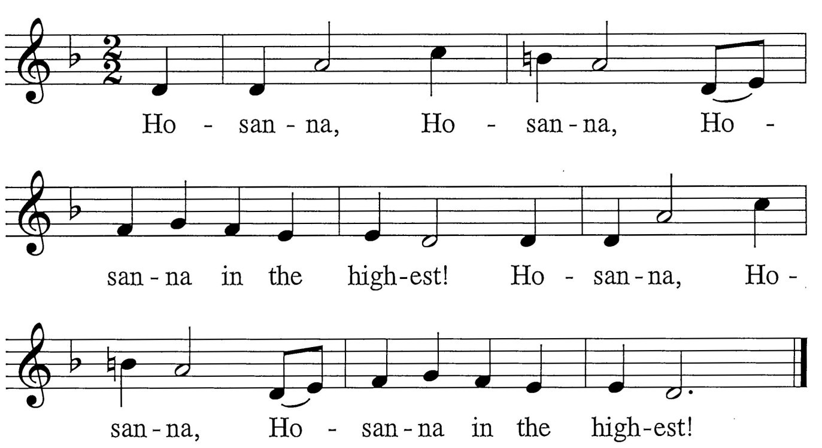

Children: Open wide the sacred door; King of glory rides ones more.
Sing hosannas, shout his name, to the world God’s love proclaim.

ALL: Refrain
Children: Blessed Christ, who comes in pow’r, saves us all from Satan’s hour; Grasping not divinity, wins our freedom on a tree.

ALL: Refrain
Children: Ev’ry tongue on earth confess, Jesus, rich in holiness, Comes to be our saving Lord. In his name be God adored.

ALL: Refrain

PRAYER OF THE DAY2
M: We praise you, O God,

 The Word 

for the great acts of love by which you redeemed us through your Son, Jesus Christ.
As he was acclaimed by those who scattered their garments and branches of palm in his path, so may we always hail him as our King
and follow him with perfect confidence;
who lives and reigns with you and the Holy Spirit, one God, now and forever.

C: Amen.

CHILDREN’S MESSAGE

FIRST LESSON Zechariah 9:9-10

- Rejoice greatly, O Daughter of Zion!
Shout, Daughter of Jerusalem! See, your king comes to you, righteous and having salvation, gentle and riding on a donkey, on a colt, the foal of a donkey.
- I will take away the chariots from Ephraim and the war-horses from Jerusalem,
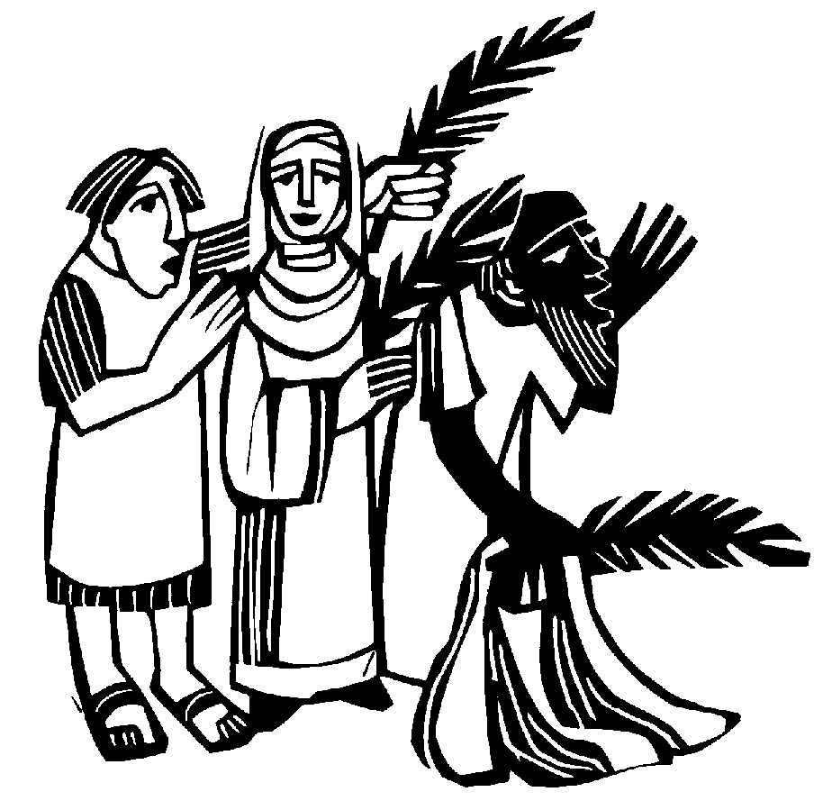and the battle bow will be broken.
He will proclaim peace to the nations.
His rule will extend from sea to sea
and from the River to the ends of the earth.

2 The Prayer of the Day is a short prayer in which believers ask God to accomplish some spiritual task, based on the theme of the day. The theme of the day finds the common thread that runs through all three Scripture lessons and is expressed most clearly in the Gospel lesson. The Prayer of the Day is often ancient. Some of them date back as far as the fifth century. It is not surprising that the Church has retained these prayers. The greatest needs of mankind never change.

CONFESSION OF FAITH The Apostles’ Creed

I believe in God, the Father almighty, maker of heaven and earth.
I believe in Jesus Christ, his only Son, our Lord,
who was conceived by the Holy Spirit, born of the virgin Mary,
suffered under Pontius Pilate,
was crucified, died, and was buried. He descended into hell.
The third day he rose again from the dead.
He ascended into heaven
and is seated at the right hand of God the Father almighty. From there he will come to judge the living and the dead.
I believe in the Holy Spirit,
the holy Christian Church, the communion of saints, the forgiveness of sins,
the resurrection of the body, and the life everlasting.
Amen.

THANK OFFERING

HYMN OF THE DAY Ride On, Ride On in Majesty

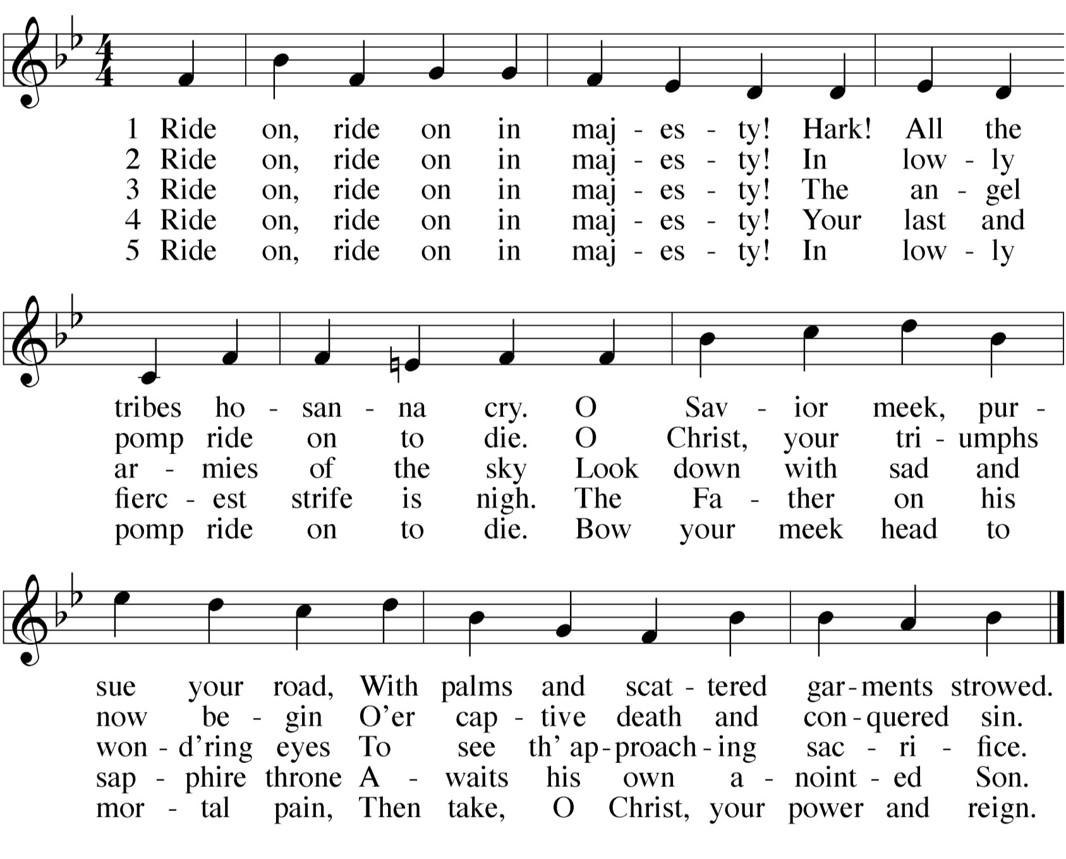

SERMON
PSALM OF THE DAY Psalm 24
M: Refrain
C: Refrain
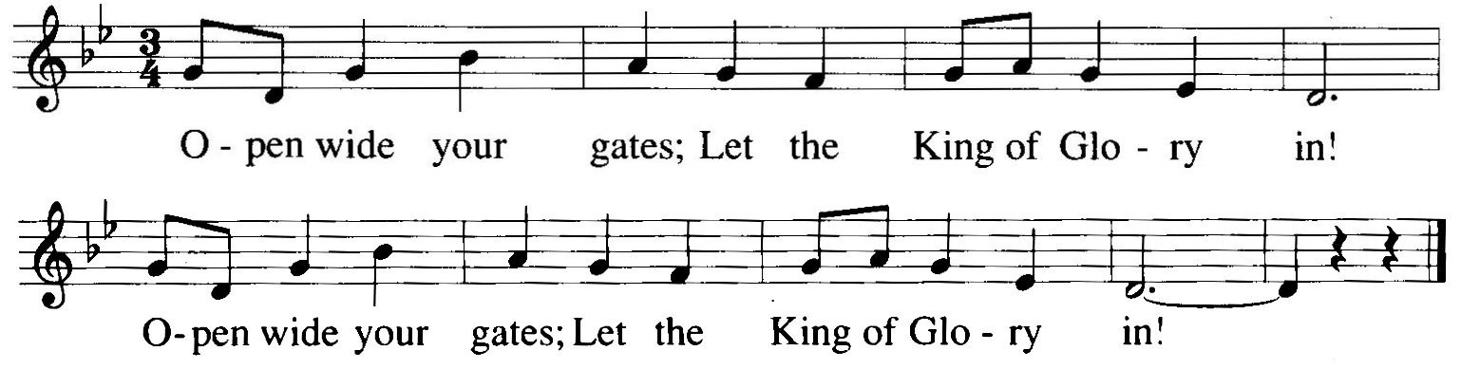
M: The Lord’s is the earth and its fullness, the world and all its peoples.
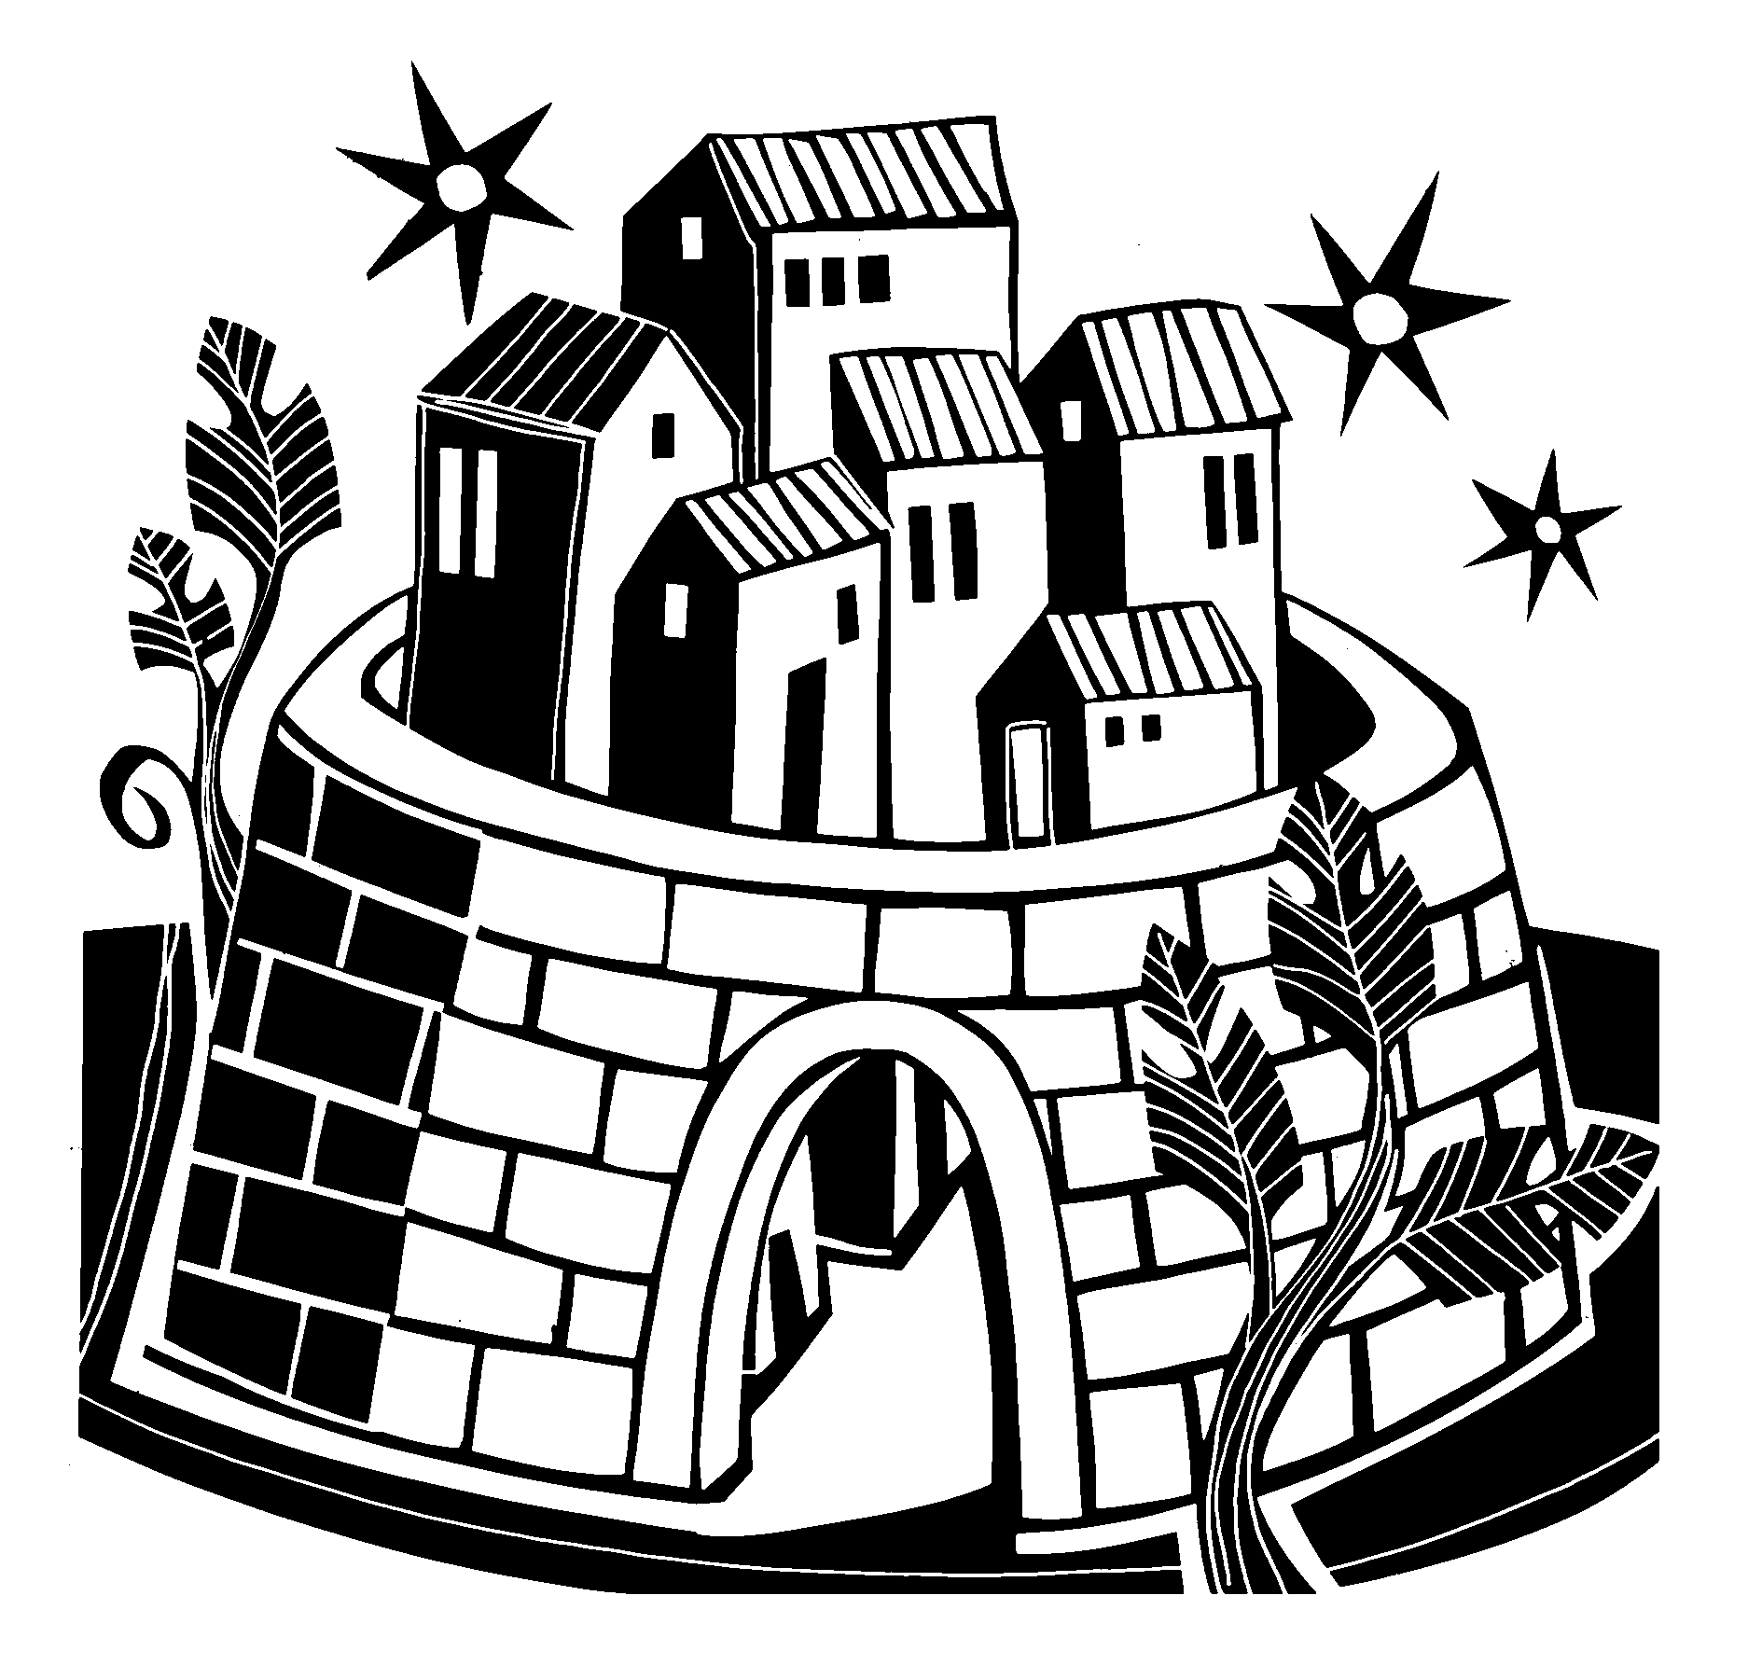It is God who set it on the seas; who made it firm on the waters.
C: Refrain
M: Who shall climb the mountain of the Lord?
Who shall stand in God’s holy place? Those with clean hands and a pure heart, who desire not worthless things.
C: Refrain
M: They shall receive blessings from the Lord and reward from the God who saves them. These are the ones who seek —
seek the face of the God of Jacob.
C: Refrain

Psalm Appreciation
By the late fourth century, it had become tradition that believers would sing Psalm 24 on Palm Sunday.
It was written by King David after he defeated the Jebusites and obtained Jerusalem. David longed to possess Jerusalem, not simply because he thought it would be a great capital city, but also because he felt that its towering Mount Zion would be a glorious place to construct a permanent temple for the Lord. When the Ark of the Covenant — the sign of God’s presence — was moved from the house of Obed-Edom and into Jerusalem, we’re told King David was overcome with joy and “danced before the LORD with all his might” (2 Samuel 6:14). He wrote Psalm 24 to commemorate that special day when the Ark entered the gates of Jerusalem.
However, if one reads carefully, the gates in this psalm are not just the literal gates of Jerusalem. King David encourages believers to open the entrance into their hearts wide, that the LORD might enter and establish his reign of grace within us.

SECOND LESSON Philippians 2:5-11
5Your attitude should be the same as that of Christ Jesus:
6Who, being in very nature God,
did not consider equality with God something to be grasped,
7but made himself nothing,
taking the very nature of a servant, being made in human likeness.
8And being found in appearance as a man, he humbled himself
and became obedient to death— even death on a cross!
9Therefore God exalted him to the highest place
and gave him the name that is above every name,
10that at the name of Jesus every knee should bow, in heaven and on earth and under the earth,
11and every tongue confess that Jesus Christ is Lord, to the glory of God the Father.

VERSE OF THE DAY John 12:23

M: Refrain
C: Refrain
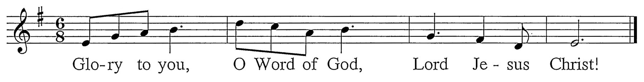
M: “The hour... the hour has finally come for the Son of Man to be glorified.”
C: Refrain (sung twice)

GOSPEL Matthew 21:1-11
1As they approached Jerusalem and came to Bethphage on the Mount of Olives, Jesus sent two disciples, 2saying to them, "Go to the village ahead of you, and at once you will find a donkey tied there, with her colt by her. Untie them and bring them to me. 3If anyone says anything to you, tell him that the Lord needs them, and he will send them right away."
4This took place to fulfill what was spoken through the prophet:
5"Say to the Daughter of Zion,
'See, your king comes to you, gentle and riding on a donkey, on a colt, the foal of a donkey.' "
6The disciples went and did as Jesus had instructed them. 7They brought the donkey and the colt, placed
their cloaks on them, and Jesus sat on them. 8A very large crowd spread their cloaks on the road, while others cut branches from the trees and spread them on
the road. 9The crowds that went ahead of him and those that followed shouted,
"Hosanna to the Son of David!"
"Blessed is he who comes in the name of the Lord!" "Hosanna in the highest!"
10When Jesus entered Jerusalem, the whole city was stirred and asked, "Who is this?"
11The crowds answered, "This is Jesus, the prophet from Nazareth in Galilee."

M: This is the Gospel of our Lord.

C: Praise be to you, O Christ!

