20

Your license informatin here

Lenten Gathering Rite: God of Creation
Words and music: Ian Callanan
© 2009 GIA Publications, Inc.

Gospel Acclamation from Mass of Light
Music: David Haas
©1988 GIA Publications, Inc.

The Tree of Life
Words: Stephen Starke © 1993 Steven Starke; admin. Concordia Publishing House Music, setting: Bruce Becker © 1995 Bruce Becker
First Sunday in Lent March 9, 2014

IN THE SHADOW OF THE CROSS
THE DEVIL IS DEFEATED

J r I E"
eat. | Yet | m | this | gar | den | al - so
file. | Oh, | day | of | sad | ness | when the
need­ | For | on | a | tree | up | - lift - ed
ceive. | And | of | this | fruit | so | pure and

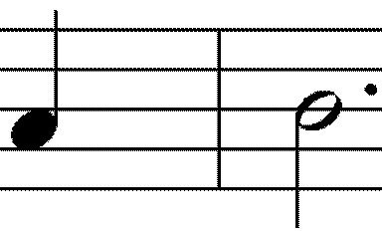 J J
r CJ I

J J J I

grew breath high sweet
An - oth - er tree, Of fear and dark His on - ly Son The Lord m - vites
of which
ness, doubt
for sin
the world
they and would to

knew; death, die, eat,

J
J
Its
Its Would To
r
J
love - ly
aw - ful
drink the
find with

J I J
i J
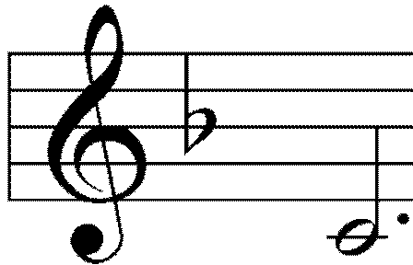limbs poi cup in

- J
r
with fruit
son first
of scorn
this cross

J I J
r
a -
dis - and
of

II

domed played dread wood
A - gainst With - in To crush
The tree
whose eat the world
the an
of life
ing God had so new - ly cient ser - pent's with ev - 'ry
warned. made. head! good.

God's first promise to send a Savior, offered in the shadow of Eden, finds itsfulfillment on the tree of Calvary, Jesus' cross.

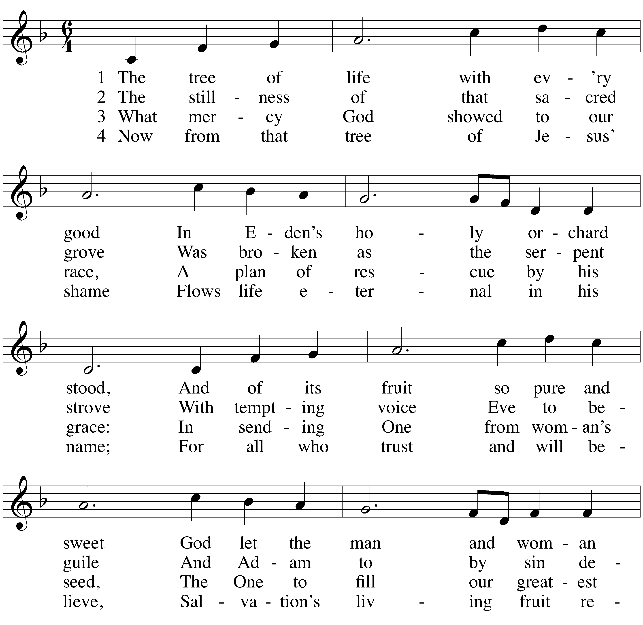CLOSING HYMN The Tree of Life

WORSHIP NOTES
THE SEASON OF LENT
The word Lent comes from an Old English word for Spring (“lengten,” the time of the year when the days grow longer). For the last 1700 years, the Church has set aside the 40 days between Ash Wednesday and Easter as a time of special preparation. It is a time of repentance and renewal.
During Lent, our rejoicing is muted as we remember our Lord’s suffering and death. But it is with a purpose: we know that the Lord who died took up his life again on Easter Sunday morning. So our 40 days of Lent are ones lived in the certain hope of the resurrection.
The color of the season is purple. Purple is the ancient color of royalty. We have this kind of king: he wore a crown of thorns, and carried a cross for us. Thanks be to God!
For the precise counters in the congregation, the Church speaks of only 40 days of Lent because we do not count the Sundays, which retained their significance as “little Easters.” That is why they are called “Sundays in Lent” and not “Sundays of Lent.”
So we walk through this Lenten season, solemn but hopeful. We walk in the shadow of the cross. Our worship follows this pattern.
IN THE SHADOW OF THE CROSS

The devil is defeated The gift comes by faith The blind can finally see Selfishness is crushed
We are raised from death to life King Jesus humbly walked

OUR THEME FOR TODAY
The devil is defeated. Satan and the demons are real. Their plan of attack, as first seen in the Garden of Eden, is to lead us astray from the sure promises of God. But God promised to send a champion to battle the devil for us. This morning, we see Jesus conquer our biggest foe. And through his Word, he gives us the power to do the same.

AN ORDER OF SERVICE FOR LENT
By combining a unique confession of sins, a traditional Lenten confession of faith, and carefully chosen lessons, this order of service allows the believer to come to a full awareness of the seriousness of his or her sin, and also to joyfully remember the source of its cure.

 The Prayers 

GATHERING SONG
M: | (verse 1 — sung) | God of creation, Giver of life,  be the light in our darkness; grant us peace in our strife. Show us your mercy.  Give us new birth.  You have made us your children
 |  | to bear fruit on the earth. | (to Kyrie, verse 1)
M: | (verse 2 — sung) | Lord, our Redeemer, Healer of souls,  be the hope that restores us. With your touch make us whole.  Here you speak to us through holy Word.  Send your Spirit among us
 |  | that your voice may be heard. | (to Kyrie, verse 2)
M: | (verse 3 — sung) | Spirit, most holy, Comforter blest,  be the fire that consumes us and our hearts’ welcome guest. Form us. Renew us.  Call us by name.  Raise us up from the ashes and create us again. | (to Kyrie, verse 3)

 The Gathering 
THE PRAYER OF THE CHURCH
Prayers and petitions are offered on behalf of the Church
M: Hear us now, Lord, as we bring you our private petitions.
Silent prayer
M: Almighty God, we come before you trusting that you hear our prayers. In your mercy, listen to our supplications on behalf of all for whom we pray and fulfill our desires and petitions according to your will, for we pray in Jesus’ name, and as he taught.

THE LORD’S PRAYER

C: Our Father in heaven, hallowed be your name, your kingdom come,
your will be done on earth as in heaven. Give us today our daily bread.
Forgive us our sins, as we forgive those who sin against us. Lead us not into temptation,
but deliver us from evil.
For the kingdom, the power, and the glory are yours now and forever. Amen.

THE BLESSING
M: Brothers and sisters, go in peace.
Live in harmony with one another. Serve the Lord with gladness.
The Lord bless you and keep you.
The Lord make his face shine on you and be gracious to you. The Lord look on you with favor and give you peace.

C: Amen.

KYRIE 1

CONFESSION OF FAITH The Apostles’ Creed

I believe in God, the Father almighty, maker of heaven and earth.
I believe in Jesus Christ, his only Son, our Lord,
who was conceived by the Holy Spirit, born of the virgin Mary,
suffered under Pontius Pilate,
was crucified, died, and was buried. He descended into hell.
The third day he rose again from the dead.
He ascended into heaven
and is seated at the right hand of God the Father almighty. From there he will come to judge the living and the dead.
I believe in the Holy Spirit,
the holy Christian Church, the communion of saints, the forgiveness of sins,
the resurrection of the body, and the life everlasting.
Amen.

THANK OFFERING

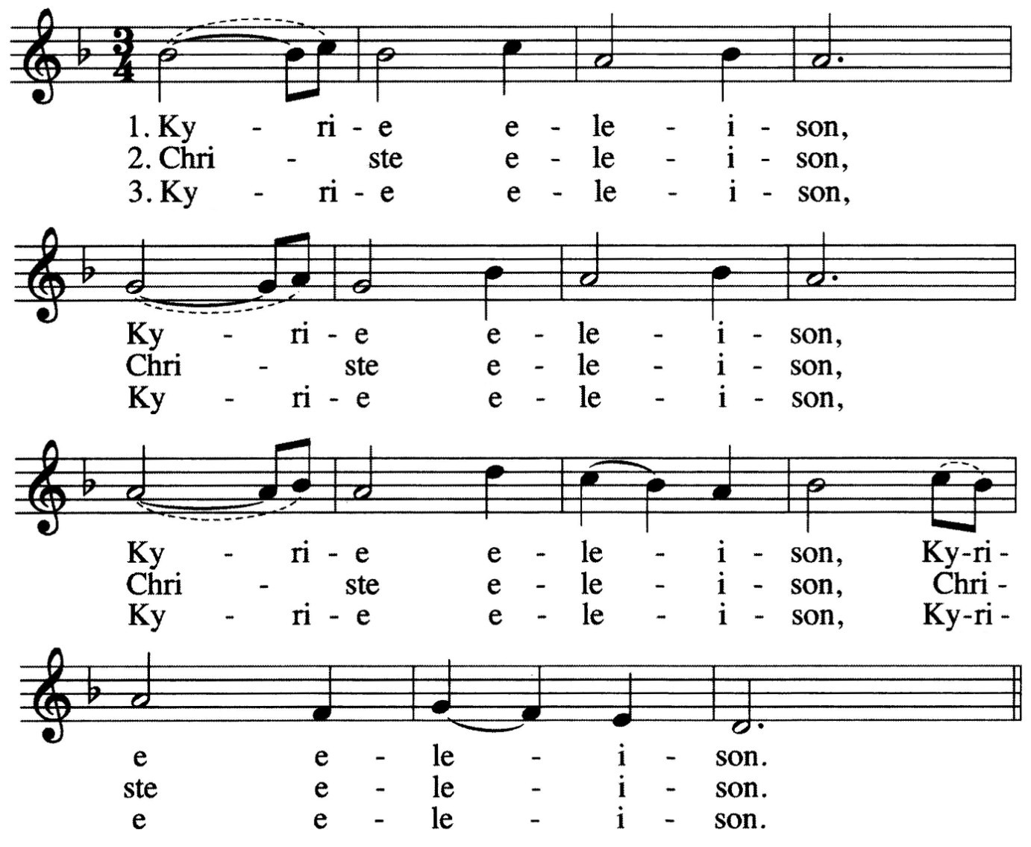ALL:

INVOCATION
M: The grace of our Lord  Jesus Christ, And the love of God,
And the fellowship of the Holy Spirit be with you all.

C: And also with you.

- The Kyrie is one of the oldest prayers in the Christian church. Kyrie eleison means “Lord, have mercy.” It is pronounced keer-ree-ay eh-lay-i-zon. Christe elison means “Christ, have mercy.” It is pronounced chrees-stay eh-lay-i-zon.

PENITENTIAL RITE
M: Coming together as one people, we remember the times
when we have failed to live the Gospel call. We ask for the mercy of God,
who is full of gentleness and love.

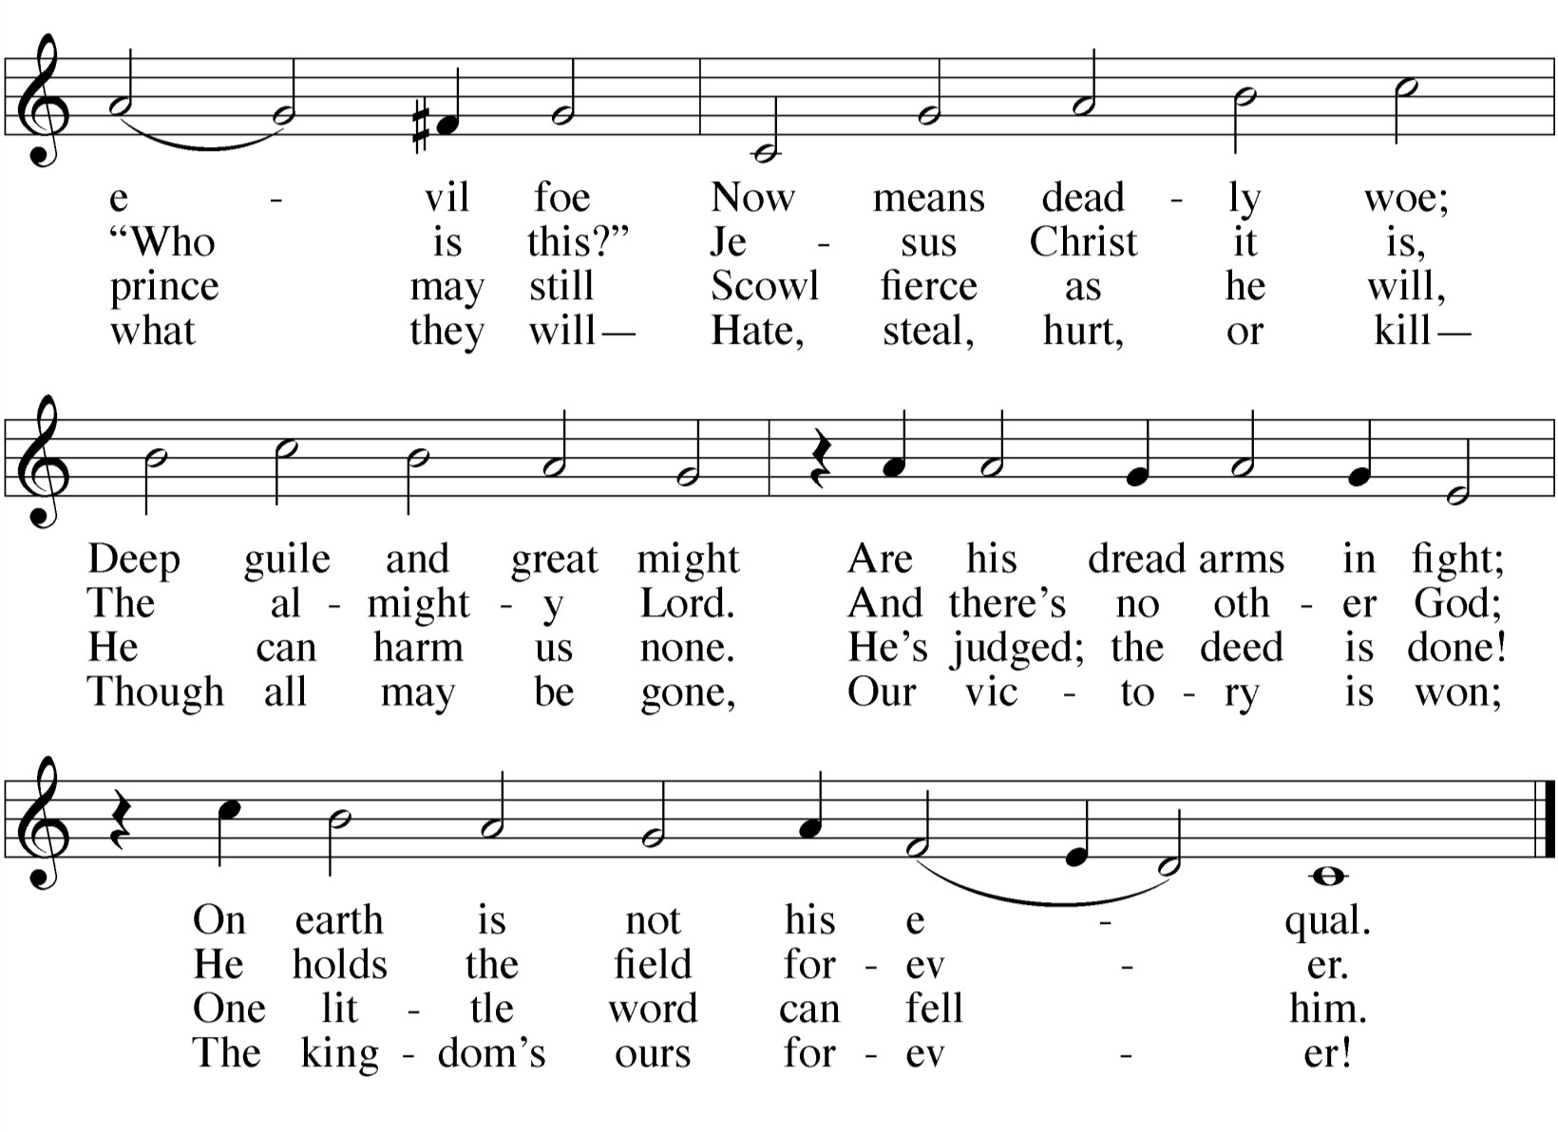M: (sung) Lord Jesus Christ, you know all our weaknesses.
You see all of our sin.

ALL: 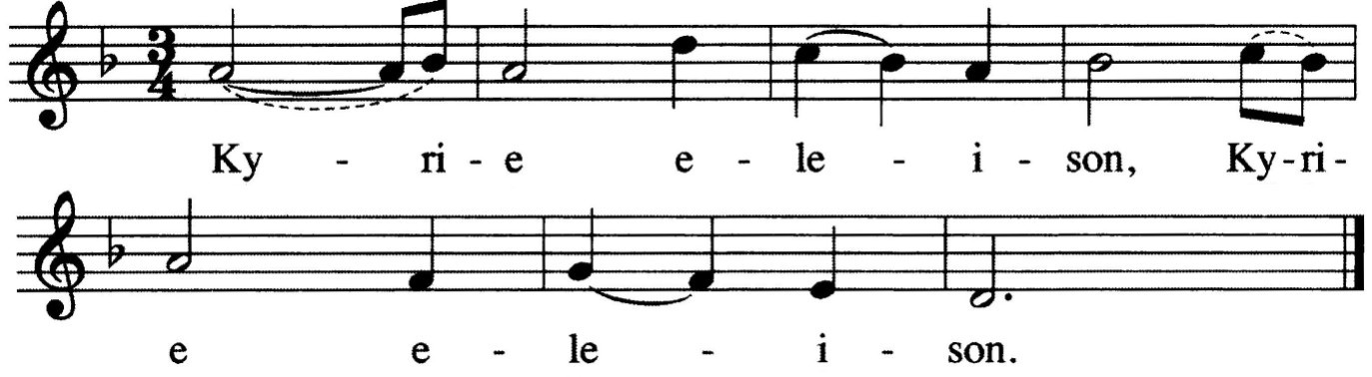
M: (sung) Lord Jesus Christ, we ask your forgiveness.
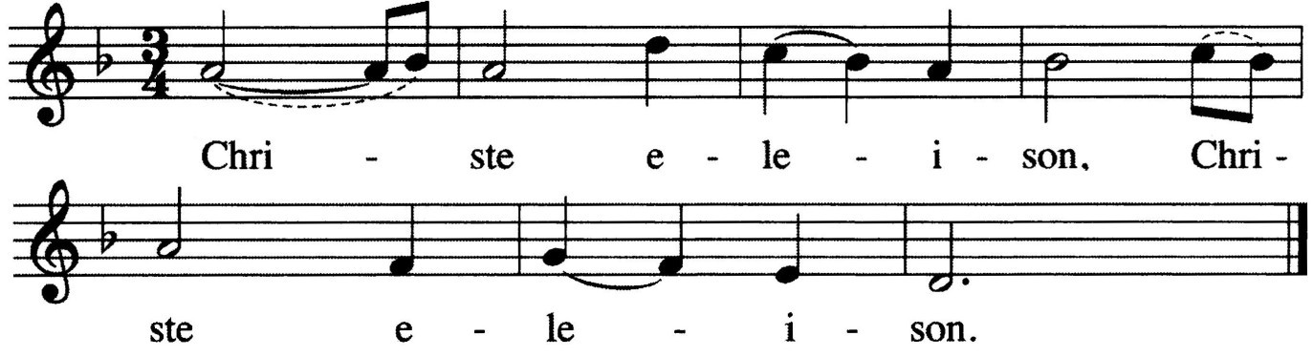Show your people mercy.

ALL:

M: (sung) Lord Jesus Christ, protect us from evil.
Crush the devil for us.

ALL:

SERMON

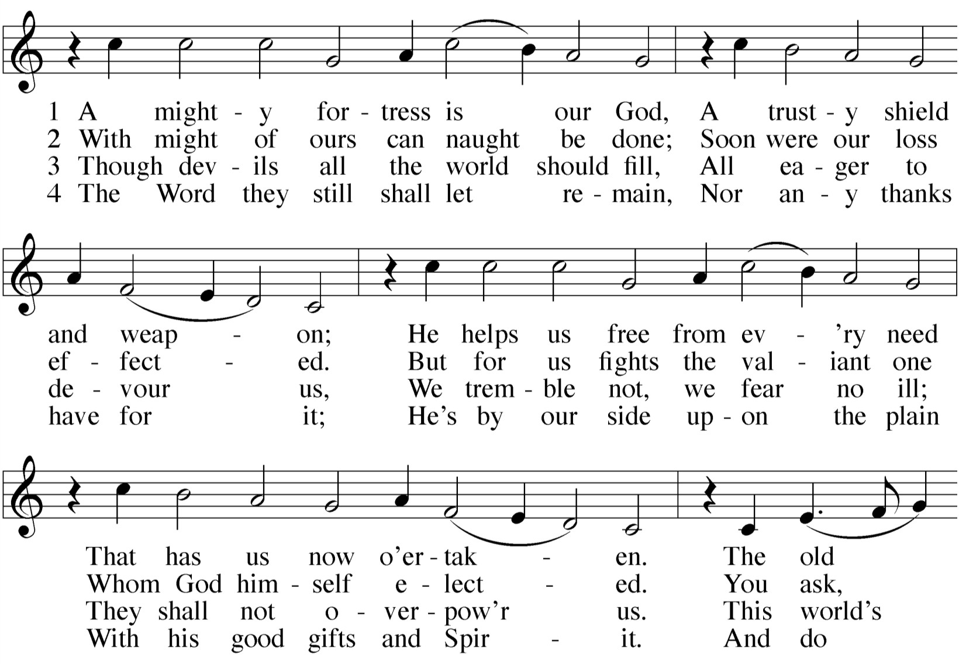HYMN OF THE DAY — 200 A Mighty Fortress Is Our God
M: God Almighty has had mercy on us,
forgiven us our sins for the sake of Jesus  Christ, and opened to us life everlasting.

C: Amen.

M: (sung) Up from the ashes we now arise,
and return to our Maker who has answered our cries.
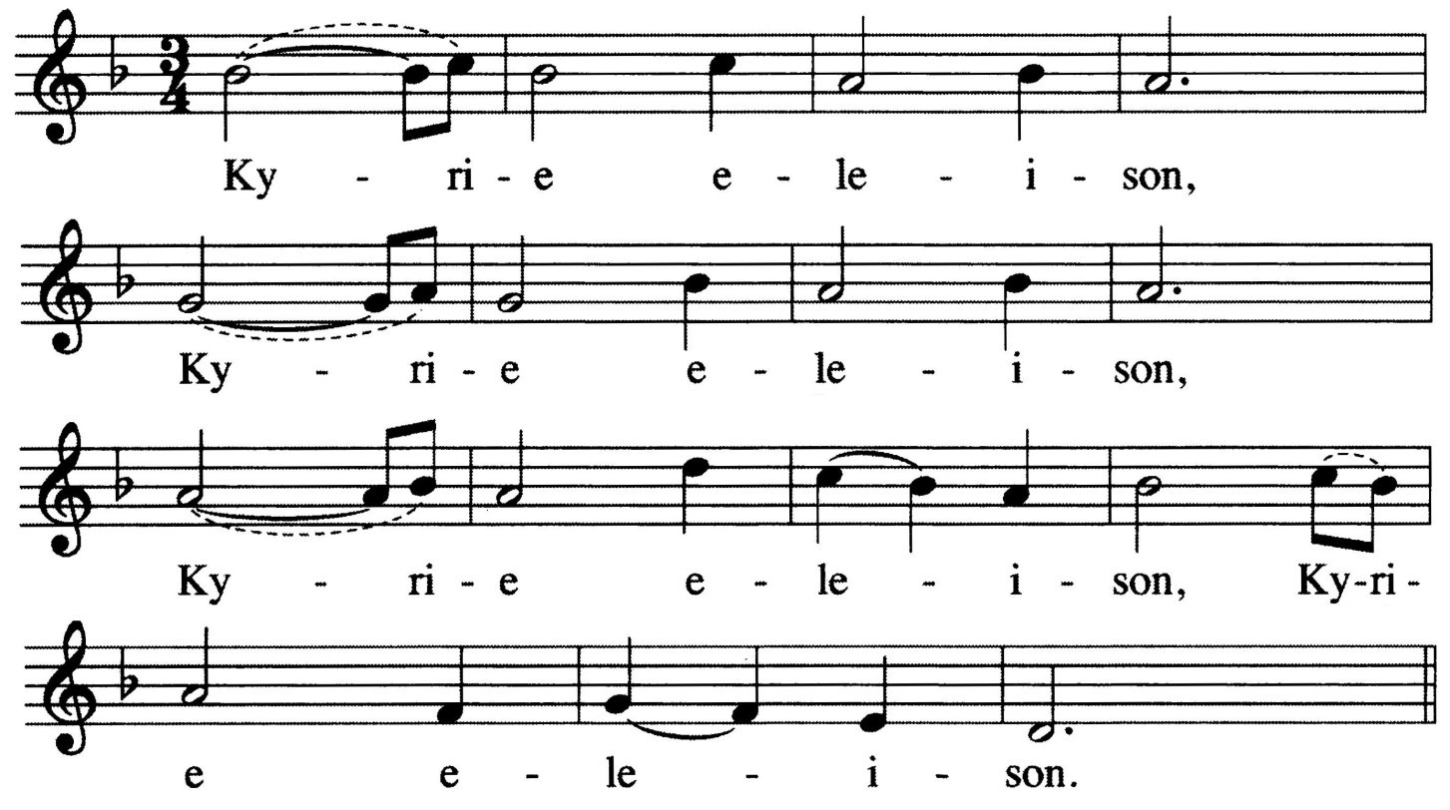Knowing God’s mercy we now stand healed, for in Jesus our Savior perfect love is revealed.

ALL:

2

- One might ask, “If the minister just proclaimed that my sins were forgiven, why would I sing ‘Lord, have mercy’ again?” It is meant to remind us that we not only need God’s mercy for forgiveness, but we also need it on an ongoing basis, that God might supply all our daily needs.

PRAYER OF THE DAY
M: Lord our strength,

 The Word 

GOSPEL Matthew 4:1-11
1Then Jesus was led by the Spirit into the desert to be tempted by the devil. 2After fasting forty days and forty nights, he was hungry. 3The tempter came to him and said, "If you are the Son of God, tell these stones to become bread."
4Jesus answered, "It is written: 'Man does not live on bread alone, but on every word

the battle of good and evil rages within and around us,
and our ancient foe tempts us with his deceits and empty promises. Keep us steadfast in your Word,
and when we fall, raise us up again and restore us through your Son, Jesus Christ our Lord,
who lives and reigns with you and the Holy Spirit, one God, now and forever.

C: Amen.
that comes from the mouth of God.'"
5Then the devil took him to the holy city and had him stand on the highest point of the temple. 6"If you are the Son of God," he said, "throw yourself down. For it is written: 'He will command his angels concerning you, and they will lift you up in their hands, so
that you will not strike your foot against a stone.'"
7Jesus answered him, "It is also written: 'Do not put the Lord your God to the test.'"
8Again, the devil took him to a very high
mountain and showed him all the kingdoms of the world and their splendor. 9"All this I will give you," he said, "if you will bow down and worship me."
10Jesus said to him, "Away from me,
Satan! For it is written: 'Worship the Lord your God, and serve him only.'"
11Then the devil left him, and angels came and attended him.

M: This is the Gospel of our Lord.

C: Praise be to you, O Christ!

VERSE OF THE DAY 3 Matthew 4:10

M: Refrain
C: Refrain
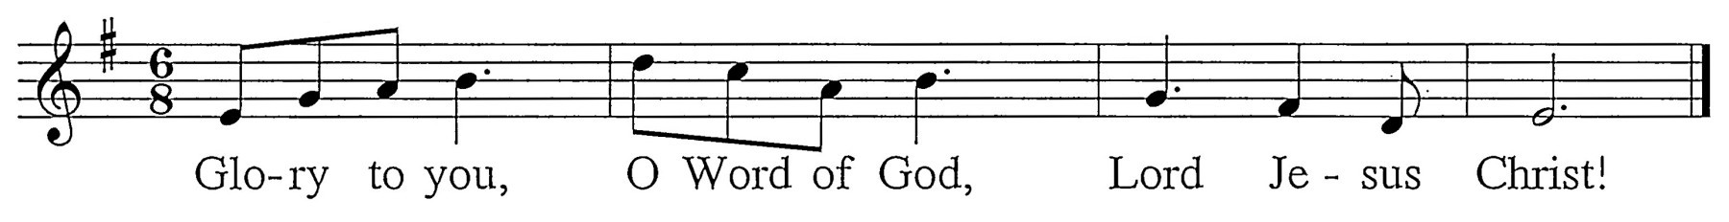
M: It is written: “Worship the Lord your God and serve him only.”
C: Refrain (sung twice) - During this refrain, the children may come forward.

CHILDREN’S MESSAGE

- The Verse of the Day is traditionally bracketed by the singing of “Alleluia” (meaning “Praise the Lord”) the most joyful word of Christian praise. In Lent, however, Alleluias are omitted from the Orders of Service, cap- turing the solemnity and seriousness of the season.

FIRST LESSON Genesis 3:1-15
1 Now the serpent was more crafty than any of the wild animals the LORD God had made. He said to the woman, "Did God really say, 'You must not eat from any tree in the garden'?"
2 The woman said to the serpent, "We may eat fruit from the trees in the garden, 3 but God did say, 'You must not eat fruit from the tree that is in the middle of the garden, and you must not touch it, or you will die.' "
4 "You will not surely die," the serpent said to the woman. 5"For God knows that when you eat of it your eyes will be opened, and you will be like
God, knowing good and evil."
6 When the woman saw that the fruit of the tree was good for food and pleasing to the eye, and also desirable for gaining wisdom, she took some and ate it. She also gave some to her husband, who was with her, and he ate it. 7 Then the eyes of both of them were opened, and they realized they were naked; so they sewed fig leaves together and made coverings for themselves.
8 Then the man and his wife heard the sound of the LORD God as he was
walking in the garden in the cool of the day, and they hid from the LORD God among the trees of the garden. 9 But the LORD God called to the man, "Where are you?"
10 He answered, "I heard you in the garden, and I was afraid because I was naked; so I hid."
11 And he said, "Who told you that you were naked? Have you eaten from the tree that I commanded you not to eat from?"
12 The man said, "The woman you put here with me—she gave me some
fruit from the tree, and I ate it."
13 Then the LORD God said to the woman, "What is this you have done?" The woman said, "The serpent deceived me, and I ate."
14 So the LORD God said to the serpent, "Because you have done this,
"Cursed are you above all the livestock and all the wild animals!
You will crawl on your belly and you will eat dust
all the days of your life.
15 And I will put enmity between you and the woman,
and between your offspring and hers; he will crush your head,
and you will strike his heel."

PSALM OF THE DAY Psalm 3
M: Lord, how many are my foes! C: How many rise up against me! M: Many are saying of me,

C: “God will not deliver him.”
M: But you, Lord, are a shield around me.

C: You bestow glory on me and lift up my head.
M: I call out to the Lord,

C: and he answers me from his holy mountain.
M: I lie down and sleep;

C: I wake again, because the Lord sustains me.
M: I will not fear

C: though tens of thousands assail me on every side.
M: Arise, Lord!

C: Deliver me, my God!
M: From the Lord comes deliverance.

C: May your blessing be on your people.
SECOND LESSON Romans 5:12-19
12Therefore, just as sin entered the world through one man, and death through sin, and in this way death came to all men, because all sinned — 13for before the law was given, sin was in the world.
But sin is not taken into account when there is no law. 14Nevertheless, death reigned from the time of Adam to the time of Moses, even over those who did not sin by breaking a command, as did Adam, who was a pattern of the one to come.
15But the gift is not like the trespass. For if the many died by the trespass of the
one man, how much more did God's grace and the gift that came by the grace of the one man, Jesus Christ, overflow to the many! 16Again, the gift of God is not like the result of the one man's sin: The judgment followed one sin and brought condemnation, but the gift followed many trespasses and brought justification. 17For if, by the trespass of the one man, death reigned through that one man, how much more will those who receive God's abundant provision of grace and of the gift of righteousness reign in life through the one man, Jesus Christ.
18Consequently, just as the result of
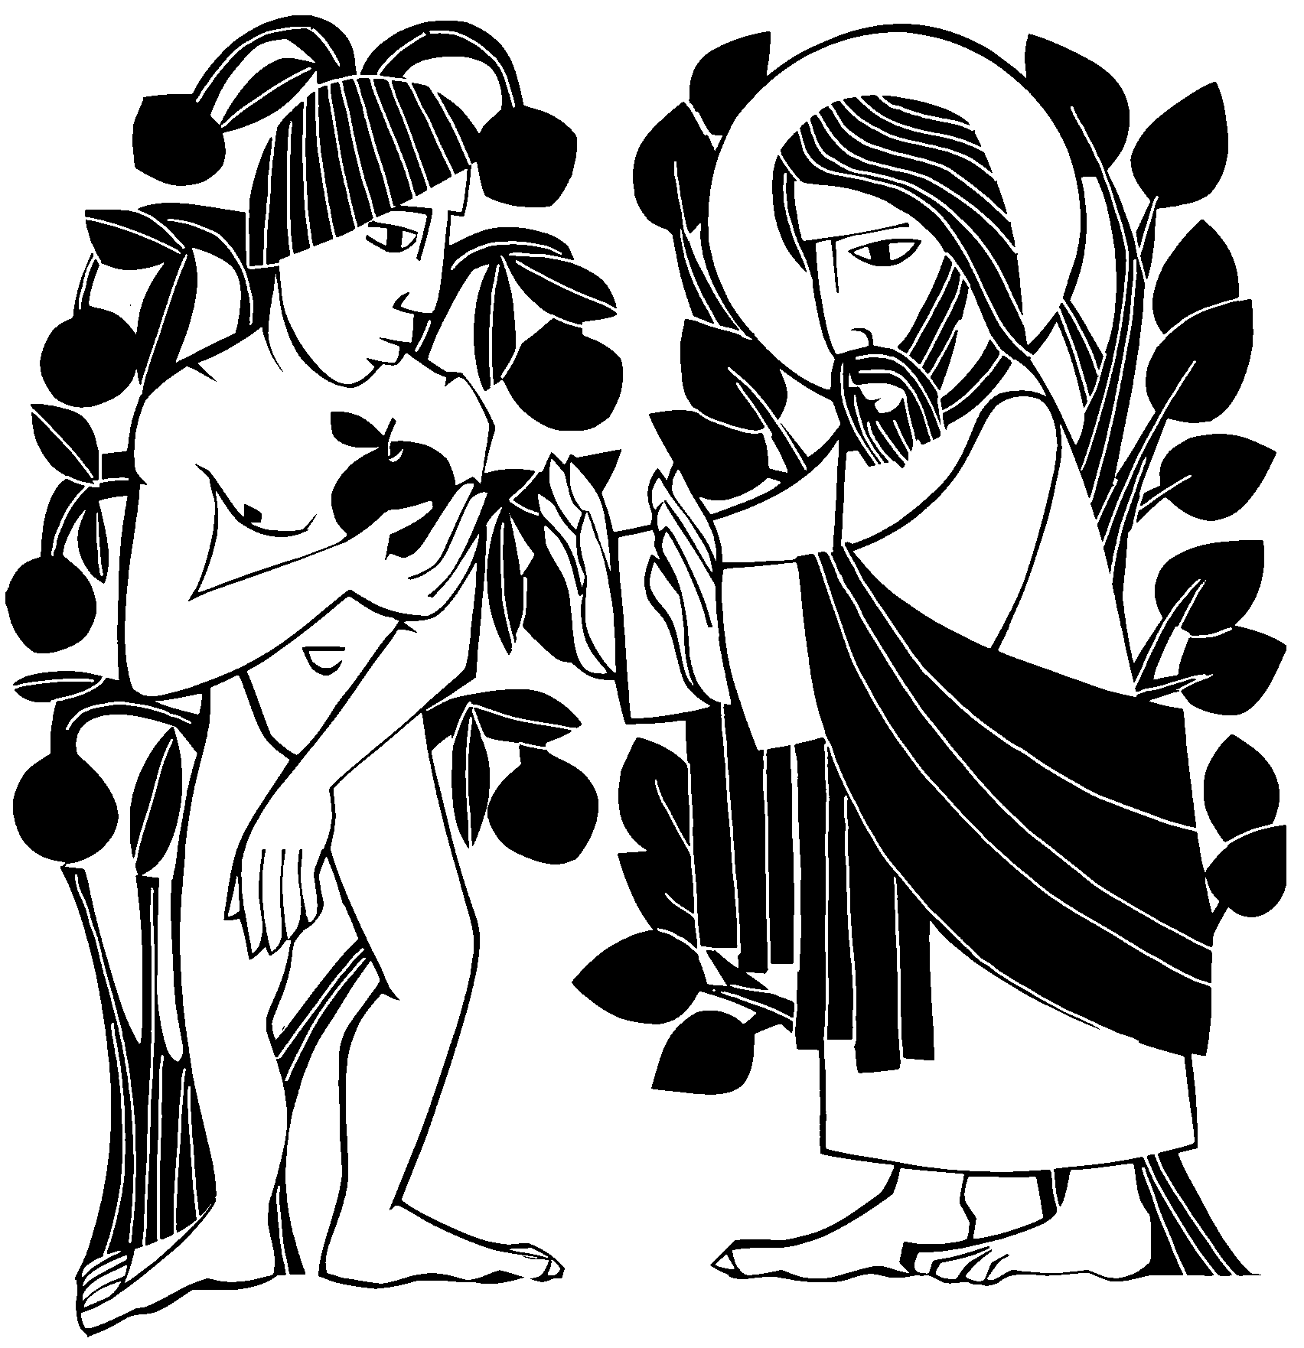one trespass was condemnation for all men, so also the result of one act of righteousness was justification that brings life for all men. 19For just as through the disobedience of the one man the many were made sinners, so also through the obedience of the one man the many will be made righteous.

