The Triduum: the Great Vigil April19, 2014

- 28 -

Your church’s license information goes here

Light of Christ / Exsultet
Text: Based on a prayer by James Dillet Freeman and the Exsultet; Marty Haugen Tune: Marty Haugen
© 1987 GIA Publications, Inc.

Song of Moses
Music: Scott Soper
© 1997 GIA Publications, Inc.

We Know That Christ Is Raised
Text: John B. Geyer (based on Romans 6:4,9) Tune: Charles Stanford

Sanctus and Agnus Dei
From Divine Service I in Christian Worship Supplement
© 2008 Northwestern Publishing House
OUR GOD ALWAYS SAVES

SERVICE NOTES: The Triduum
After six weeks of Lent, the Christian Year has now reached its climax. We have come to the celebration of the suffering, death, and resurrection of our Lord and Savior Jesus Christ. This is the celebration for which we have been preparing throughout Lent. Now we see what our Savior came to do.

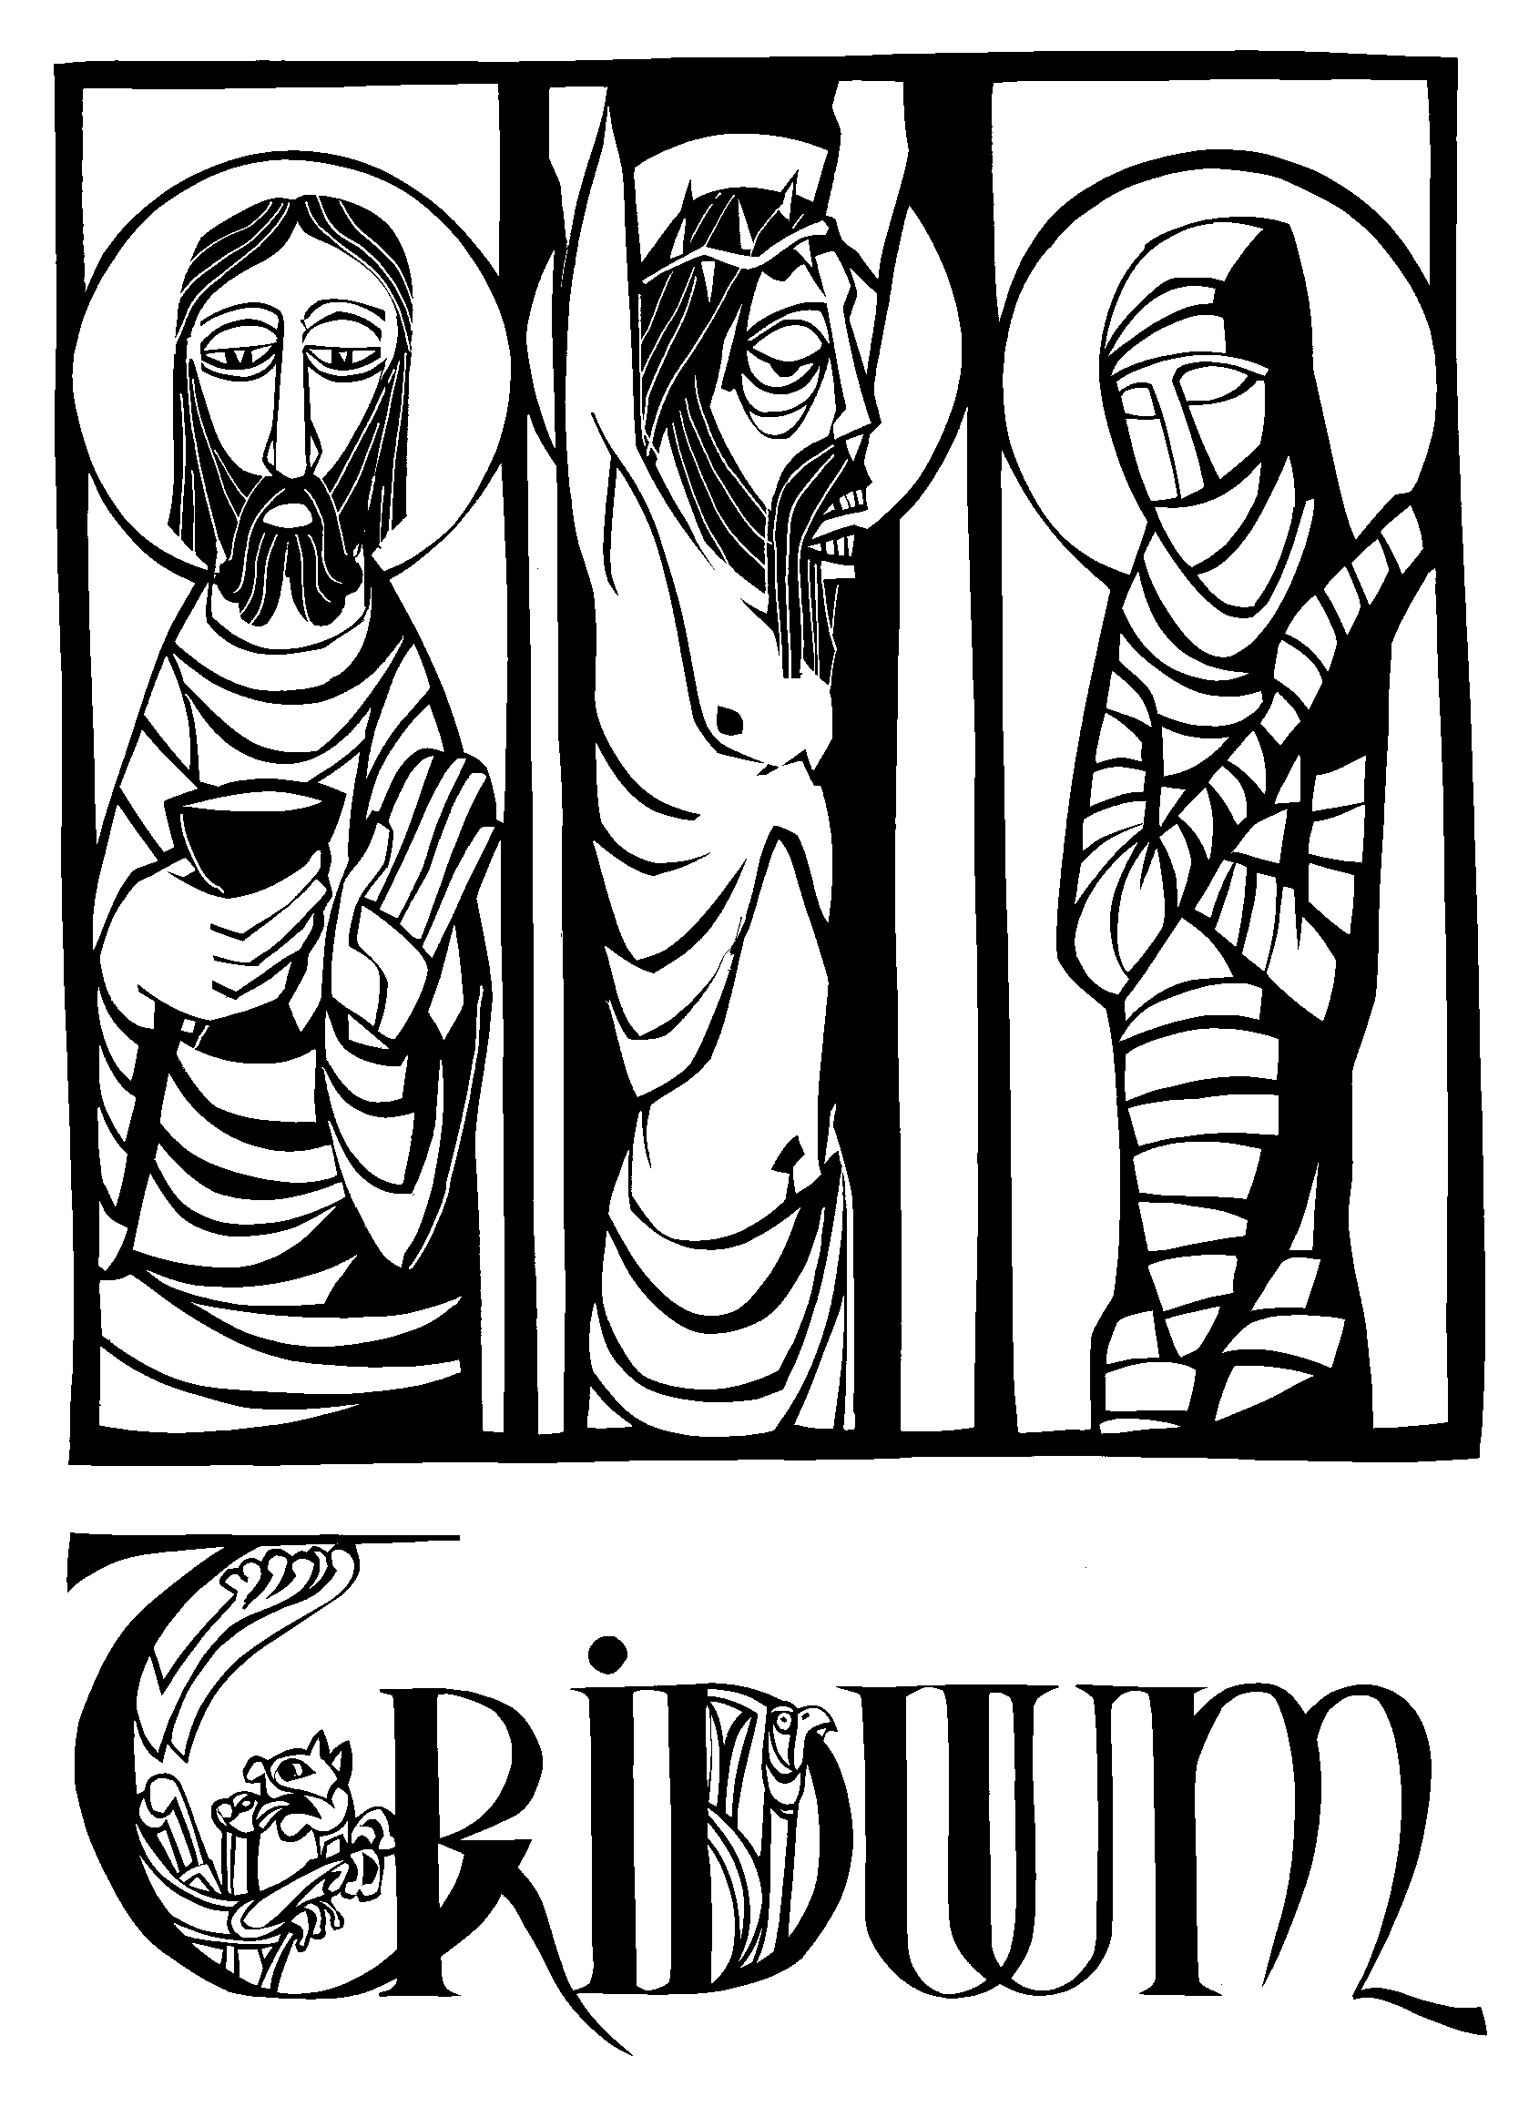We see him suffer and die for our sins and for the sins of the world. And we see him rise triumphantly on Easter morning to assure us that our salvation is complete, the victory is won.
Prior to the fourth century, Easter Day itself included all three emphases — Christ’s suffering, death, and resurrection. But the early Church fathers decided that it might be wise to spread those three emphases out over three days.
And so Maundy Thursday was formed to commemorate the beginning of Christ’s suffering, as he gathers in the upper room, washing his disciples feet, institutes the Lord’s Supper, then proceeds to the Garden of Gethsemane for prayer.
Good Friday was set aside to ponder the intensity of Christ’s passion, as he is put on trial before Pontius Pilate, scourged, and crucified. On the cross, he speaks only seven times before he dies.
Finally, the practice of the Easter Vigil was begun. It was not the high festival service of Easter. Rather, it was a service to prepare oneself for that festival. The Vigil was also used as the entrance rite into the Church, as converts were baptized, confirmed, and communed all during the vigil.
The greatest theologian of the early Church, St. Augustine, called these days of special observance, “the most holy Triduum of the crucified, buried, and risen Lord.” (Triduum is Latin for three days.) These days have long been understood as the climax of the Church’s year. Together they form a unit. Therefore, as we celebrate these Three Holy Days, our worship will form a unit. What follows is a single service, celebrated over three days, which will take us through our Savior‘s sufferings to his glorious triumph on Easter.
Because these three services form one unit, you will notice some unusual things. First, there is no benediction after parts 1 and 2. The benediction will occur at the end of the service on Easter morning. Secondly, after parts 1 and 2, the congregation is asked to leave the church in silence.

After a brief greeting, the congregation will be dismissed.
An offering plate is located at the sanctuary entrance. If you brought a separate offering for the Easter Vigil, you may leave it there.
Soft post-service music will be played.
Please feel free to stay for personal prayer and meditation.

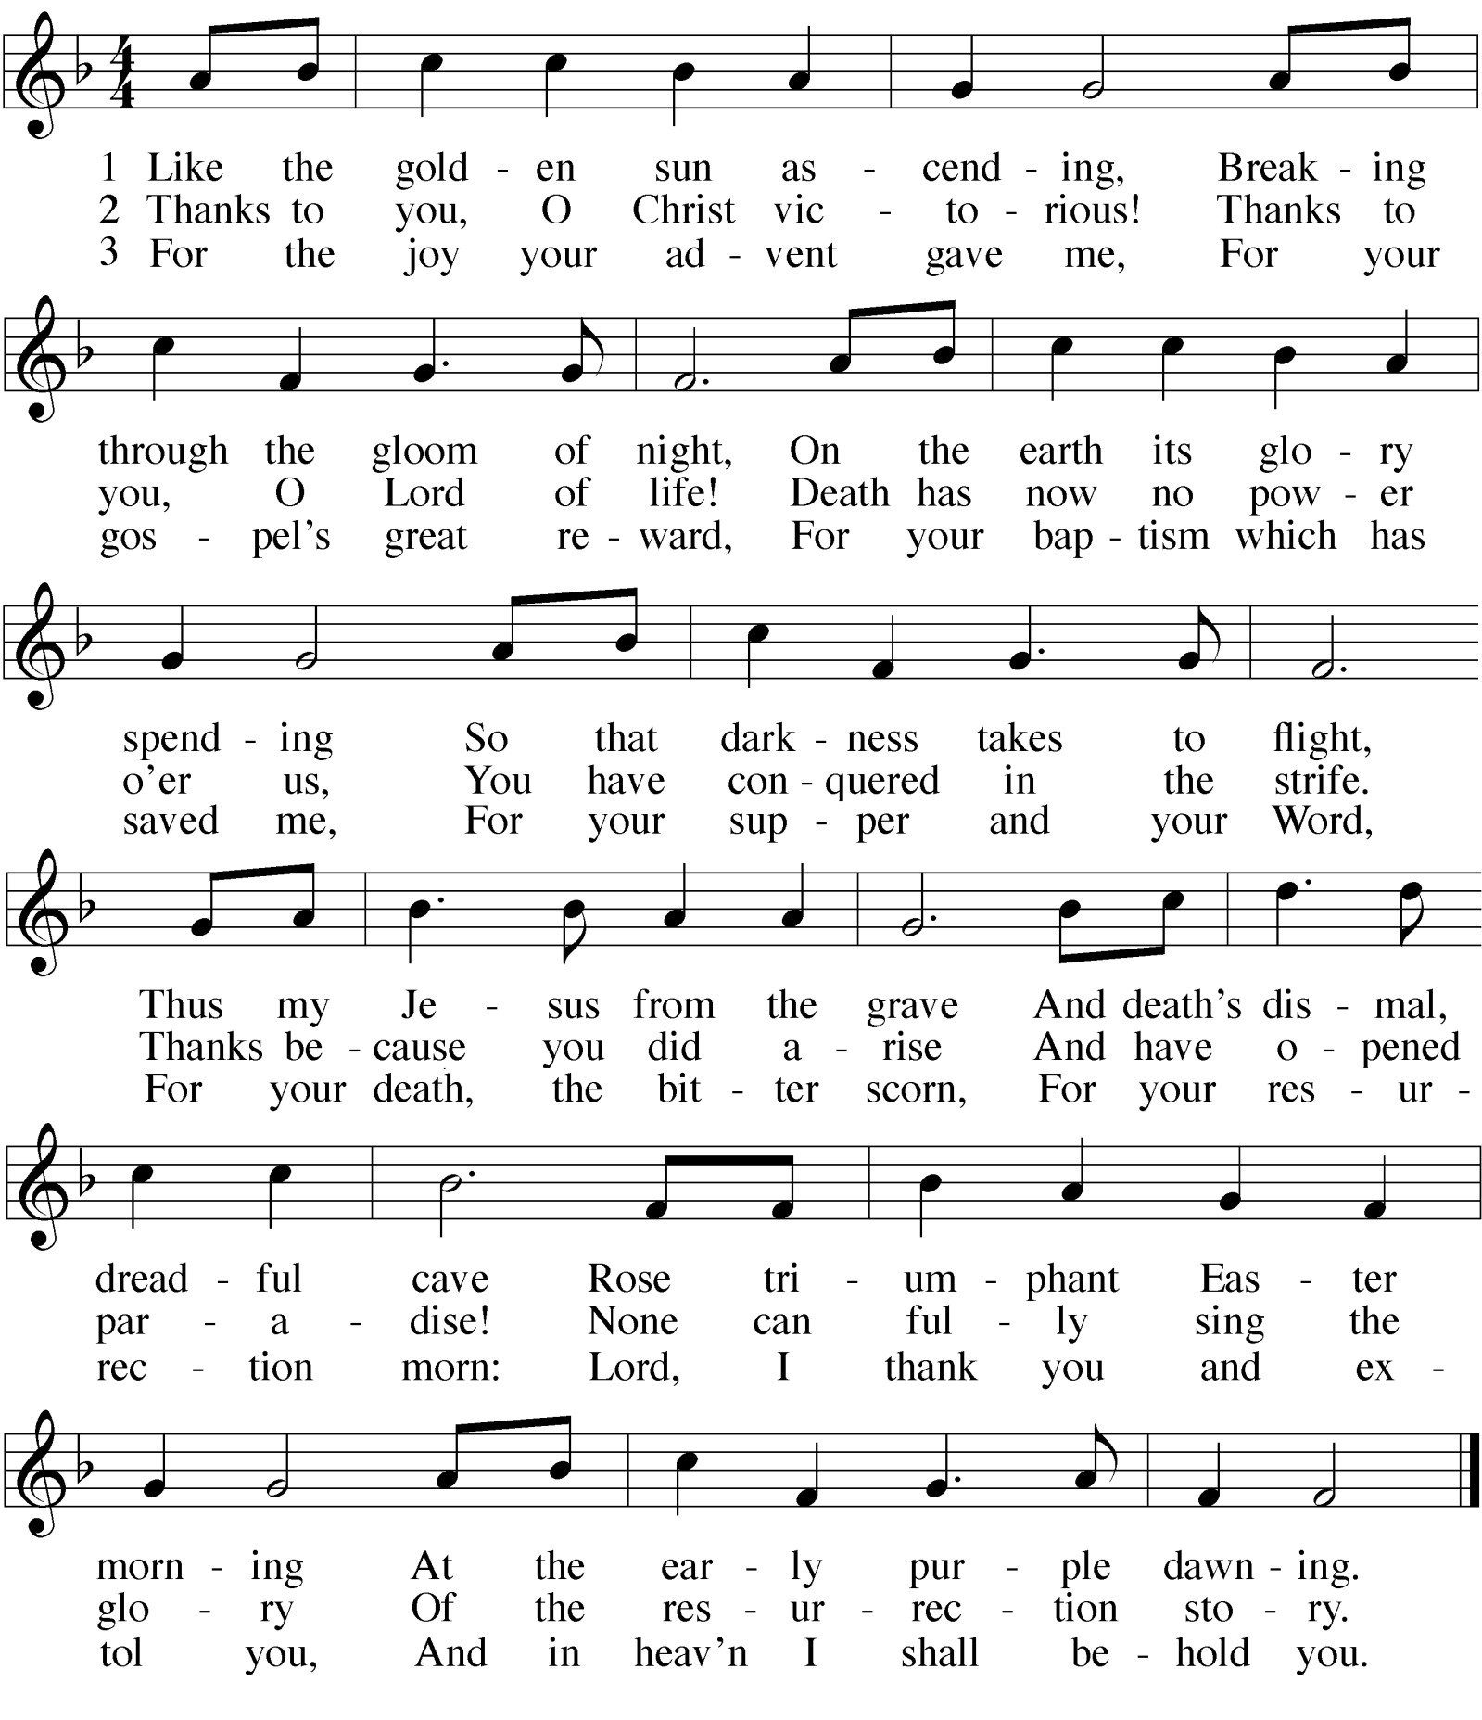HYMN Like the Golden Sun Ascending
Part III — The Great Vigil
A vigil is a service of Scripture readings and prayers in which believers vigilantly and eagerly wait and watch for the celebration of the Savior‘s deliverance. The Great Easter Vigil is the most well-known and historic of the Church‘s vigils. In fact, in its general structure, it is one of the most ancient services of the Christian Church. Early records indicate that it may have been celebrated in Jerusalem already by the second century, and soon spread to the rest of the church.
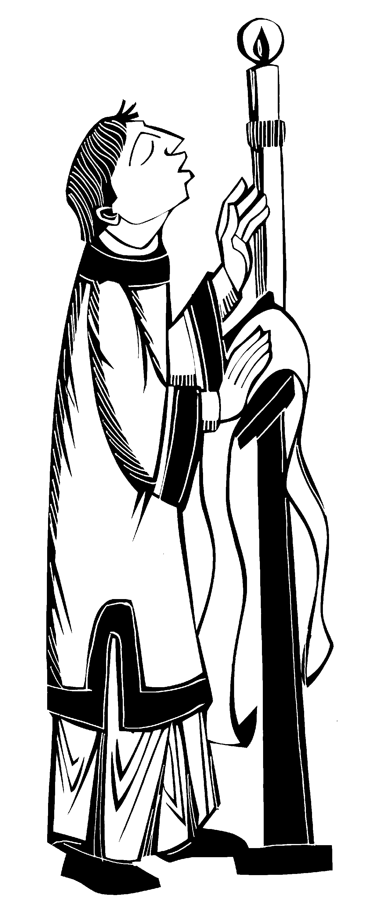From its beginnings, the Easter Vigil was closely connected with Holy Baptism. In the pagan world, a conversion to Christianity meant a clean break from one‘s former lifestyle. It also meant facing difficult times, perhaps even death. As a result, the instruction of adults was intensive and thorough. This instruction intensified during the season of Lent, as the students pondered not only the Savior‘s battle with evil, but also their own battle with Satan and his forces. At the Easter Vigil converts were baptized, confirmed, and received their first communion.
Fire has long been a sign of God‘s presence - the burning bush on Mount Sinai, the pillar of fire in the desert, the tabernacle lamps, and the sacrificial fires on the altar of the temple in Jerusalem. The large paschal candle (from the Greek pascha meaning “Easter”) used prominently in worship this morning symbolizes the resurrection victory over the darkness of sin and death. It further emphasizes the link between baptism and the resurrection (Romans 6:3-5). This morning the candle is lit from the final candle of Good Friday. The paschal candle is used only three times in worship: throughout the entire season of Easter, at baptisms, and at funerals.
It is customary for the congregation to assemble outside the sanctuary of the church and follow the paschal candle in procession into the church. This reminds us of the women and disciples’ procession to the empty tomb early Easter morning. The church remains dim, but gradually grows brighter during the course of worship. This symbolizes the spreading of the good news and resurrection joy of that first Easter.
After the 40 days of Lent, in which our worship has been subdued, with the Vigil it becomes boisterously joyful again. We sing the Exsultet, which means “rejoicing.” It is considered the greatest Christian hymn of the Easter Vigil. Records of it being used in connection with the lighting of the paschal candle stem back to the Sacramentary of Adrian, one of the earliest known liturgical books. And the most joyful term in the Christian church — Alleluia! — is used once again this morning.
As we conclude our Lenten journey this morning amidst the songs of acclamation, may you be filled with joy, peace, and hope.
God bless your worship.

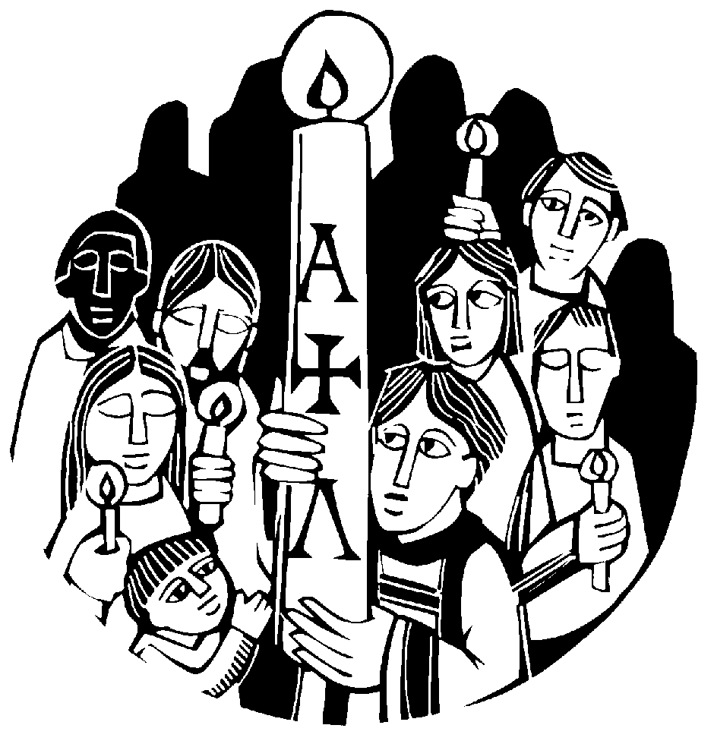ORDER OF SERVICE

The congregation may gather in a convenient place outside the sanctuary of the church. All are given candles to be lit later from the paschal candle.
In the semidarkness a single flame from the Passion wreath burns.

INVOCATION
M: In the name of the Father and of the Son  and of the Holy Spirit.

C: Amen.
M: On this most holy day, in which our Lord Jesus Christ passed over from death to life, we are gathered here in vigil and prayer. This is the Passover of the Lord in which, by hearing his Word and celebrating his sacraments, we share in his victory over death.

PRAYER
M: O God, you are like a refiner’s fire,
and your Spirit kindles the hearts of your faithful people with the fire of your love.
Bless, we ask you, this new flame
and those who keep this joyful Easter festival. Burning with desire for life with you,
may we be found rightly prepared to share in the Feast of Light which has no end, through Jesus Christ, your Son, our Lord,
who lives and reigns with you and the Holy Spirit, one God, now and forever.

C: Amen.

CLOSING PRAYER
M: We thank you, Lord,
that you have nourished us with your Easter sacraments. Fill us with your Spirit,
the Spirit of your love,
that those whom you have satisfied with one heavenly bread may be united in one holy will, through Jesus Christ our Lord.

C: Amen.

THE BLESSING
M: Brothers and sisters, go in peace.
Live in harmony with one another. Serve the Lord with gladness.
The Lord bless you and keep you.
The Lord make his face shine on you and be gracious to you. The Lord look on you with favor and give  you peace.

C: Amen.

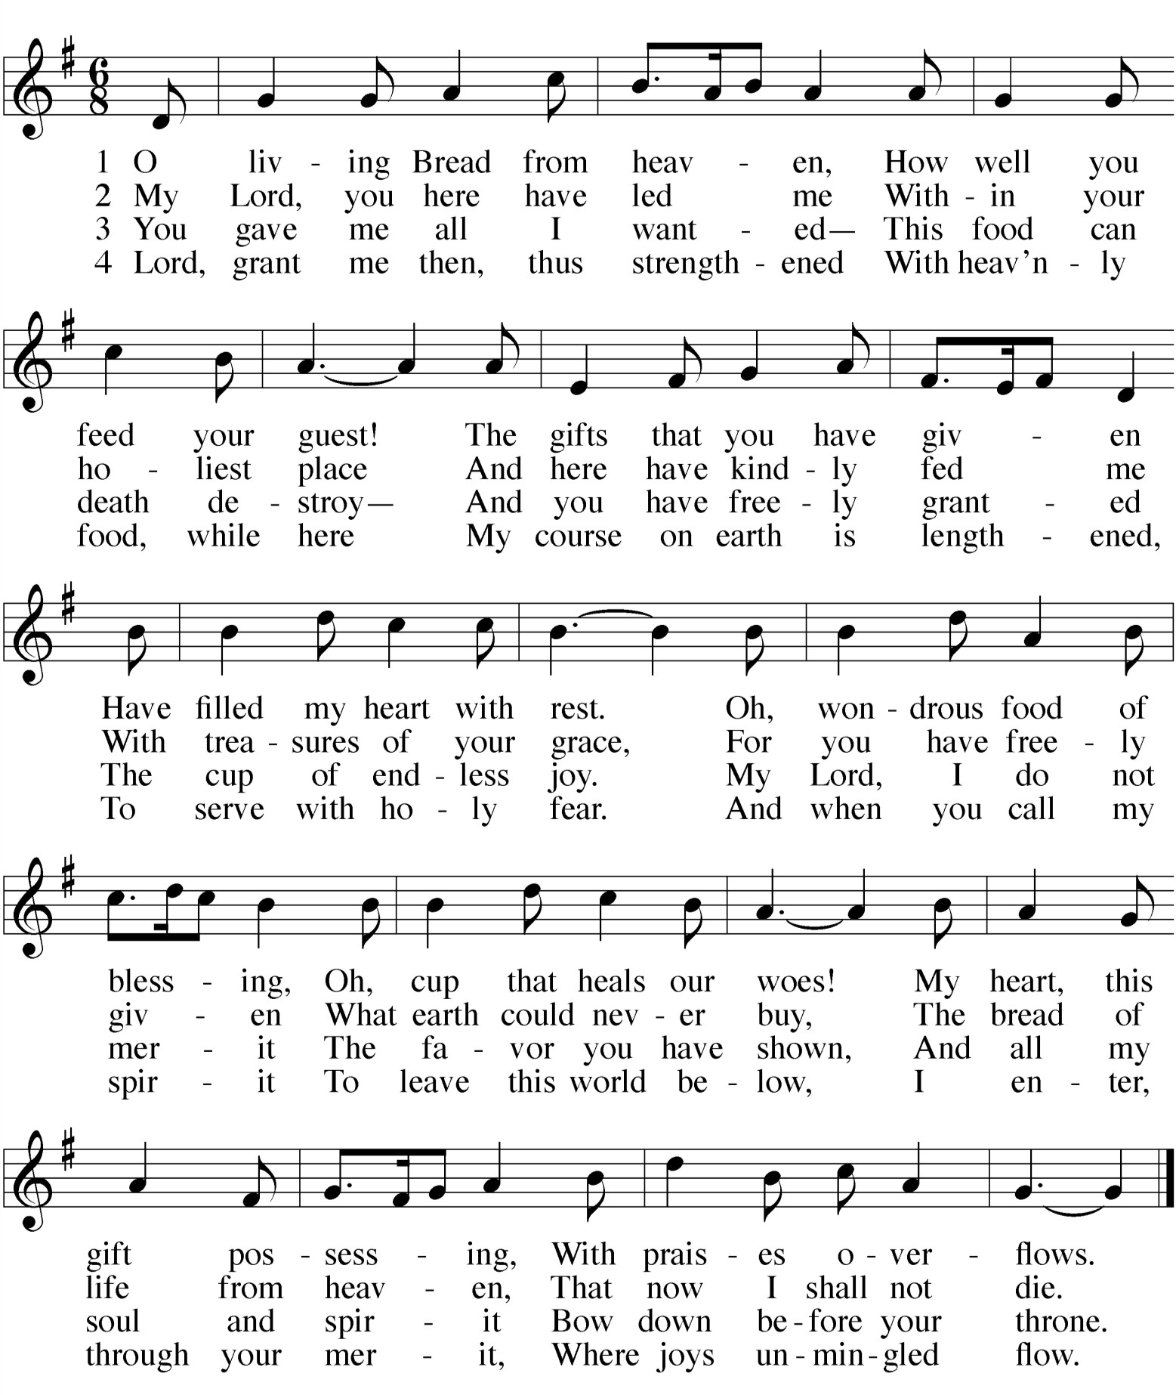HYMN 314 O Living Break from Heaven

LIGHTING OF THE PASCHAL CANDLE
M: Jesus Christ is the light of the world.

C: The light no darkness can overcome.
Then, lighting the paschal candle from the newly kindled fire, the minister says:
M: Christ Jesus is the same yesterday, today, and forever, the beginning and the end,
the Alpha and the Omega.
His are time and eternity;
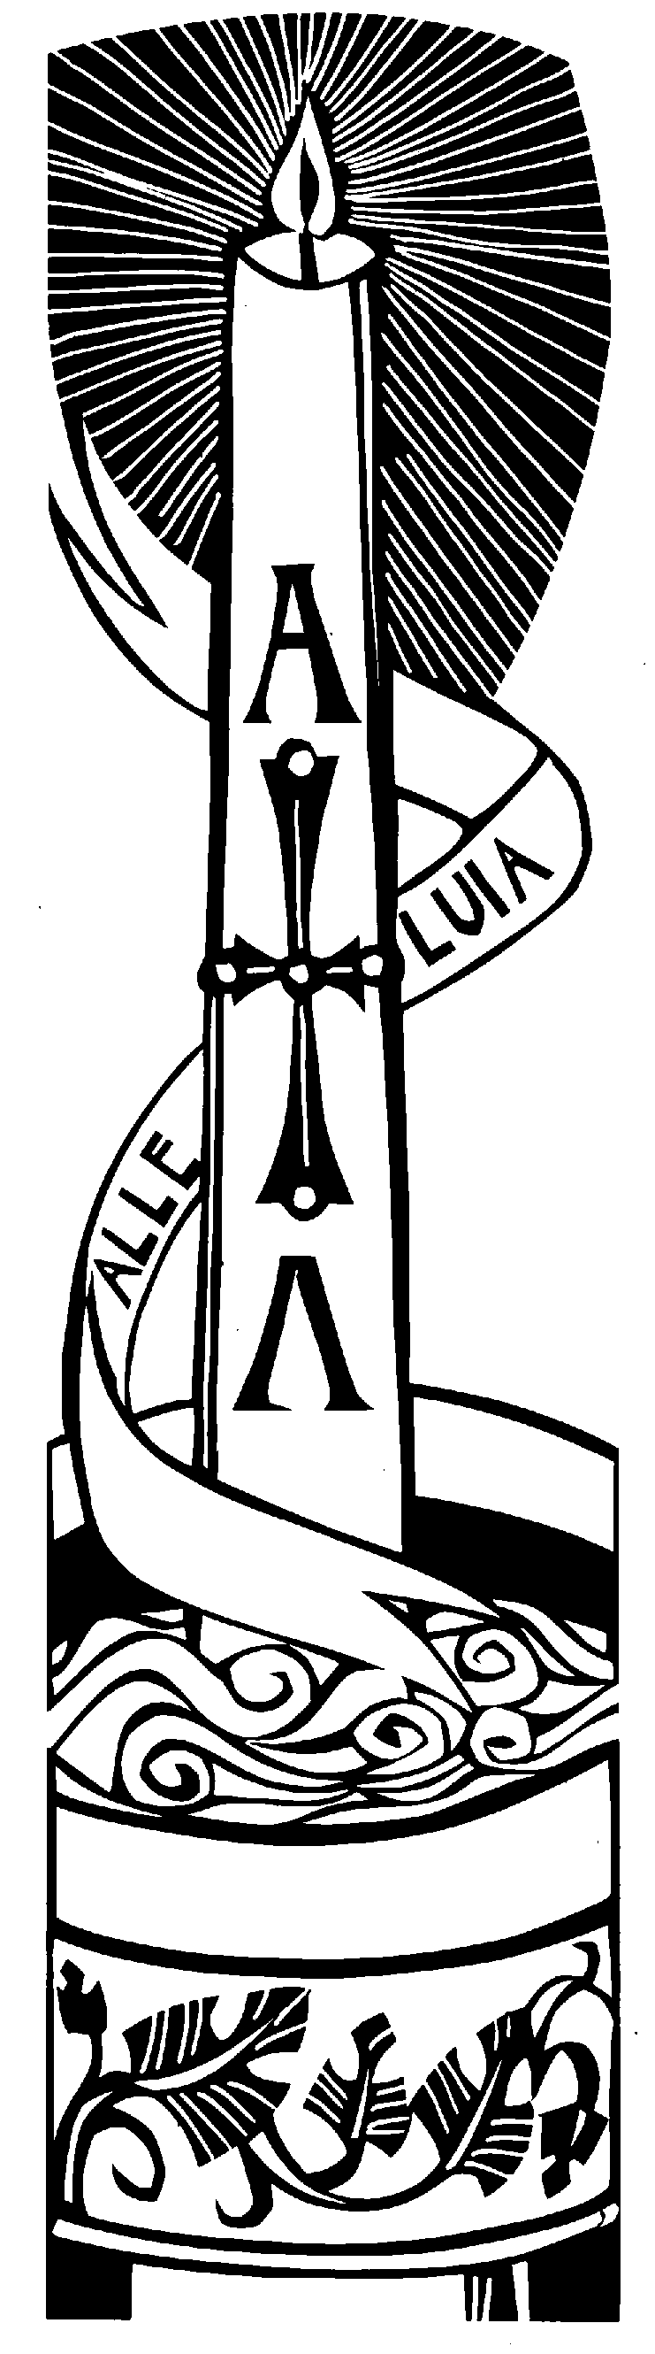his are the glory and the dominion now and forever. By his wounds we are healed, now and forever.
May the light of Christ, who is risen in glory from the dead, scatter all the darkness of our hearts and minds.
M: Let us pray.
Almighty and most merciful Father, once we were darkness,
but now we are light in Jesus Christ our Lord. Bless abundantly all who joyfully celebrate in faith the resurrection of our Lord Jesus Christ this day. Fill them with your heavenly blessing in him,
who lives and reigns with you and the Holy Spirit, now and forever.

C: Amen.

All light their candles from the paschal candle. Then, the paschal candle is held aloft by the candle bearer, and all follow in procession into the church.
After a one verse musical introduction, the congregations sings :

THE EASTER EXSULTET

M: Refrain

C: Refrain

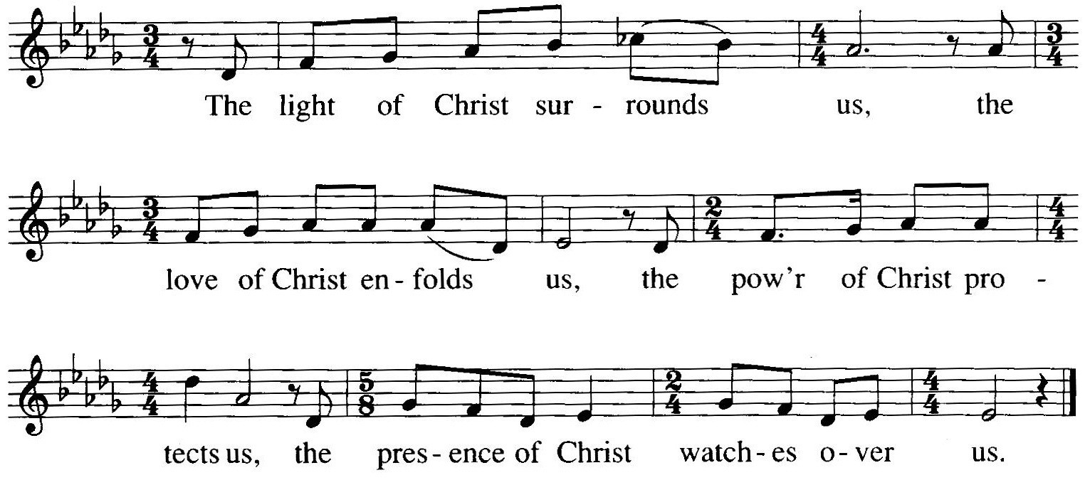

M: All the earth is ablaze with the glory of our God, for the Light has come to burn away the darkness.

C: Refrain
M: Let us fill every space with the sound of our joy, praising Christ, who is living now among us.

C: Refrain
M: In the east, the Morning Star rises bright upon you; in its peaceful light shines the glory of the Lord.

C: Refrain
We are a Sacramental Church
We follow the historic Christian practice of close communion. We ask that only members of Beautiful Savior Lutheran or one of our sister congregations partake of the sacrament. If you are not a member, please speak to one of the pastors before communing.

DISTRUBUTION
After the first table returns to their seats, the congregation will sing the distribution hymns:

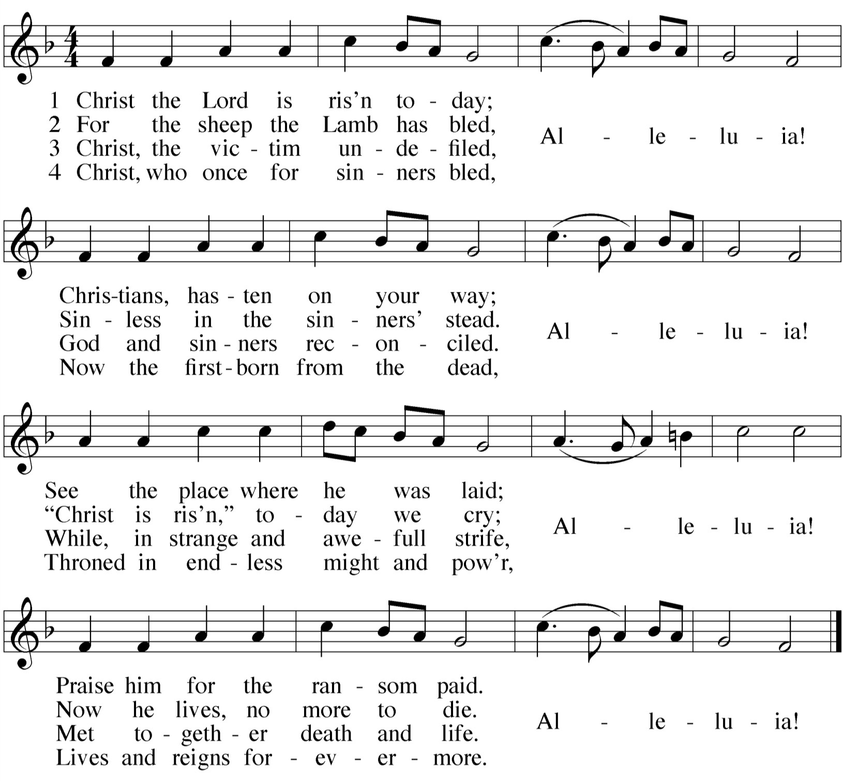HYMN 150 Christ the Lord Is Risen Today

OPENING SENTENCES FOR EASTER DAWN

After a brief musical introduction, the congregation joins in singing “Oh Christ, Lamb of God.” While the congregation is singing this canticle, the usher will direct the first table of communicants to come forward.

O CHRIST, LAMB OF GOD
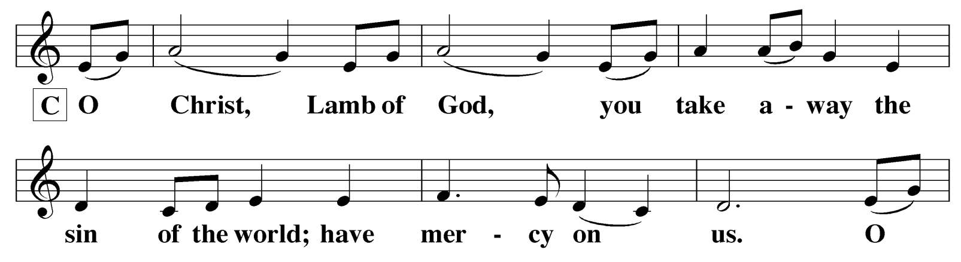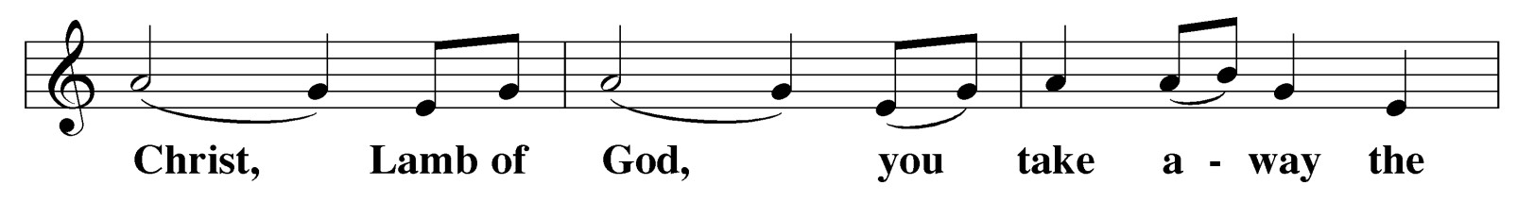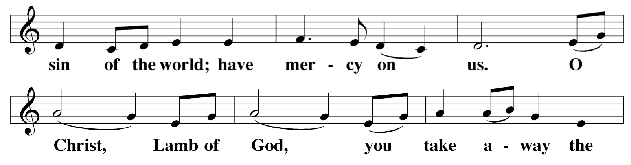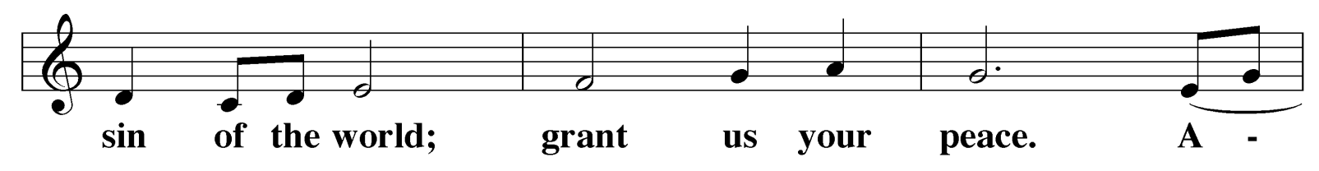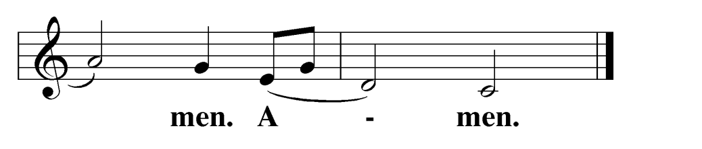Agnus Dei
M: The Lord be with you.

C: And also with you.
M: Lift up your hearts.

C: We lift them up to the Lord.
M: Let us give thanks to the Lord our God.

C: It is right to give him thanks and praise.
M: It is truly good and right that we should at all times and in all places, with all our hearts and minds and voices, praise you, O Lord, Holy Father, almighty and everlasting God, and your one and only Son, Jesus Christ.
For he is the true Paschal Lamb, who offered himself for the sin of the world, who has cleansed us by the shedding of his precious blood.
This is the day when you brought our fathers, the children of Israel, out of bondage in Egypt and led them through the Red Sea on dry ground.
This is the day when all who believe in Christ are delivered from bondage to sin and are restored to life and immortality.
This is the day when Christ, the Life, arose from the dead. The seal of the grave is broken and the morning of the new creation breaks forth out of night.
Oh, how wonderful and beyond all telling is your mercy toward us, O God, that to redeem a slave you gave your Son.
How holy is this morn when all wickedness is put to flight and sin is washed away.
How holy is this morn when innocence is restored to the fallen and joy is given to those downcast.
How blessed is this morn when man is reconciled to God in Christ. Holy Father, accept now the sacrifices of our thanksgiving and praise.
Let Christ, the true Light and Morning Star, shine in our hearts, he who gives light to all creation, who lives and reigns with you and the Holy Spirit, one God, now and forever.

C: Amen
The candles are extinguished.

After a brief musical introduction, the congregation sings “Holy, Holy, Holy.”

HOLY, HOLY, HOLY
Sanctus

 Service of Lessons 
CREATION Genesis 1:1-2:3

PRAYER
M: Let us pray.
Almighty God, you most wonderfully created human nature and yet more wonderfully redeemed it.
By your mercy renew us in the image of him who came to share our humanity,
your Son, Jesus Christ our Lord.

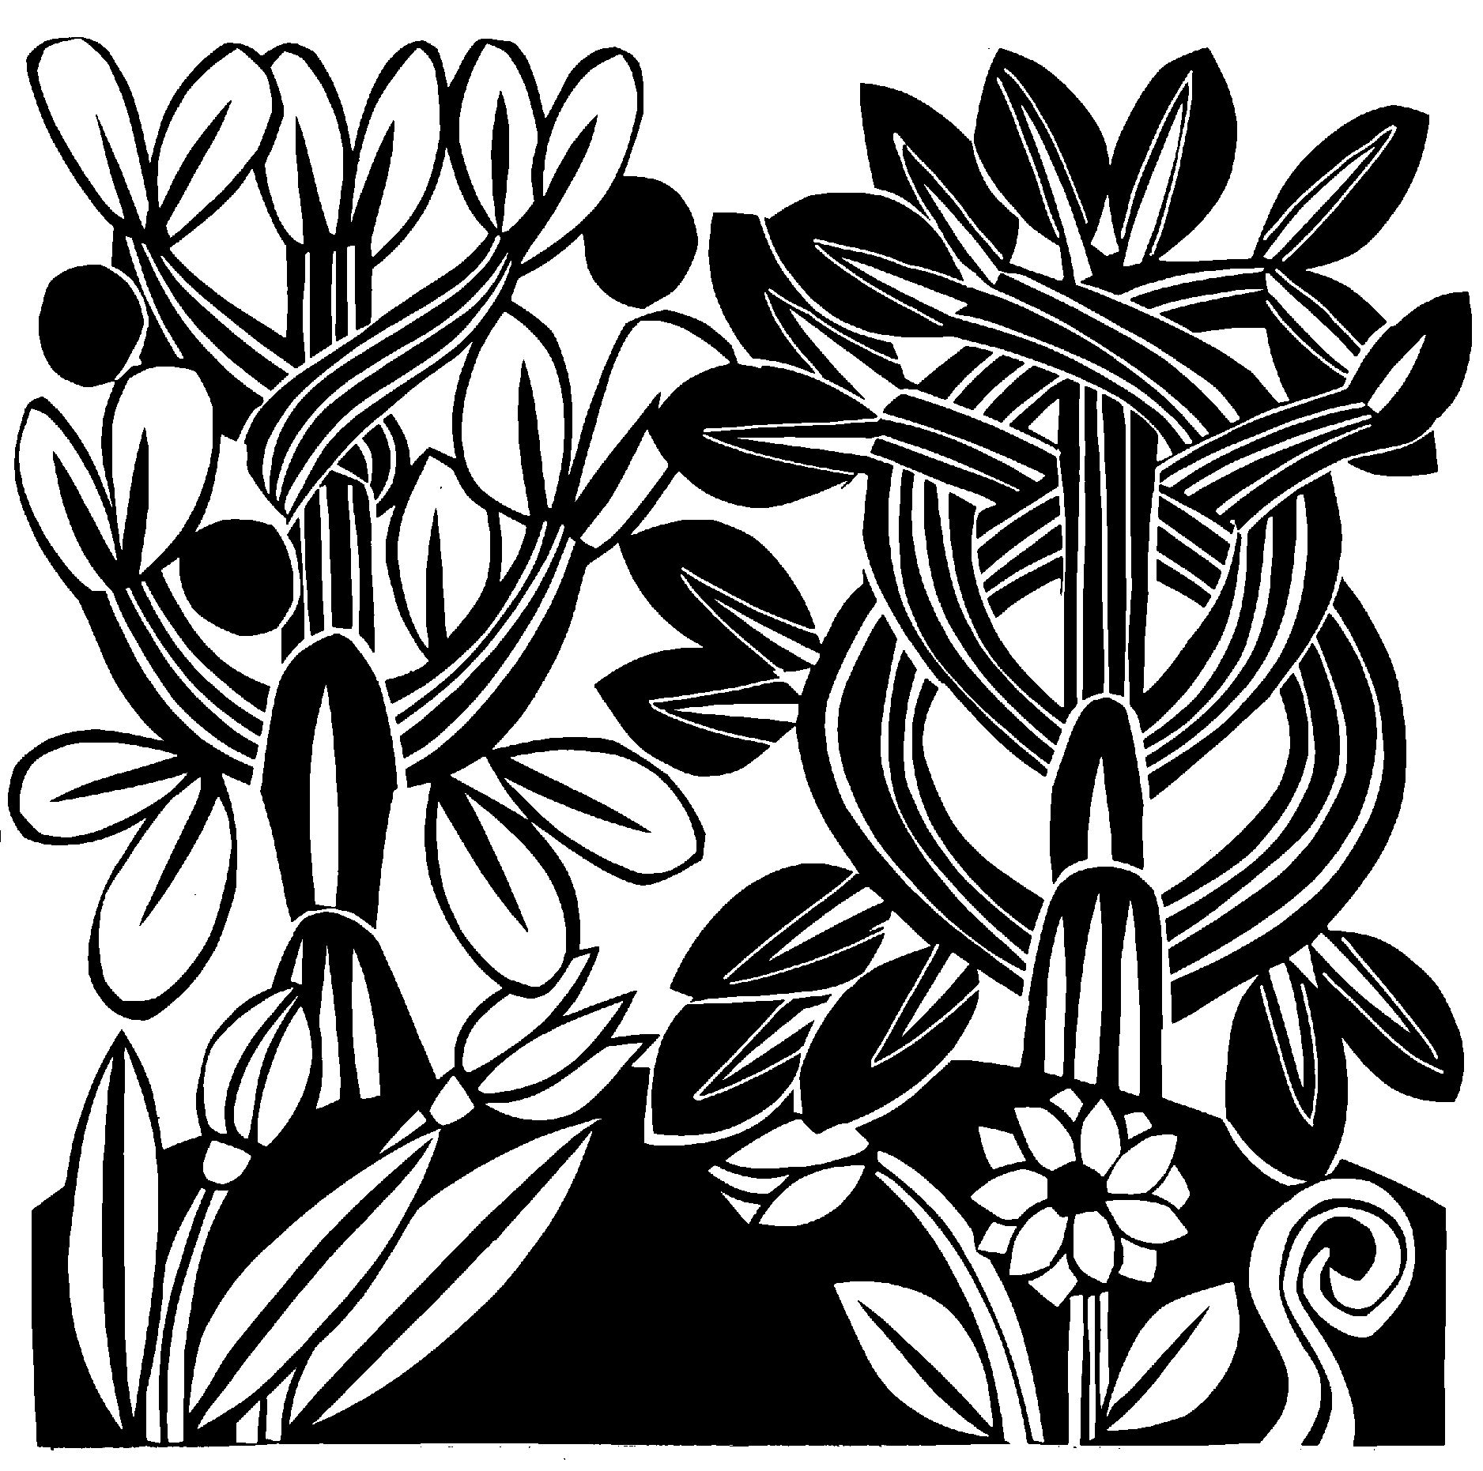C: Amen.

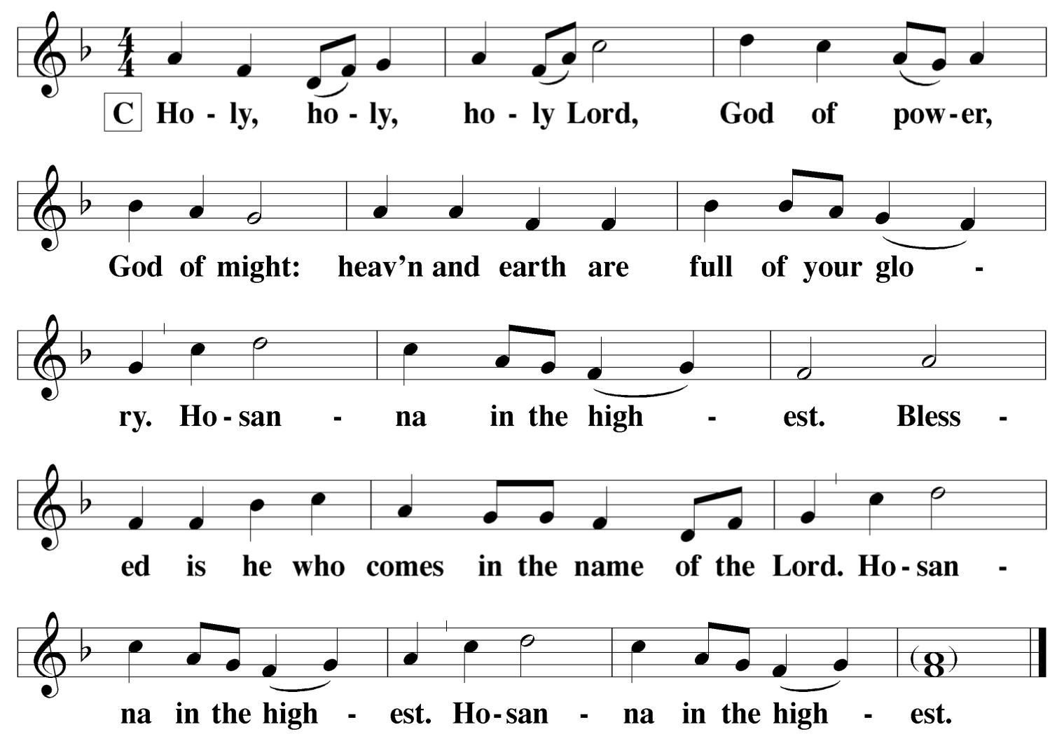C:

WORDS OF INSTITUTION
M: Our Lord Jesus Christ, on the night he was betrayed, took bread; and when he had given thanks, he broke it and gave it to his disciples, saying, “Take and eat; this is my  body, which is given for you. Do this in remembrance of me.”
Then he took the cup, gave thanks, and gave it to them, saying, “Drink from it, all of you; this is my  blood of the new covenant, which is poured out for you for the forgiveness of sins. Do this, whenever you drink it, in remembrance of me.”
The peace of the Lord be with you always.

C: Amen.

PRAYER OF THE DAY
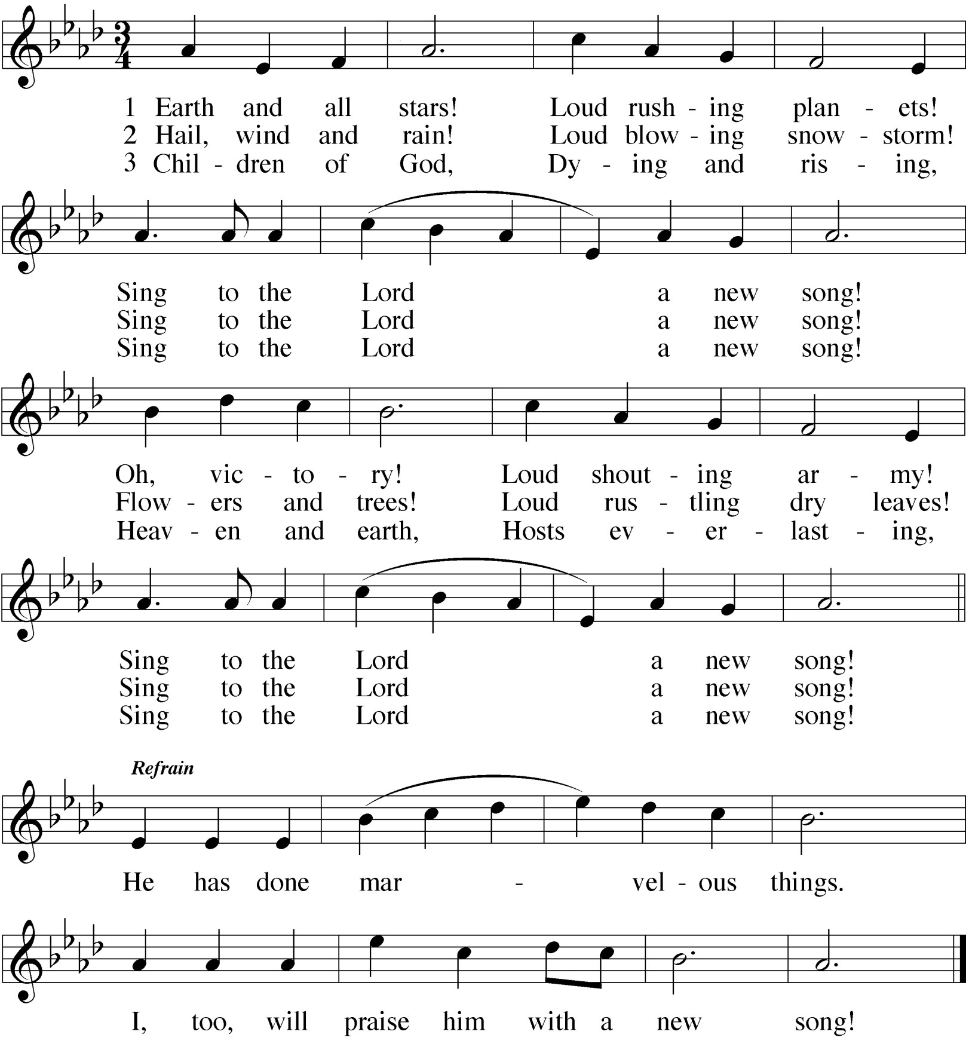M: O God, who made this most holy morn to shine with the glory of the resurrection of our Lord, preserve in all your people the Spirit of adoption which you have given, that they may serve you in faith and joy, through Jesus Christ, your Son, our Lord, who lives and reigns with you and the Holy Spirit, one God, now and forever.

C: Amen.
M: We pray in Christ’s name, and as he taught.

LORD’S PRAYER

C: Our Father in heaven, hallowed be your name, your kingdom come,
your will be done on earth as in heaven. Give us today our daily bread.
Forgive us our sins, as we forgive those who sin against us. Lead us not into temptation, but deliver us from evil.
For the kingdom, the power, and the glory are yours now and forever. Amen.

PREFACE
M: We give you thanks, O Lord, holy Father, almighty and everlasting God,
through Jesus Christ, Our Lord,
and we praise you especially for your glorious resurrection of your Son,
the true Passover Lamb, who by his sacrifice took away the sins of the world and by his resurrection restored everlasting life.
Therefore, with all the saints on earth and hosts of heaven, we praise your holy name and join their glorious song:
RESPONSE Earth and All Stars

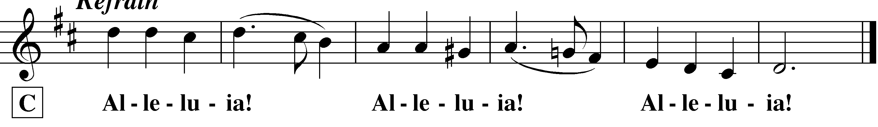

ISRAEL’S DELIVERANCE AT THE RED SEA Exodus 14:10-15:1 PRAYER
M: Let us pray.
O God, you once delivered your people Israel from slavery under Pharaoh
and led them safely through the Red Sea. By this you gave us a picture of Baptism.
Lead us always to rejoice in your baptismal promise, that we may live in its grace and declare to all people your desire to make them children of Abraham, through Jesus Christ our Lord.

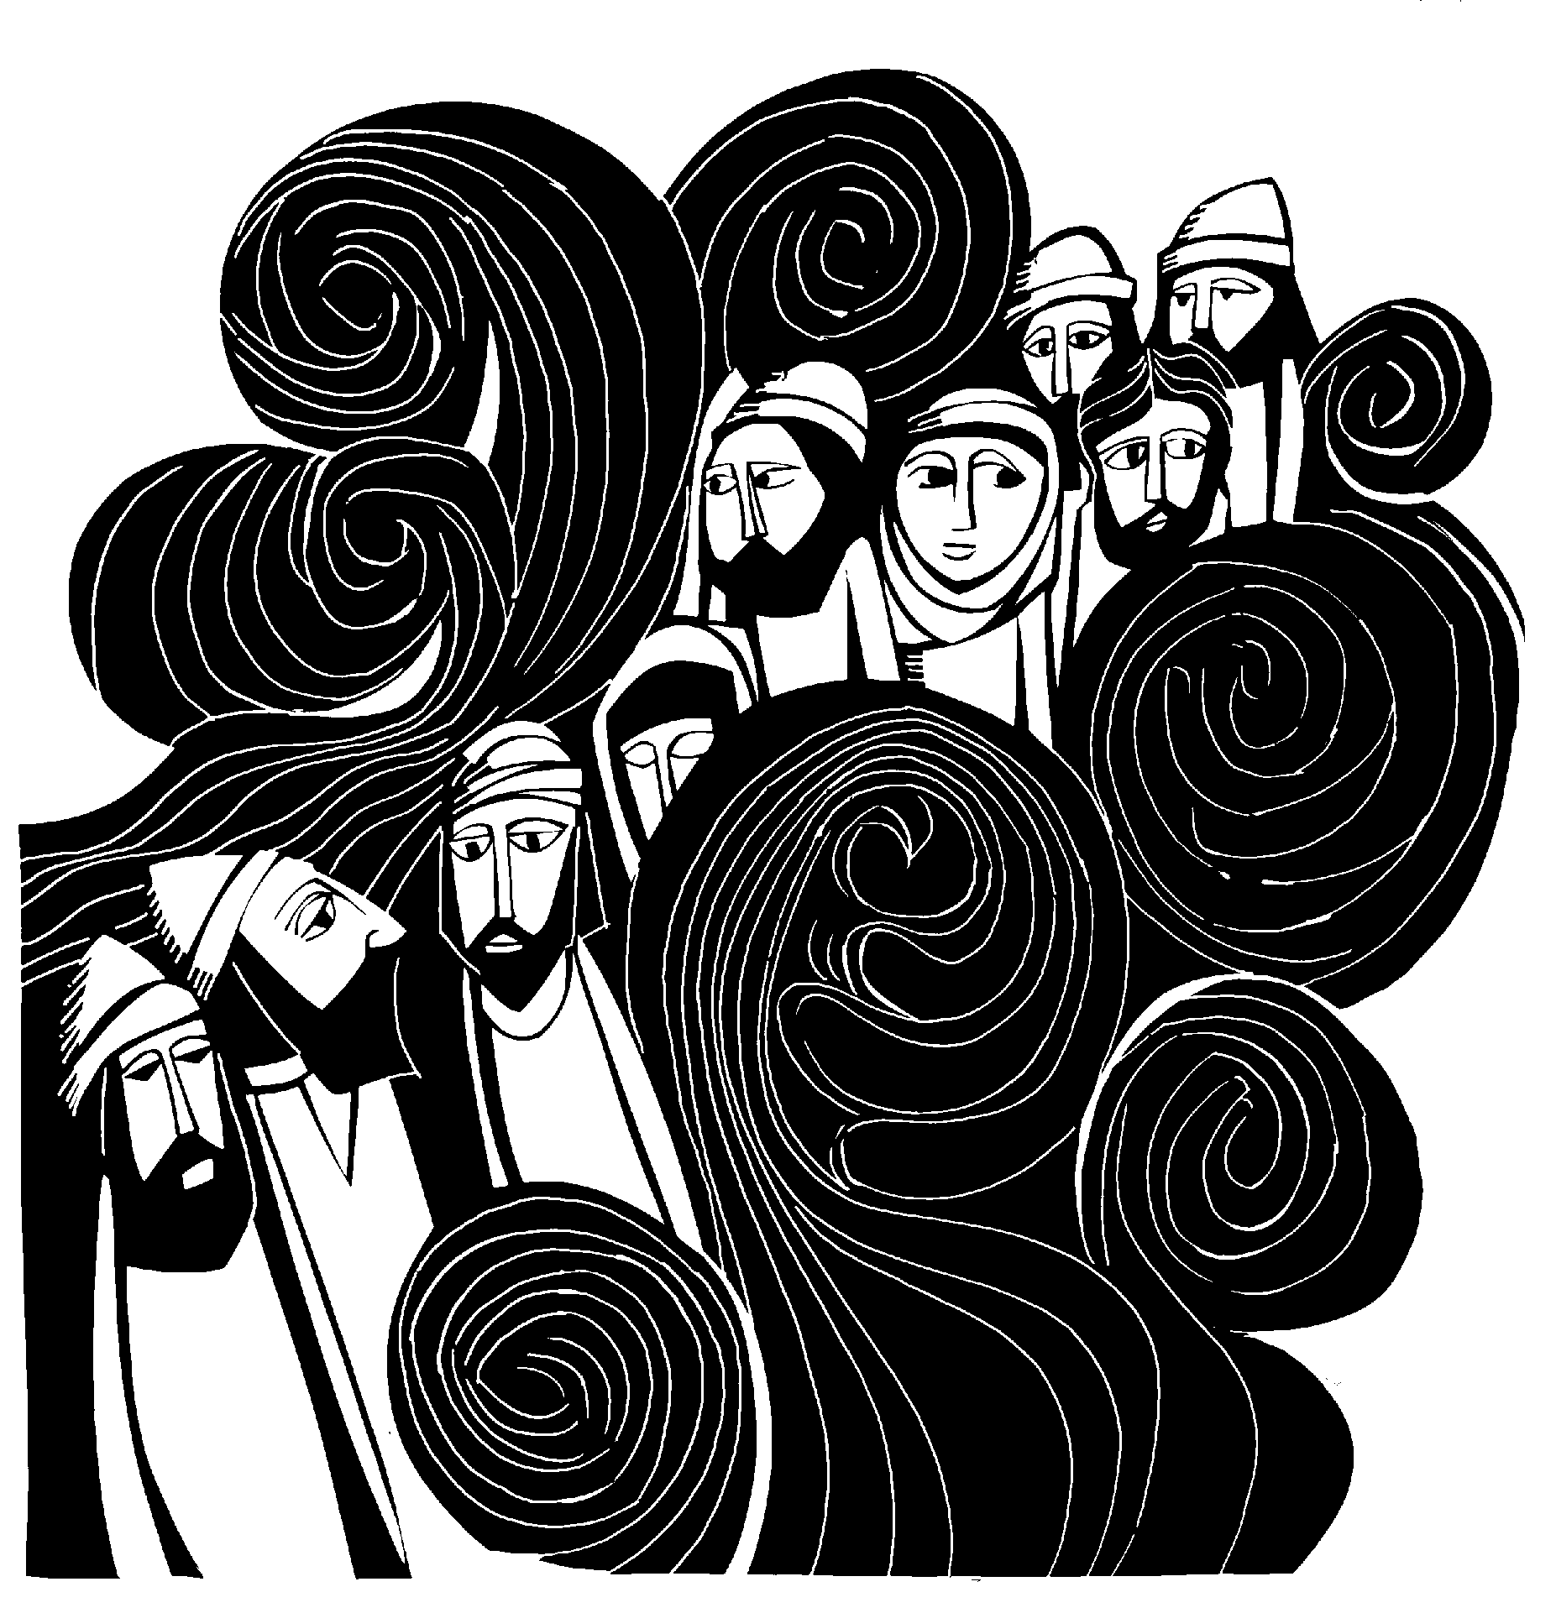C: Amen.
did not understand from Scripture that Jesus had to rise from the dead.)
10Then the disciples went back to their homes, 11but Mary
stood outside the tomb crying. As she wept, she bent over to look into the tomb 12and saw two angels in white, seated where Jesus' body had been, one at the head and the other at the foot.
13They asked her, "Woman, why are you crying?"
"They have taken my Lord away," she said, "and I don't know where they have put him." 14At this, she turned around and saw Jesus standing there, but she did not realize that it was Jesus.
15"Woman," he said, "why are you crying? Who is it you are looking for?"
Thinking he was the gardener, she said, "Sir, if you have carried him away, tell me where you have put him, and I will get him."
16Jesus said to her, "Mary."
She turned toward him and cried out in Aramaic, "Rabboni!" (which means Teacher).
17Jesus said, "Do not hold on to me, for I have not yet re-
turned to the Father. Go instead to my brothers and tell them, 'I am returning to my Father and your Father, to my God and your God.' "
18Mary Magdalene went to the disciples with the news: "I have seen the Lord!" And she told them that he had said these
things to her.

M: This is the Gospel of our Lord.

C:

 Service of Holy Communion 
M: ALLELUIA! CHRIST IS RISEN!

C: HE IS RISEN INDEED! ALLELUIA!
M (sung): Alleluia! Alleluia! Alleluia!

C:

M: For as in Adam all will die, in Jesus Christ all are alive. So we lift up our joyful cry:

C:

GOSPEL John 20:1-18

1Early on the first day of the week, while it was still dark, Mary Magdalene went to the tomb and saw that the stone had been removed from the entrance. 2So she came running to Simon Peter and the other disciple, the one Jesus loved, and said, "They have taken the Lord out of the tomb, and we don't know where they have put him!"
3So Peter and the other disciple started for the tomb. 4Both
were running, but the other disciple outran Peter and reached the tomb first. 5He bent over and looked in at the strips of linen lying there but did not go in. 6Then Simon Peter, who was be- hind him, arrived and went into the tomb. He saw the strips of linen lying there, 7as well as the burial cloth that had been around Jesus' head. The cloth was folded up by itself, separate from the linen. 8Finally the other disciple, who had reached the tomb first, also went inside. He saw and believed. 9(They still

RESPONSE Song of Moses

For the refrain, the cantor sings a line, then the congregation repeats it. The cantor sings the verses.

Refrain 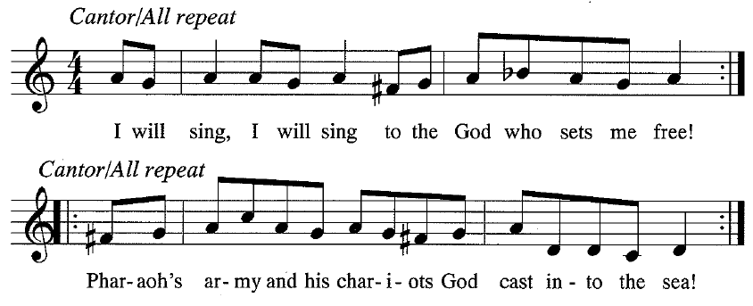
M: The Lord is my strength, my protection and my shield; Pharaoh’s army and his chariots God cast into the sea. Our God is a warrior whose name is ― the Lord,
God of might, God of victory.
All: Refrain

M: The brave and the mighty, the pride of Pharaoh‘s army, God plunged them to the bottom of the sea like a stone. The hand of the Lord is magnificent in power;
the Lord has crushed our foes!
All: Refrain

M: O God who redeems, who delivers us from slav‘ry, you set us on the mountain of your holy place.
Your throne and your temple shall endure for all time; your reign shall never end!
All: Refrain

SALVATION OFFERED FREELY TO ALL Isaiah 55:1-11 PRAYER
M: Let us pray.
Almighty God, you created and sustain all things by the power of your Word.
You send forth your Spirit to renew your creation. Give your saving water of life to all who thirst,
that they may bear much fruit in your glorious kingdom, through Jesus Christ our Lord.
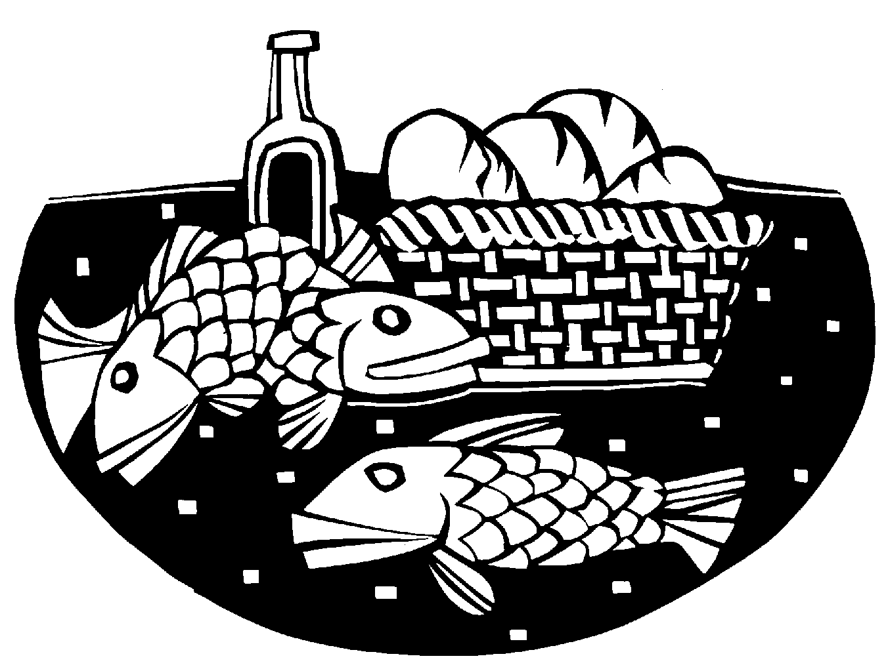C: Amen.

RENUNCIATION AND CONFESSION OF FAITH
M: In Holy Baptism God forgives our sins and grants us a new life in Christ, our Lord. By faith we renounce the devil and all his works and all his ways; we confess the gift of faith in God the Father, Son and Holy Spirit.
I ask you: Do you renounce the devil and all his works and all his ways?

C: I do renounce them.
M: Do you believe in God the Father?

C: Yes, I believe in God, the Father almighty, maker of heaven and earth.
M: Do you believe in Jesus Christ, his only Son?

C: Yes, I believe in Jesus Christ, his only Son, our Lord, who was conceived by the Holy Spirit, born of the Virgin Mary, suffered under Pontius Pilate, was crucified, died, and was buried. He descended into hell. The third day he rose again from the dead. He ascended into heaven and is seated at the right hand of God the Father almighty. From there he will come to judge the living and the dead.
M: Do you believe in the Holy Spirit?

C: Yes, I believe in the Holy Spirit, the holy Christian Church, the communion of saints, the forgiveness of sins, the resurrection of the body, and the life everlasting.
M: Is it your earnest purpose to continue steadfast in the faith into which you were baptized and, as a member of the Church, to be diligent in the use of the means of grace and prayer?

C: Yes, with the help of God.
M: Almighty God, the Father of our Lord Jesus Christ, who has given you the new birth of water and of Spirit and has forgiven you all your sins, strengthen you with his grace to life everlasting.

C: Amen.
The rite of Holy Baptism may take place here.

 Service of Holy Baptism 

M: On this holiest of days the whole Church of our Lord Jesus Christ recalls his death and burial, rejoicing in the gospel of his glorious resurrection. St. Paul said, “Do you not know that all of us who were baptized into Christ Jesus were baptized into his death? We were therefore buried with him through baptism into death in order that, just as Christ was raised from the dead through the glory of the Father, we too may live a new life.”
During the one verse musical introduction, the pastor dips the paschal candle in the baptismal font, as a sign of Christ’s death and resurrection, which gives baptism its power. After the musical introduction the congregation joins to sing:
RESPONSE At the Lamb’s High Feast We Sing

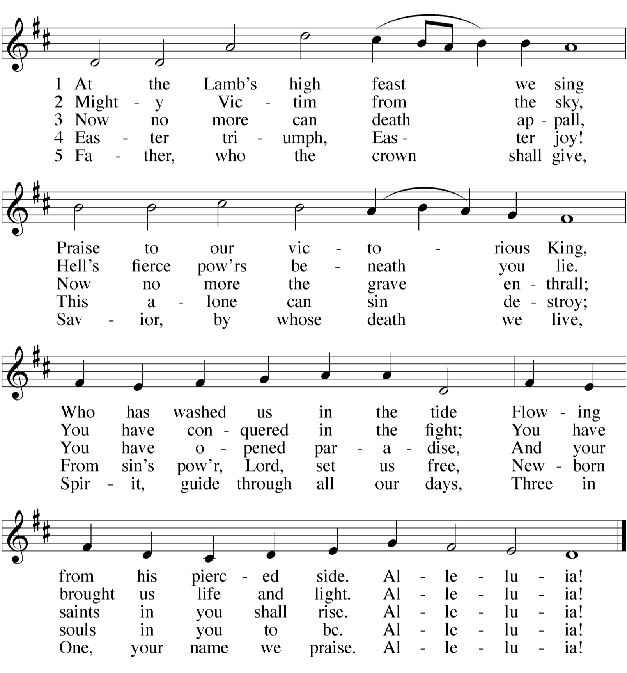
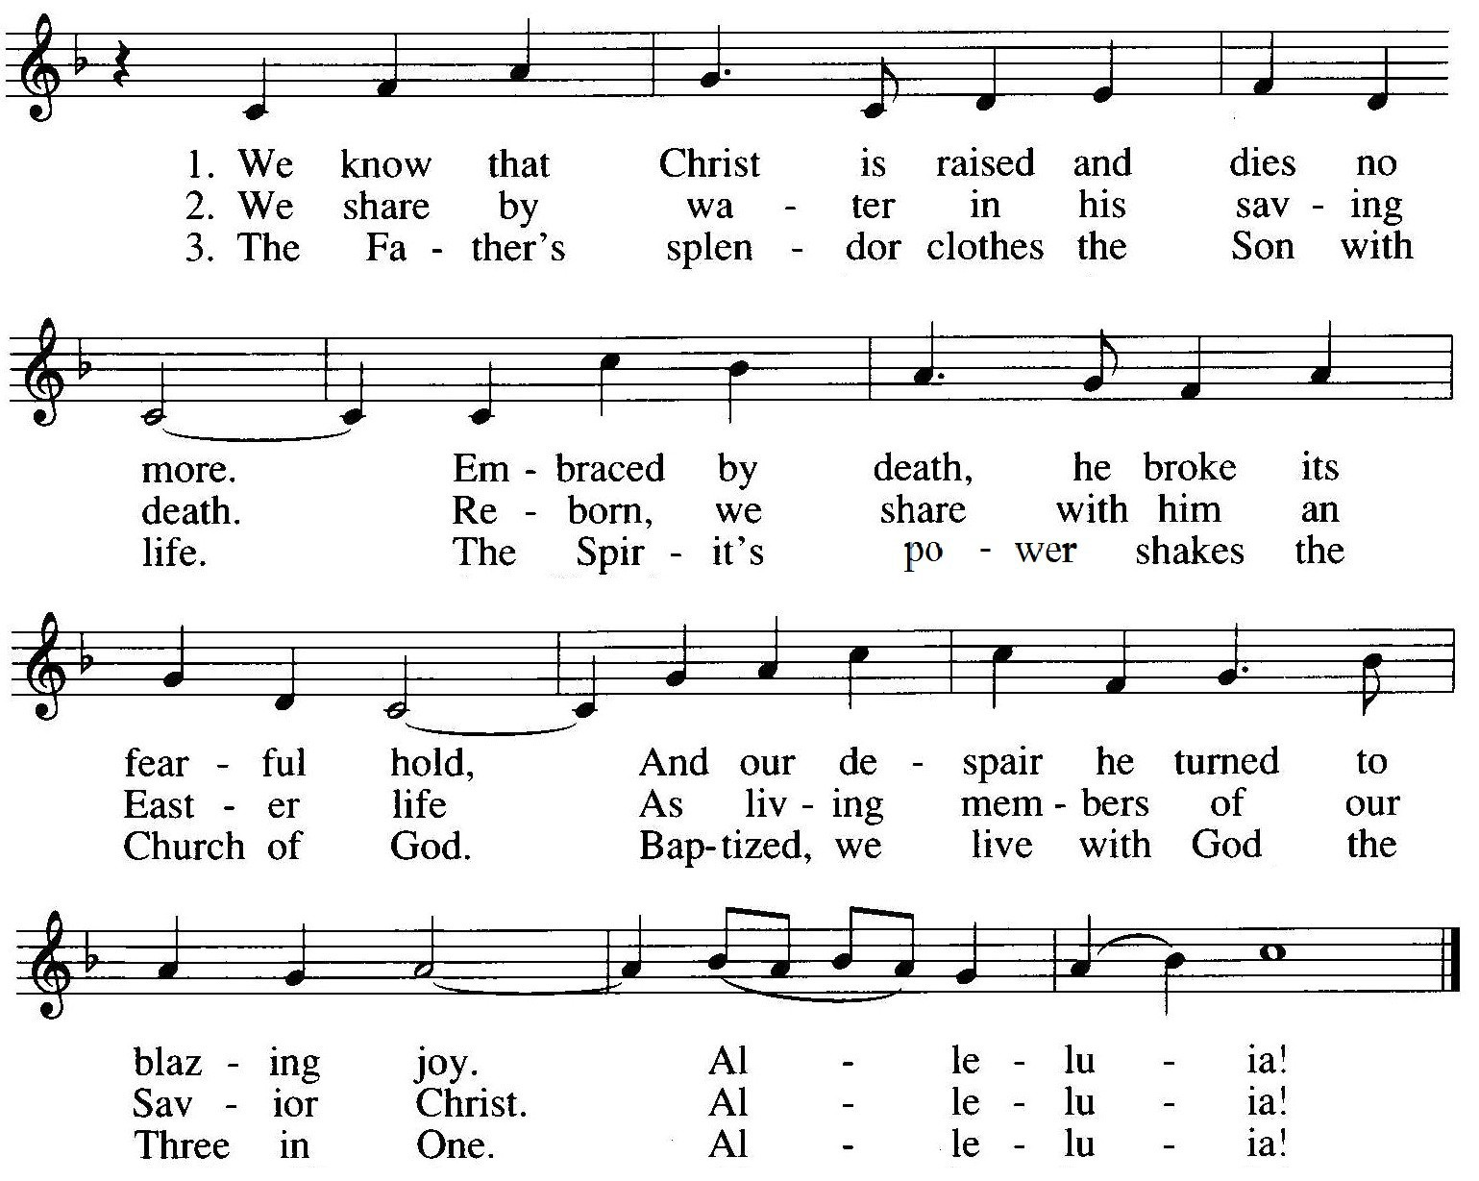

BAPTIZED FOR RESURRECTION Romans 6:3-11 PRAYER
M: Let us pray.
Almighty God, in our baptism you made Christ’s death our death to sin,
Christ’s righteousness our sure hope of salvation,
Christ’s resurrection our resurrection to a new and nobler life. We give you thanks for the gift of baptism,
through which you incorporated us into Christ’s body, the Church, and made us temples of your Spirit.
Pour out your Holy Spirit on us now; enlighten us with your wisdom.
Renew our call to ministry and strengthen us for loving service, that we may proclaim and live Christ’s good news.
In his name we pray.
C: Amen.
RESPONSE Scatter the Darkness, Break the Gloom

