- 20 -
- -

Your congregational license information goes here

Psalm 134 — In the Silence of Night
Music: David Haas
© 1997 GIA Publications, Inc.

Jesus, Remember Me
Music: Jacques Berthier
© 1981 GIA Publications, Inc.

Psalm 22 — My God, My God
Music: Marty Haugen
© 1983 GIA Publications, Inc.

Psalm 31 — I Trust In You, O Lord
from Christian Worship: New Service Settings
© 2002 Northwestern Publishing House

The Power of the Cross
Text and Music: Keith Getty
© 2005 Thank You Music

Rest, O Christ, From All Your Labor
Text: Herman Stuempfle © 1993 GIA Publications, Inc.
Tune: Geistliche Volkslieder
Setting: Paul Bunjes © 1982 Concordia Publishing House
Good Friday April 19, 2014

THE SEVEN WORDS

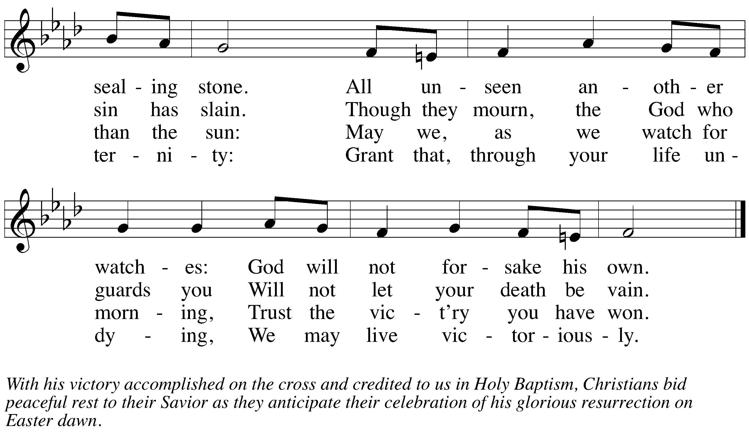SERVICE NOTES: The Triduum
After six weeks of Lent, the Christian Year has now reached its climax. We have come to the celebration of the suffering, death, and resurrection of our Lord and Savior Jesus Christ. This is the celebration for which we have been preparing throughout Lent. Now we see what our Savior came to do.

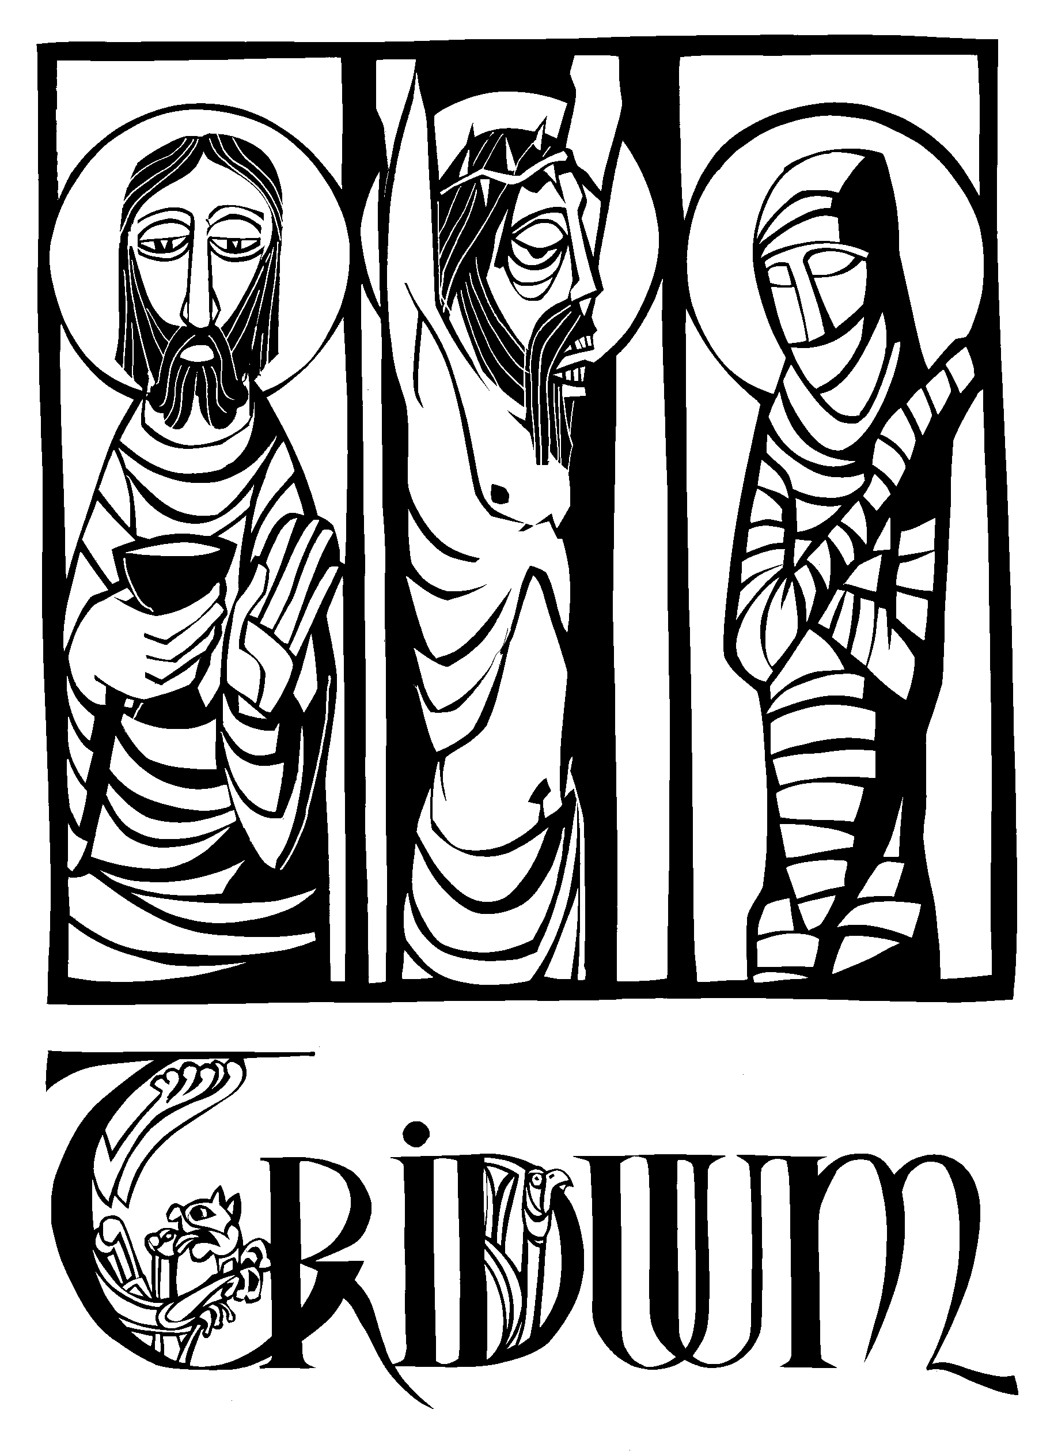We see him suffer and die for our sins and for the sins of the world. And we see him rise triumphantly on Easter morning to assure us that our salvation is complete, the victory is won.
Prior to the fourth century, Easter Day itself included all three emphases — Christ’s suffering, death, and resurrection. But the early Church fathers decided that it might be wise to spread those three emphases out over three days.
And so Maundy Thursday was formed to commemorate the beginning of Christ’s suffering, as he gathers in the upper room, washing his disciples feet, institutes the Lord’s Supper, then proceeds to the Garden of Gethsemane for prayer.
Good Friday was set aside to ponder the intensity of Christ’s passion, as he is put on trial before Pontius Pilate, scourged, and crucified. On the cross, he speaks only seven times before he dies.
Finally, the practice of the Easter Vigil was begun. It was not the high festival service of Easter. Rather, it was a service to prepare oneself for that festival. The Vigil was also used as the entrance rite into the Church, as converts were baptized, confirmed, and communed all during the vigil.
The greatest theologian of the early Church, St. Augustine, called these days of special observance, “the most holy Triduum of the crucified, buried, and risen Lord.” (Triduum is Latin for three days.) These days have long been understood as the climax of the Church’s year. Together they form a unit. Therefore, as we celebrate these Three Holy Days, our worship will form a unit. What follows is a single service, celebrated over three days, which will take us through our Savior‘s sufferings to his glorious triumph on Easter.
Because these three services form one unit, you will notice some unusual things. First, there is no benediction after parts 1 and 2. The benediction will occur at the end of the service on Easter morning. Secondly, after parts 1 and 2, the congregation is asked to leave the church in silence.

PSALM 51
For the penitential psalm, the congregation is invited to kneel.
The minister himself kneels before the altar. Speaking on behalf of the congregation, he confesses our sin to God in the words of King David.
After the completion of the psalm, there is no blessing, for this is only day two of the Triduum. Our worship continues for another day.
After a period of optional meditation, the congregation leaves the church in silence. Please do not converse with one another inside the church. There will not be a greeting line at the doorway.
We gather Saturday evening (8:00PM) for the Great Vigil.

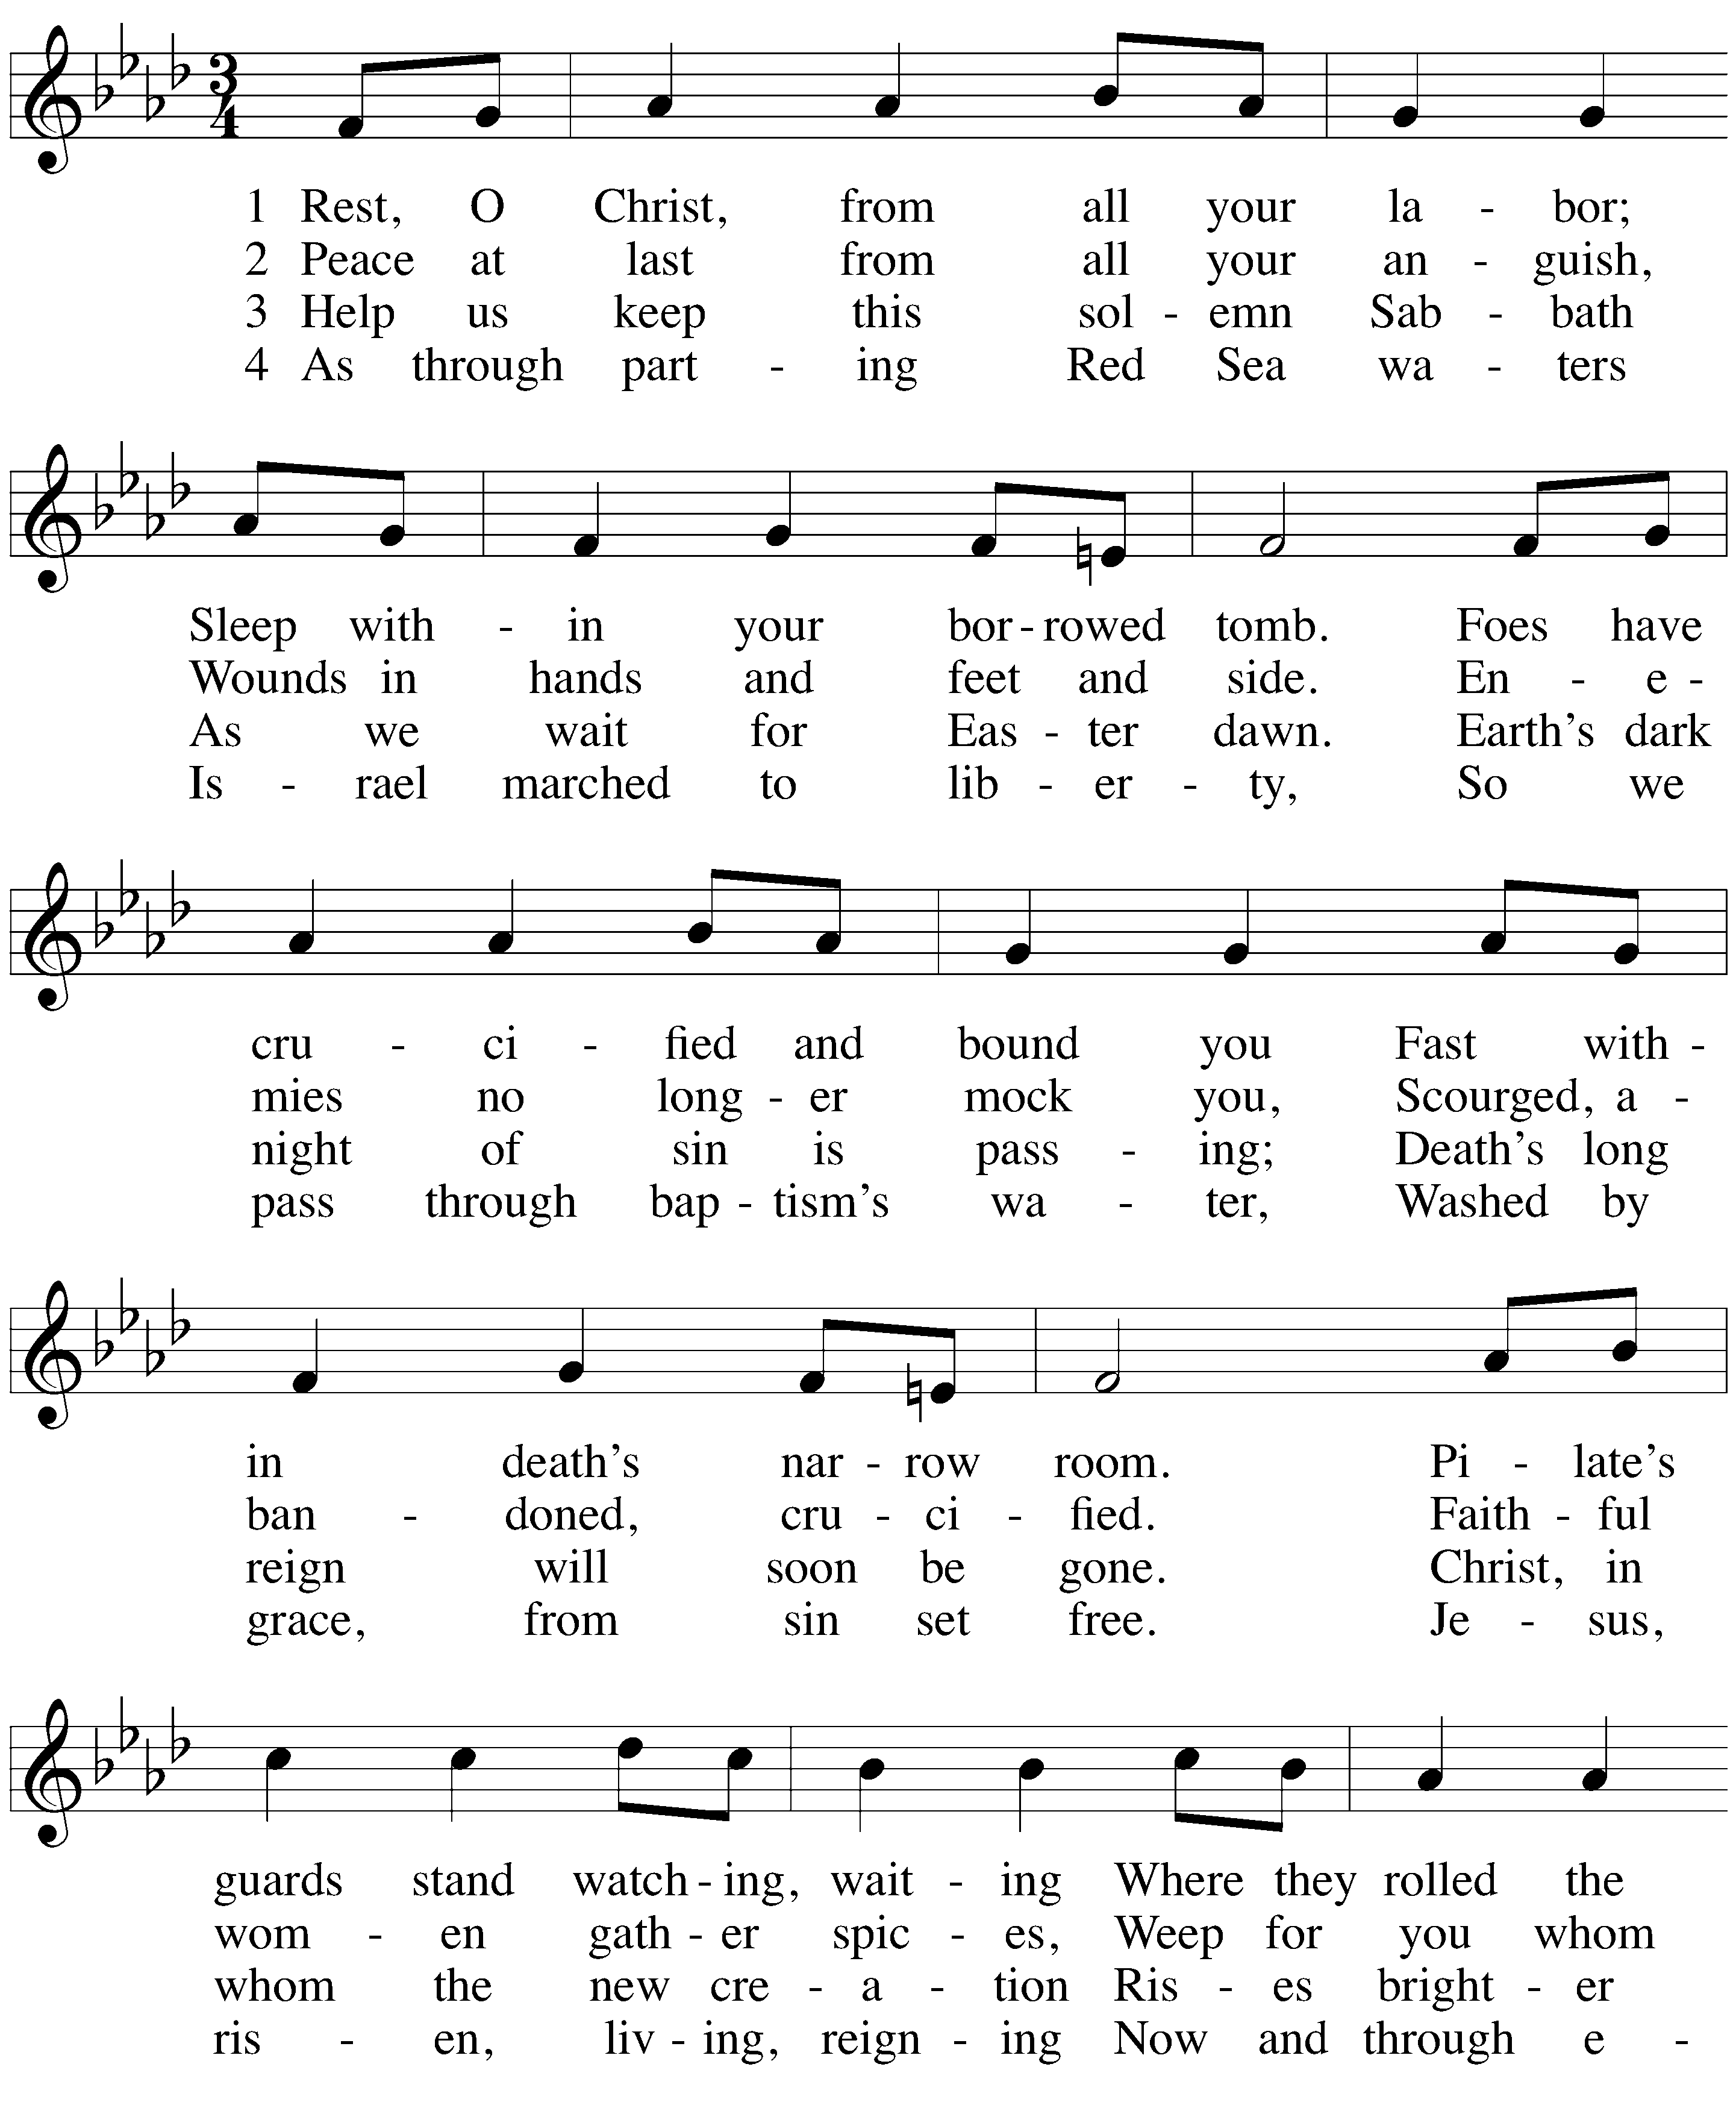HYMN Rest, O Christ, From All Your Labor

Part II — Good Friday
The Seven Words Scripture tells us of seven things Jesus said from the cross. All seven are short. All seven are profound, showing the depth of his love for us. Tonight, our worship revolves around looking at these seven words.
Tenebrae: A Service of Darkness The word tenebrae (TEN-e-bray) means “darkness.” The service we use tonight follows a pattern that has existed in Good Friday worship for centuries. Throughout the service light will grow dim and candles will be extinguished, representing Christ’s life ebbing away.
The Reproach Prophecies A reproach is a strong expression of disapproval. Often it involves discrediting someone, proving that an accusation they made against you was false. In the reproach prophecies, the Lord himself does just that. The people of Israel, in their worldly problems, would have the audacity to claim that God was at fault. God makes it clear to Israel that when life fell apart, it was never because he left them. It was always the other way around. We utilize these prophecies in our confession of sins.
Symbolic Silence The mood of the service is most solemn, encouraging the worshipers to reflect deeply upon their own life in the light of the Passion of our Lord. No closing blessing is pronounced and the congregation disperses into the night, leaving the darkened church in silence, yet remembering the Light which lingers and casts hope through the gloom of Good Friday.

In keeping with the solemnity of the day, there will be no post-service music.
Silence for meditation is appreciated.
God bless your worship.

ORDER OF SERVICE
Ringing of the bells

CONFESSION OF SINS1 Based on the Reproach Prophecies
M: Behold the cross, on which hung the Savior of the world.

C: Come let us worship.
M: The Lord says,
“My people, what wrong have I done to you? How have I offended you? Answer me!
Through baptism, I led you from slavery to freedom, but you lead your Savior to the cross.”

C: Holy God, holy and merciful,
holy and just, have mercy upon us.
M: “I planted you as my fairest vineyard, I grafted you into the one true vine,
I gave you the water of salvation,
but you give me gall and vinegar to drink, and leave me thirsting upon a cross.”

C: Holy God, holy and merciful,
holy and just, have mercy upon us.
M: “I gave you a royal scepter, but you give me a crown of thorns.
I raised you up to newness of life, but you raise me high upon a cross.”

C: Holy God, holy and merciful,
holy and just, have mercy upon us.
M: “I give you heaven, and yet you complain about that which you think you lack.
I give you eternity, and yet you worry about this life. You suffer, and you then blame me,
though I have proven my love!
Should not I take everything from you?”

C: Holy God, holy and merciful,
holy and just, have mercy upon us.
A: Let us pray for those who are outside the Church, that they may come to know the one true God and Jesus Christ whom he has sent.
Silent prayer
M: Almighty and everlasting God, your Son was lifted up on the cross so that he might draw all people to himself. Through the proclamation of your Word, mercifully gather from the nations a people that are your very own, that we may join together around your throne in glory to praise and thank you forever, through Christ our Lord.

C: Amen.
A: Let us pray for our enemies and for all those who hate us.
Silent prayer
M: Almighty and everlasting God, no one can harm us without grieving you, whose name we bear. We ask that you would change the hearts of those who work against us and who hate us without reason. Give them repentance and faith so that they may be glad with us and find joy in your love, through Christ our Lord.

C: Amen.
A: Let us pray for all who suffer under cross and trial.
Silent prayer
M: Almighty and everlasting God, you sent your Son into the world to bear our griefs and to carry our sorrows. Help those who are suffering for your name’s sake and who are struggling against temptation, that they may not be overwhelmed with sadness but find relief in your grace, through Christ our Lord.

C: Amen.
A: Finally, let us pray for all those things for which our Lord would have us ask in the words he himself has taught us.

C: Our Father in heaven, hallowed be your name, your kingdom come,
your will be done on earth as in heaven. Give us today our daily bread.
Forgive us our sins, as we forgive those who sin against us. Lead us not into temptation,
but deliver us from evil.
For the kingdom, the power, and the glory are yours now and forever. Amen.

BIDDING PRAYER
A: Let us pray for the whole Church, that our gracious Father would defend her from the devil and keep her faithful to her Lord.
Silent prayer
M: Almighty and everlasting God, you have revealed your saving name to the world through Jesus Christ our Lord. Protect us from the assaults of the evil one, and help us remain faithful to your Word so that in every adversity we may stand firm in our faith and give ourselves fully to our Savior’s work, through Christ our Lord.

C: Amen.
A: Let us pray for those who serve in the public ministry and for all people of God.
Silent prayer
M: Almighty and everlasting God, you rule over all things for the good of your people. Preserve us from divisive spirits and false teachers. Give your servants the grace to proclaim Christ joyfully in word and deed so that all who hear them may come to know their Savior better and be strengthened for their lives of service, through Christ our Lord.

C: Amen.
A: Let us pray for those who are being instructed in the Word, that they remain firm in the simple faith of Baptism.
Silent prayer
M: Almighty and everlasting God, you make us your own dear children by the washing of rebirth and renewal in the Holy Spirit. Give strength to all who are buried with Christ in Baptism, that each day they may die to sin and rise again to live new and holy lives, through Christ our Lord.

C: Amen.
A: Let us pray for our earthly government, our rulers, and all who are in authority.
Silent prayer
M: Almighty and everlasting God, you have established earthly government to keep a measure of order in this dying world and to protect us from the disorder of sin. Give to all rulers the wisdom to govern well and to all citizens the desire to obey them, so that we may live peaceful lives in all godliness and holiness, through Christ our Lord.

C: Amen.

M: “What more could I have done for you?
I gave you my peace and my truth, but you fight with each other,
you cause pain to those I love,
you dismiss those I chose to lead you.
Should not my anger burn? Should not I destroy you?”

C: Holy God, holy and merciful,
holy and just, have mercy upon us.
M: “I come as your brother and sister, hungry, yet you give me no food, thirsty, yet you give me no drink,
a stranger, and you do not welcome me, naked, and you do not clothe me,
sick and in prison, and you do not visit me.”

C: Holy God, holy and merciful,
holy and just, have mercy upon us.
Silence for personal reflection and confession
M: The Lord also says,
"This is the covenant I will make with the house of Israel.
I will put my law in their minds and write it on their hearts. I will be their God, and they will be my people.
For I will forgive their wickedness and will remember their sins no more."

C: Amen
M: Behold the cross, on which hung the Savior of the world.

C: Come let us worship.

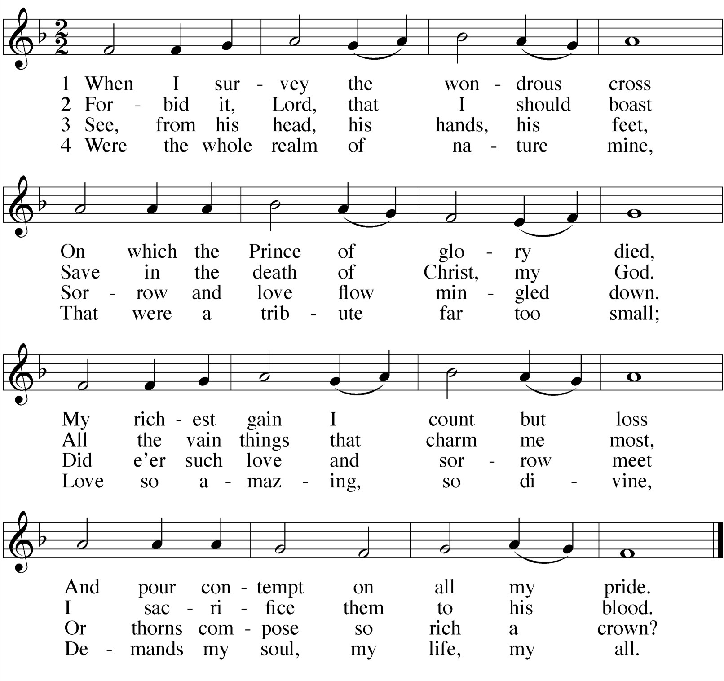HYMN When I Survey the Wondrous Cross
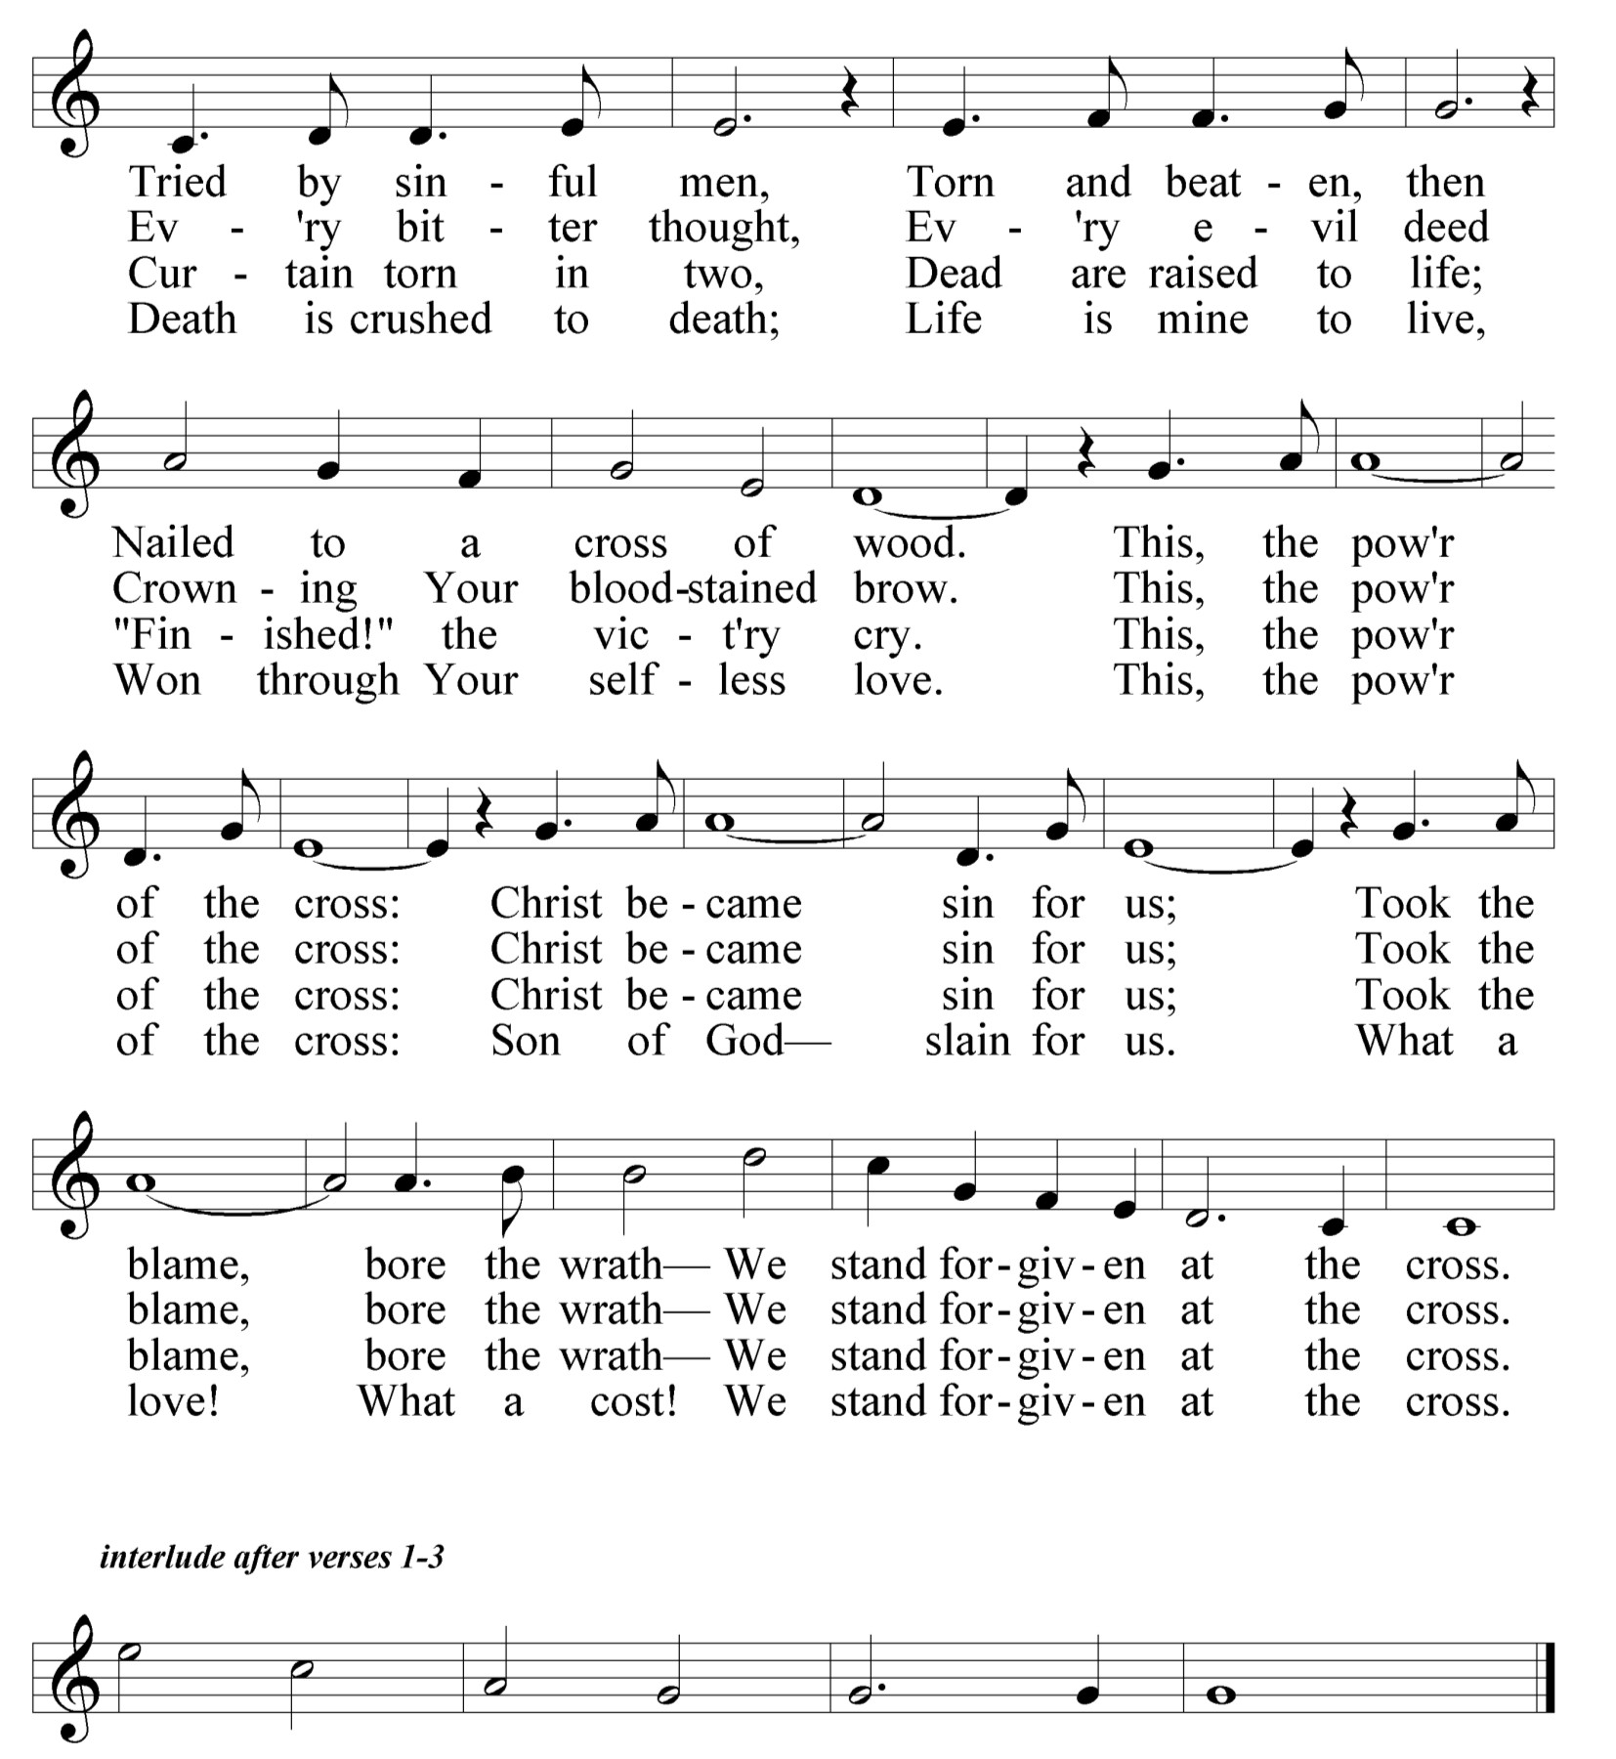

THANK OFFERING

THE SEVENTH WORD 

Luke 23:33-46
THE FIRST WORD 
Luke 23:26-34

ANTIPHON Jeremiah 23:9,20
M: My heart is broken within me;

C: all my bones tremble.
M: I am like a drunken man,

C: like a strong man overcome by wine,
M: because of the LORD

C: and his holy words.
M: The anger of the LORD will not turn back

C: until he fully accomplishes the purposes of his heart.
M: In days to come

C: you will understand it clearly.

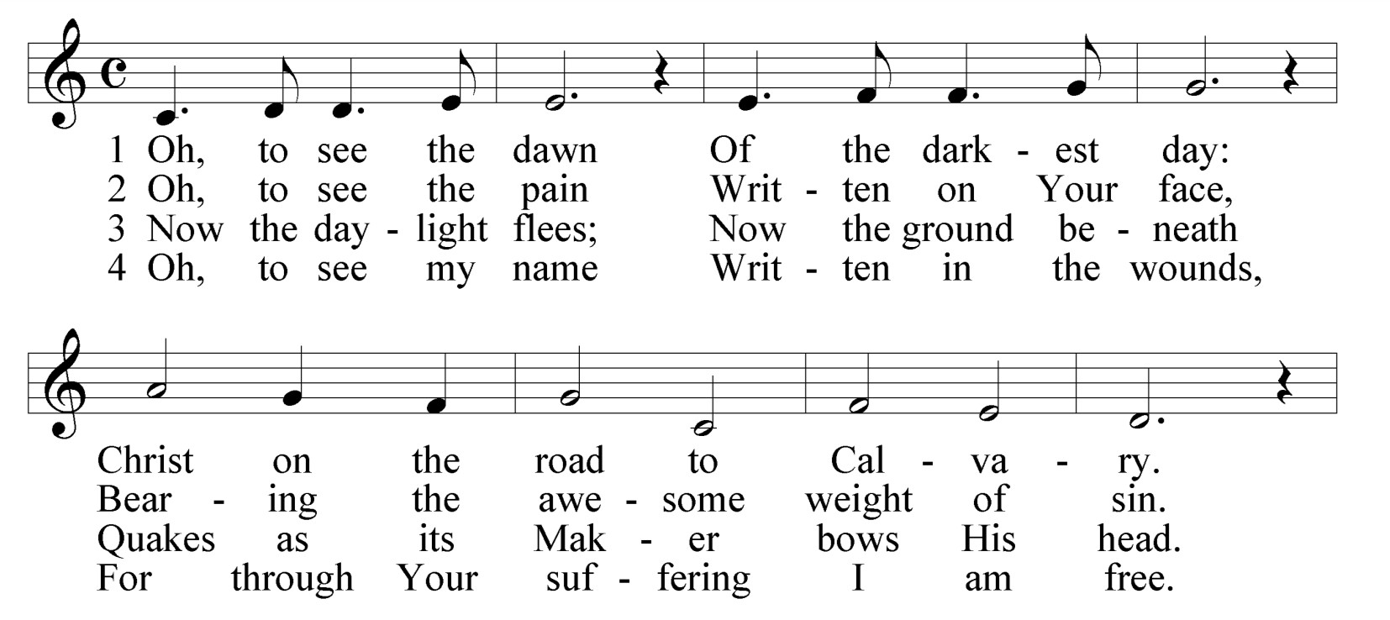HYMN The Power of the Cross
ANTIPHON Isaiah 53:6-7
M: We all, like sheep, have gone astray, each of us has turned to his own way,

C: and the LORD has laid on him the iniquity of us all.
M: He was oppressed and afflicted,

C: yet he did not open his mouth;
M: he was led like a lamb to the slaughter, and as a sheep before her shearers is silent

C: so he did not open his mouth.

PSALM 134
This psalm is done in an mantra style, with the refrain and the verses sung simultaneously. The minister introduces the refrain. The congregation then repeats the refrain, and keeps on repeating the refrain until the final verse. After the minister concludes with the final verse, the congregation sings the refrain one final time.

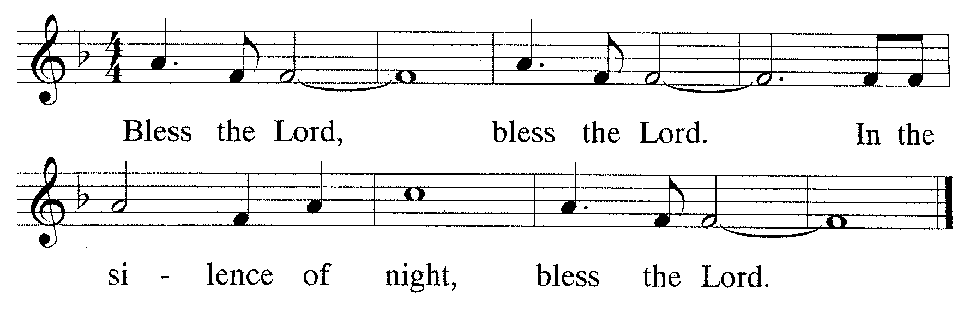

M: Verses
Bless the Lord, all who serve in God’s house, who stand watch throughout the night. Lift up your hands in the holy place and bless the Lord, and bless the Lord.
And may God, the maker of earth and sky, bless you, bless you from Zion.

THE SECOND WORD 
Luke 23:38-43

The minister sings this first

ANTIPHON Isaiah 53:12
M: He poured out his life unto death,

C: and was numbered with the transgressors.
M: For he bore the sin of many,

C: and made intercession for the transgressors.

MUSICAL PRAYER
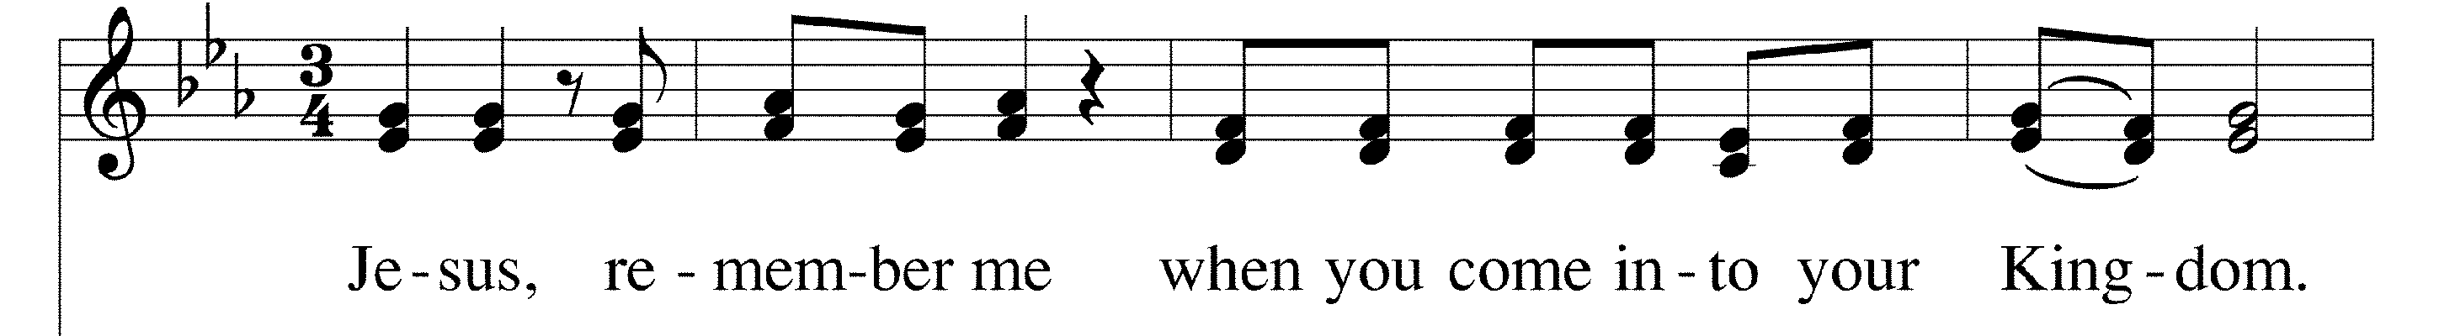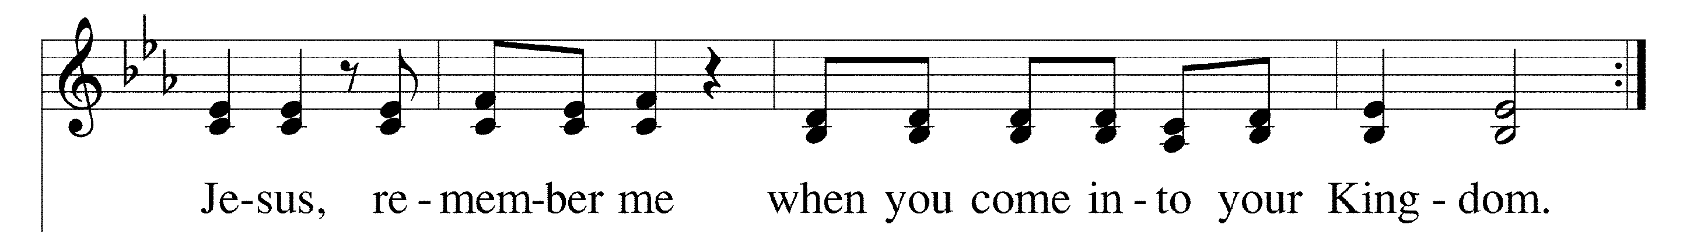The presiding minister sings the verse once. The congregation then repeats the verse four times, getting slightly louder each time.
set of verses.

C: Refrain

For all the remaining verses, congregation may join in.

C: 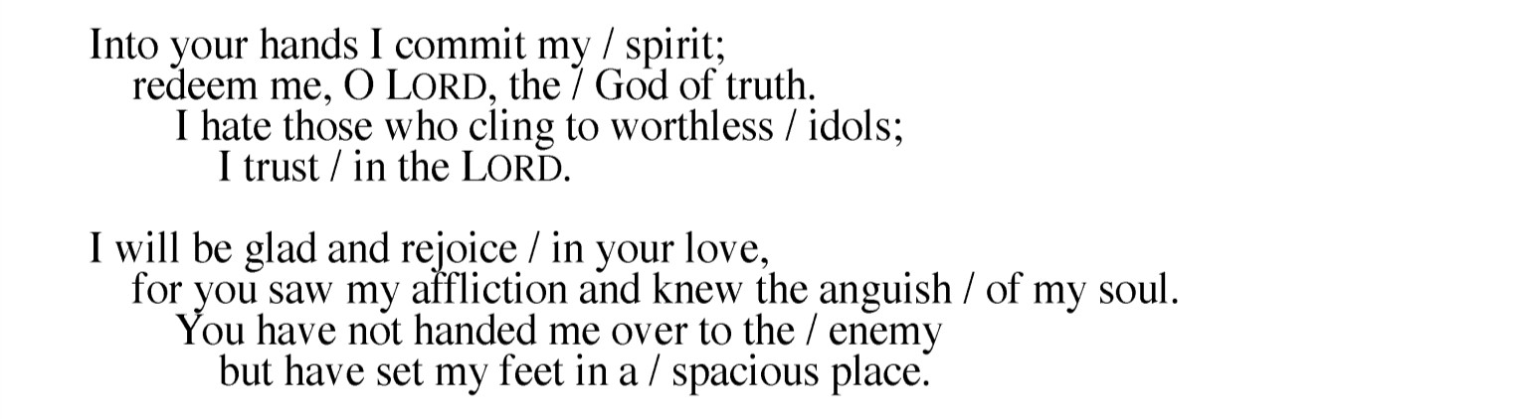
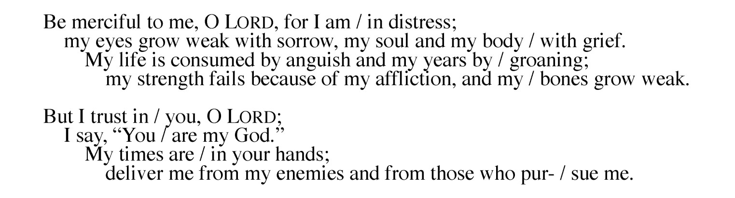C: Refrain C:

THE THIRD WORD 
John 19:25-27

C: Refrain

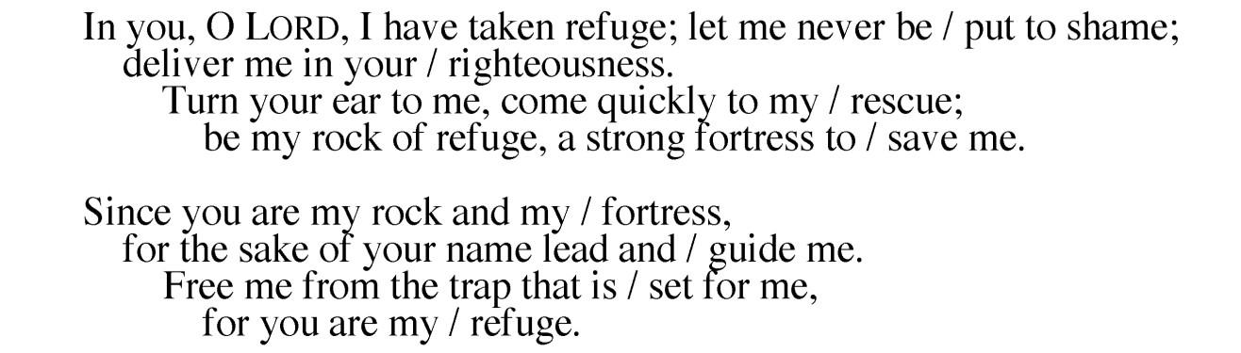
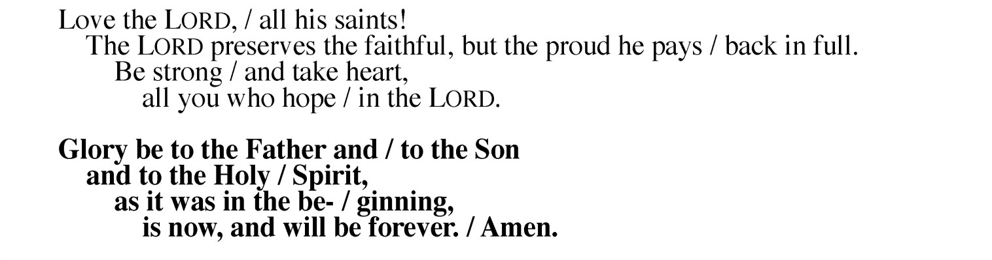ANTIPHON Isaiah 53:8-9 C:
M: He was cut off from the land of the living;

C: for the transgression of my people he was stricken,
M: though he had done no violence,

C: nor was any deceit in his mouth.

C: Refrain

THE SIXTH WORD 
John 19:30

HYMN Were You There

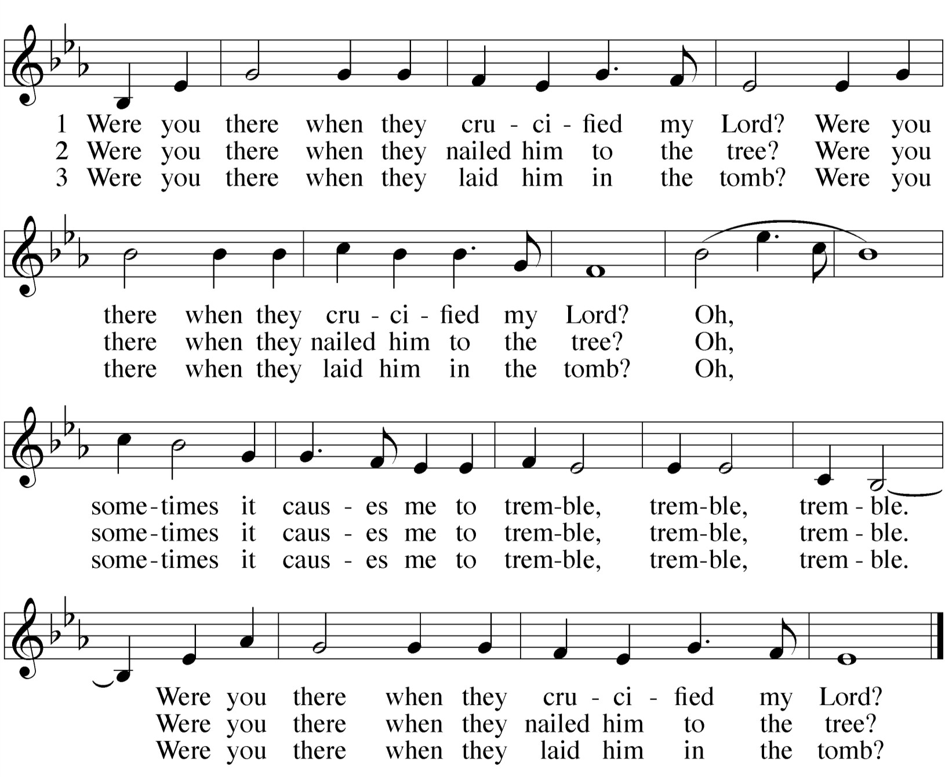ANTIPHON Isaiah 59:16; 1 Timothy 1:15; 2 Peter 1:17
M: The LORD saw that there was no one,
he was appalled that there was no one to intervene.

C: so his own arm worked salvation for him, and his own righteousness sustained him.
M: Here is a trustworthy saying that deserves full acceptance:

C: Christ Jesus came into the world to save sinners— of whom I am the worst.
Silence to meditate upon the worst of our sins
M: Jesus Christ received honor and glory from God the Father when the voice came to him from the Majestic Glory, saying,

C: "This is my Son, whom I love; with him I am well pleased."

PSALM 31
The minister introduces the refrain. The congregation then repeats the refrain.
The minister sings the first set of verses. The congregation may join in the subsequent verses as they feel comfortable. The psalm tones are identical same for all sets of verses.
M: Refrain

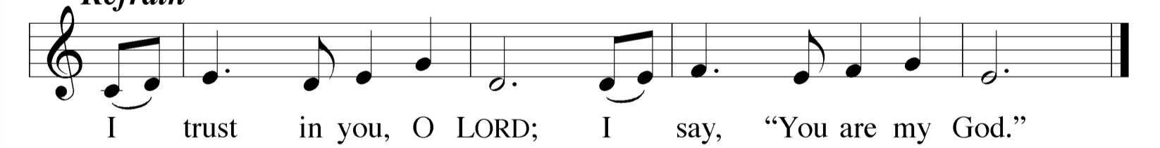C: Refrain

THE FOURTH WORD 
Matthew 27:45-49
THE FIFTH WORD 
John 19:28,29

ANTIPHON Isaiah 59:16
M: The LORD saw that there was no one,

C: he was appalled that there was no one to intervene.
M: So his own arm worked salvation for him,

C: and his own righteousness sustained him.

PSALM 22
M: Refrain

C: Refrain

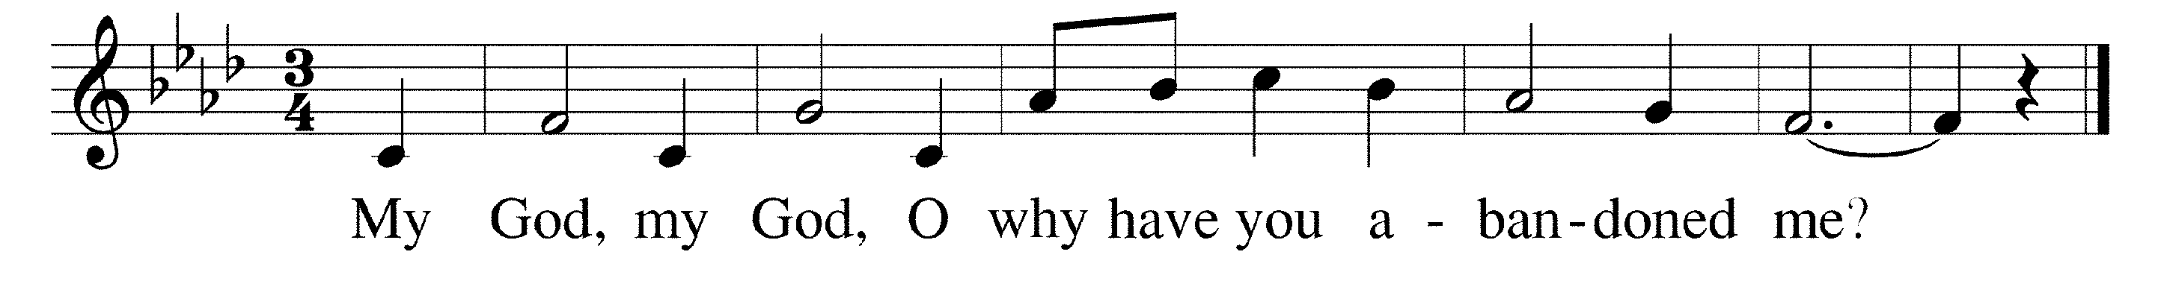

M: All who see me laugh at me. They mock me and they shake their heads: “He relied on the Lord. Let the Lord be his refuge.”

C: Refrain
M. As dogs around me, they circle me about,
Wounded me and pierced me. I can number all my bones.

C: Refrain
M: My clothing they divided, for my garments casting lots.
O Lord, do not desert me, but hasten to my aid.

C: Refrain
M: I will praise you to my people, and proclaim you in their midst.
O fear the Lord, my people! Give glory to God’s name!

C: Refrain
ANTIPHON Psalm 14:1-3
M: The LORD looks down from heaven

C: to see if there are any who understand, any who seek God.
M: He looks, and he says:

C: “They are corrupt, their deeds are vile; there is no one who does good.
M: All have turned aside, they have together become corrupt.

C: There is no one who does good, not even one.”

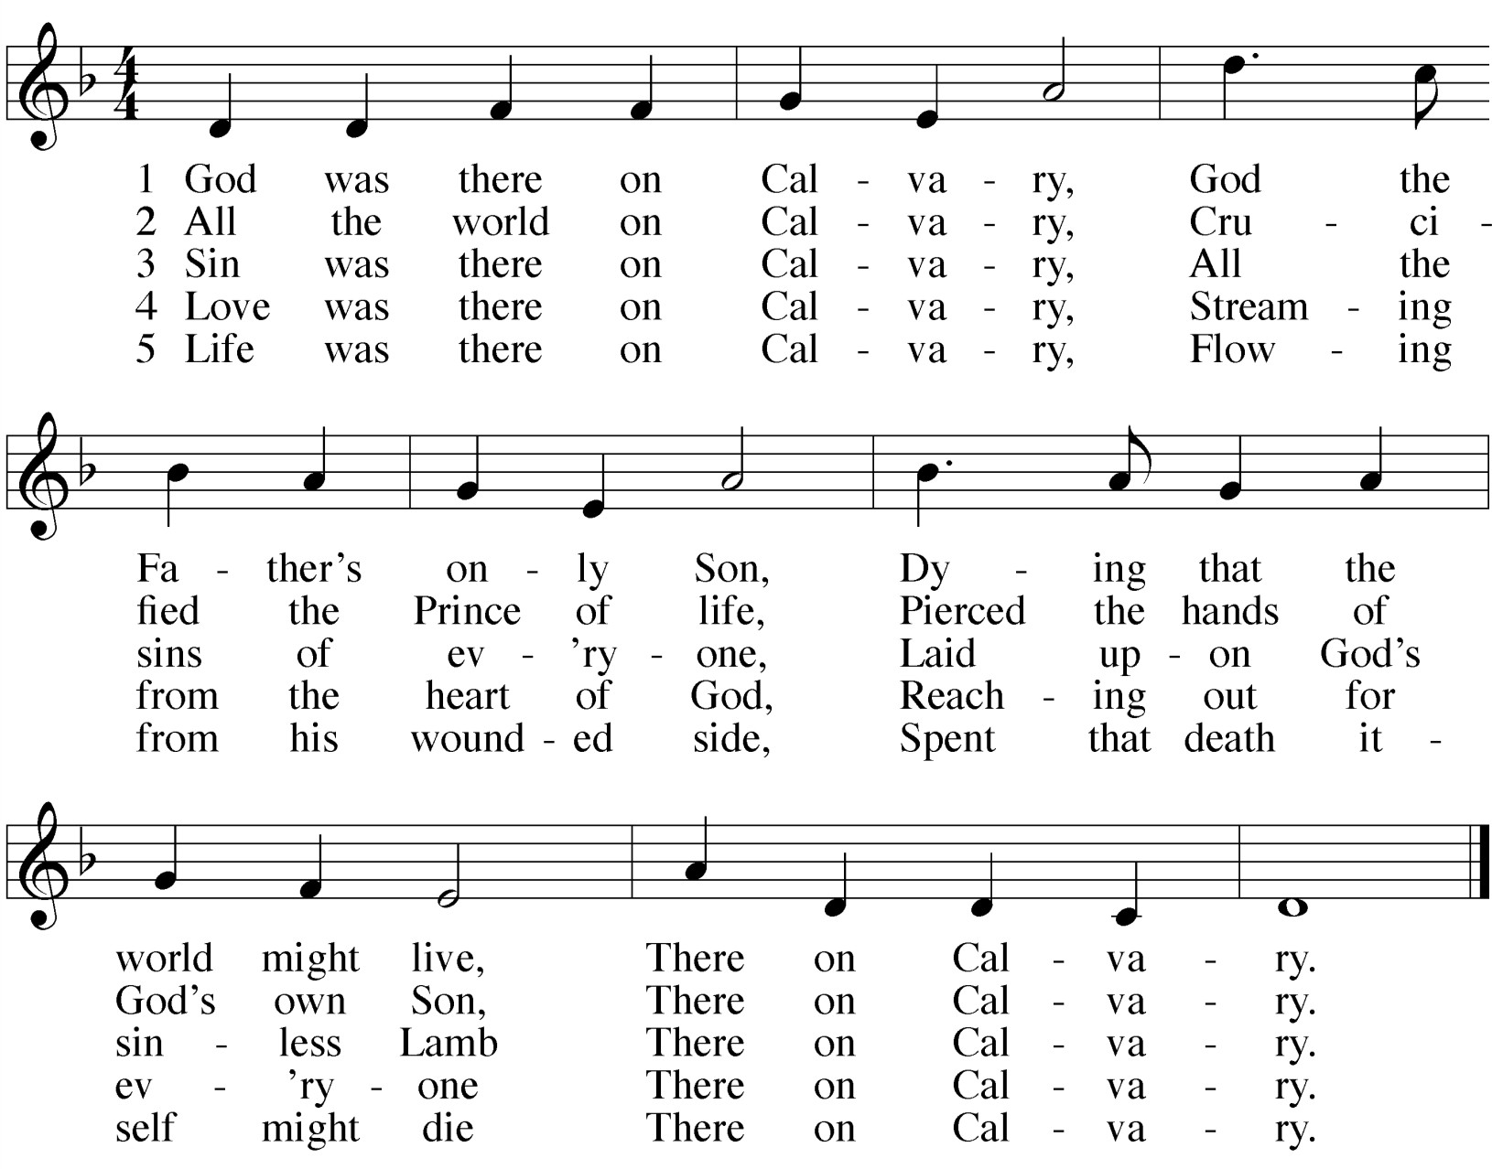HYMN God Was There on Calvary

