24

Your congregational license information goes here

When You Woke That Thursday Morning
Text: Jaroslav J. Vajda © 1991 Concordia Publishing House Tune: David Schack ©1992 David Schack
Setting: Kermit Moldenhauer ©2006 Kermit Moldenhauer

Psalm 116: I Will Take the Cup of Life
Text and Music: David Haas ©1987 GIA Publications, Inc.

Gospel Acclamation for Lent
Music: Michael Joncas ©1990 GIA Publications, Inc.

Lamb of God
Music: Michael Joncas ©1988 GIA Publications, Inc.

In Peace Lord
from Divine Service I in Christian Worship Supplement
©2008 Northwestern Publishing House
The Triduum: Maundy Thursday April 17, 2014

A MEAL TO SAVE YOU

SERVICE NOTES: The Triduum
After six weeks of Lent, the Christian Year has now reached its climax. We have come to the celebration of the suffering, death, and resurrection of our Lord and Savior Jesus Christ. This is the celebration for which we have been preparing throughout Lent. Now we see what our Savior came to do.
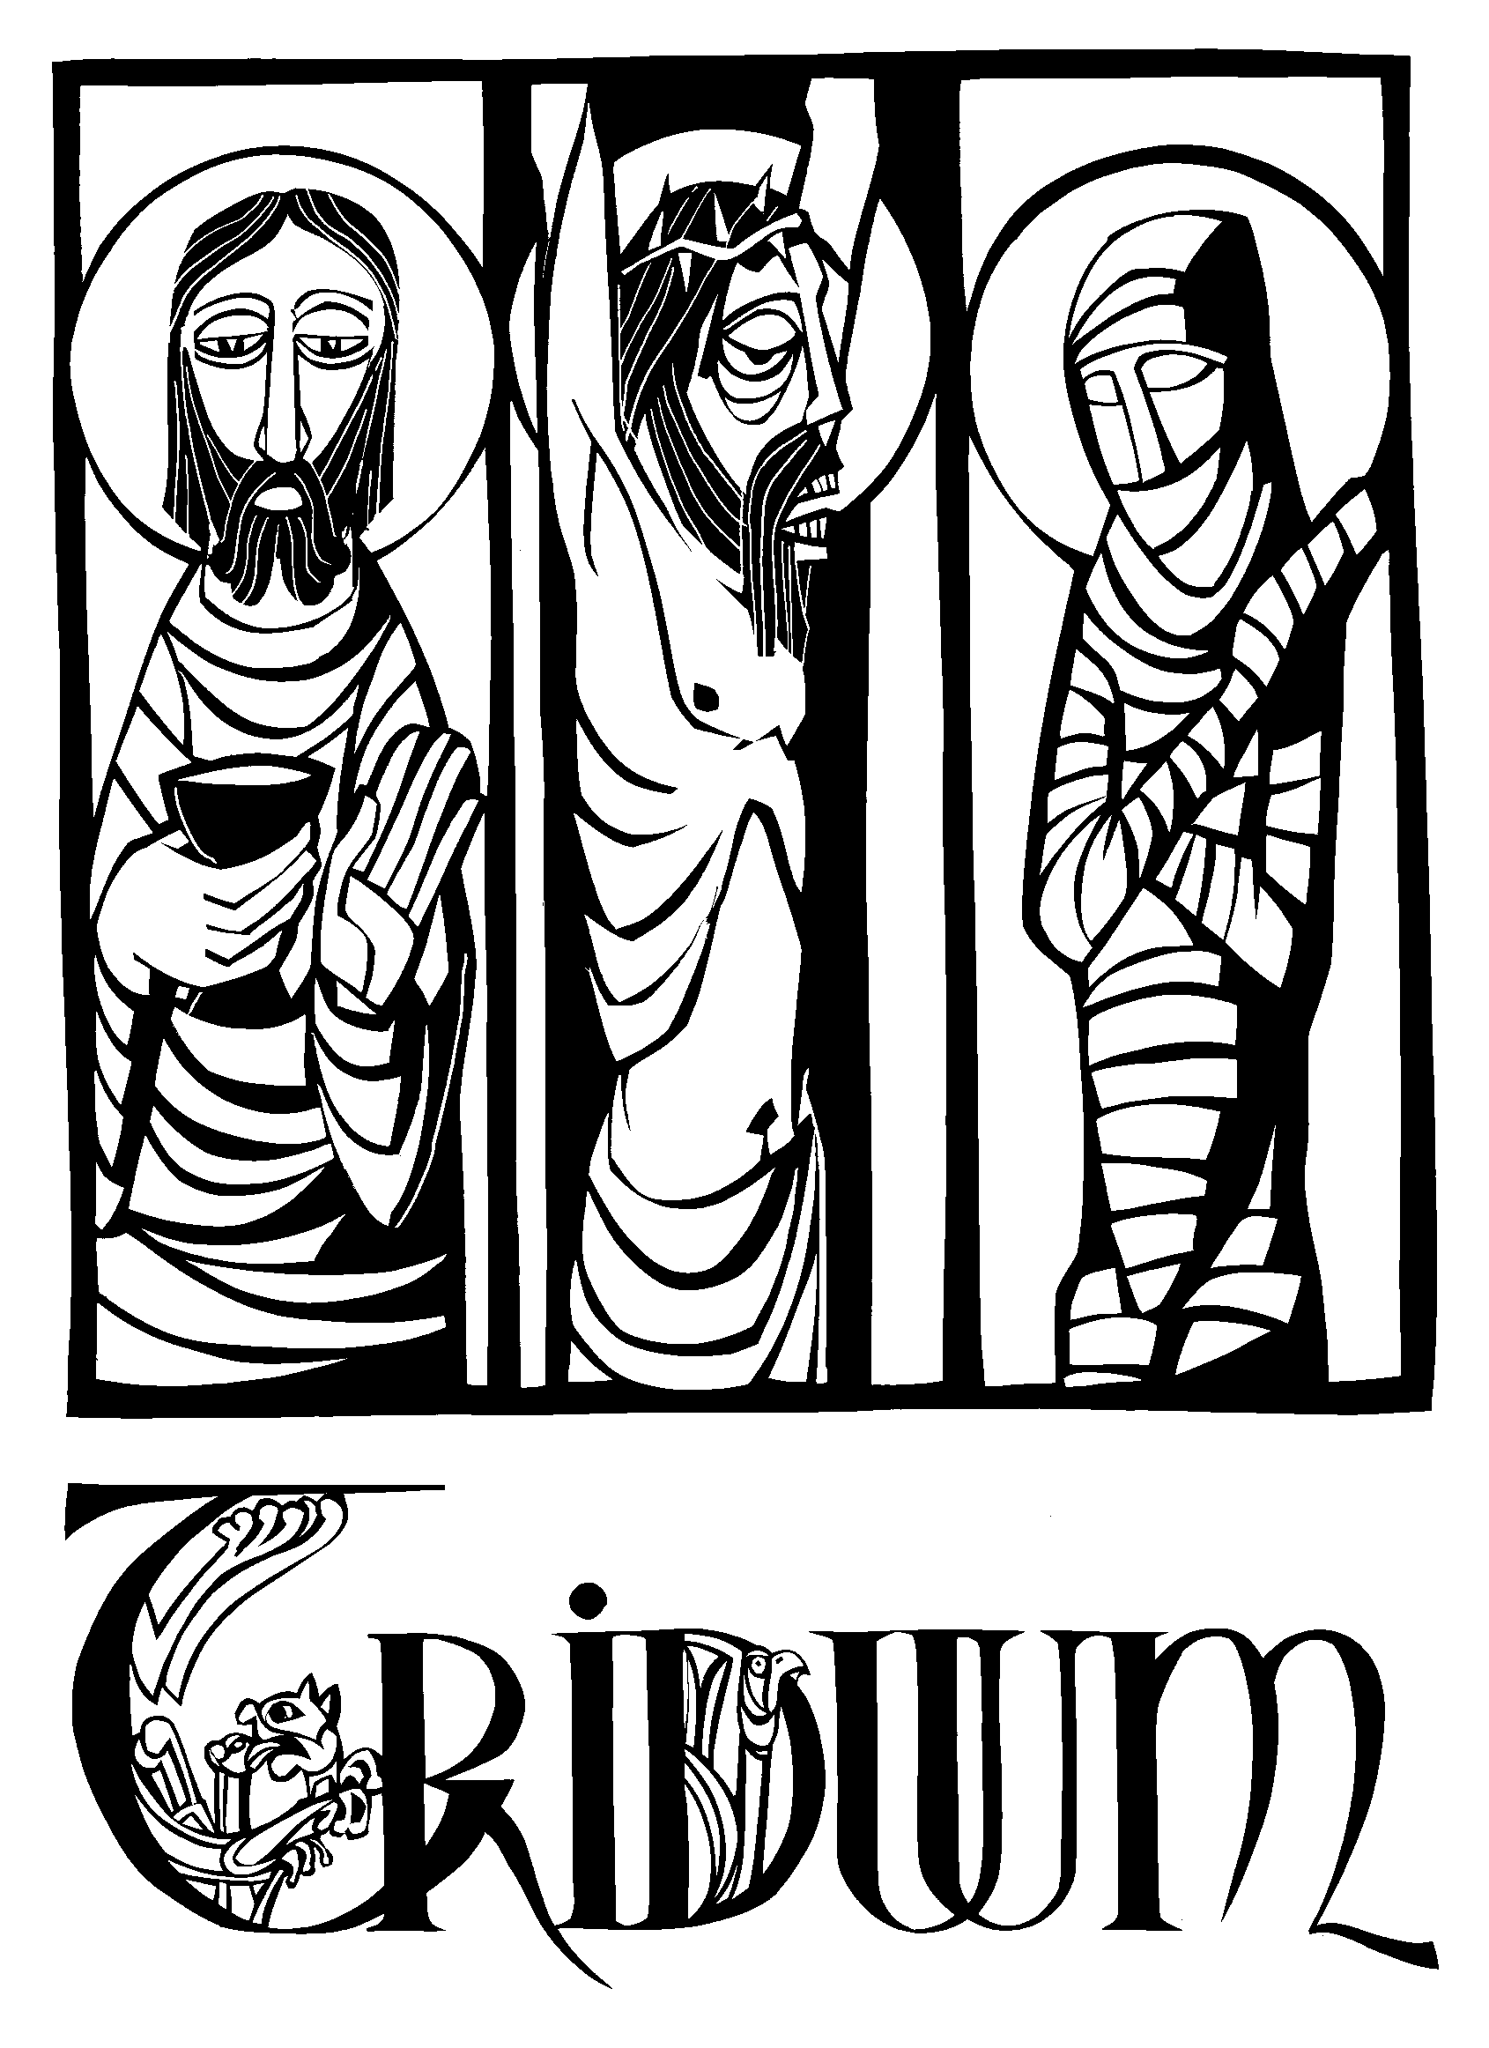We see him suffer and die for our sins and for the sins of the world. And we see him rise triumphantly on Easter morning to assure us that our salvation is complete, the victory is won.
Prior to the fourth century, Easter Day itself included all three emphases — Christ’s suffering, death, and resurrection. But the early Church fathers decided that it might be wise to spread those three emphases out over three days.
And so Maundy Thursday was formed to commemorate the beginning of Christ’s suffering, as he gathers in the upper room, washes his disciples feet, institutes the Lord’s Supper, then proceeds to the Garden of Gethsemane for prayer.
Good Friday was set aside to ponder the intensity of Christ’s passion, as he is put on trial before Pontius Pilate, scourged, and crucified. On the cross, he speaks only seven times before he dies.
Finally, the practice of the Easter Vigil was begun. It was not the high festival service of Easter. Rather, it was a service to prepare oneself for that festival. The Vigil was also used as the entrance rite into the Church, as converts were baptized, confirmed, and communed all during the Vigil.
The greatest theologian of the early Church, St. Augustine, called these days of special observance, “the most holy Triduum of the crucified, buried, and risen Lord.” (Triduum is Latin for three days.) These days, combined with Easter, have long been understood as the climax of the Church’s year. Together they form a unit. Therefore, as we celebrate these Three

PSALM 88
Sung by a soloist

O LORD, the God who saves me, day and night I cry out before you.
May my prayer come before you; turn your ear to my cry.
For my soul is full of trouble
and my life draws near the grave.
I am counted among those who go down to the pit;
I am like a man without strength. I am set apart with the dead,
like the slain who lie in the grave, whom you remember no more, who are cut off from your care.
You have put me in the lowest pit, in the darkest depths.
Your wrath lies heavily upon me; you have overwhelmed me with all your waves.
You have taken from me my closest friends and have made me repulsive to them.
I am confined and cannot escape; my eyes are dim with grief.
I call to you, O LORD, every day; I spread out my hands to you.
Do you show your wonders to the dead?
Do those who are dead rise up and praise you?

Is your love declared in the grave, your faithfulness in Destruction?
Are your wonders known in the place of darkness, or your righteous deeds in the land of oblivion?
But I cry to you for help, O LORD; in the morning my prayer
comes before you.
Why, O LORD, do you reject me and hide your face from me?
From my youth I have been afflicted and close to death;
I have suffered your terrors and am in despair.
Your wrath has swept over me; your terrors have destroyed me.
All day long they surround me like a flood; they have completely engulfed me.
You have taken my companions and loved ones from me;
the darkness is my closest friend.

Holy Days, our worship will form a unit. The three comprise a single service, celebrated over three days, which will take us through our Savior‘s sufferings to his glorious triumph on Easter.
Because these three services form one unit, you will notice there is no benediction after parts 1 and 2. The benediction will occur at the end of the Vigil. Secondly, after parts 1 and 2, the congregation is asked to leave the church in silence.
After the completion of the psalm, there is no blessing, for this is only day one of the Triduum. Our worship continues for two more days.
The church is darkened. The congregation leaves the sanctuary in silence. Please do not converse with one another inside the church. There will not be a greeting line at the doorway. You may remain for silent prayer and meditation if you desire.
We gather tomorrow evening at 7:00PM to reflect upon our Savior’s death.

STRIPPING OF THE ALTAR

Psalm 88 is sung by a soloist. During the singing of the psalm, the altar is solemnly stripped in token of the Lord’s abandonment by his disciples and in preparation for Good Friday.

 Candles extinguished — Jesus said, “I am the light of the world.
Whoever follows me will never walk in darkness, but will have the light of life.” The events of Good Friday snuffed out the human life of Jesus, the Light of the world. As even creation was dark when he suffered, so we extinguish our candles.
 Altar book removed — The Altar Book and hymnal guides our worship together as we hear his Word and respond with prayer and songs of praise. As Jesus suffers these normally joyful sounds grow quiet.
 Communion vessels removed — Jesus offered his body and blood as the payment for our sins. They have been given to us in, with and under the form of bread and wine in this Holy Supper. As he was removed from us in the grave, so we remove the elements and vessels of this Sacrament.
 Paraments removed — Paraments are the cloths that cover our altar and display symbols of our God and salvation. Purple, the color of Lent, also points to the purple robe Jesus wore as the soldiers mocked him. As Jesus was stripped of the purple robe, and of his dignity, so we remove the paraments from the altar.
 The altar is draped in black — Our altar is in the form of a table. It is here where our Lord Jesus serves us as both host and meal at his banquet feast. It is draped in black to remind us of the death of our Savior in our behalf.
Part I — Maundy Thursday
Maundy Thursday derives its name from the words Jesus spoke to his disciples on this evening: “A new command I give you: Love one another" (John 13:34). The Latin word for command is mandatum, where we get Maundy. On Maundy Thursday, Christ gave a mandate to his followers — to love one another as he has loved us. He demonstrates the full extent of his love by humbly washing his disciple’s feet and by feeding them his very flesh for their salvation. Clearly, Christ loves us more than life. Reconciled to God through the flesh and blood of Christ, we are empowered to follow his command to love each other.
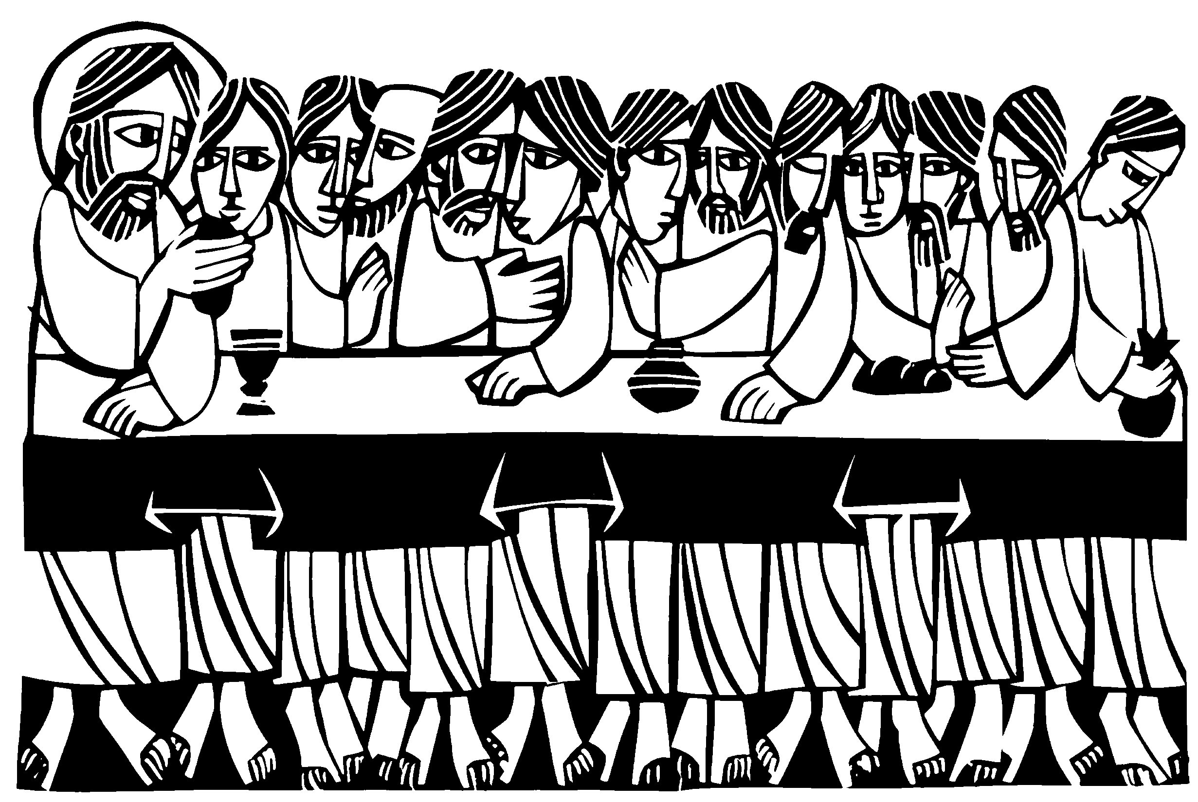It was on this evening nearly two thousand years ago that Jesus and his disciples gathered together in a large upper room in Jerusalem to celebrate the Passover, the Feast of Unleavened Bread. This meal commemorated the deliverance of God's people from the clutches of slavery in Egypt. All the firstborn sons of Egypt died that night, but all Israel was saved. They were saved because the blood of the Passover Lamb they had sacrificed marked their doors. The angel of death saw the blood on their doorframes,
and passed over their homes as he went throughout the land of Egypt killing the firstborn. This evening we celebrate the fact that Christ is our Passover Lamb. In sacrificing himself, Jesus ends the need for the Passover, and replaces it with a much greater meal when he institutes the Sacrament of Holy Communion. The Lord’s Supper is celebrated tonight using freshly baked unleavened bread, identical to what was used at Passover.
The stripping of the altar. The post-communion portion of the service takes us from the upper room in Jerusalem where the disciples celebrated the Passover to the Garden of Gethsemane, in preparation for Good Friday. The altar, which is one of the most prominent symbols of Christ in the church, is solemnly stripped of its vestments in memory of the abandonment of Jesus in Gethsemane. The service ends in silence. The congregation hears no closing blessing…yet.

In keeping with the solemnity of the day, there will be no post-service music.
Silence for meditation is appreciated.
God bless your worship.

ORDER OF SERVICE

 The Gathering 

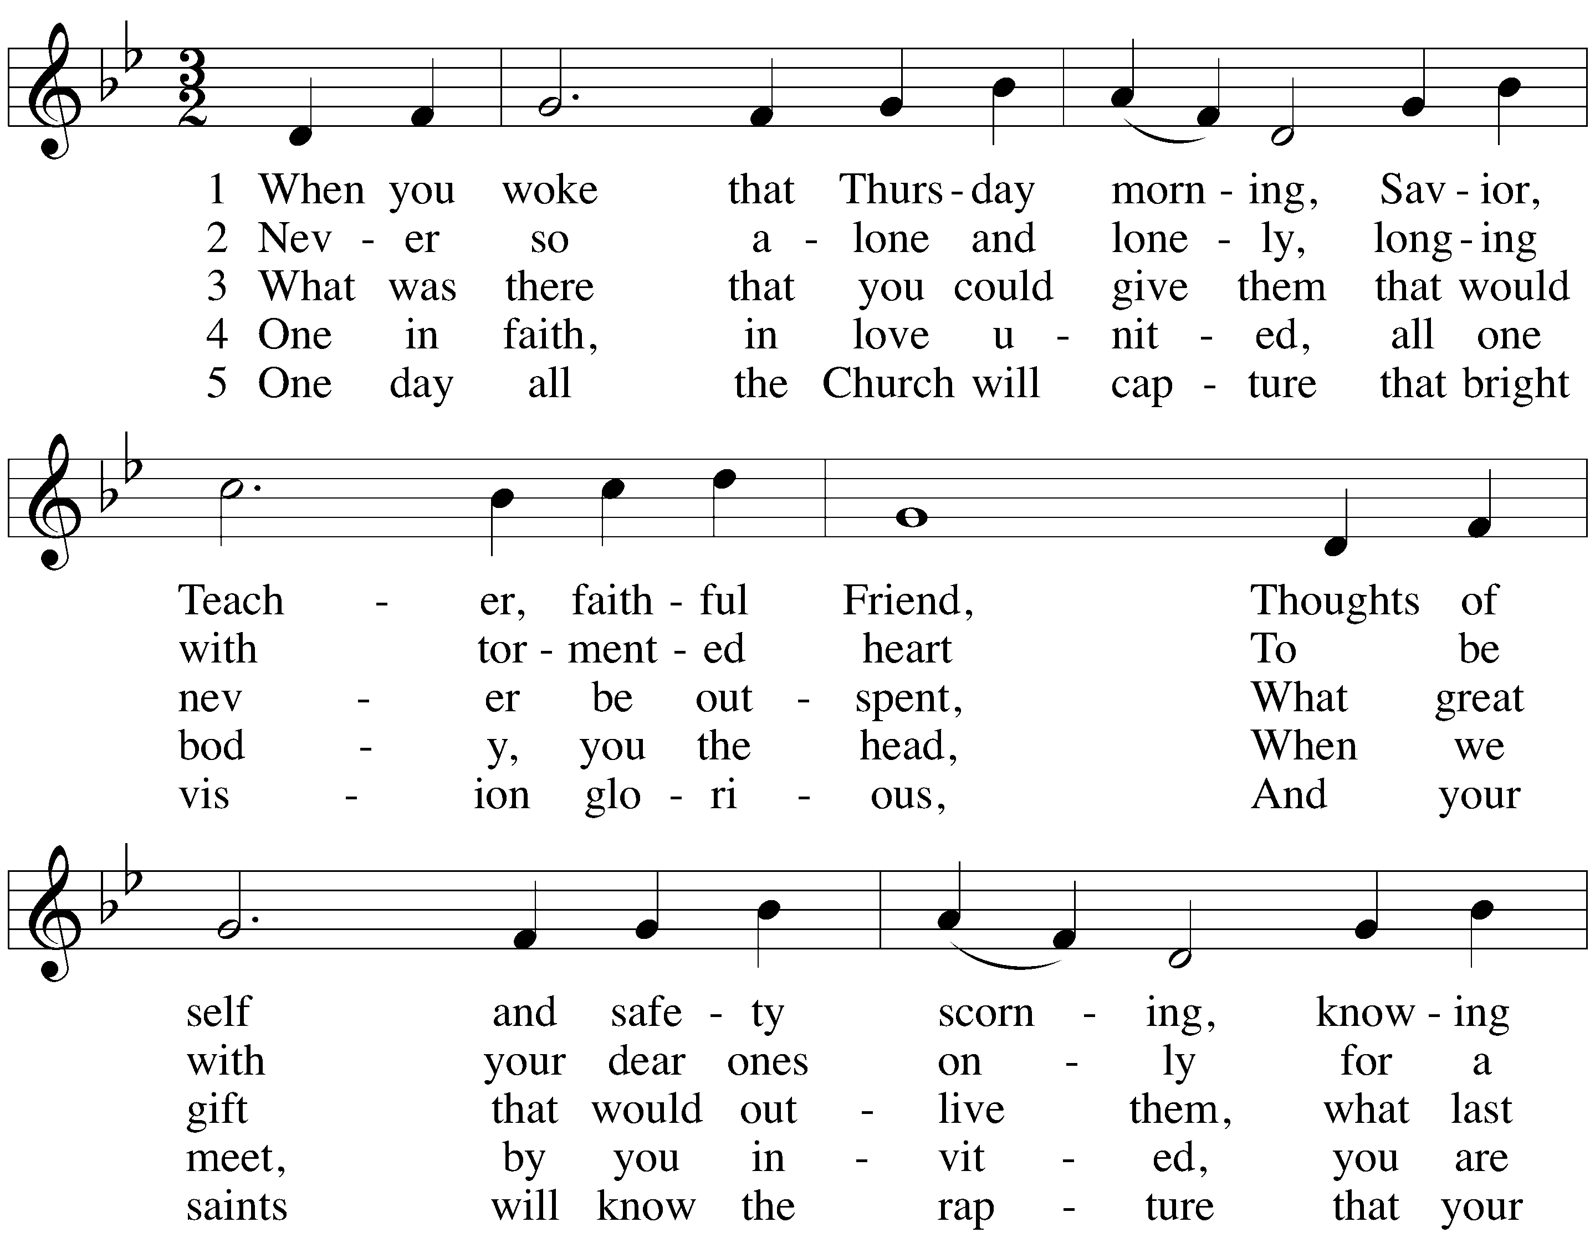HYMN When You Woke That Thursday Morning

CLOSING PRAYER
M: O God the Father, source of all goodness,
in your loving kindness you sent your Son to share our humanity.
We thank you that through him you have given us pardon and peace in this sacrament.
We also pray that you will not forsake us
but will rule our hearts and minds by your Holy Spirit so that we willingly serve you day after day,
through Jesus Christ, our Lord,
who lives and reigns with you and the Holy Spirit, one God, now and forever.

C: Amen.

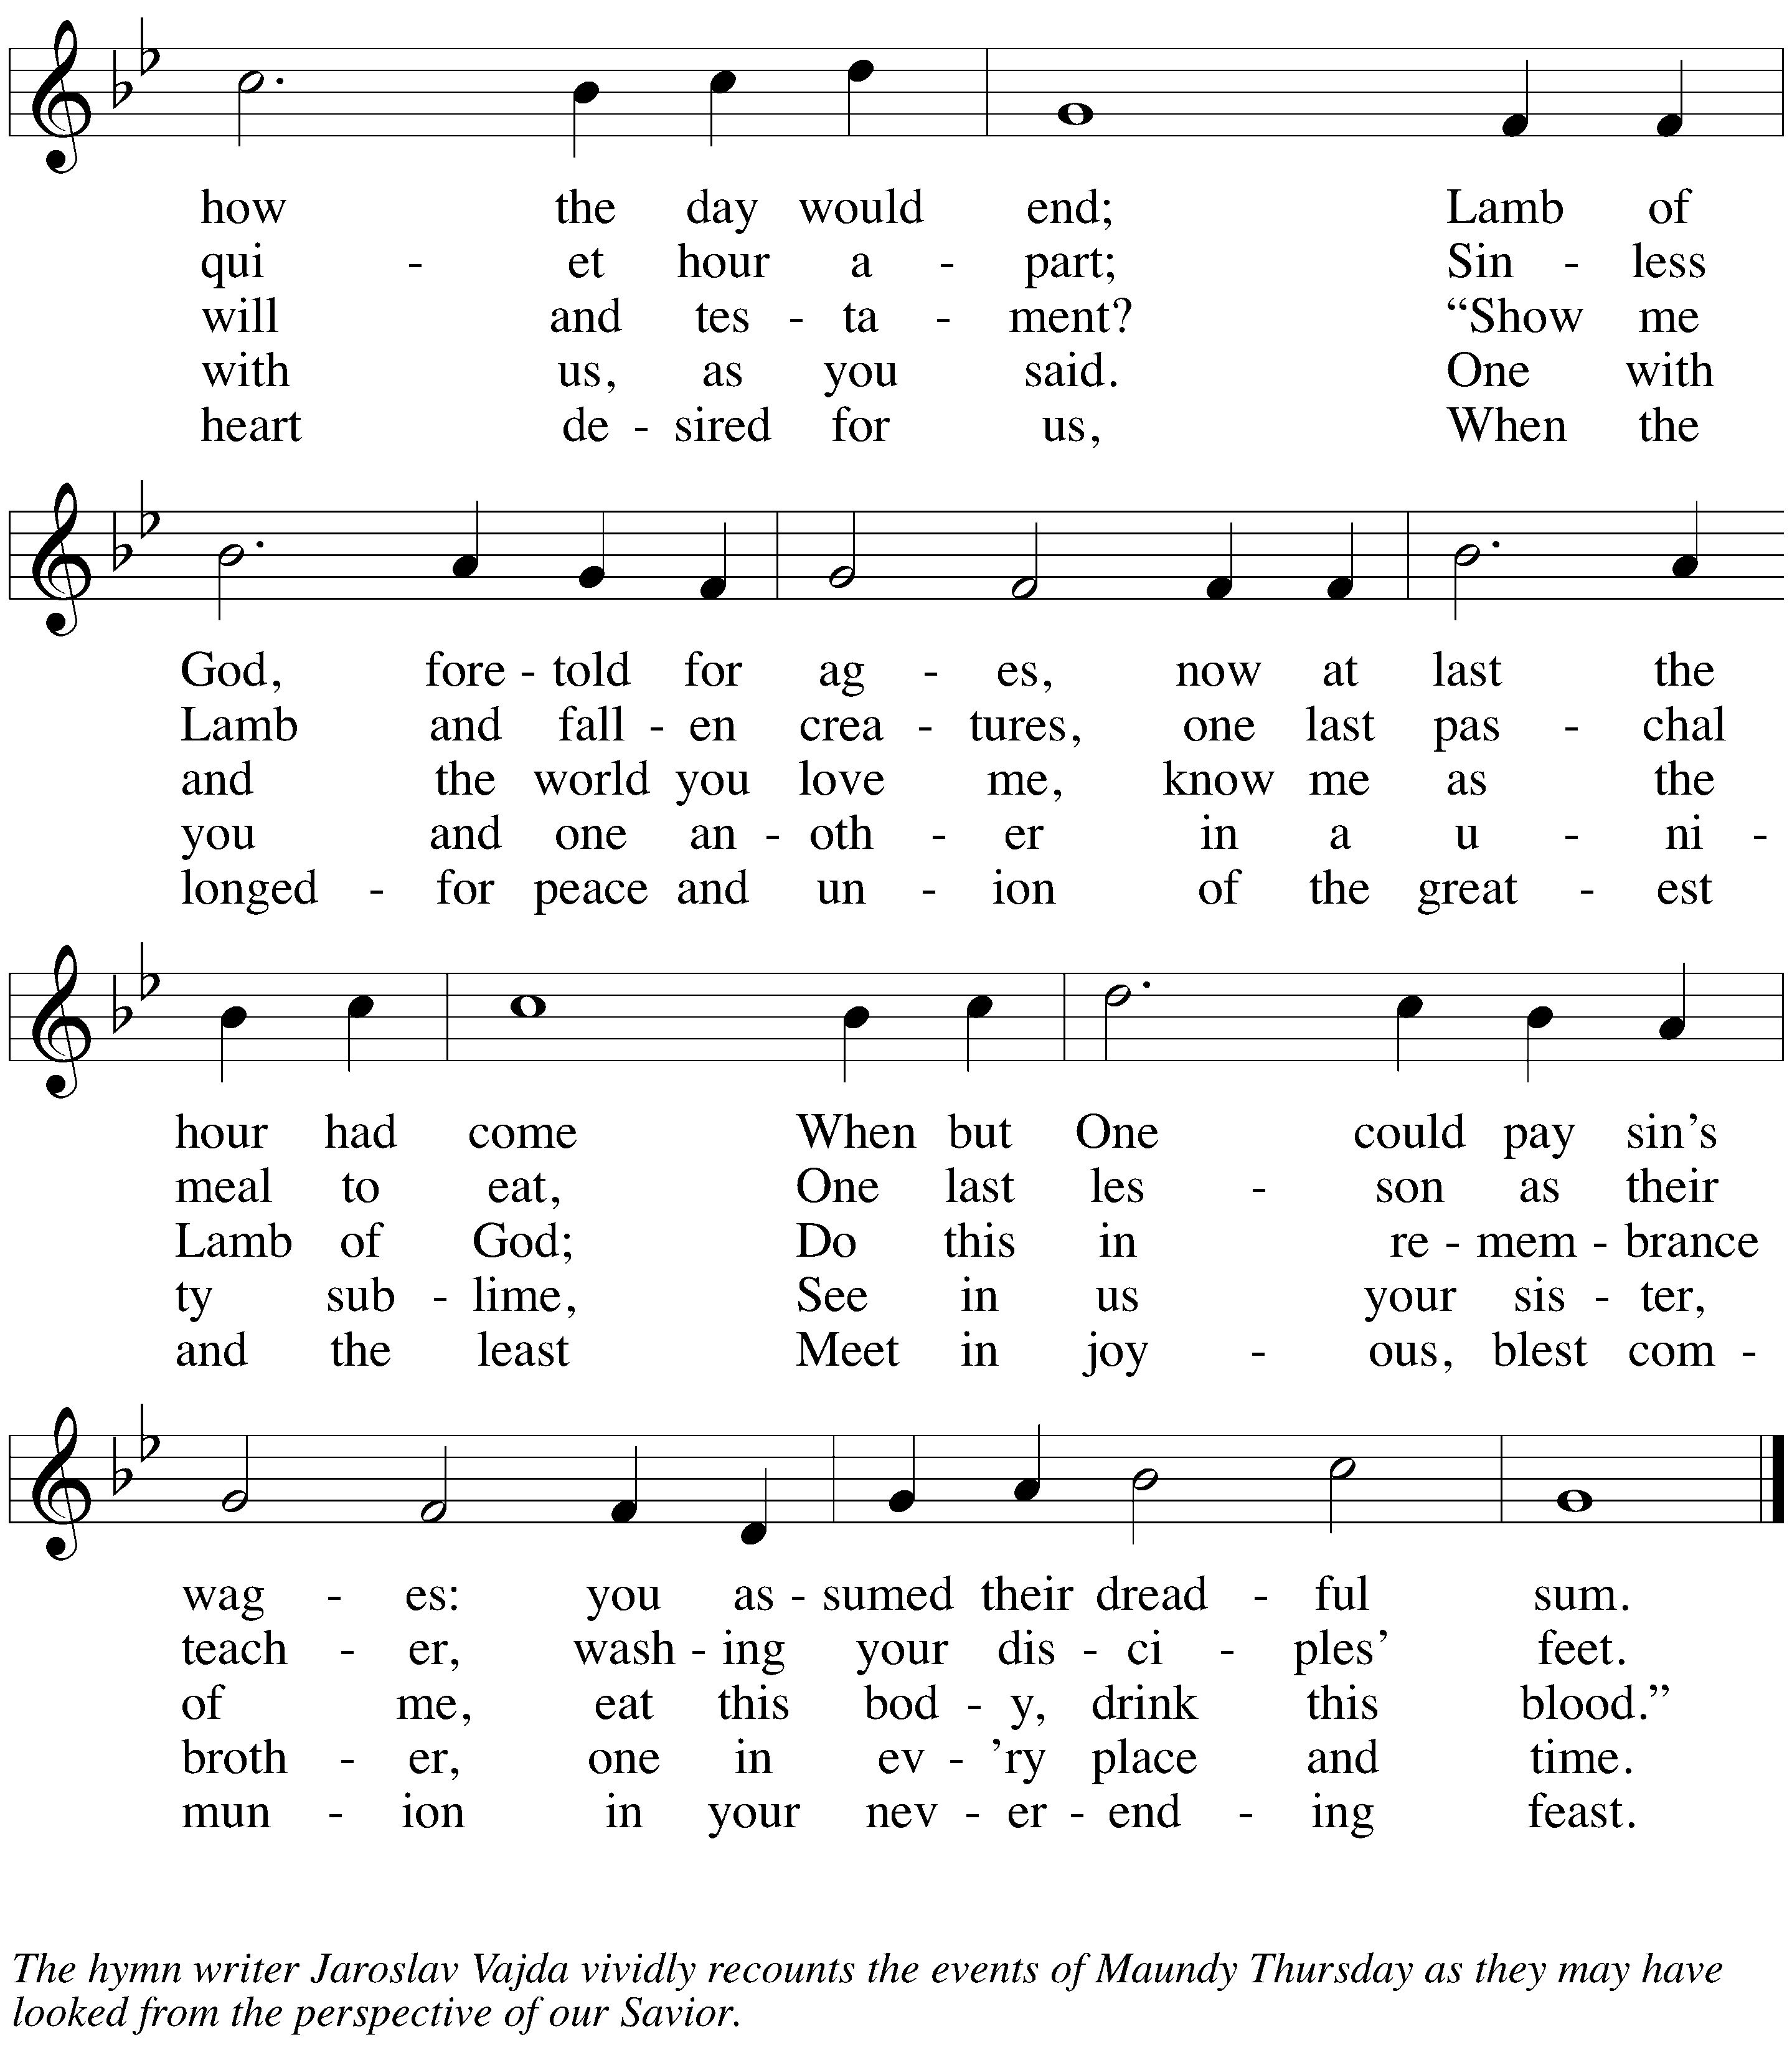

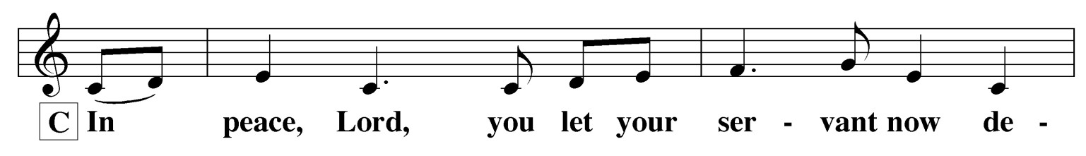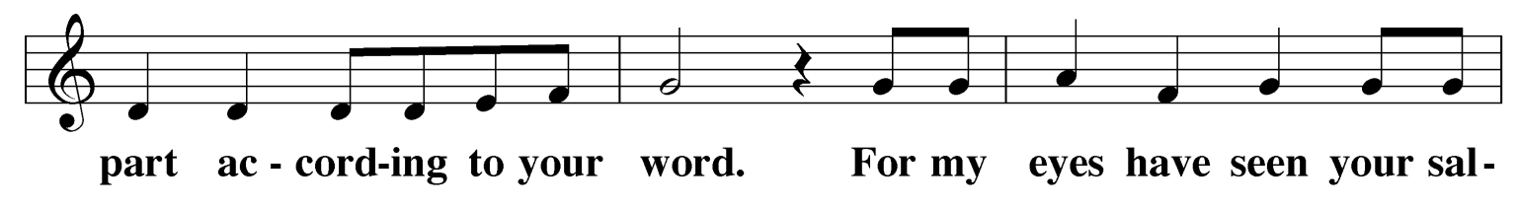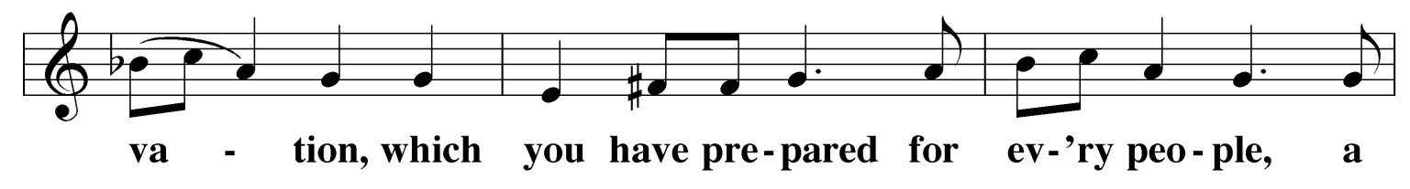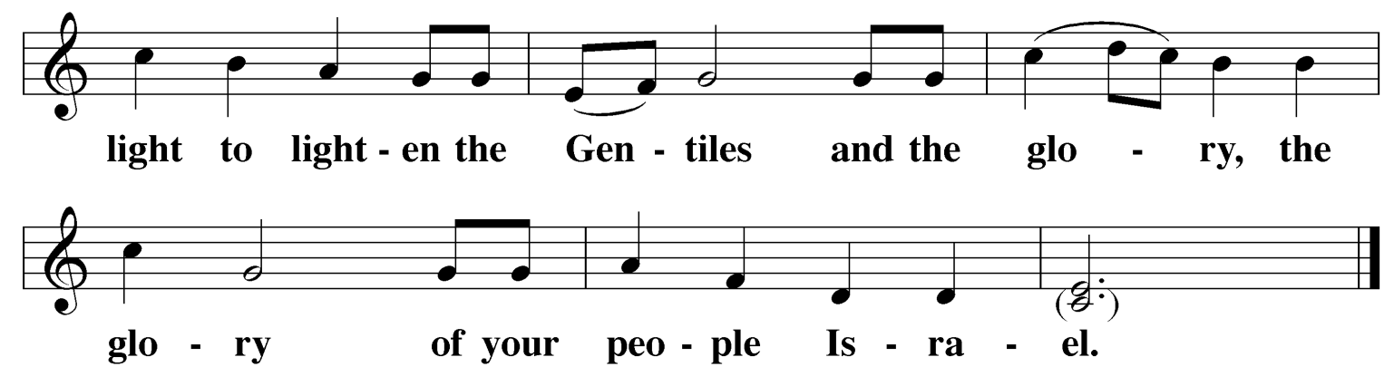SONG OF SIMEON Nunc Dimittis

C:

INSTRUCTION FOR THE END OF LENT
M: In this Lenten season we have heard again how our Lord walked the path of suffering which led him to the cross for our salvation. We have also heard our Lord’s call to intensify our struggle against sin, death, and the devil—all that keeps us from loving God and one another. This is the struggle to which we were committed at Baptism; God’s forgiveness and the power of his Spirit to amend our lives
continue with us because of his love for us in Jesus our Savior.
Within the family of the Church, God never wearies of giving peace and new life. In the absolution, we receive forgiveness as from God himself. This absolution we should not doubt but firmly believe that our sins are thus forgiven before God in heaven, for it comes to us in the name and by the command of our Lord.
We who receive God’s love in Jesus Christ are called to love one another, to be servants to
each other, as Jesus became our servant.
In Holy Communion the members of Christ’s body participate most intimately in his love. Remembering our Lord’s Last Supper with his disciples, we eat the bread and drink the cup of this meal. Together we receive the Lord’s gift of his body and blood for forgiveness and participate in that new covenant that makes us one with him and one another. The Lord’s Supper is the promise of the great banquet we will share with all the faithful when our Lord returns, the joyous culmination of our reconciliation with God and each other.

CONFESSION AND ABSOLUTION
M: Let us confess our sins to God and ask for his forgiveness.

C: Almighty God, merciful Father,
I confess to you that I have not loved you with all my heart. In what I have done and left undone,
I have pursued my ways instead of your ways.
I have not loved my brothers and sisters as myself.
For this I deserve your punishment both now and in eternity. I am truly sorry for my sins.
I repent of them.
I beg for your mercy, O Lord.
Silence for meditation

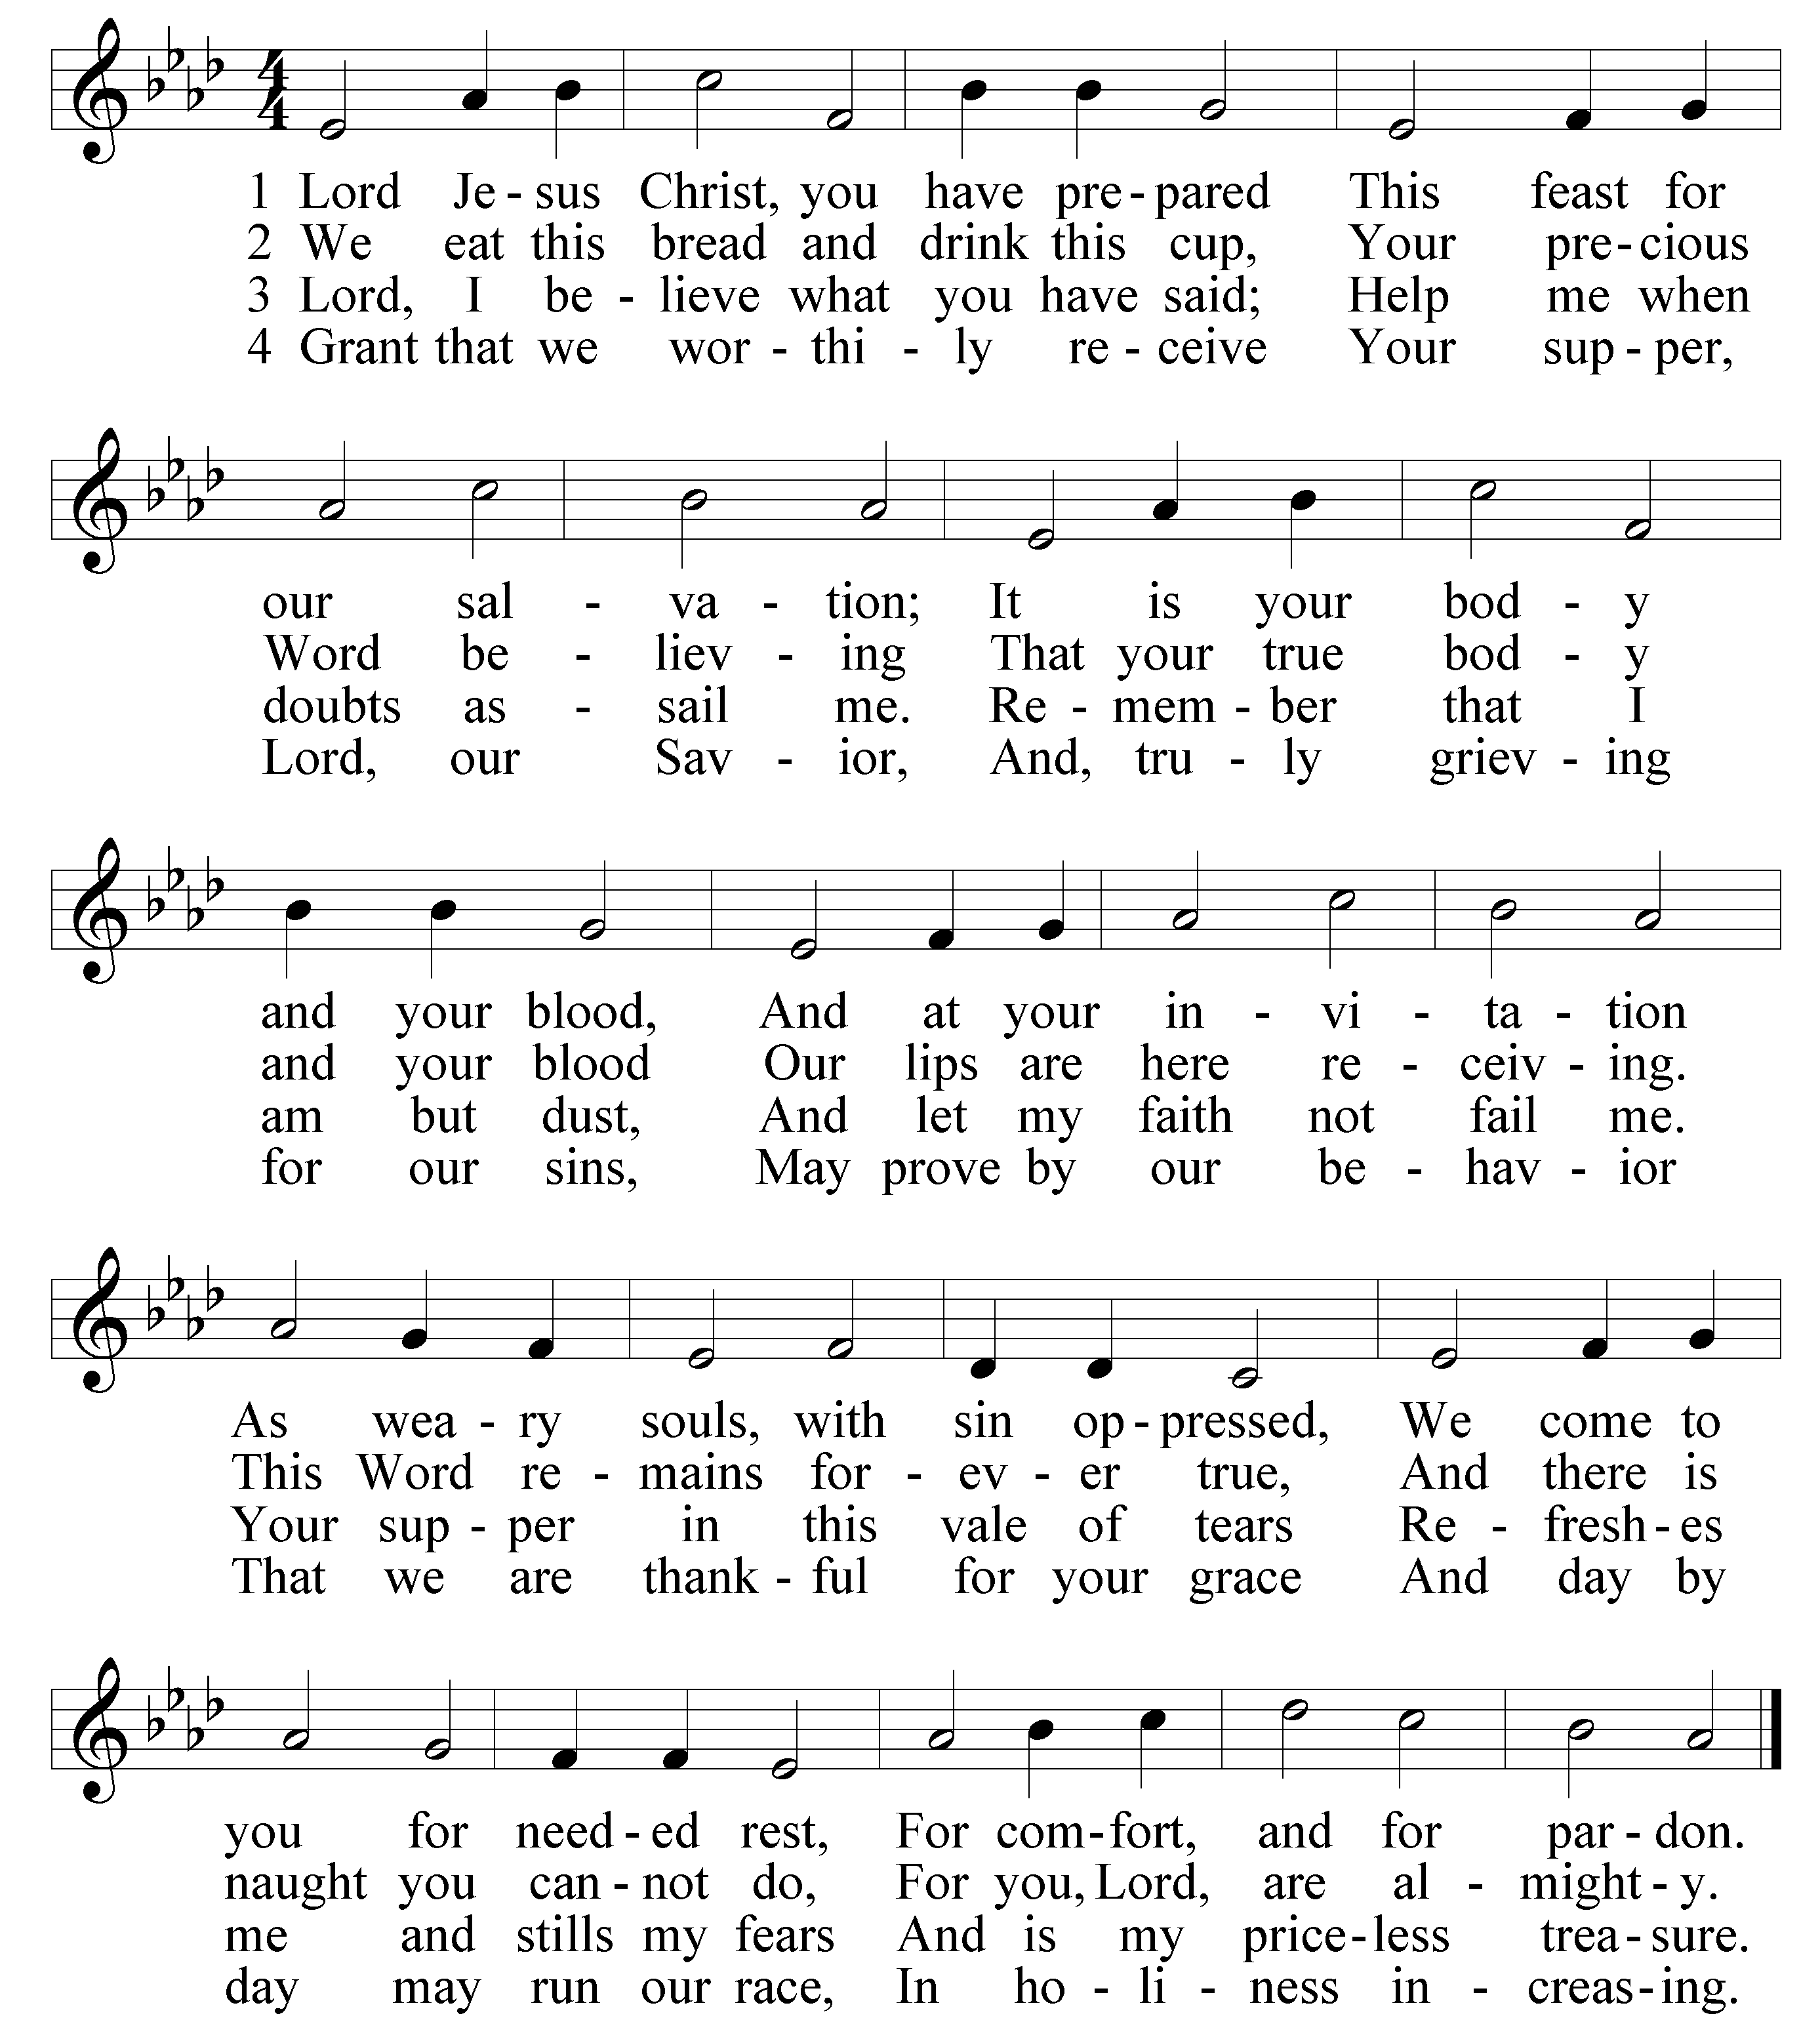DISTRIBUTION HYMN Lord, Jesus Christ, You Have Prepared

PRAYER OF PREPARATION
M: Let us pray.
Lord Jesus Christ,

C: we lift up our hearts with thanksgiving and praise.
Through the blood of your covenant,
you have made us worthy to receive your Holy Supper.
In this sacrament, time and eternity meet
as we celebrate a foretaste of the feast now enjoyed by all who are in heavenly glory.
As we receive your true body and blood, we rejoice in our salvation through you,
who with the Father and the Holy Spirit are one God, now and forever. Amen.

Distribution
There are three distributing ministers tonight. We commune in tables of 12 to 14. The first minister will distribute the bread.
The second minister will then walk by you carrying the individual cups of wine. If you wish to partake of the common cup, do not take an individual cup. If you wish to partake of an individual cup, take one when the assistant comes by and hold it in your hand. Do not drink it yet.
The third minister will then distribute the common cup. If he sees you have an individual cup, he will motion you to drink it at that time. If he sees you do not have an individual cup, he will give you the common cup.
Using a single loaf of bread and a common cup is meant to symbolically convey the message of 1 Corinthians 10:17. “We, who are many, are one body, for we all partake of one loaf.”

M: Forgive us for the sake of Jesus Christ who suffered and died for us.

C: Cleanse me from my sins. Release me from my guilt.
Grant me your Holy Spirit to amend my sinful life.
M: The almighty God has been merciful to us and has sent his Son to die for all.
For his sake, God forgives our sins and calls us from darkness to his marvelous light.
Therefore, as a called servant of Christ and by his authority, I forgive you all your sins in the name of the Father and of the Son  and of the Holy Spirit.

C: Amen.

EXHORTATION
M: Our Lord Jesus Christ has forgiven us and reconciled us to God and has promised us the power to forgive and love each other. Relying on his promise, therefore, be reconciled with one another.

C: Brothers and sisters, may the peace of Christ rule in our hearts, in our words, and in our actions.

PRAYER OF THE DAY
M: Let us pray.
Lord Jesus Christ, in the Sacrament of Holy Communion you give us your true body and blood as a remembrance of your suffering and death on the cross. Grant us so firmly to believe your words and promise that we may always partake of this Sacrament to our eternal good, for you live and reign with the Father and the Holy Spirit, one God, now and forever.

C: Amen.

 The Word 

FIRST LESSON Exodus 12:1-14
1 The LORD said to Moses and Aaron in Egypt, 2 "This month is to be for you the first month, the first month of your year. 3 Tell the whole community of Israel that on the tenth day of this month each man is to take a lamb for his family, one for each household. 4 If any household is too small for a whole lamb, they must share one with their nearest neighbor, having taken into account the number of people there are. You are to determine the amount of lamb needed in accordance with what each person will eat. 5 The animals you choose must be year-old males without defect, and you may
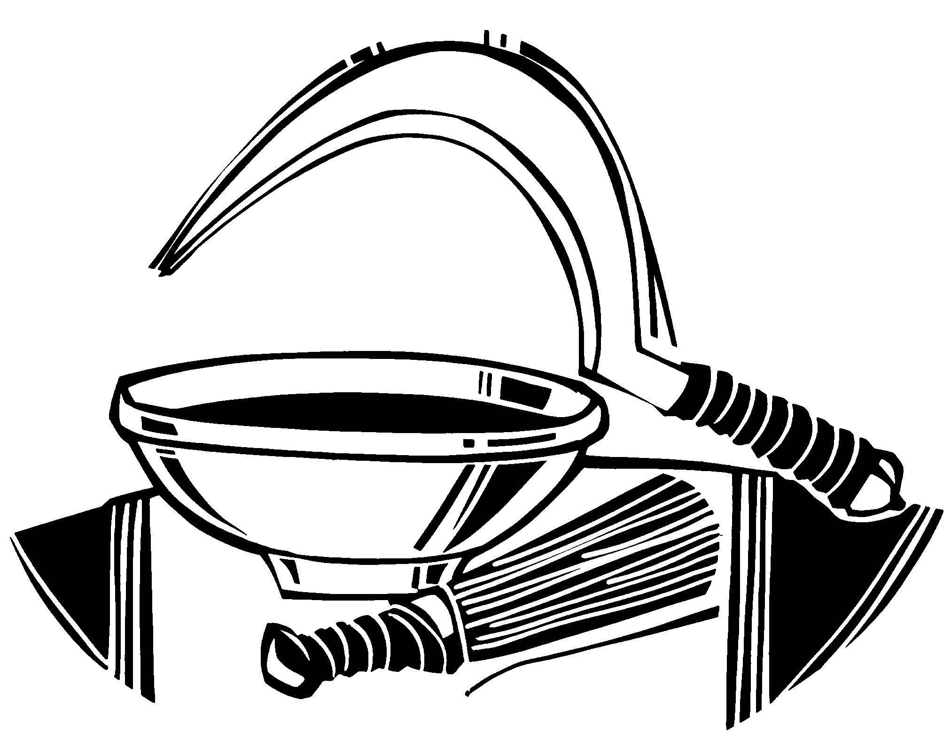take them from the sheep or the goats. 6 Take care of them until the fourteenth day of the month, when all
the people of the community of Israel must slaughter them at twilight. 7 Then they are to take some of the blood and put it on the sides and tops of the doorframes of the houses where they eat the lambs. 8 That same night they are to eat the meat roasted over the fire, along with bitter herbs, and bread made
without yeast. 9 Do not eat the meat raw or cooked in water, but roast it over the fire—head, legs and inner parts. 10 Do not leave any of it till morning; if some is left till morning, you must burn it. 11 This is
how you are to eat it: with your cloak tucked into your belt, your sandals on your feet and your staff in your hand. Eat it in haste; it is the LORD's Passover.
12 "On that same night I will pass through Egypt and strike down every firstborn—both men and animals—and I will bring judgment
on all the gods of Egypt. I am the LORD. 13 The blood will be a sign
for you on the houses where you are; and when I see the blood, I will pass over you. No destructive plague will touch you when I strike Egypt.
14 "This is a day you are to commemorate; for the generations to
come you shall celebrate it as a festival to the LORD -a lasting ordinance.

JESUS, LAMB OF GOD
Agnus Dei

M: Jesus, Lamb of God, you take away the sins of the world: have mercy, have mercy on us.

M: Bread of life and saving cup…

ALL: 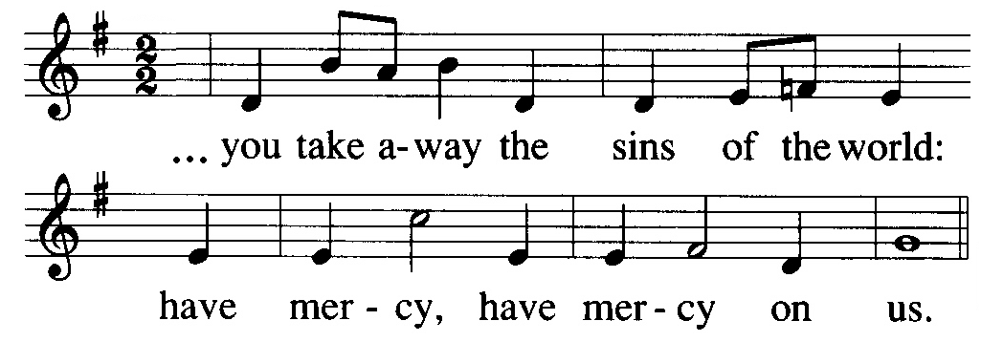
M: Loving Savior, Prince of Peace...

ALL:
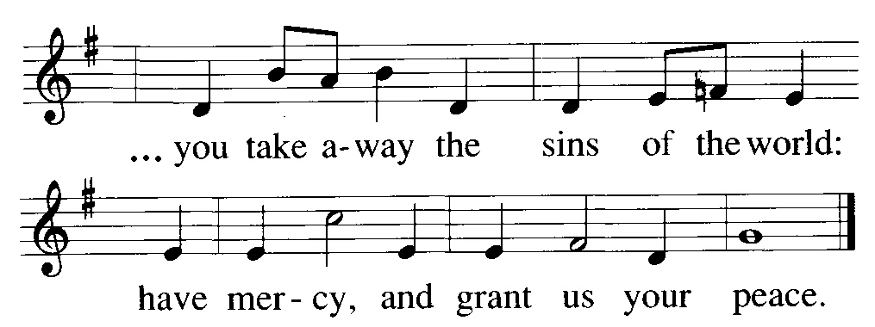M: Jesus, Lamb of God…

ALL:

 The Sacrament 

We follow the historic Christian practice of close communion. We ask that only members of Beautiful Savior Lutheran or one of our sister congregations partake of the sacrament. If you are not a member, please speak to one of the pastors before communing.

PREFACE
M: The Lord be with you.

C: And also with you.
M: Lift up your hearts.

C: We lift them up unto the Lord.
M: Let us give thanks to the Lord, our God.

C: It is good and right so to do.
M: It is truly good and right that we should at all times and in all places give you thanks, O Lord, holy Father, almighty God, through Jesus Christ, our Lord, who brought the gift of salvation to all people by his death on the tree of the cross, so that the devil, who overcame us by a tree would in turn by a tree be overcome.

WORDS OF INSTITUTION
M: Our Lord Jesus, on the night he was betrayed, took bread; and when he had given thanks he broke it and gave it to his disciples, saying, “Take and eat; this is my body, which is given for you. Do this in remembrance of me.” Then he took the cup, gave thanks and gave it to them, saying, “Drink from it, all of you; this is my blood of the new covenant, which is poured out for you for the forgiveness of sins. Do this, whenever you drink it, in remembrance of me.”
The peace of the Lord be with you always.

C: Amen.

PSALM OF THE DAY Psalm 116
M: Refrain

C: Refrain
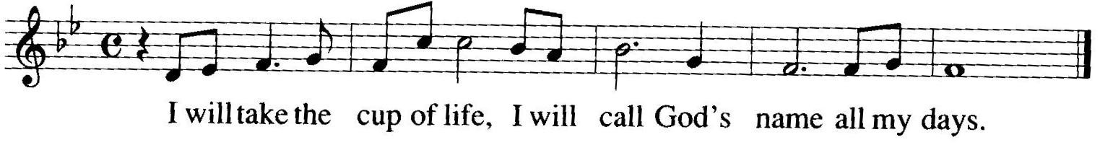

M: How can I make a return for the goodness of God?
This saving cup I will bless and sing, and call the name of God!

C: Refrain
M: The dying of those who keep faith is precious to our God.
I am your servant called from your hands. You have set me free!

C: Refrain
M: To you I will offer my thanks and call upon your name.
You are my promise for all to see. I love your name, O God!

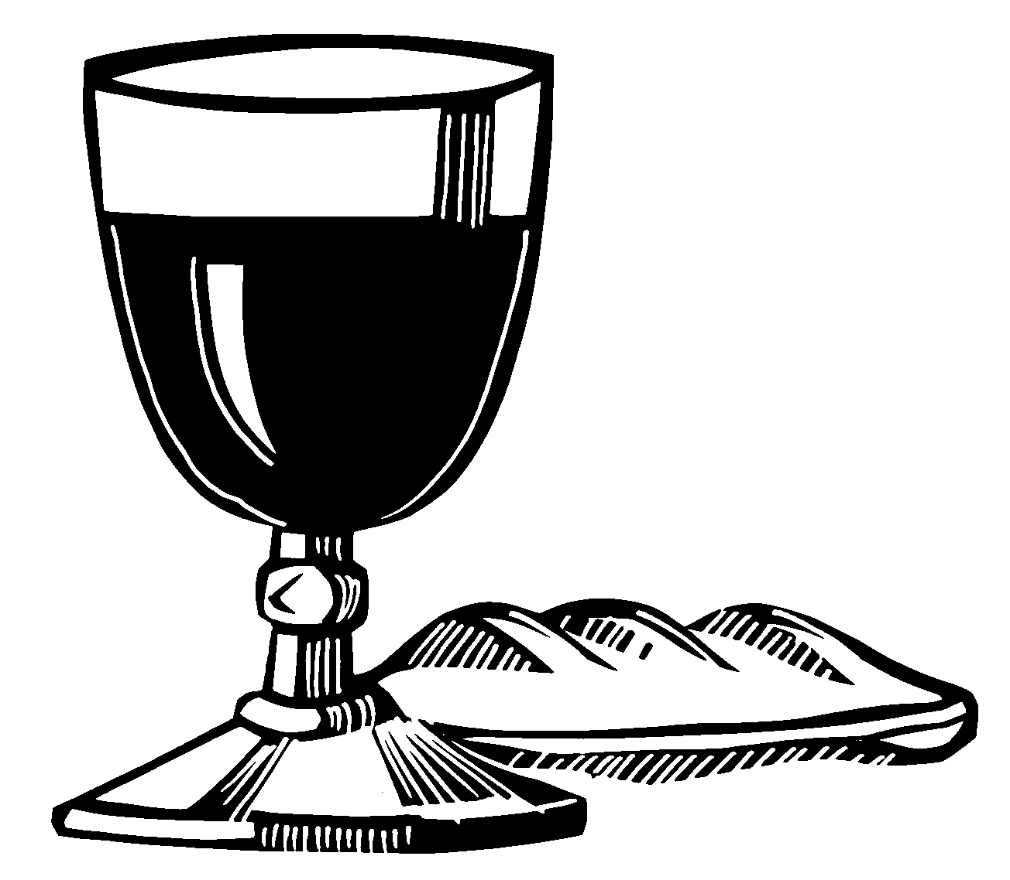C: Refrain

 The Prayers 

SECOND LESSON 1 Corinthians 11:23-28
23For I received from the Lord what I also passed on to you: The Lord Jesus, on the night he was betrayed, took bread, 24and when he had given thanks, he broke it and said, "This is my body, which is for you; do this in remembrance of me." 25In the same way, after supper he took the cup, saying, "This cup is the new covenant in my blood; do this, whenever you drink it, in remembrance of me." 26For whenever you eat this bread and drink this cup, you proclaim the Lord's death until he comes.
27Therefore, whoever eats the bread
or drinks the cup of the Lord in an unworthy manner will be guilty of sinning against the body and blood of the Lord. 28A man ought to examine himself before he eats of the bread and drinks of the cup.

THE PRAYER OF THE CHURCH
M: Lord Jesus, you are the Lamb of God, pictured in the ancient Passover feast, now giving to us your own body and your own blood in Holy Communion. Just as the Passover lambs assured the Israelites of God’s promise to deliver them from death,

C: Strengthen our belief that the bread is your real body and the wine is your real blood, given to us for our forgiveness, life, and salvation.
M: Prepare us to receive this sacrament remembering your death and repenting of our sins.

C: Unite us by our oneness of faith throughout this congregation and our synod, and love us to the end that we may love others as you have loved us.
M: We rejoice in our fellow believers who have been instructed in your Word and confirmed in the Lutheran faith, who are now ready to receive Holy Communion.

C: Equip them with every spiritual blessing for doing your will.
M: We pray for those absent from the sacrament because of their own neglect.

C: Call them in your mercy to return and renew their faith.
M: Keep in your care those unable to receive the sacrament often because they are homebound, hospitalized, imprisoned, serving in the military, or otherwise separated from the fellowship of believers. Encourage them so that they do not lose hope.

C: Be gracious to us all and nourish us with this feast, that we remain faithful unto death, and become partakers of the wedding feast of the Lamb. Amen.
Special prayers and petitions may follow
M: Here us, Lord, as we bring you our private petitions.
Silent prayer

THE LORD’S PRAYER
M: We bring these and all our petitions confidently in the name of Christ, who taught us to pray.

C: Our Father in heaven, hallowed be your name, your kingdom come, your will be done on earth as in heaven. Give us today our daily bread. Forgive us our sins, as we forgive those who sin against us. Lead us not into temptation, but deliver us from evil. For the kingdom, the power, and the glory are yours now and forever. Amen.

RESPONSE
M: O Lord, we praise you, bless you, and adore you, In thanksgiving bow before you.
Here with your body and your blood you nourish Our weak souls that they may flourish.

C: 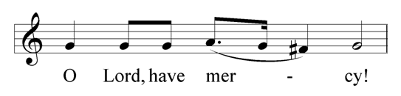
M: May your body, Lord, born of Mary, That our sins and sorrows did carry, And your blood, for us plead
In all trial, fear and need.

C:
M: May God bestow on us his grace and favor To please him with our behavior
And live together here in love and union, Cherishing our blest communion.

C:
M: Let not your good Spirit forsake us; Grant that heavenly-minded he make us. Give your Church, Lord, to see
Days of peace and unity.

C:
THANK OFFERING

VERSE OF THE DAY 1 Corinthians 11:26
M: Refrain

C: Refrain

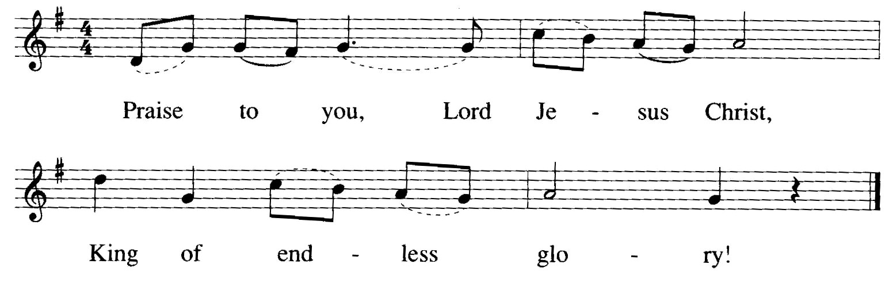
M: When you eat this bread and drink of this cup you proclaim the death of the Lord.

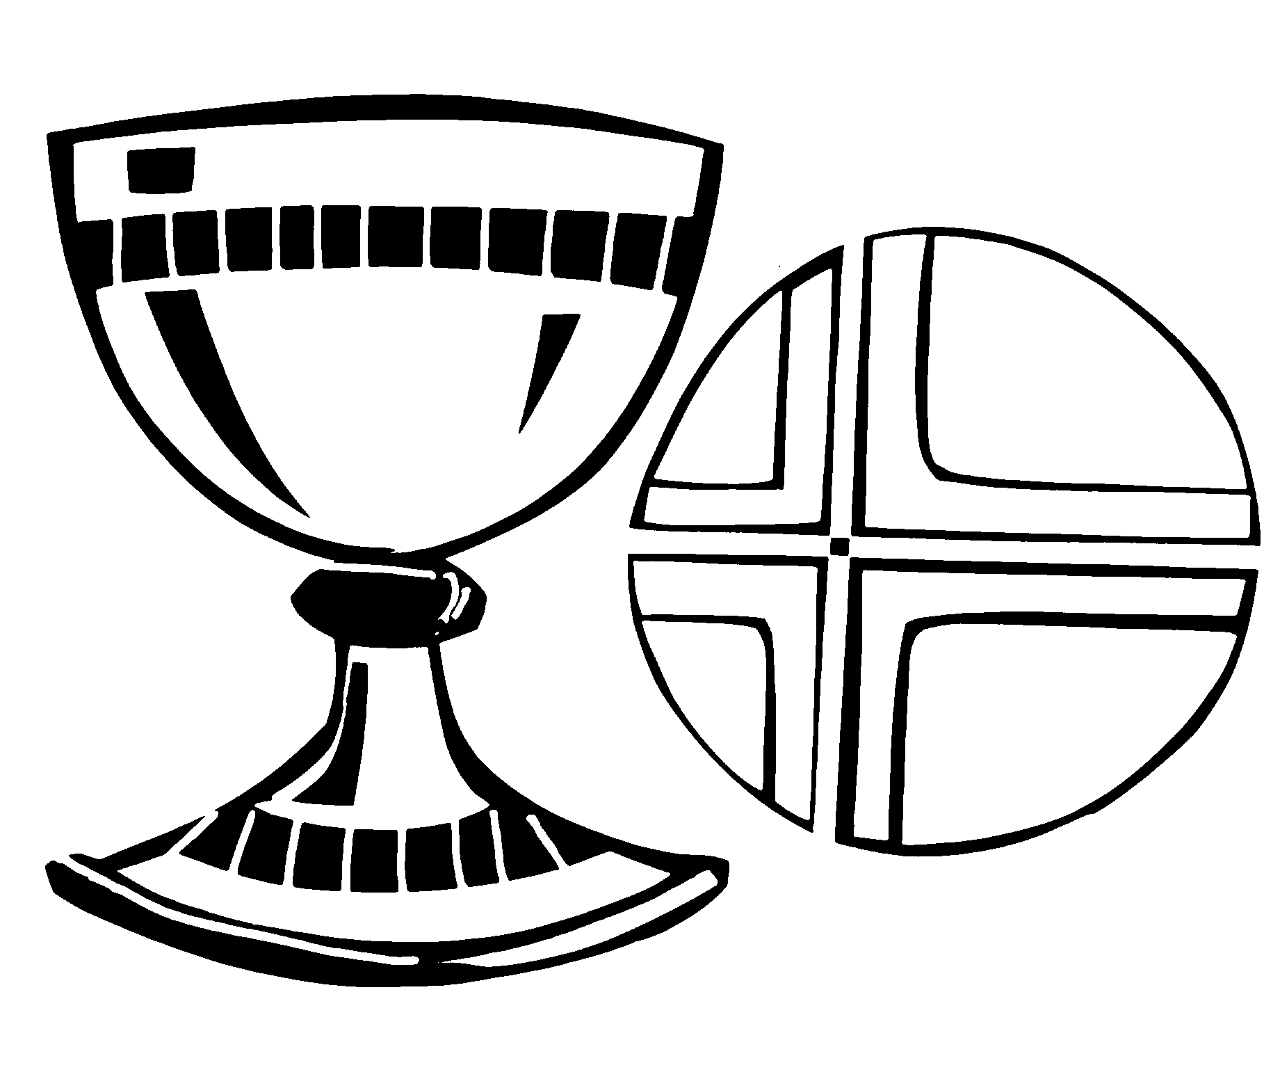C: Refrain

GOSPEL John 13:1-15,34

1It was just before the Passover Feast. Jesus knew that the time had come for him to leave this world and go to the Father. Having loved his own who were in the world, he now showed them the full extent of his love.
2The evening meal was being served, and the devil had already prompted Judas Iscariot, son of Simon, to
betray Jesus. 3Jesus knew that the Father had put all things under his power, and that he had come from God
and was returning to God; 4so he got up from the meal, took off his outer clothing, and wrapped a towel around
his waist. 5After that, he poured water into a basin and
began to wash his disciples' feet, drying them with the towel that was wrapped around him.
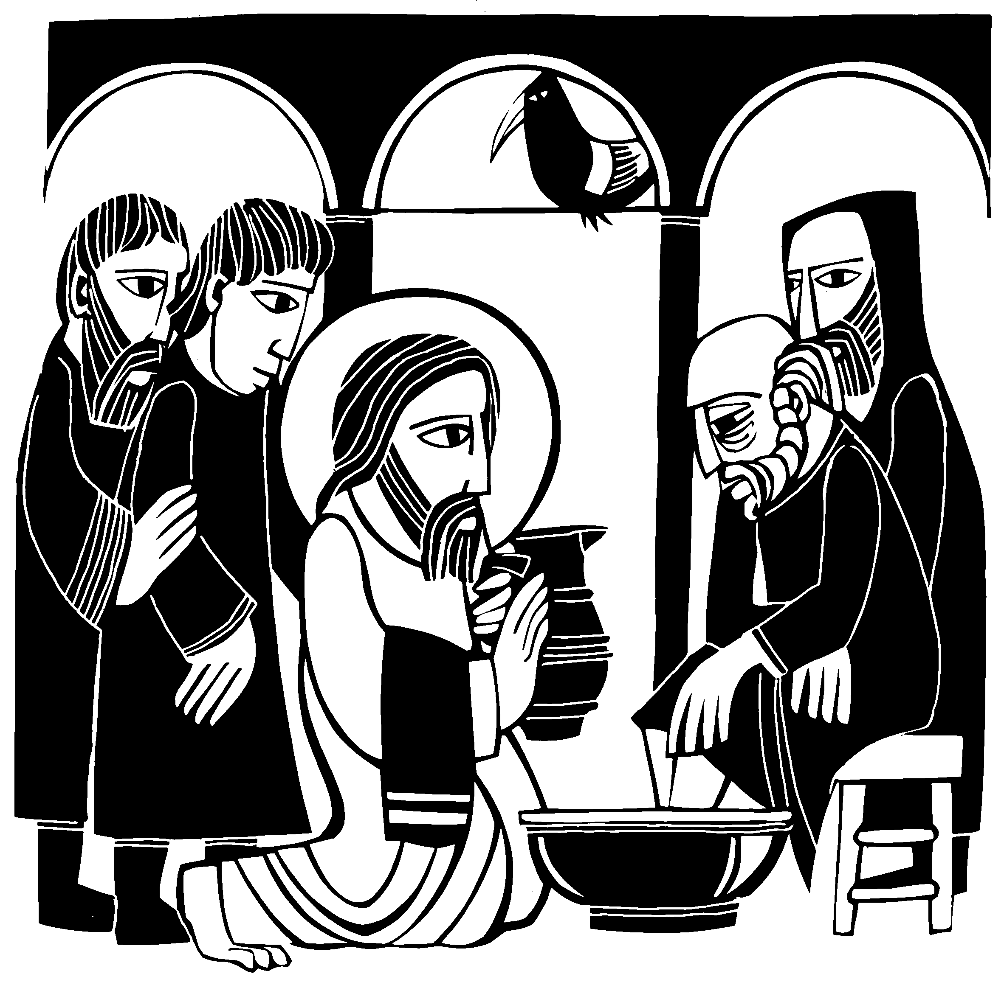6He came to Simon Peter, who said to him, "Lord, are you going to wash my
feet?"
7Jesus replied, "You do not realize now what I am doing, but later you will
understand."
8"No," said Peter, "you shall never wash my feet."
Jesus answered, "Unless I wash you, you have no part with me."
9"Then, Lord," Simon Peter replied, "not just my feet but my hands and my
head as well!"
10Jesus answered, "A person who has had a bath needs only to wash his feet; his whole body is clean. And
you are clean, though not every one of you." 11For he knew who was going to betray him, and that was why he said not every one was clean.
12When he had finished washing their feet, he put on his clothes and returned to his place. "Do you understand
what I have done for you?" he asked them. 13"You call me 'Teacher' and 'Lord,' and rightly so, for that is what I
am. 14Now that I, your Lord and Teacher, have washed your feet, you also should wash one another's feet. 15I have set you an example that you should do as I have done for you.
HYMN I Come, O Savior, to Your Table
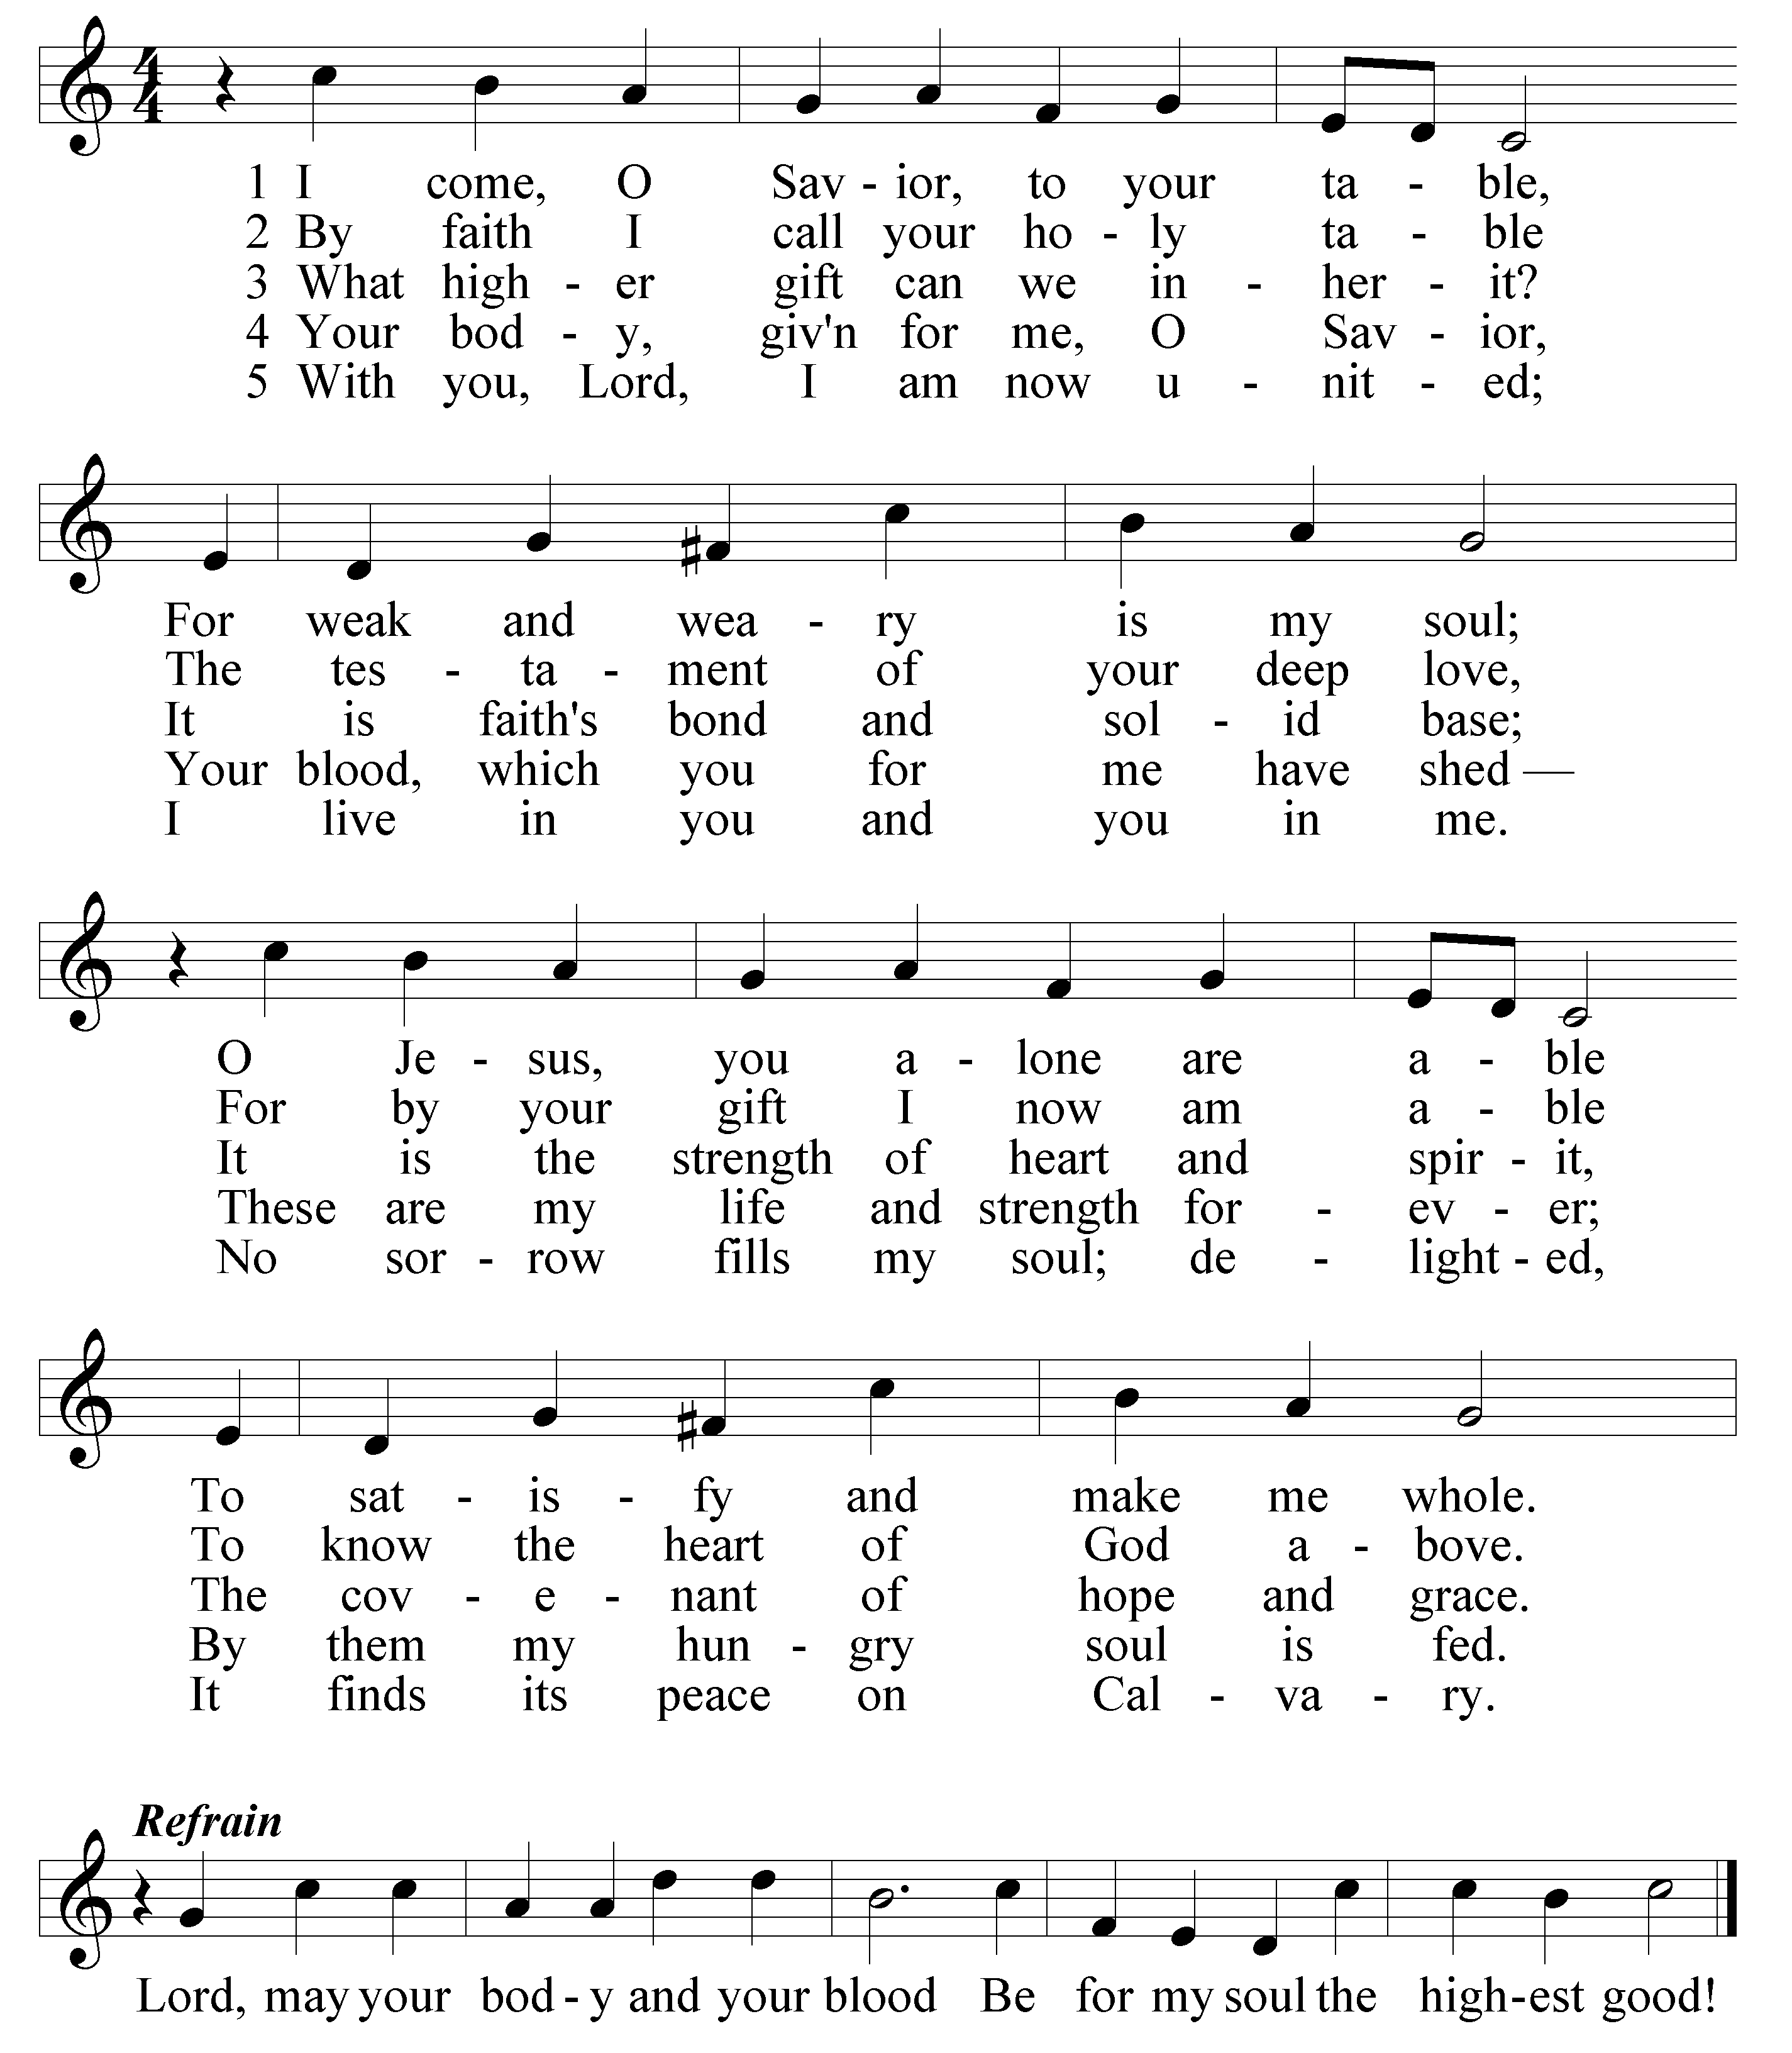

SERMON

